ClassConnect: A Real-Time Attendance Management System Empowering Education Through Broadcasting Technology

Urmil Pawar  
Computer Engineering  
Thakur College Of Engineering and Technology  
Mumbai, India  
urmilpawar2003@

gmail.com

Prabhat Pankaj  
Computer Engineering  
Thakur College Of Engineering and Technology  
Mumbai, India  
prabhatpankajofficial@gmail.com

Shlok Prajapati  
Computer Engineering  
Thakur College Of Engineering and Technology  
Mumbai, India  
shlokprajapati2003@

gmail.com

Ms. Vaishali Nirgude  
Computer Engineering  
Thakur College Of Engineering and Technology  
Mumbai, India vaishali.nirgude@thakureducation.org

***Abstract*—Attendance monitoring is a crucial aspect of educational and organizational environments, ensuring accountability and efficient management. Traditional attendance methods often encounter challenges related to inefficiency and inaccuracies, underscoring the need for modern technologies that enable real-time solutions. This paper reviews existing attendance tracking methodologies and, through a comparative analysis, highlights the benefits of integrating these technologies to contribute to the development of more accurate and efficient solutions. Based on the research, the paper proposes a novel system that leverages GPS and biometric authentication to overcome the limitations of conventional approaches. By utilizing these technologies, the system improves accuracy, automates attendance processes, ensures real-time tracking, reduces manual intervention, saves time, and paves way for more robust attendance management in modern institutions.**

***Keywords—*** ***Attendance monitoring, Efficient management, Real-time solutions, Attendance tracking methodologies, Comparative analysis, GPS authentication, Biometric authentication, Accuracy, Automated attendance, Real-time tracking, Time-saving***

# Introduction

Attendance management is a crucial aspect of organizational operations, ensuring compliance, participation tracking, and accountability. Traditional methods, such as manual roll calls or paper-based systems, are prone to inefficiencies, errors, and even manipulation, often resulting in distractions, missed attendance records, and proxy attendance, undermining the process’s reliability. This has rose interest in exploring modern technologies to enhance and streamline attendance monitoring.

Recent advancements in technology have given rise to various automated attendance systems, including QR code scanning, RFID tagging, GPS tracking, and biometric authentication. While these methods improve accuracy and speed compared to traditional approaches, they also come with challenges, such as infrastructure costs, privacy concerns, and technical limitations.

In this context, our paper surveys existing attendance marking methodologies and introduces a novel solution based on GPS and biometric authentication to address the limitations of conventional methods. By combining location-based tracking with biometric identity verification, the proposed system aims to provide a secure and automated attendance monitoring solution across different environments. Our GPS- and biometric-based solution aims to contribute to the development of reliable, efficient, and secure attendance monitoring systems tailored to diverse organizational needs.

# Literature Survey

Through a detailed comparative analysis of various attendance systems, this paper seeks to shed light on the evolving landscape of attendance management technologies, highlighting both their strengths and shortcomings.

|  |  |  |  |  |  |  |
| --- | --- | --- | --- | --- | --- | --- |
| Paper | Methodology | | Advantage | | | Drawbacks |
| [1]Attendance Management System Using a Mobile Device and a Web Application | Utilizing a mobile device and web application for students to register attendance using selfies or signatures with data stored in a database for reference in the future. | | **Enhanced Efficiency**  **Real-time Monitoring**  **Digital Record Keeping** | | | **Feedback Limitations:** The system lacks functionality for facilitating feedback from participants, hindering interactive engagement and potentially limiting opportunities for lecturer-student interaction and improvement.  **Privacy Concerns:** Collection and storage of personal data (e.g., facial images, signatures) raise privacy considerations, indicating the requirement of robust security measures |
| [2]An automated student attendance tracking system based on voiceprint and location | Students use one app to submit attendance via voiceprints, while lecturers manage sessions through another. Servers handle attendance collection, verification, and database storage. | | **Enhanced Efficiency**  **User-Friendly Interfaces**  **Digital Record Keeping** | | | **Privacy Concerns**: Voiceprint verification raises privacy concerns related to the collection and storage of biometric data. It should be highly secured.  **Reliance on Internet Connectivity:** The system relies on stable Internet connectivity for communication between devices and servers. In environments with poor or unreliable internet access, the system's functionality may be compromised. |
| [3] Bluetooth Based Attendance Management  System | Bluetooth and RFID technology | | **Timesaving**  **Independent Redesign**  **Efficiency** | | | **Reduced Constructive Feedback:** The system lacks functionality for facilitating feedback from participants, hindering interactive engagement, and potentially limiting opportunities for lecturer-student interaction and improvement.  **Proxy Attendance:** One of the drawbacks of the Bluetooth attendance system is the possibility of proxy attendance, where someone else can mark attendance on behalf of another individual. |
| [4] Development of Attendance Management System using Biometrics. | Biometric technology | | **Enhanced Security**  **Accuracy**  **Adaptability** | | | **Cost Considerations:** While fingerprint technology offers security benefits, the initial setup costs might be higher due to the need for fingerprint scanners and database infrastructure. |
| [5] Online Attendance Monitoring System Using QR Code (OAMS) | | QR Code, Face Recognition, RFID, Biometric (Fingerprint) | | F**ast, Automated**  **Accurate**  **Cost-effective**  **User-friendly** | **Relies on mobile devices and internet connectivity:** poor network coverage or lack of access to a device could hinder its functionality  **Inaccuracy:** Lack of accuracy in face recognition techniques | |

# Literature Review

In this literature review, we will look into a comprehensive exploration of the methodologies and approaches adopted by key research papers in our domain of study. Building upon the foundational information presented in the literature survey section, we now shift our focus to a detailed examination of each selected paper's unique contributions and techniques.

The review is sorted with the names of the paper

### 1)Attendance Management System Using a Mobile Device and a Web Application: The proposed system for attendance management combines the use of mobile devices and web services to address the challenges typically encountered in traditional attendance tracking methods. During lectures, a mobile device equipped with a custom application is passed among participants, allowing them to register their attendance individually. Participants can choose to register using either a selfie or a signature. If they opt for a selfie, a photo is taken and stored for attendance purposes. If they choose a signature, they digitally sign the screen, and the attendance record is stored with identification by the signature. Once registration is complete, the participant's name is removed from the list of available participants on the device's screen, facilitating easy identification of absentees for the lecturer. The system also allows for the storage of facial images or signatures as evidence of participation. These records are stored in a database, accessible for administrative purposes.

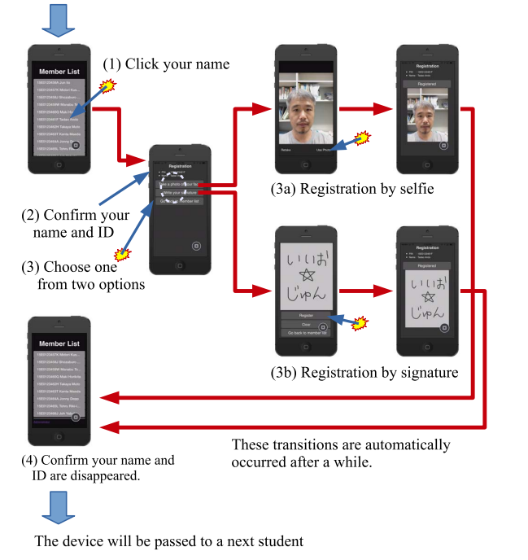

**Fig. 1.Proposed System Architecture. Adapted from [2]**

### 2) An Automated Student Attendance Tracking System Based on Voiceprint and Location: This system architecture outlines a approach to attendance tracking using smartphone applications and voiceprint verification. Both students and lecturers use smartphone applications for attendance tracking. The student version captures voiceprints and submits attendance records, while the lecturer version controls the lifecycle of attendance and checking.

### The Voiceprint Recognition server verifies students' voiceprints to authenticate their identity. When a student submits their presence, the server compares the captured voice clip with the stored voiceprint template to confirm the match. The Attendance Collecting Server receives attendance submissions from students and controls the primary logic of attendance tracking. It communicates with both student and lecturer applications, coordinating the beginning and ending of attendance activities. It also validates the submissions and calculates the distance between the student's location and the classroom.

### All attendance records are stored in the database server. Each record contains essential information such as student ID, course ID, and submission time. Additionally, course-related information like lecture time and location is stored, linking attendance records with specific courses. The Data Presentation Server provides functionalities for accessing attendance data through a web-based portal. It retrieves course information and attendance records from the database and presents them in the portal. The portal includes interactive plots for statistical analysis and allows users to export attendance data.

### Security measures include token-based security to prevent forgery during attendance submission. A dynamically generated token is retrieved after successful voiceprint verification and used to authenticate submission requests.

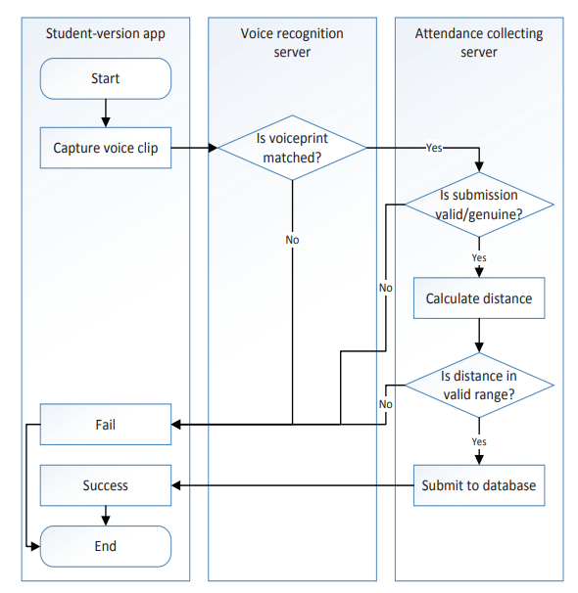

**Fig. 2.** **The process of students attendance submission. Adapted from [2]**

### 3) Blueetooth Based Attendance Management System: The proposed system for attendance management combines the use of Bluetooth and RFID technology to track student attendance efficiently. Student information is collected through RFID cards, sent to the computer, and then to the lecturer's mobile phone for attendance records. Communication architecture within the system employs heterogeneous protocols like TCP/IP, Bluetooth, NFC, and USB. Bluetooth technology is chosen for its range, low power consumption, and suitability for cell phones and battery-operated devices. The system aims to enhance staff attendance through fingerprint biometric authentication and automated class attendance recording, ensuring reliable data transmission and efficient communication between components. Once registration is complete, the participant's name is removed from the list of available participants on the device's screen, facilitating easy identification of absentees for the lecturer. The approach includes a 'Top-Down' analysis and design method with 'Bottom-Up' integration and testing process.

**Fig. 3.** **Bluetooth based Attendance Management System. Adapted from [3]**

### 4) Development of Attendance Management System using Biometrics: This system aims to streamline the process of recording and managing student attendance in educational institutions.. Both students and lecturers use smartphone applications for attendance tracking. During this administrative phase, the system administrator logs in to the system. Student biometric data, including fingerprints, is captured and stored in the database for registration. Course, lecturer, and exam details are also registered at this stage to facilitate attendance tracking. When a lecture begins, the lecturer selects the course code and attendance type. Students then place their fingerprints on the biometric reader. The system compares the captured fingerprint features with the stored templates in the database to verify attendance.

### All attendance records are stored in the database server. Each record contains essential information such as student ID, course ID, and submission time. Additionally, Reports are generated for each course, listing the total number of students present and their attendance status. The system automatically records students for the lecture, mid-semester test, or semester exam upon successful fingerprint verification. A message confirms the attendance recording to the user.

The system utilizes biometric authentication to prevent impersonation and ensure accurate attendance tracking. Rather than traditional methods like paper sheets, the biometric system enhances security and efficiency in managing student attendance.

**Fig. 4.** **General Architecture of a Biometric System. Adapted from [4]**

### 5) Online Attendance Monitoring System Using QR Code (OAMS): QR code-based systems offer a promising solution for attendance monitoring due to their simplicity, cost-effectiveness, and ease of implementation. Mishra et al. propose an Online Attendance Monitoring System Using QR Code (OAMS), which combines QR codes with face recognition technology for automated attendance recording. This approach provides advantages such as speed, automation, accuracy, and user-friendliness. However, reliance on mobile devices and internet connectivity may pose limitations in certain contexts.

### RFID-based systems are another option for automating attendance tracking through radio frequency data communication between RFID tags and readers. Despite offering scalability and automation, RFID systems have drawbacks such as high initial costs and susceptibility to interference from metal and liquids. Nevertheless, RFID remains a viable choice for institutions investing in advanced attendance management solutions.

### In contrast, biometric fingerprint systems offer high accuracy in identifying individuals but are often accompanied by significant costs, data breach risks, and biases in results. The need for specialized hardware and concerns regarding privacy and security make biometric systems less feasible for widespread adoption in educational settings.

# Methodology

***Working of the System***

*Workflow:*

The workflow of the Attendance Tracking and Management System is as follows:

1. **Teacher Connection:** The teacher fills in the required information on the interface form, such as user type, name, initials, department, division, and year, and connects to the WebSocket server.
2. **Session Creation:** Upon the teacher’s connection, a new session map is created with the teacher’s initials as the key.
3. **Student Connection:** Students fill out their details, including user type, name, roll number, branch, division, year, and the teacher’s initials (who is currently taking the lecture) on their interface form. They then connect to the WebSocket server.
4. **Mapping Students to Teachers:** Students are mapped to the session based on the teacher’s initials. This ensures that each student is linked to the correct session for attendance tracking.
5. **Attendance Start:** When the teacher clicks the 'start' button, a message indicating that attendance has started is sent to the students' devices. The message also includes the teacher's location, and the session map on the WebSocket server is cleared.
6. **Student Authentication:** Upon receiving the attendance message, the students’ devices will open an interface prompting biometric authentication. Simultaneously, the system checks if the students are within a specific radius of the teacher’s location (geolocation check).
7. **Data Validation:** Students who successfully authenticate and are within the required radius will have their data sent to the 'validation server' to be stored in the database.
8. **Attendance Stop:** When the teacher clicks the 'stop' button, a request is sent to the report generation server. The server will fetch and display a detailed list of the students present in the session.

*Use of Teacher Initials :* In cases where lectures or practicals are conducted in a batch-wise mode (with a single class split into multiple batches), the teacher remains a unique identifier. Regardless of the number of batches, the teacher is the constant entity to identify which students belong to which session, ensuring clarity.

*Authentication only Using Mobile OS Verification:* The system does not require external authentication devices. When students are prompted for biometric authentication, a request is sent to their mobile phone’s operating system to use the stored biometric data. This method is similar to how the phone unlocks itself via biometrics. The mobile OS simply verifies whether the user attempting to mark attendance is the owner of the device, returning a yes/no response after authentication.

***Mathematical Model***

The working of our project consists of three major phases:

1. Client Connection and Session Initialization
2. Attendance Verification and Marking
3. Session Closure and Report Generation

*1. Set Definitions*

1. Let *T* represent the set of all teachers:

*T={t1​,t2​,…,tn​}*

1. Let *L* represent the set of all sessions created by teachers:

*L={L1​,L2​,…,Lk}*

1. Let *S* represent the set of all students:

*S={s1​,s2​,…,sm​}*

1. Let *A* represent the set of students who are successfully authenticated for attendance:

*A={a1​,a2​,…,aj​} ⊆ S*

2. *Variables and Functions*

1. *t ∈ T*: A teacher in the system.
2. *s ∈ S*: A student in the system.
3. *L(t):* The lecture created by teacher t.
4. *bio(s):* A function that returns 1 if the student s successfully passes biometric authentication, otherwise 0.
5. *loc(s):* A function that determines the location of the teacher or student
6. *geo(s,t):* A function that checks if the student s is within the required geolocation radius of teacher t.

$$geo\left(s,t\right)=\left\{\begin{aligned}1 if d\left(loc\left(s\right),loc\left(t\right)\right)≤ r \\ 0 if d\left(loc\left(s\right),loc\left(t\right)\right)> r\end{aligned}\right.$$

where *d(loc(s), loc(t))* is the distance between the location of student s and teacher t, and r is the required radius.

1. *auth(s,t):* A function that returns 1 if student s is authenticated (biometrically and geographically) for teacher t’s session, otherwise 0.

*auth(s,t) = bio(s) ∧ geo(s,t)*

1. *att(s,t):* A function that represents whether a student is marked as present in a teacher t’s session:

$$att(s, t) =\left\{\begin{aligned}1 if auth(s,t) = 1 \\ 0 if auth(s,t) = 0\end{aligned}\right.$$

*3.Conditions*

1. The distance between the student and the teacher must satisfy:

*d(loc(s),loc(t)) ≤ r*

1. The student must pass biometric authentication:

*bio(s)=1*

1. If both conditions are satisfied, the student’s attendance is marked:

*att(s,t)=1*

Otherwise:

*att(s,t)=0*

4. *Workflow Representation*

*L(t)={s ∈ S ∣ auth(s,t)=1 }*

***System Architecture:***

Phase 1 ***:*** Client Connection and Session Initialization

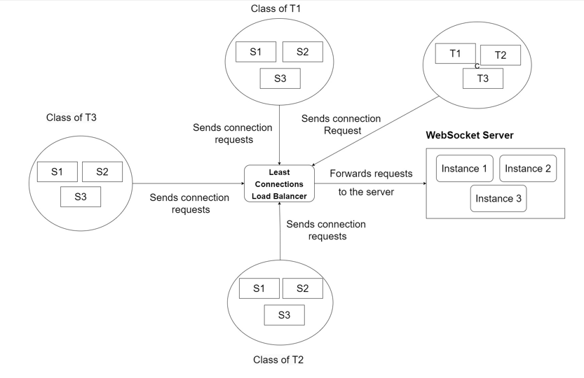

Phase 2 ***:*** Attendance Verification and Marking

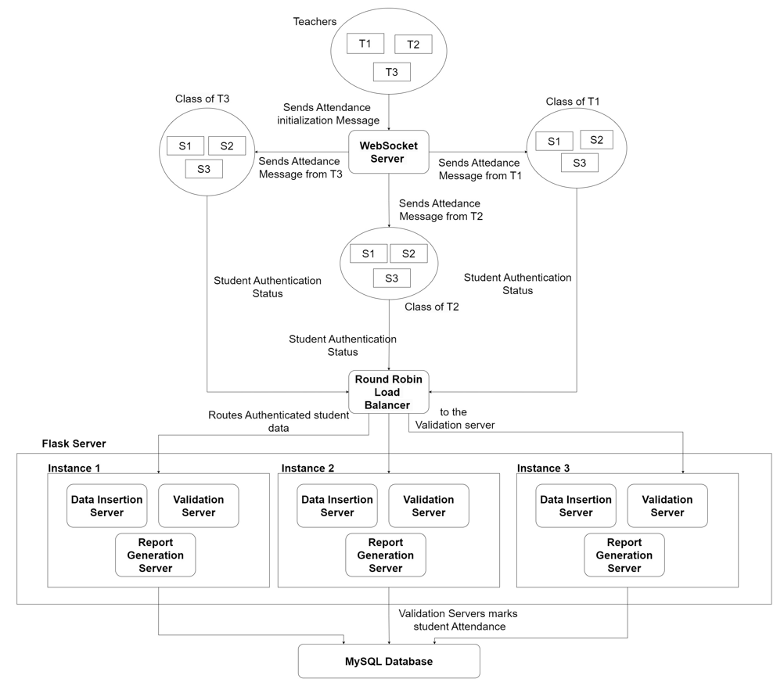

Phase 3 : Session Closure and Report Generation

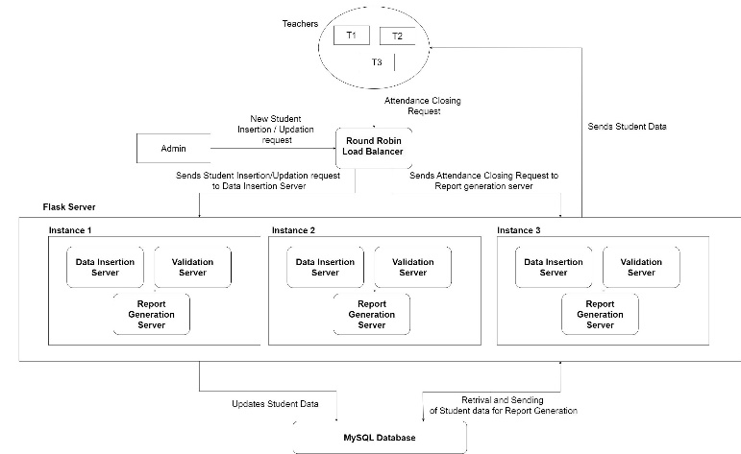

***Dataflow Diagram(DFD)***

Following are the three major components of our DFD

*External Entities:*

1. **Teacher**: Fills in session details and starts/stops the attendance.
2. **Student**: Fills in details and participates in the attendance session to mark their presence.
3. **Admin**: Updates new or existing student data.
4. **WebSocket Server**: Holds the mapping of students with their respective teachers.
5. **Validation Server**: Receives student attendance data to insert into the database.
6. **Report Generation Server**: Generates attendance **Admin**: Updates new or existing student data.
7. **Data Insertion Server**: Inserts the data of new students or updates existing student data.

*Processes:*

1. **Teacher Connection**: The teacher submits details and connects to the WebSocket server.
2. **Student Connection**: Students submit their details and connect to the WebSocket server.
3. **Mapping Students to Teachers**: Students are mapped to their teacher’s session.
4. **Attendance Start**: Attendance begins and students receive the attendance message.
5. **Student Authentication**: Marks the student’s attendance as ‘present’ whose Biometric authentication and geolocation check are successful.
6. **Attendance Stop**: Attendance ends and the report is generated.
7. **Student Data Insertion** : Insertion of new student data into the database.

*Data Stores:*

1. **MySQL Database**: Contains data about the student, lectures and mapping or present student to the lectures.

The diagram is as follows:

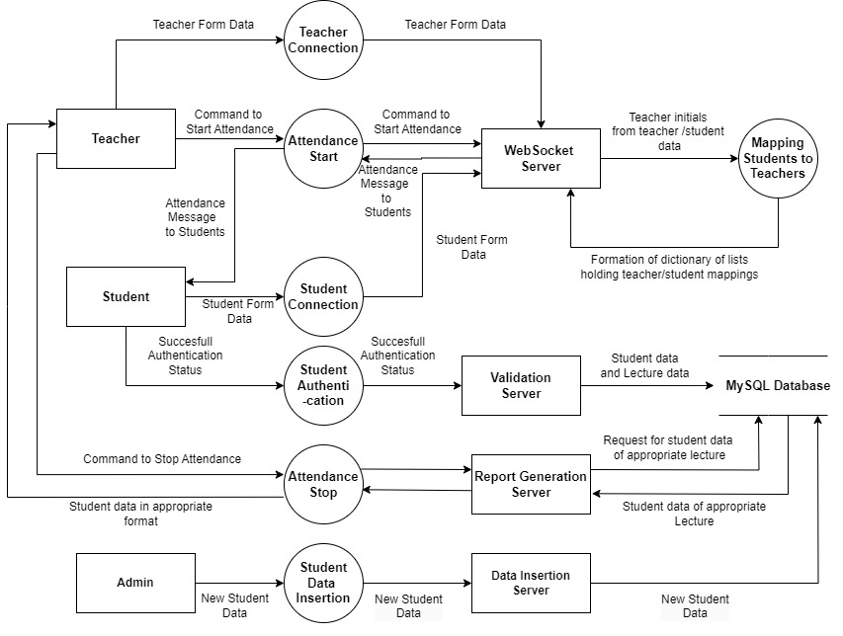

***Database Design***

The database consist of three tables:

1. Students: Contains data about individual student
2. Lecture: Contains details about the lecture
3. Attendance: Contains mappings of students to the respective lectures

The Structure of the tables is as follows:

1. Students

|  |  |  |
| --- | --- | --- |
| u_id | roll_no | name |

1. Lecture

|  |  |  |  |  |  |
| --- | --- | --- | --- | --- | --- |
| l_id | lecture  -name | branch | division | teacher_  initials | date |

1. Attendance

|  |  |
| --- | --- |
| U_id | l_id |

The ‘Attendance’ table is created separately to eliminate redundancy and the data insertion process is also optimized for duplicate entries such that no additional entry will be added for the same student

***Server Routing***

There are two major servers implemented :

1. WebSocket Server (websocket_server.js): Responsible for connecting clients (mapping students to their respective teachers)
2. Flask Servers (app.py): Flask servers are further classified in multiple functionalities based on routes:
3. /attendance_data: Route for handling Lecture Insertion and mapping student Database
4. /student_details: Route for Inserting Student details for college authorities
5. /report_data: Route for retrieving the data for report generation

Working:

1. If the college authorities want to insert or change their student data then they can send a POST request to /student_details with following example JSON content as the body:

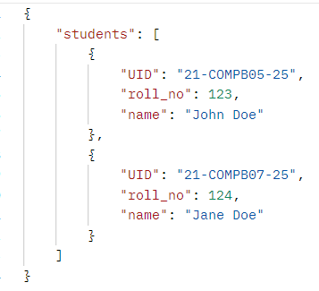

1. 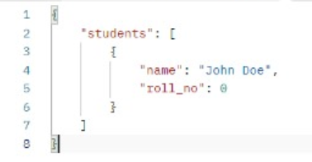Whenever the the teacher closes the session a request will be sent to /report_data to retrieve the names of the students who attended the session. The following data about the students will be retrieved
2. 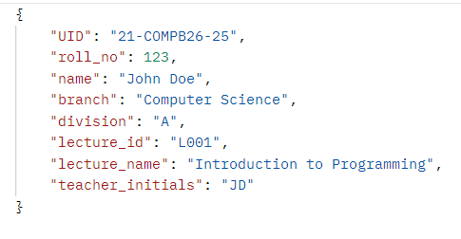Whenever the student authentication will be successful a request will be sent to /attendance details for mapping them with the lecture and inserting a new lecture with following details.

***Hosting***

The deployment of both servers is done on Microsoft Azure using the Azure App service. The MySQL server which holds the database is also created using the Azure MySQL server.

Following are the FQDN for the same:

1. WebSocket server:

<https://www.postman.com/avionics-astronomer-74847053/workspace/google-solution-challenge/ws-raw-request/66eff66035488341439b692c>

1. Flask servers:

<https://flask-servers-gqazghgmg7hnbsgv.centralindia-01.azurewebsites.net>

A virtual network is created in azure in which all the servers (MySQL, WebSocket and flask) are connected. A private endpoint is being created only between the flask and MySQL server to secure the data for external access.

***Load Balancing***

In a real-time environment, multiple users may attempt to access the server simultaneously. To prevent server overload and enhance availability, load balancers are employed to efficiently distribute traffic among the servers.

1. The load balancer managing traffic on the WebSocket server uses the 'Least Connections' algorithm, which directs traffic to the server with the fewest active connections.
2. For the 'Validation' and 'Report Generation' servers, the load balancer uses the 'Round Robin' algorithm to evenly distribute traffic, sequentially sending requests to each server in turn.

***Future Upgrades***

1. Teachers will have the ability to manually edit the list of present students after clicking the 'stop' button, allowing for corrections.
2. A notification system will be available for students, providing real-time updates on their attendance percentage.

# CONCLUSION

In this paper, we tried to analyze the existing research going on in the field of Attendance Tracking and Management Systems and implemented a solution incorporating GPS and biometric authentication to ensure accurate and secure attendance tracking.

Our literature review has provided a thorough examination of key research papers in the domain of Attendance Management Systems. Each paper contributed unique methodologies and approaches, shedding light on diverse techniques to address challenges in this field.

Our methodology proposes a system that streamlines attendance processes by utilizing WebSocket connections, biometric authentication, and geolocation verification, eliminating proxy attendance. It efficiently manages sessions using teacher initials and mobile OS biometrics, ensuring security and ease of use. With scalable architecture and potential upgrades, the system enhances performance and user experience.

In the future, we are planning to include manual attendance edits for teachers after report generation and real-time attendance notifications for students, enhancing flexibility.

# REFERENCES

1. Mishra, S., Kumar, C., Ali, A., & Bala, J. (2021). Online Attendance Monitoring System using QR code (OAMS). 2021 2nd International Conference on Intelligent Engineering and Management (ICIEM).
2. Mb, S., & Roy, R. (2015). A web enabled secured system for attendance monitoring and real time location tracking using Biometric and Radio Frequency Identification (RFID) technology. 2015 International Conference on Computer Communication and Informatics (ICCCI -2015), Jan. 08 – 10, 2015, Coimbatore, INDIA.
3. Lodha, R., Gupta, S., Jain, H., & Narula, H. (2015). Bluetooth Smart Based Attendance Management System. Procedia Computer Science, 45, 524–527.
4. Idowu, O. J. (2012). Development of Attendance Management System using Biometrics. Department of Electrical and Electronics, University of Benin, Edo State, Nigeria.
5. Yang, S., Song, Y., Ren, H., & Huang, X. (2016). An automated student attendance tracking system based on voiceprint and location.
6. A. K. Jain, A. Ross, and S. Prabhakar, "A Biometric Attendance Management System Based on Fingerprint Recognition," International Journal of Computer Science and Information Technologies, vol. 4, no. 5, pp. 647-652, 2021.
7. S. Kumar, M. A. Patil, and P. G. Khot, "Smart Attendance System using GPS and Facial Recognition," IEEE Access, vol. 9, pp. 34321-34328, Mar. 2021.
8. L. Zhang and H. Wang, "A Comparative Study on QR Code, Biometric, and RFID Technologies for Automated Attendance Systems," Journal of Education and Information Technologies, vol. 25, no. 6, pp. 1234-1245, Dec. 2020.
9. M. S. Alkahtani, "RFID and Bluetooth-based Attendance System for Improved Accuracy and Automation," IEEE Transactions on Education, vol. 64, no. 4, pp. 311-319, Nov. 2020.
10. N. Ratha and R. Bolle, "Privacy and Security Issues in Biometric Attendance Systems: A Review," ACM Computing Surveys, vol. 53, no. 2, pp. 1-33, Apr. 2021.