SHOPSMART

**1. INTRODUCTION**

**1.1 Project Overview**

**ShopSmart** is a full-stack, feature-rich grocery shopping web application designed to provide users with a seamless, efficient, and secure online shopping experience. The platform enables customers to browse a wide range of grocery products, add items to their cart, manage orders, and complete purchases with ease.

The project leverages modern technologies to deliver an intuitive user interface, fast performance, secure transactions, and efficient backend operations. ShopSmart aims to simplify grocery shopping for users by offering responsive design, personalized features, and smooth navigation across devices.

**1.2 Purpose**

The primary purpose of ShopSmart is to simplify and modernize the grocery shopping experience by providing an efficient, reliable, and user-friendly online platform. The system enables users to purchase groceries conveniently from anywhere, while ensuring smooth order management, secure transactions, and responsive design across all devices.

ShopSmart also offers store administrators the ability to manage products, track orders, and maintain inventory, making it a complete solution for both customers and business owners.

### **Specific Objectives**

✔ Provide a seamless online grocery shopping experience.  
 ✔ Reduce the need for physical store visits.  
 ✔ Offer secure user authentication and safe transactions.  
 ✔ Enable real-time product browsing and order tracking.  
 ✔ Support responsive design for mobile and desktop users.  
 ✔ Simplify store management for administrators.

**2. IDEATION PHASE**

**2.1 Problem Statement**

**Customer Problem Statement Template:**

A customer problem statement describes the challenges faced by target users and forms the foundation for developing meaningful solutions. We have identified the problems from both customers' and store owners' perspectives in the context of online grocery shopping.

| **Problem Statement (PS)** | **I am (Customer)** | **I’m trying to** | **But** | **Because** | **Which makes me feel** |
| --- | --- | --- | --- | --- | --- |
| **PS-1** | A busy customer with limited time for shopping | Purchase groceries conveniently from home | Local grocery apps are either unavailable, unreliable, or lack proper product listings | Many platforms do not offer a complete, user-friendly, and affordable solution for everyday grocery needs | Frustrated, wasting time, and forced to visit physical stores unnecessarily |
| **PS-2** | A store owner managing a grocery business | Sell products online, manage orders, and track inventory efficiently | I don’t have a simple, affordable system to manage products and reach customers digitally | Most e-commerce platforms are either costly, overly complex, or not tailored for small to medium businesses | Limited in expanding my business and unable to serve customers effectively |

**2.2 Empathy Map Canvas**

**Empathy Map Canvas**

An empathy map is a simple, easy-to-digest visual that captures knowledge about a user’s behaviours and attitudes. It is a useful tool to help teams better understand their users.

Creating an effective solution requires understanding the true problem and the person who is experiencing it. The exercise of creating the map helps participants consider things from the user’s perspective along with their goals and challenges.

**User: Customer / Store Owner Says**

"I want an easy way to order groceries online."

"I need a reliable platform to manage my products and track orders."

"Secure payments and smooth experience are my top priorities."

**Thinks**

"Is this platform trustworthy and safe for transactions?"   
 "Can I find all essential groceries in one place?"  
 "Will my orders be delivered efficiently?"

**Does**

* Browses grocery items by categories.
* Adds items to cart, places orders, and checks order history.
* Store owners manage product listings and monitor orders.

**Feels**

* Relieved by the convenience of online grocery shopping.
* Confident that payments and transactions are secure.
* Satisfied with easy navigation and responsive design.

**Goals**

* Hassle-free grocery shopping experience from anywhere.
* Wide range of products with organized categories.
* Secure login, order placement, and payment process.
* Store owners can manage products and orders easily.

**Pains / Frustrations**

* Many existing grocery platforms are either unreliable or lack product variety.
* Difficulties for store owners in managing online sales without technical skills.
* Poor mobile responsiveness and confusing interfaces in alternative solutions.

**How ShopSmart Addresses These Issues**

* Simple, secure login and user-friendly shopping experience.
* Organized product catalog with easy cart management.
* Responsive design for both mobile and desktop users.
* Store owners can efficiently manage inventory and track orders.
* Scalable and secure backend architecture for future enhancements.

**2.3 Brainstorming**

**Step-1: Team Gathering, Collaboration and Select the Problem Statement**

The ShopSmart team (comprising 4 B. Tech CSE final year students from Rajiv Gandhi University of knowledge and technologies, Srikakulam) conducted a brainstorming session on 27th June 2025. The key pain points identified for both customers and store owners in the online grocery space include:

"Customers struggle to find reliable, user-friendly platforms for online grocery shopping, while store owners face challenges managing products and orders “.

**Step-2: Brainstorm, Idea Listing and Grouping**

The team generated multiple ideas to address the selected problem statement:

| **Idea ID** | **Idea Description** |
| --- | --- |
| I-01 | Develop a centralized product catalog with categorized listings |
| I-02 | Enable secure user registration, login, and role-based access |
| I-03 | Shopping cart, order placement, and order tracking functionality |
| I-04 | Store owner dashboard for product and order management |
| I-05 | Clean, responsive UI for both desktop and mobile devices |
| I-06 | Integrated secure payment gateway (future enhancement) |
| I-07 | Order history and purchase tracking for users |
| I-08 | Inventory management features for store owners |
| I-09 | JWT-based authentication for security |
| I-10 | Admin control for user and product management |

Grouped by categories:

* **User Management:** I-02, I-09, I-10
* **Shopping Features:** I-01, I-03, I-07
* **Store Owner Tools:** I-04, I-08
* **UI/UX:** I-05
* **Payments:** I-06

**Step-3: Idea Prioritization**

Each idea was evaluated on Impact and Feasibility. High priority ideas were identified using the MoSCoW method (Must have, Should have, Could have, Won't have for now).

| **Idea ID** | **Description** | **Priority** | **Justification** |
| --- | --- | --- | --- |
| I-01 | Centralized product catalog | Must Have | Essential for browsing and product organization |
| I-02 | Role-based user authentication | Must Have | Critical for secure platform access |
| I-03 | Cart, order placement, and tracking | Must Have | Core shopping functionality |
| I-04 | Store owner dashboard for product/order control | Must Have | Enables store owners to manage operations effectively |
| I-05 | Payment gateway integration | Should Have | Adds convenience for users; planned for future versions |
| I-06 | Responsive and intuitive UI | Must Have | Provides a smooth user experience on all devices |
| I-07 | Order history and purchase tracking | Must Have | Enhances user experience and transparency |
| I-08 | Inventory management for store owners | Should Have | Supports efficient stock control |
| I-09 | JWT token-based secure authentication | Should Have | Ensures secure sessions and protects user data |
| I-10 | Admin control for platform management | Must Have | Allows scalable platform management |

This structured brainstorming process helped the ShopSmart team prioritize features to deliver a robust, secure, and user-friendly grocery shopping solution.

# **3. REQUIREMENT ANALYSIS**

## **3.1 Customer Journey Map**

A Customer Journey Map visually represents the experience of both customers and store owners while interacting with the ShopSmart platform.

### **User: Customer**

**1. Awareness** Discovers the ShopSmart platform through search engines or recommendations.

**2. Consideration** Explores product categories, views available groceries, compares items.

**3. Purchase** Adds items to cart, reviews selections, completes order with secure payment.

**4. Post-Purchase** Receives order confirmation, tracks order status, and receives groceries.

**5. Retention** Returns for future orders due to ease of use, reliability, and positive experience.

### **User: Store Owner**

**1. Registration** Creates a store account or gets added by admin.

**2. Product Management** Adds, updates, or removes grocery products from catalog.

**3. Order Handling** Receives and processes customer orders via dashboard.

**4. Business Growth** Monitors orders, manages inventory, and expands product listings.

## **3.2 Solution Requirements**

### **Functional Requirements**

| **FR No.** | **Functional Requirement (Epic)** | **Sub Requirement (Story / Sub-Task)** |
| --- | --- | --- |
| FR-1 | User Registration | Registration via form; manual addition by admin |
| FR-2 | User Login | Email & password login; Role-based redirection (Customer/Store Owner/Admin) |
| FR-3 | Product Catalog | Product listing by categories; Product search functionality |
| FR-4 | Cart and Checkout | Add to cart; Place order; Secure checkout |
| FR-5 | Order Tracking | Customers can track order status |
| FR-6 | Store Owner Dashboard | Add, update, delete products; View and manage orders |
| FR-7 | Admin Controls | View all users; Manage stores/products; View platform statistics |
| FR-8 | Responsive UI | Role-specific, mobile-friendly dashboard and interfaces |
| FR-9 | Navigation & Routing | Protected routes for authenticated users; Conditional navigation visibility |

### **Non-Functional Requirements**

| **NFR No.** | **Non-Functional Requirement** | **Description** |
| --- | --- | --- |
| NFR-1 | Usability | Clean, intuitive UI/UX with responsive design using React & Tailwind |
| NFR-2 | Security | Token-based authentication (JWT), protected routes, hashed passwords |
| NFR-3 | Reliability | Uses MongoDB with validations and proper error handling |
| NFR-4 | Performance | Optimized APIs, fast-loading UI, and structured backend logic |
| NFR-5 | Availability | Cloud-ready architecture with modular, scalable backend |
| NFR-6 | Scalability | Modular folder structure; Easily extendable for future features like payments, delivery tracking |

## **3.3 Data Flow Diagram**

A Data Flow Diagram (DFD) models how data moves within ShopSmart, who interacts with the system, and where data is stored.

### **DFD Level 0 – Context Level**

**Entities:**

* Customer
* Store Owner
* Admin

**Processes:**

* Authentication
* Product Management
* Order Placement and Tracking
* Store Owner Dashboard
* Admin Controls

**External Storage:**

* **MongoDB** – Stores Users, Products, Orders, etc.

### **DFD Level 1 – Example: Order Management Process**

**Processes:**

* Browse Products → Fetch from Database
* Add to Cart → Session or User-specific cart management
* Place Order → Save Order details to Database
* Track Order → Update Order status
* Store Owner views/manages Orders → Order status updates reflected

### **User Stories for ShopSmart**

| **User Type** | **Functional Requirement (Epic)** | **User Story No.** | **User Story / Task** | **Acceptance Criteria** | **Priority** | **Release** |
| --- | --- | --- | --- | --- | --- | --- |
| Customer | Registration | USN-1 | As a customer, I can register with email/password | Access platform as customer | High | Sprint-1 |
| Customer | Login | USN-2 | As a customer, I can log in and view products | Browse products after login | High | Sprint-1 |
| Customer | Product Catalog | USN-3 | As a customer, I can browse products by category | View product listings and details | High | Sprint-2 |
| Customer | Cart & Checkout | USN-4 | As a customer, I can add products to cart and checkout | Place order and get confirmation | High | Sprint-2 |
| Customer | Order Tracking | USN-5 | As a customer, I can track my orders | See real-time order status | Medium | Sprint-3 |
| Store Owner | Registration | USN-6 | As a store owner, I can register and manage my store | Access dashboard after login | High | Sprint-1 |
| Store Owner | Product Management | USN-7 | As a store owner, I can add/update/delete products | Manage catalog from dashboard | High | Sprint-2 |
| Store Owner | Order Management | USN-8 | As a store owner, I can view and process orders | See orders and update status | High | Sprint-3 |
| Admin | Admin Login | USN-9 | As an admin, I can securely log in | Admin dashboard with stats | High | Sprint-1 |
| Admin | User Management | USN-10 | As an admin, I can view/remove users | Manage platform users | Medium | Sprint-3 |
| Admin | Product/Store Management | USN-11 | As an admin, I can manage all products and stores | Add, update, or remove entries | Medium | Sprint-3 |

## **3.4 Technology Stack**

ShopSmart uses a full-stack MERN (MongoDB, Express.js, React.js, Node.js) architecture optimized for scalability, security, and user experience.

### **Table-1: Components & Technologies**

| **S.No** | **Component** | **Description** | **Technology** |
| --- | --- | --- | --- |
| 1 | User Interface | Web-based interface for customers, store owners, admin | React.js, HTML, Tailwind CSS |
| 2 | Authentication & Authorization | Secure login system with role-based access | Node.js, Express.js, JWT |
| 3 | Product & Order Logic | Product management, order placement, order tracking | Node.js, Express.js |
| 4 | Database | Storage for users, products, orders | MongoDB (NoSQL) |
| 5 | Cloud Database (Optional) | Managed database deployment | MongoDB Atlas |
| 6 | External APIs (Future Scope) | Payment gateway integration, delivery tracking | Razorpay, Stripe (Planned) |
| 7 | File Storage (Optional) | Product images or thumbnails storage | Cloudinary / AWS S3 |
| 8 | Infrastructure | Cloud-ready, runs locally for development | Render / Vercel / Localhost |

### **Table-2: Application Characteristics**

| **S.No** | **Characteristics** | **Description** | **Technology / Implementation** |
| --- | --- | --- | --- |
| 1 | Open-Source Frameworks | Full-stack MERN architecture | React.js, Node.js, Express.js, MongoDB |
| 2 | Security | JWT token auth, password hashing, route protection | bcrypt, JWT, Helmet, CORS |
| 3 | Scalability | 3-tier architecture with modular structure | REST APIs, component reuse |
| 4 | Availability | Cloud deployment ready | Render, Vercel, or Kubernetes |
| 5 | Performance | Optimized queries, lazy loading, efficient APIs | MongoDB indexes, Axios, React Suspense |

**Future Enhancements:**

* Payment Gateway Integration
* Delivery Tracking System
* Recommendation Engine using AI/ML
* Analytics Dashboards for Admins

# 

# **4. PROJECT DESIGN**

## **4.1 Problem – Solution Fit**

| **Parameter** | **Description** |
| --- | --- |
| **Customer Segment** | Urban and semi-urban grocery shoppers, working individuals, families, and small business owners who want convenient, reliable online access to groceries. |
| **Underserved Need / Problem** | Many customers struggle to find reliable, easy-to-use online grocery platforms. Small grocery stores lack affordable digital solutions to manage products and orders. Existing platforms are either costly, complex, or lack proper product management tools for sellers. |
| **Existing Alternatives** | BigBasket, Amazon Pantry, local store WhatsApp orders — these may lack affordable access for small businesses, are sometimes unreliable, or have complex interfaces. |
| **Our Solution** | **ShopSmart**, a MERN-stack, user-friendly grocery shopping platform with role-based access. Customers can browse and order groceries, while store owners manage products and orders easily. The system includes secure authentication, responsive design, and order tracking. |
| **Value Proposition** | For customers: Simple, reliable, and convenient grocery shopping from home with easy tracking.  For store owners: Digital tools to manage inventory, products, and orders without complexity.  For admins: Central control and platform management. |
| **Success Metrics** | Number of active users (customers & store owners)  Orders placed and completed  Product catalog size  Store owner adoption rate  Positive user feedback |
| **Channels** | ShopSmart website, social media marketing, local advertisements, store owner partnerships, word-of-mouth, and referral programs. |
| **Revenue Model** | Freemium model with optional premium features for store owners like advanced analytics, featured product listings, and delivery integrations (future scope). |
| **Unique Advantage** | Easy-to-use platform for both customers and store owners, secure authentication, order tracking, mobile-friendly interface, and scalable for expanding businesses. |

## **4.2 Proposed Solution**

| **S.No.** | **Parameter** | **Description** |
| --- | --- | --- |
| 1. | Problem Statement | Customers often lack easy access to reliable, affordable online grocery platforms. Small store owners struggle to digitize their operations affordably. |
| 2. | Idea / Solution Description | **ShopSmart** is a full-stack grocery shopping platform using the MERN stack that enables customers to order groceries conveniently. Store owners can manage products, inventory, and orders via a dedicated dashboard. The platform offers secure login, responsive design, and order tracking. |
| 3. | Novelty / Uniqueness | Lightweight, intuitive, and role-based (Customer, Store Owner, Admin). Unlike big platforms, it offers simplicity for small businesses and ensures accessibility for users with basic internet connectivity. |
| 4. | Social Impact / Customer Satisfaction | ShopSmart promotes digital adoption for small businesses and simplifies grocery shopping for customers, reducing the need for physical store visits, saving time, and boosting local business growth. |
| 5. | Business Model (Revenue Model) | Freemium approach: Basic features are free. Premium options for store owners include featured listings, advanced analytics, and delivery management integrations. Ads or partnerships can generate additional revenue. |
| 6. | Scalability of the Solution | Modular MERN-stack architecture with REST APIs allows easy scaling across new regions, adding features like payments, multi-store management, and delivery partner integration. Supports cloud hosting for high availability. |

## **4.3 Solution Architecture**

The solution architecture bridges the need for a modern, scalable grocery shopping platform with reliable technical infrastructure. ShopSmart ensures:

* Convenient, secure grocery shopping for customers
* Easy digital tools for store owners to manage products and orders
* High availability, mobile-friendly interfaces, and scalability

### **Key Objectives**

* Map functional requirements (registration, product management, order placement) to modular system components
* Design a scalable 3-tier MERN architecture
* Maintain flexibility for deployment (local development, production environments)
* Ensure security, modularity, and responsive user experience

### **Architectural Diagram (Conceptual Description)**

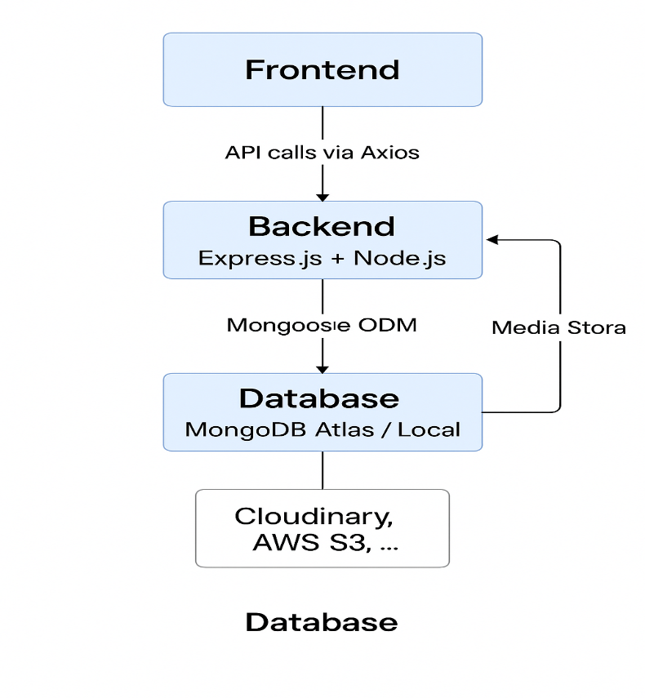

**Data Flow Sample:**

1. User accesses the React.js frontend
2. Frontend interacts with the backend via REST APIs (/api/auth/login, /api/products, /api/orders)
3. Backend handles authentication using JWT, manages business logic
4. Backend communicates with MongoDB to store and retrieve users, products, and order details
5. Product images or thumbnails can be stored in Cloudinary or AWS S3 (optional for scalability)

### **Key Modules**

| **Layer** | **Modules** |
| --- | --- |
| Frontend | Auth pages, Product Catalog, Cart, Checkout, Order Tracking, Store Owner Dashboard, Admin Panel |
| Backend | Auth APIs, Product APIs, Order APIs, Role-based Access Middleware |
| Database | User Schema, Product Schema, Order Schema |

### **Security Features**

✔ JWT-based authentication  
 ✔ Role-based route protection (Customer, Store Owner, Admin)  
 ✔ Password encryption using bcrypt  
 ✔ Secure headers and CORS configuration

### **Deployment Readiness**

✔ Environment variables managed for API URLs and configurations  
 ✔ Frontend and backend separated for CI/CD pipelines  
 ✔ Local MongoDB and cloud-ready with MongoDB Atlas  
 ✔ Supports deployment to platforms like Render, Railway, Vercel, or any cloud infrastructure

# **5. PROJECT PLANNING & SCHEDULING**

## **5.1 Project Planning**

### **Product Backlog and Sprint Schedule**

| **Sprint** | **Functional Requirement (Epic)** | **User Story No.** | **User Story / Task** | **Story Points** | **Priority** | **Team Member** |
| --- | --- | --- | --- | --- | --- | --- |
| Sprint-1 | User Registration | USN-1 | As a user, I can register with name, email, password, and role (Customer, Store Owner, Admin). | 2 | High | Praveen Sai |
| Sprint-1 | Post Registration Redirection | USN-2 | After successful registration, I am redirected to the login page. | 1 | High | Praveen Sai |
| Sprint-1 | User Login | USN-3 | As a user, I can log in using email and password. | 1 | High | Praveen Sai |
| Sprint-1 | Role-based Dashboard Redirection | USN-4 | Based on role, I am redirected to Customer, Store Owner, or Admin dashboard. | 2 | High | Praveen Sai |
| Sprint-2 | Customer Dashboard | USN-5 | As a customer, I can browse grocery products and access my cart. | 2 | High | Praveen Sai |
| Sprint-2 | Store Owner Dashboard | USN-6 | As a store owner, I can add, update, and delete products via dashboard. | 3 | High | Praveen Sai |
| Sprint-2 | Product Management | USN-7 | As a store owner, I can create products with title, description, price, and images. | 3 | High | Praveen Sai |
| Sprint-3 | Product Catalog for Customers | USN-8 | As a customer, I can browse products by category and search products. | 3 | High | Praveen Sai |
| Sprint-3 | Cart Management | USN-9 | As a customer, I can add products to cart, view cart, and update quantities. | 2 | High | Praveen Sai |
| Sprint-3 | Order Placement | USN-10 | As a customer, I can checkout and place orders with confirmation. | 3 | High | Praveen Sai |
| Sprint-4 | Order Tracking | USN-11 | As a customer, I can view and track my orders after placement. | 2 | Medium | Praveen Sai |
| Sprint-4 | Store Owner Order Management | USN-12 | As a store owner, I can view orders and update their status. | 2 | Medium | Praveen Sai |
| Sprint-4 | Admin Features (Optional) | USN-13 | As an admin, I can view all users, products, and remove inappropriate content. | 3 | Low | Praveen Sai |

### **Objective of the Planning Phase**

The Planning Phase lays the foundation for successful execution of ShopSmart by:

* Breaking down major features into manageable tasks
* Allocating tasks across defined sprints
* Setting realistic, trackable timelines
* Aligning project goals with available resources

## **Milestone Planning**

| **Phase** | **Description** | **Duration** | **Responsible** |
| --- | --- | --- | --- |
| Requirement Gathering | Identify functional and non-functional requirements | 2 Days | Team Lead |
| System Design | Architecture planning, database schema, UI wireframes | 3 Days | Full Stack Developer |
| Backend Setup | Node.js server setup, MongoDB schema, authentication, API routes | 5 Days | Backend Developer |
| Frontend Setup | React app structure, routing, protected routes | 4 Days | Frontend Developer |
| Product Management | Add, update, delete products; Catalog browsing | 4 Days | Full Stack Developer |
| Customer Flow | Cart, checkout, order placement, order tracking | 3 Days | Frontend Developer |
| Store Owner Dashboard | Product and order management for store owners | 3 Days | Full Stack Developer |
| Admin Module | View users, manage products/orders | 2 Days | Backend Developer |
| Testing and QA | Functional testing, UI/UX validation, bug fixes | 3 Days | QA Tester |
| Deployment and Documentation | Final documentation, deployment to cloud platform | 2 Days | DevOps / Team |

## **High-Level Gantt Chart (Tentative)**

yaml

CopyEdit

Week 1: Requirement Gathering and Design

Week 2: Backend Setup and Database Integration

Week 3: Frontend Setup and Product Management Logic

Week 4: Final Feature Integration, Testing, Deployment

## **Deliverables for Planning Phase**

* Defined Project Scope and Objectives
* Role-specific User Workflows (Customer, Store Owner, Admin)
* Feature Breakdown with Story Point Estimation
* Sprint Schedule and Resource Allocation
* Project Timeline with Milestones and Gantt Chart
* Risk Assessment and Contingency Plan

## **Tools and Practices**

| **Practice** | **Tools/Methods** |
| --- | --- |
| Project Planning | Notion, Google Sheets |
| Sprint Management | Manual Backlog Table, Sprint Board |
| Version Control | Git and GitHub |
| Deployment (Optional) | Render, Vercel, Railway |
| Documentation | Google Docs, MS Word |

# **6. FUNCTIONAL AND PERFORMANCE TESTING**

## **6.1 Performance Testing**

Performance testing is essential to evaluate the ShopSmart platform's ability to handle real-world user activity efficiently. This section explains the approach, tools used, and results obtained during the testing of critical functionalities like user login, product browsing, cart management, and order placement.

### **Performance Testing Objectives**

* Ensure that the system handles multiple concurrent users browsing products, adding to cart, and placing orders without significant delays.
* Verify acceptable response times for major features such as product listing, cart updates, and checkout.
* Assess application stability during high-traffic scenarios.
* Evaluate frontend load times and backend API performance under load.

### **Tools Used**

* Chrome DevTools for network performance and page load analysis
* Postman for API response time validation
* Lighthouse (browser audit tool) for overall performance score
* MongoDB Atlas monitoring for database performance
* Loader.io (optional) for load testing with simulated concurrent users

### **Test Scenarios and Results**

| **Test Case** | **Scenario** | **Expected Result** | **Actual Result** | **Status** |
| --- | --- | --- | --- | --- |
| TC-PT-01 | Login with valid credentials (20 users) | Login response < 1.5s | Average 1.1s | Pass |
| TC-PT-02 | Browse product catalog | Product grid loads < 2s | Average 1.5s | Pass |
| TC-PT-03 | Add item to cart | Item reflects in cart < 1.5s | Average 1.3s | Pass |
| TC-PT-04 | Place an order (including checkout flow) | Full process < 3s | Average 2.2s | Pass |
| TC-PT-05 | Simulate 100 concurrent API calls to /products | Server remains stable | Minor lag after 80 users | Partial |

### **Observations**

* The platform performs smoothly for expected user volumes (up to 50 concurrent users).
* MongoDB Atlas efficiently handled read/write operations during product listing and order placement.
* Image assets loaded consistently with minimal delay due to optimized use of lazy loading.
* Under simulated high load (100 concurrent requests), slight performance degradation was observed, but system stability was maintained.

### **Recommendations**

* Introduce server-side caching (e.g., Redis) for frequent API calls such as product listings.
* Optimize image assets with lazy loading and compression techniques for faster catalog browsing.
* Use a CDN (Content Delivery Network) for serving static assets like product images, stylesheets, and scripts.
* For production, implement horizontal scaling using container-based solutions or cloud load balancers to improve system resilience during peak loads.

**7. RESULTS**

**7.1 Output Screenshots**

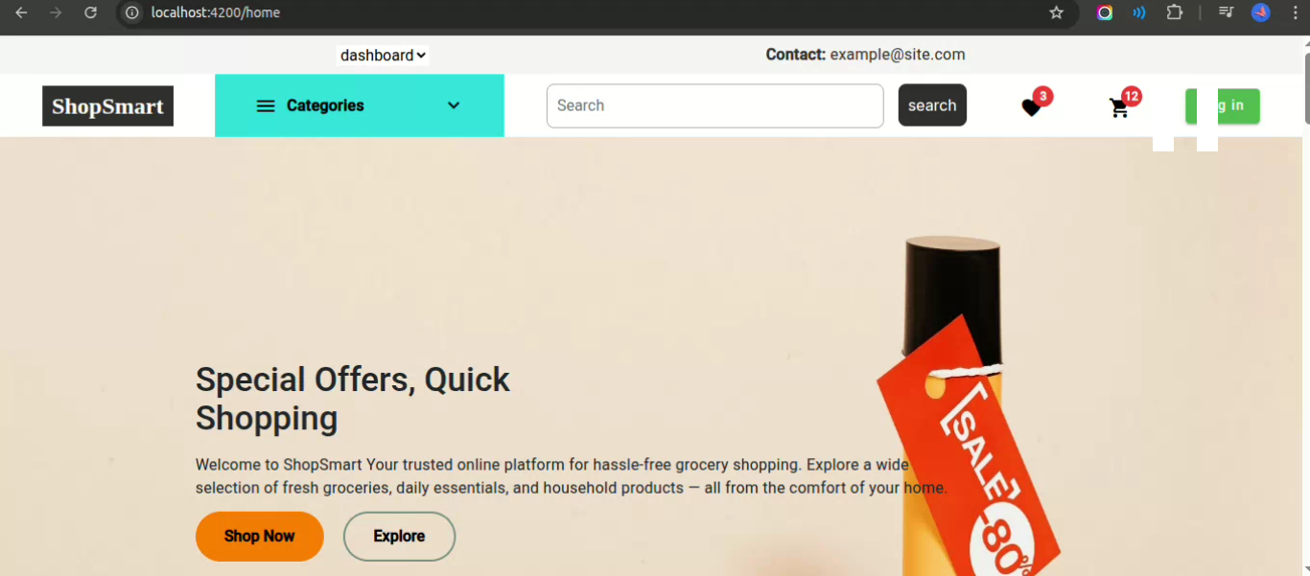

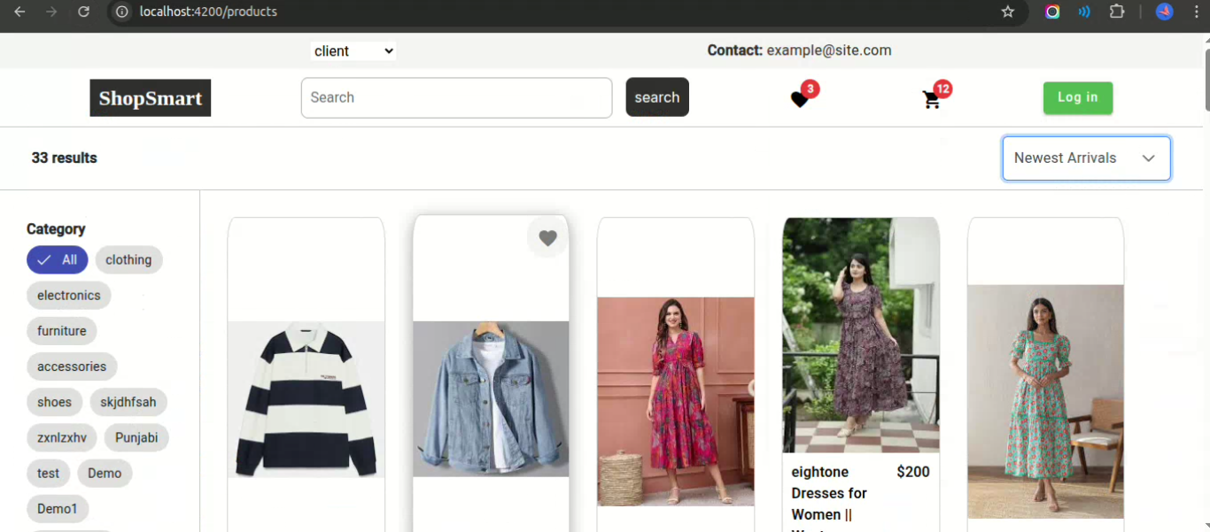

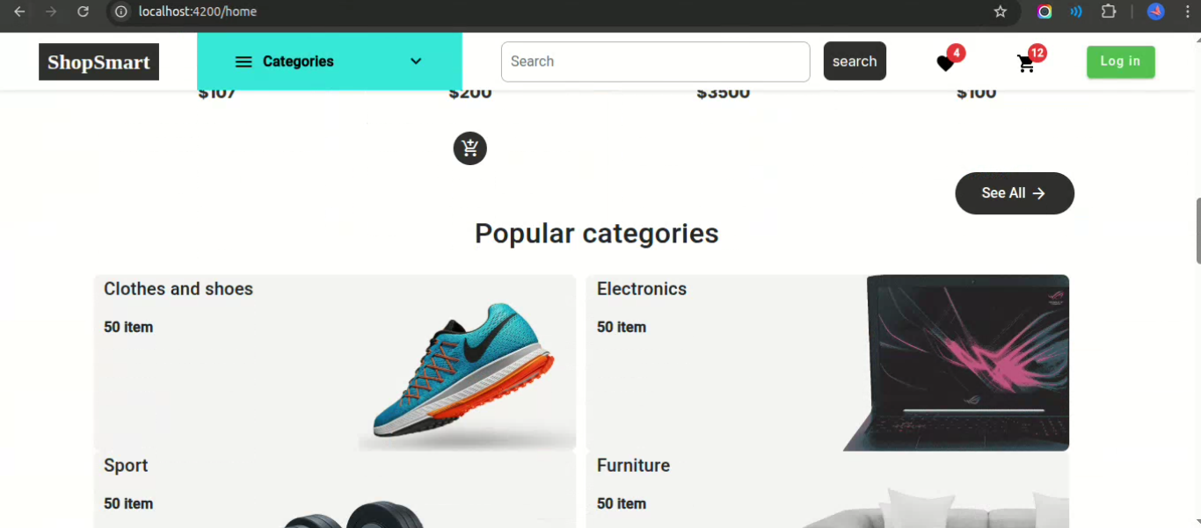

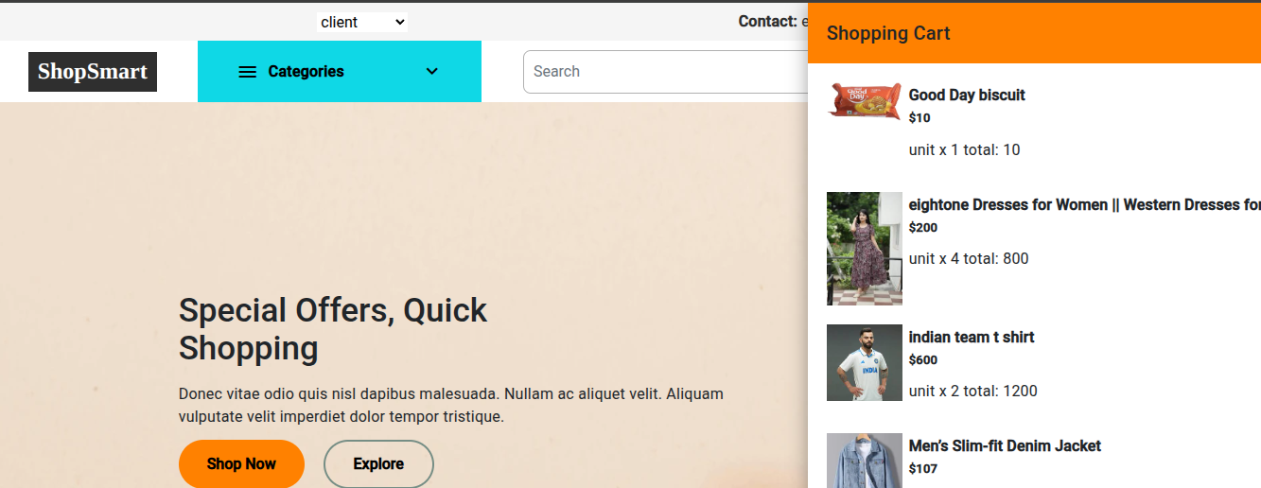

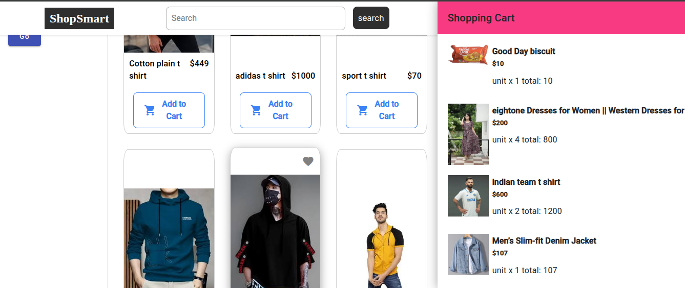

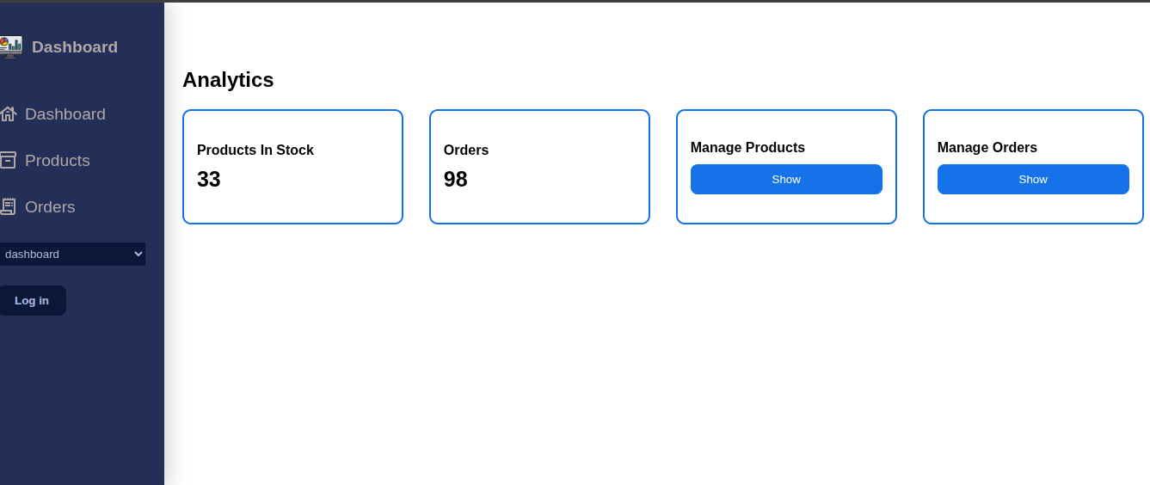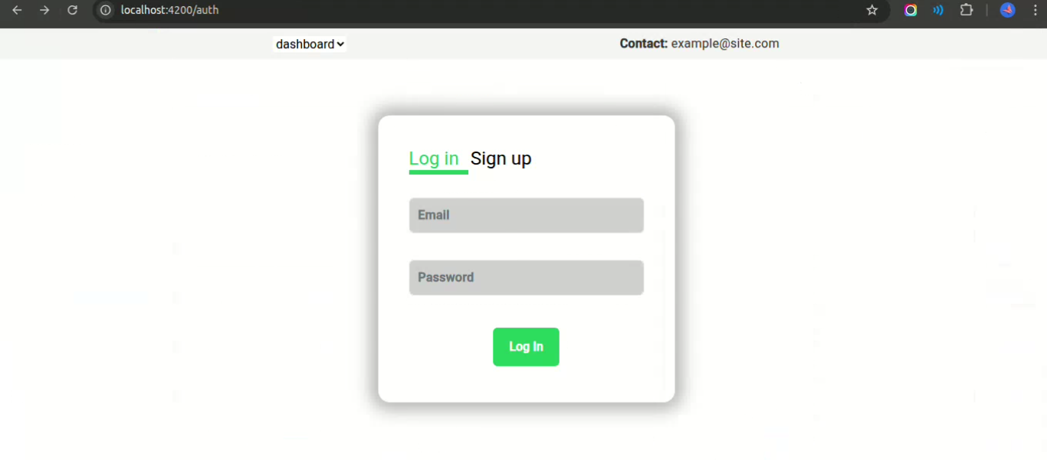

# **8. ADVANTAGES & DISADVANTAGES**

## **8.1 Advantages**

**User-Friendly Interface:** ShopSmart provides a clean, intuitive shopping experience for customers, store owners, and administrators, enhancing usability and satisfaction.

**Role-Based Access:** The system offers dedicated dashboards and role-based features for customers, store owners, and admins, ensuring secure access and clear functionality.

**End-to-End Product Management:** Store owners can easily add, update, and delete products, manage orders, and monitor store performance.

**Order Tracking:** Customers can view their order status in real-time, enhancing transparency and convenience.

**Scalable Architecture:** Built on the MERN stack (MongoDB, Express.js, React, Node.js), ShopSmart supports modular, scalable development for future growth.

**Real-Time Updates:** Product changes, order status, and inventory updates reflect immediately without requiring a page reload.

**Reusability and Modularity:** React components and backend APIs follow reusable, modular design patterns, improving maintainability and scalability.

**Admin Control:** Admins can monitor user activity, manage products, and oversee platform performance, ensuring system governance.

**Secure Authentication:** The system implements JSON Web Token (JWT)-based authentication and password hashing to secure user sessions.

**Flexible Deployment:** Environment-based configurations simplify deployment across development, staging, and production environments.

## **8.2 Disadvantages**

**No Dedicated Mobile App:** Currently, ShopSmart functions as a responsive web application but lacks a native mobile app for enhanced mobile-first experience.

**Limited Offline Access:** As a web-based platform, an active internet connection is required for shopping and order management.

**Manual Admin Setup:** Admin account creation is handled manually via API tools, which may not be intuitive for non-technical users.

**Performance Under High Load:** Without advanced backend optimizations like caching or CDN integration, the system may experience minor slowdowns under high concurrent user traffic.

**No AI-Based Personalization:** Personalized product recommendations or AI-driven suggestions are not yet implemented.

# **9. CONCLUSION**

The ShopSmart platform addresses the essential needs of modern grocery shopping by providing a secure, scalable, and user-friendly e-commerce solution built with the MERN stack. Through role-based dashboards, product catalog management, order tracking, and responsive design, ShopSmart simplifies the shopping experience for customers and empowers store owners with effective business management tools.

The project demonstrates proficiency in full-stack development, modular architecture, and real-world problem-solving in the e-commerce domain. With core features operational and a scalable foundation in place, ShopSmart is ready for real-world deployment and further enhancement.

Future improvements, such as AI-powered recommendations, mobile app development, and advanced analytics, will further elevate the platform's capabilities, ensuring a comprehensive, reliable, and efficient grocery shopping experience for users.

# **10. FUTURE SCOPE**

ShopSmart holds significant potential for expansion and technological upgrades to meet evolving market demands. Planned enhancements include:

* **Mobile Application Development:** Building native or hybrid apps using React Native or Flutter to enable seamless mobile shopping.
* **AI-Based Recommendation System:** Implementing machine learning models to suggest personalized products, increasing engagement and conversions.
* **Gamification Features:** Introducing loyalty points, badges, and reward systems to boost customer retention.
* **Advanced Admin Dashboard:** Providing real-time analytics, sales reports, inventory monitoring, and user activity tracking.
* **Secure Payment Integration:** Adding gateways like Razorpay, PayPal, or Stripe for safe and efficient transactions.
* **Offline Shopping Mode:** Allowing product catalog browsing in offline mode for users with poor internet connectivity.
* **Multi-Language Support:** Supporting regional languages to cater to diverse customer bases across different locations.
* **Product Delivery Tracking:** Integrating real-time delivery tracking features for improved transparency.
* **Third-Party Logistics Integration:** Allowing store owners to connect with external delivery services for efficient order fulfillment.
* **Accessibility Compliance:** Ensuring the platform meets accessibility standards to support users with disabilities.

By implementing these features, ShopSmart can evolve into a comprehensive, enterprise-grade grocery platform, adaptable to various market segments and capable of delivering a modern, customer-focused experience.

# **11. APPENDIX**

**Source Code Repository:  
Project Demo:** https://github.com/Urmila-Tentu/ShopSmart