Let Claude set up the Instagram, Facebook and TikTok MCP
Start Here, written for non-technical users
You do not need to follow the long guide. Install three small programs and a browser extension, log in to your accounts, download the project, paste one prompt into Claude, fill in a few blanks, and Claude does the setup with you. It works on Windows, Mac and Linux.
Download source: https://github.com/Urnesto/facebook-ig-mcp.git

1. What you need first
Accounts:
You need | Notes
A Facebook account | The one that will own the Page
An Instagram Business or Creator account | Already created
A TikTok account (only if you want TikTok) | Set to private
A Claude account on a paid plan (Pro, Max, Team or Enterprise) | Needed for Claude Code and for the browser extension
Google Chrome (or Microsoft Edge) | Claude works in your browser through an extension

Programs: three small programs and one browser extension must be installed once. You do not need a GitHub account, and nothing has to be bought. Follow the part for your computer.

On Windows
- Open PowerShell: click the Start button, type PowerShell, and press Enter. A blue or black window opens. You type or paste commands there and press Enter after each one. To paste, press Ctrl+V or right-click.
- Install Claude Code. Paste this line and press Enter:
irm https://claude.ai/install.ps1 | iex
- Install the uv helper:
powershell -ExecutionPolicy ByPass -c "irm https://astral.sh/uv/install.ps1 | iex"
- Install Git (recommended). If this line gives an error, skip it; section 3 has a way without Git:
winget install --id Git.Git -e
- Close the PowerShell window and open a new one, so the new programs are found.

On a Mac
- Open Terminal: press Cmd+Space, type Terminal, and press Enter. To paste, press Cmd+V.
- Install Claude Code:
curl -fsSL https://claude.ai/install.sh | bash
- Install the uv helper:
curl -LsSf https://astral.sh/uv/install.sh | sh
- Git installs itself: the first time you use it, the Mac asks to install "command line developer tools". Click Install and wait.
- Close the Terminal window and open a new one.

The Claude browser extension (Windows and Mac)
Claude opens the Facebook, Instagram and TikTok pages for you and clicks through them. For that it needs the Claude in Chrome extension.
- Open Google Chrome and go to https://claude.com/chrome
- Click Add to Chrome and confirm.
- Click the Claude icon in Chrome's toolbar and log in with your Claude account.
Without the extension Claude can still do the setup, but it can only give you links and instructions; you would do every click yourself.
Links if a command does not work:
- Claude Code setup: https://code.claude.com/docs/en/setup
- Claude Code with Chrome: https://code.claude.com/docs/en/chrome
- The uv helper: https://docs.astral.sh/uv/getting-started/installation/
- Git: https://git-scm.com/downloads

2. Log in to your accounts in Chrome first
Claude cannot type your passwords, so it cannot log in for you. Before you start Claude, open Chrome and log in to each of these. Stay logged in and leave Chrome open.
Log in to | Link | Needed for
Facebook | https://www.facebook.com/login | Creating the Page and linking Instagram
Meta for Developers | https://developers.facebook.com/apps/ | The Meta app and the keys. Click Continue with Facebook
Instagram | https://www.instagram.com/accounts/login/ | Linking the Instagram account to the Page
TikTok | https://www.tiktok.com/login | Adding your account to the TikTok app (only for TikTok)
TikTok for Developers | https://developers.tiktok.com/login | The TikTok app and its keys (only for TikTok)

If you have no developer accounts yet, sign up on the same pages. Both are free:
- Meta for Developers: https://developers.facebook.com/async/registration
- TikTok for Developers: https://developers.tiktok.com/signup
If Facebook asks for an SMS code or to confirm "this was you" while Claude works, do it on your phone. Claude waits.

3. Download the project and start Claude
From here on, every command is the same on Windows, Mac and Linux.

With Git
Paste these lines one at a time and press Enter after each:
cd ~
git clone https://github.com/Urnesto/facebook-ig-mcp.git
cd facebook-ig-mcp
claude --chrome

Without Git
- Open this link in your browser. A ZIP file downloads: https://github.com/Urnesto/facebook-ig-mcp/archive/refs/heads/main.zip
- Unpack it. On Windows, right-click the file and choose Extract All. On a Mac, double-click it.
- Rename the unpacked folder from facebook-ig-mcp-main to facebook-ig-mcp.
- Move the folder into your personal folder: C:\Users\YourName on Windows, or your home folder on a Mac.
- In PowerShell or Terminal, paste these two lines:
cd ~/facebook-ig-mcp
claude --chrome

The first time Claude starts
- Claude asks you to log in to your Claude account. Follow what it shows.
- If Claude asks whether to trust the files in this folder, choose yes.
- If Claude asks whether to use the instagram server from this project, choose yes.
- If Claude shows "Claude wants to use your browser", choose Install extension or yes. Type /chrome at any time to check that the browser is connected.

4. Copy this prompt, fill in the blanks, and paste it into Claude
Replace everything in square brackets with your own details. Delete the lines for parts you do not want.
Set up the Instagram, Facebook and TikTok MCP in this folder.
Use the setup-social-mcp skill and do every step you can yourself.
When you need me, tell me one thing to click or type and wait.

My details:
- Computer: [Mac / Windows / Linux]
- Parts I want: [Facebook and Instagram] [Followers and DMs] [TikTok]

Facebook and Instagram:
- Facebook Page name: [Ernest Claude]
- Create the Page if it does not exist: [yes / no]
- Page category: [Personal blog]
- Instagram username: [my_instagram_name]
- Meta app: [create a new one named "My Claude assistant" / use my app named ...]

TikTok:
- TikTok username: [my_tiktok_name]
- TikTok app: [create a new one / use my app named ...]
- App description: [Posts my own videos to my TikTok account.]
- My website: [https://example.com]
- Terms of Service page: [https://example.com/terms]
- Privacy Policy page: [https://example.com/privacy]

Passwords and secret keys: open the setup wizard for me.
I will type them there myself. Do not ask for them in the chat.

5. What Claude does, and what you click and paste
Claude installs the project, creates the Facebook Page, opens every web page, fills in the forms with the details from your prompt, saves the settings that are not secret, runs the checks and connects everything.
Claude is not allowed to touch passwords and secret keys. It cannot reveal them, copy them or type them. So for five values it opens the right page and a setup window (a terminal window with a question in it), and you copy the value from the page and paste it into the setup window.
How to paste into the setup window: click the window, press Cmd+V on a Mac or Ctrl+V on Windows (or right-click), then press Enter. Nothing appears on screen while you paste a secret. That is normal.
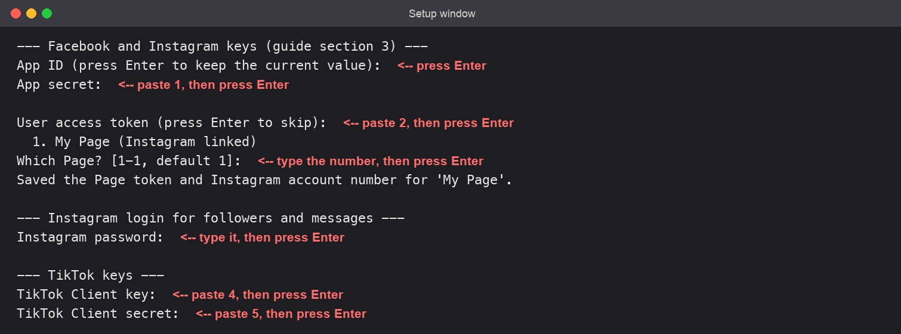
The setup window asks one question at a time. The red notes show which paste goes where.

The setup window, question by question
Claude opens the setup window for you. If you want to open it yourself, type this in a terminal in the project folder:
uv run python -m src.setup_wizard
It asks these questions, in this order. Answer each one and press Enter. To skip a question, or to keep a value that is already saved, just press Enter.
The window asks | What you enter | Where you get it
App ID | Press Enter. Claude has already filled it in | Nothing to do
App secret | Paste the App secret | Paste 1 below
User access token | Paste the access token | Paste 2 below
Which Page? [1-2, default 1] | Type the number shown next to your Page | The list the window prints just above
Instagram username, without @ | Press Enter if Claude filled it in, or type it | Your Instagram name
Instagram password | Type your Instagram password | You know it. Paste 3 below
TikTok Client key | Paste the Client key | Paste 4 below
TikTok Client secret | Paste the Client secret | Paste 5 below

When it finishes, the window prints Saved and a list with set or EMPTY next to each value. EMPTY means that value is still missing; run the window again and fill in only that one.
Two more windows may follow. Claude opens them when they are needed:
The window asks | What you enter | Where you get it
Enter code (6 digits) | The 6-digit code | The newest email from Instagram
Nothing: your browser opens a TikTok page | Click Authorize | In the browser

If something goes wrong, the window prints a short message, for example "Could not get the Page token". Copy that message to Claude. Do not copy your keys.

Paste 1. App secret
- Claude opens your Meta app's settings page.
- Click Show next to App secret. A window titled "Confirm with password" opens; click Confirm, type your Facebook password and submit.
- Select the secret that appears and copy it.
- In the setup window, at App secret:, paste and press Enter.
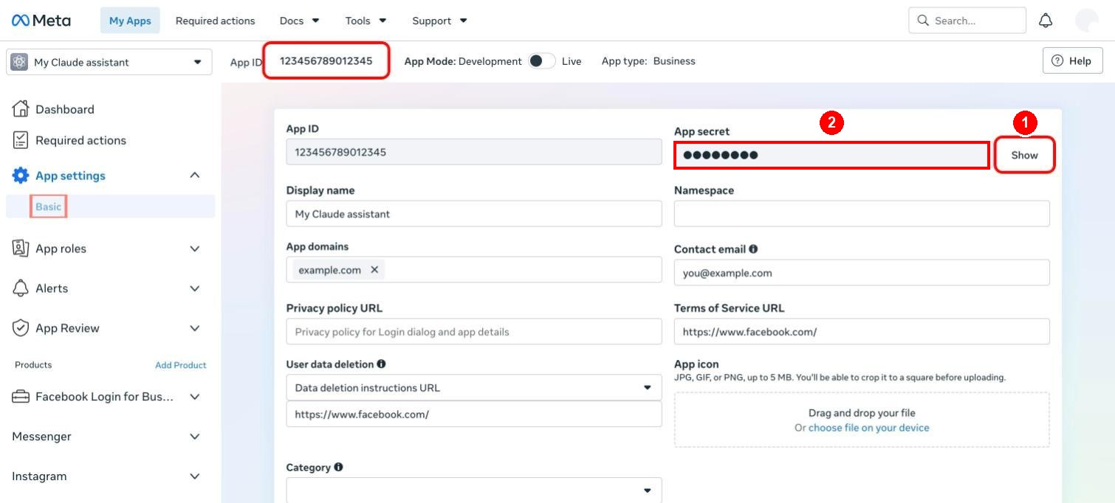
1: click "Show" and confirm with your Facebook password. 2: the secret appears in this field; select it and copy it.

Paste 2. Access token
- Claude opens the Graph API Explorer with your app and the permissions already selected.
- Click the blue Generate Access Token button.
- In the Facebook window that opens, select your Page and your Instagram account, and approve.
- Click the copy icon to the right of the Access Token box.
- In the setup window, at User access token:, paste and press Enter.
- The setup window lists your Pages. Type the number next to your Page and press Enter.
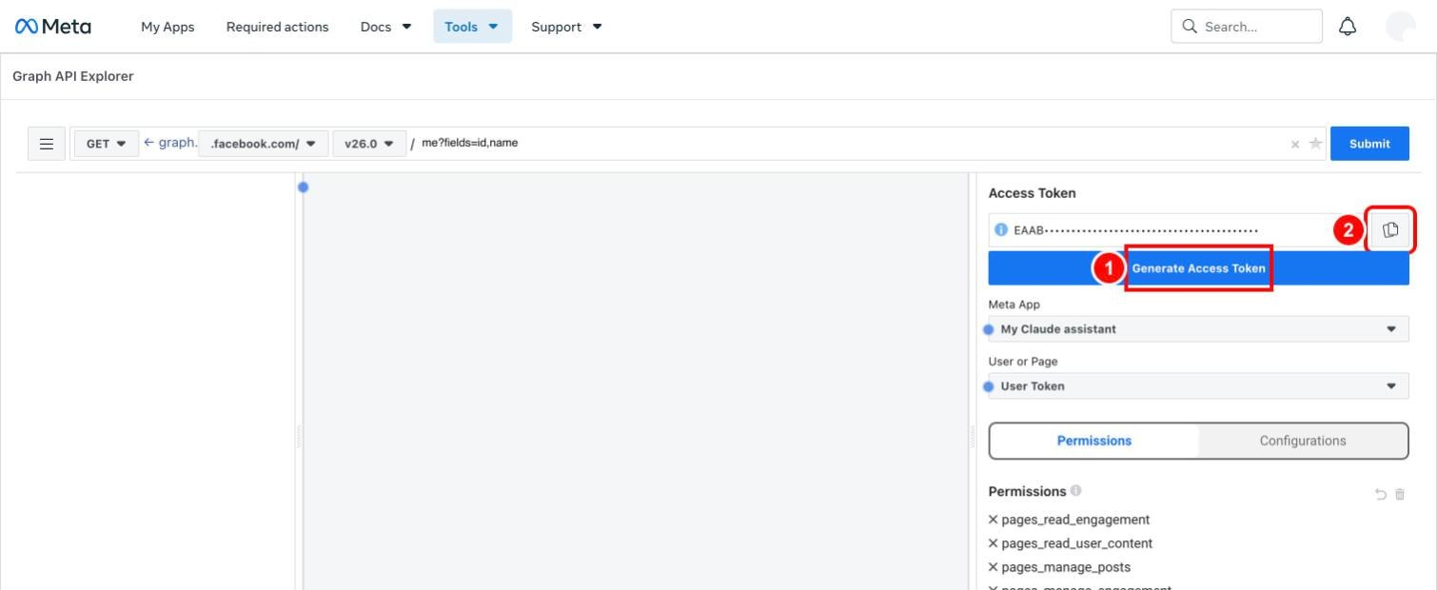
1: click "Generate Access Token" and approve in the Facebook window. 2: click the copy icon to copy the new token.

Paste 3. Instagram password
Only if you want the follower list and direct messages.
- In the setup window, at Instagram password:, type your Instagram password and press Enter.
- Claude opens a second setup window. Instagram emails you a 6-digit code. Type the code there and press Enter.

Paste 4 and 5. TikTok Client key and Client secret
Only if you want TikTok.
- Claude opens your TikTok app's Sandbox page.
- Under Credentials, click the eye icon next to Client key, select the key and copy it.
- In the setup window, at TikTok Client key:, paste and press Enter.
- Do the same with Client secret, at TikTok Client secret:.
- Claude opens a TikTok page in your browser. Click Authorize.
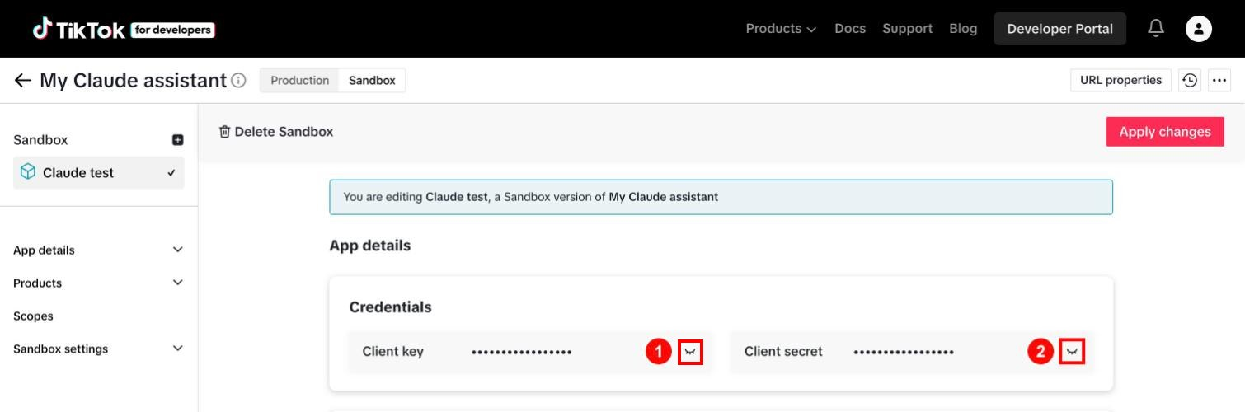
1: click this eye icon to show the Client key, then copy it. 2: the same for the Client secret.

Other clicks Claude will ask for
When | What you click | Why only you can
Starting Claude in the project folder | Yes to use the instagram server | It gives Claude the tools
Creating the Facebook Page | Finish the SMS check in the Facebook app on your phone, if Facebook asks | Security check on your account
Linking Instagram to the Page | Connect account, then log in to Instagram | Your login
Adding your TikTok account to the app | Add account, Continue, then log in to TikTok | Your login
Any time Claude says "log in" | Log in on the page it opened | Your password

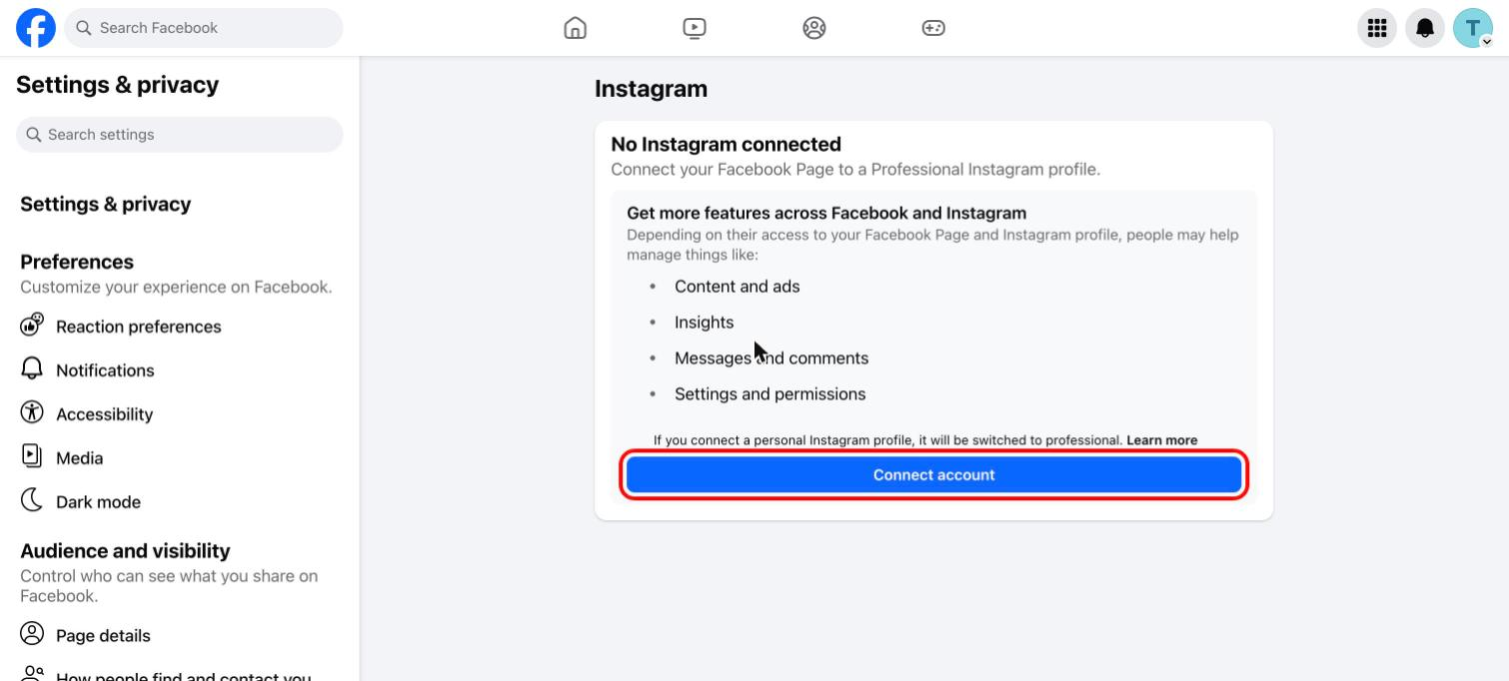
Linking Instagram: click "Connect account" and log in to Instagram.

6. When Claude says it is done
Try these, one at a time:
- "Show my Instagram profile info."
- "Show my last 5 Facebook posts."
- "Get my Instagram followers."
- "Which TikTok account is connected?"
- "Show my Instagram usage."
To publish something, just ask, for example: "Post this on my Facebook Page: Hello!" Claude shows you the text and asks before anything goes out.

7. If you get stuck
- Say to Claude: "Check what is missing in my setup." It lists which settings are filled in, without showing them.
- The full guide with a screenshot for every click is SETUP_GUIDE.md in the project folder, also as Instagram_MCP_Setup_Guide.docx.
- The project on GitHub: https://github.com/Urnesto/facebook-ig-mcp

8. Using it in Claude every day

Start Claude
Open a terminal (Terminal on a Mac, PowerShell on Windows) and paste these two lines:
cd ~/facebook-ig-mcp
claude --chrome
Then type /mcp. The line instagram should say connected. If it does not, select it and choose reconnect.

Just ask in plain words
You never type tool names. Say what you want and Claude picks the right tool.
You want to | Say something like
See your Instagram profile | "Show my Instagram profile."
See your latest posts | "Show my last 5 Instagram posts." / "Show my last 5 Facebook posts."
See how a post did | "How did my latest Instagram post perform?"
See Page statistics | "Show my Facebook Page statistics for this week."
Post on Facebook | "Post this on my Facebook Page: (your text)"
Post on Facebook later | "Schedule this Facebook post for tomorrow at 10:00: (your text)"
Post a photo on Instagram | "Publish this photo on Instagram: (link to the photo), caption: (your text)"
Post a video on TikTok | "Post clip.mp4 from my Downloads folder to TikTok with the caption: (your text)"
Read comments | "Show the comments on my latest Facebook post."
Answer a comment | "Reply to that comment: Thank you!"
Hide a comment | "Hide that comment."
Get your followers | "Get my Instagram followers." / "Who is new since last time?"
Message someone | "Send a DM to USERNAME: (your text)"
See what is used up | "Show my Instagram usage."

Claude asks before it acts
Before anything is published, sent or deleted, Claude shows you exactly what it is about to do and asks for permission. Read it, then choose yes or no. Reading things (profile, posts, comments, statistics) needs no confirmation of the content, only your approval to use the tool the first time.

Things to know
- Instagram photos need a web link. Instagram only accepts a picture or video that is already on a public web address, not a file on your computer. TikTok videos can come straight from a file.
- TikTok posts are private at first. They stay visible only to you until TikTok has reviewed and audited your app.
- There are daily limits. 25 Instagram posts, 25 Facebook posts, 15 TikTok posts, 20 direct messages and 10 follower downloads per 24 hours. Claude tells you when a limit is reached.
- No double messages. Claude refuses to message a person it has already messaged, unless you clearly say you want to message them again.
- Followers and direct messages to any user are unofficial. Instagram does not approve of them. Use them sparingly and never send the same text to many people.

When something stops working
What you see | What to do
Claude does not know the Instagram tools | Type /mcp and reconnect instagram
"Token is invalid" or a permission error | Say: "Set up the Facebook and Instagram keys again."
"Instagram sent a verification code" | Say: "Log me in to Instagram again." and type the emailed code in the window that opens
"Not logged in to TikTok" | Say: "Log me in to TikTok again." and click Authorize in the browser
"Limit reached" | Wait, or ask "Show my Instagram usage."
Anything else | Say: "Check what is missing in my setup."

