Paddle Ball



B.S. (CS) Final Year Project Report

Submitted by:
Maria Aqdas JUW19820
Urooba Shamim JUW16399

July 2021

Department of Computer Science and Software Engineering

Jinnah University for Women
5-C Nazimabad, Karachi 74600

Table of Contents

Project Summary 1
Algorithm 2
Project Flow 3
Code Explanation 4
Screenshots 5

Project Summary:

INTRODUCTION:
The two paddles return the ball back and forth. The score is kept by the numbers at the top of the screen.

GAME PLAY:
It is a two dimensional sports game that simulates table tennis. The player controls in game paddle by moving it vertically across the left or right side of the screen. Player use the paddle to hit a ball back and forth .
Pong is one of the most famous arcade games. Each player controls a paddle in the game by dragging it vertically across the screen’s left or right side. Players use their paddles to strike back and forth on the ball.
Turtle is an inbuilt graphic module in python. It uses a panel and pen to depict illustrations.

FEATURES:

- Step 1:
Create two paddles A and B on the left and right side of the screen.
- Step 2:
Create a ball.
- Step 3:
Create an event to move the paddle vertically on pressing a certain key.
- Step 4:
Create the function to update the score after each player misses a collision.

GitHub Link

https://github.com/UroobaShamim/Python-Project
https://github.com/MariaAqdas/Python-Project

Algorithm

STEP#1 START
STEP#2 Import pygame, sys and random prompt pygame.locals import *
STEP#3 Define variables font = “small_pixel-7.ttf”, screen_width=800 and screen_height=600
STEP#4 Initialize pygame
STEP#5 Open new pygame window
Screen=pygame.display.set_mode((screen_width, screen_height))
STEP#6 Define variables white=(255, 255, 255), black=(0, 0, 0), gray=(77, 77, 77, 255), clock = pygame.time.Clock(), FPS=60
STEP#7 Call the main_menu() function
STEP#8 STOP

ALGORITHM (main_menu() function):

STEP#1 START
STEP#2 Define variables menu=True, selected="start"
STEP#3 while menu
for event in pygame.event.get():
if event.type==pygame.QUIT:
pygame.quit()
sys.exit()
if selected=="start" then
Call the function game() in the class paddle ball()
if selected=="quit" then
pygame.quit()
sys.exit()
STEP#4 Update pygame display
STEP#5 Set pygame display caption as “Paddle Ball”

ALGORITHM (text_format(displaytext, textFont, textSize, textColor) function):

STEP#1 START
STEP#2 newFont = pygame.font.Font(textFont, textSize)
STEP#3 newText = newFont.render(displaytext, 0, textColor)
STEP#4 return newText

ALGORITHM (game() function) in class Paddle Ball:

STEP#1 START
STEP#2 Call the method __init__(self) to initialize attributes in class
STEP#3 Call the function generatePlatforms()
STEP#4 while True:
Blit bg_surface in position (bg_x,bg_y)
for event in pygame.event.get() then
if event.type == QUIT then
pygame.quit()
sys.exit()

ALGORITHM (updatePlatforms(self) function) in class Paddle Ball:

STEP#1 START
STEP#2 for p in platforms:
if rect.colliderect(player) and gravity and playery < (p[1] - cameray) then
if p[2] != 2

ALGORITHM (drawPlatforms(self) function) in class Paddle Ball:

STEP#1 START
STEP#2 for p in self.platforms:
check = platforms[1][1] - cameray
if check > 600 then
platform = random.randint(0, 950)
if p[2] == 0 then
Blit fixedplatform (p[0], p[1] - cameray)
elif p[2] == 1 then
Blit movingplatform (p[0], p[1] - cameray)
elif p[2] == 2 then
if not p[3]:
Blit breakplatform (p[0], p[1] – cameray)
else
Blit brokenplatform (p[0], p[1] - cameray)
STEP#3 for spring in springs:
if spring[-1] then
Blit spring_1 (spring[0], spring[1] - cameray)
else
Blit spring (spring[0], spring[1] – cameray)

ALGORITHM (generatePlatforms(self) function) in class Paddle Ball:

STEP#1 START
STEP#2 Define variable on = 500
STEP#3 while on > -100 then
x = random.randint(0,700)
platform = random.randint(0, 1000)
if platform < 800 then
platform = 0
elif platform < 900 then
platform = 1
else then
platform = 2
platforms.append([x, on, platform, 0])
Subtract 50 from on

ALGORITHM (game_over(self) function) in class Paddle Ball:

STEP#1 START
STEP#2 Define variables menu=True, selected="playagain"
STEP#3 while menu then
for event in pygame.event.get() then
if event.type==pygame.QUIT then
pygame.quit()
sys.exit()
if selected=="playagain" then
return
if selected=="quit":
pygame.quit()
sys.exit()
Update pygame display

Project Flow

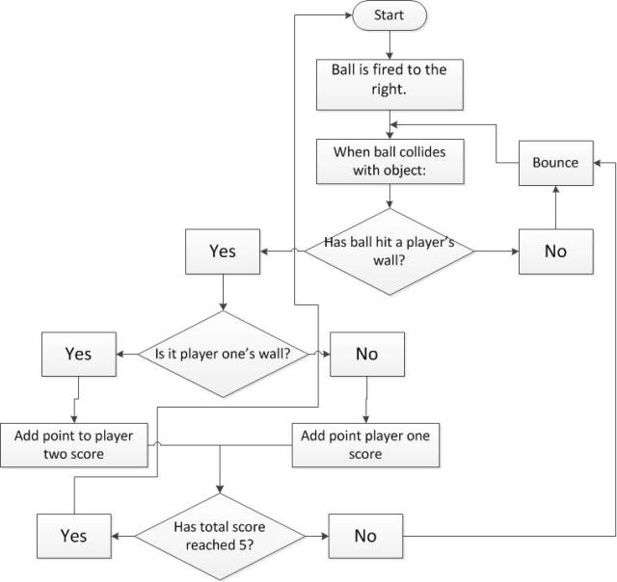

Code Explanation

Step 1: Importing and initialising the Pygame library

Your Python code will need to start with the following two lines of code:
Python

1  2  3 | # Import the pygame library and initialise the game engine  import pygame  pygame.init()

Step 2: Defining the colours you will use in your game
You will have to declare a constant for each of the main colours used within your game. To help you identify colour codes you may use a colour picker. Pong is a very basic game and only uses two colours: black and white.
Python

4:  5:  6: | # Define some colors  BLACK = (0,0,0)  WHITE = (255,255,255)

Step 3: Open a new window
Step 4: The main program loop
The main program loop is the key wrapper for your game.
The main program loop will contain 3 main sections:
- Capturing Events: Used to constantly “listen” to user inputs and react to these. It could be when the user use the keyboard or the mouse.
- Implementing the Game Logic. What happens when the game is running? Are cars moving forward, aliens falling from the sky, ghosts chasing you, etc.
- Refreshing the screen by redrawing the stage and the sprites.
The main program loop will also use a frame rate to decide how often should the program complete the loop (& refresh the screen) per second. To implement this we will use the clock object from the pygame library.
The main program loop will use a timer to decide how many times it will be executed per second.
The main program loop will use a timer to decide how many times it will be executed per second.
Python

16  17  18  19  20  21  22  23  24  25  26  27  28  29  30  31  32  33  34  35  36  37  38  39  40  41  42  43  44  45  46  47  48  49  50  51  52  53  54  55  56  57  58  59 | # Import the pygame library and initialise the game engine  import pygame  pygame.init()  # Define some colors  BLACK = (0,0,0)  WHITE = (255,255,255)  # Open a new window  size = (700, 500)  screen = pygame.display.set_mode(size)  pygame.display.set_caption("Pong")  # The loop will carry on until the user exit the game (e.g. clicks the close button).  carryOn = True  # The clock will be used to control how fast the screen updates  clock = pygame.time.Clock()  # -------- Main Program Loop -----------  while carryOn:  # --- Main event loop  for event in pygame.event.get(): # User did something  if event.type == pygame.QUIT: # If user clicked close  carryOn = False # Flag that we are done so we exit this loop  # --- Game logic should go here  # --- Drawing code should go here  # First, clear the screen to black.  screen.fill(BLACK)  #Draw the net  pygame.draw.line(screen, WHITE, [349, 0], [349, 500], 5)  # --- Go ahead and update the screen with what we've drawn.  pygame.display.flip()  # --- Limit to 60 frames per second  clock.tick(60)  #Once we have exited the main program loop we can stop the game engine:  pygame.quit()

Screenshots
Add screenshots of your project with proper figure captions

