Web Engineering   
Assignment 2  
Urooj Ayub  
04456  
BESE-4B

**Link to Public Repository - https://github.com/UroojAyub/Widgets.git**

# Description

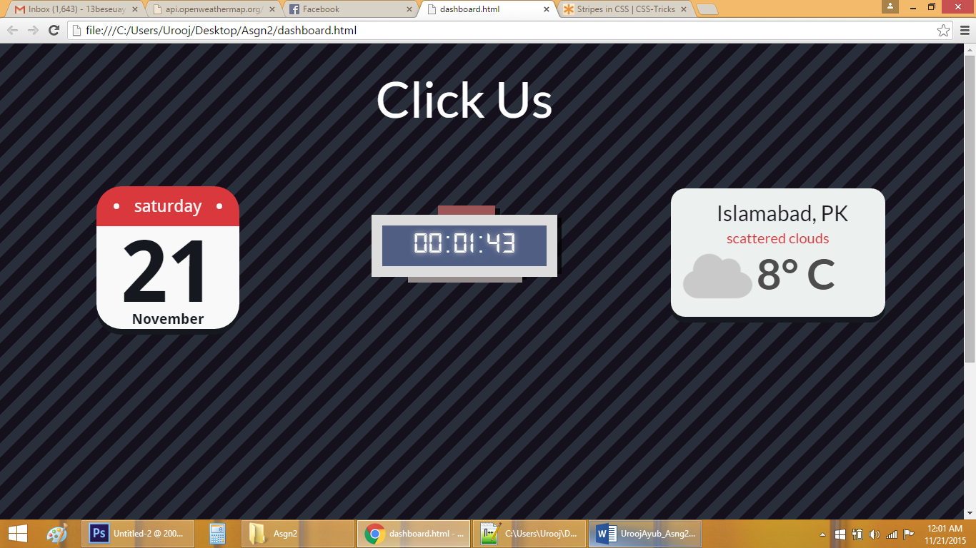

This assignment consisted of three parts.

A calendar- It was made through a combination of Javascript and angular JS

A digital and analog clock- Pure Javascript was used to change the time and the needles. Needles were made in CSS.

A weather widget- We used a weather.com api to get the weather for Islamabad. It returned a JSON string which was parsed and necessary info was extracted and displayed with styling effects.

A shorter version of each widget is displayed at first. On clicking a widget the detailed version is opened.