**LAB-03**

**Objective:** **To learn query execution in OLTP databases**

**SQL QUERIES:**

1. Write An SQL Query To Fetch “FIRST_NAME” From Worker Table Using The Alias Name As <WORKER_NAME>.

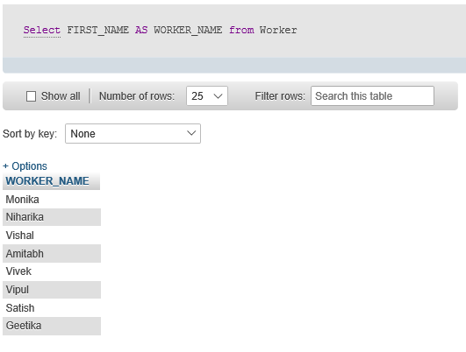

1. Write An SQL Query To Fetch “FIRST_NAME” From Worker Table In Upper Case.

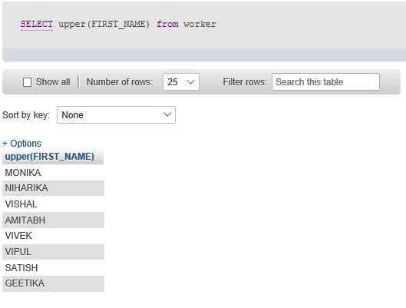

1. Write An SQL Query To Fetch Unique Values Of DEPARTMENT From Worker Table.

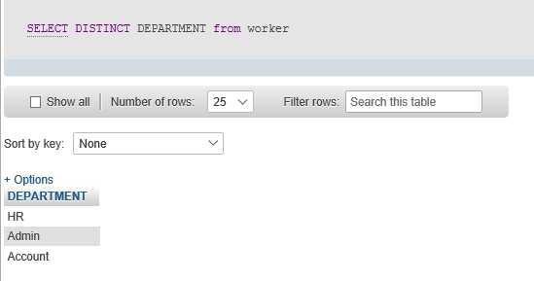

1. Write An SQL Query To Print Last Three Characters Of  FIRST_NAME From Worker Table.

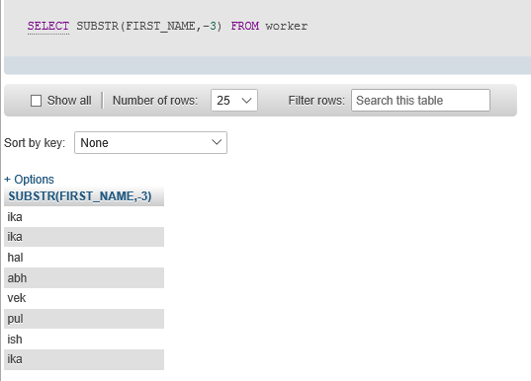

5. Write An SQL Query To Print The FIRST_NAME From Worker Table After Removing White Spaces From The Left Side.

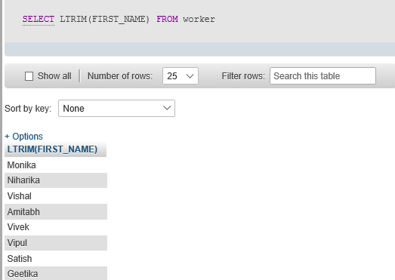

1. Write An SQL Query To Print The FIRST_NAME From Worker Table After Replacing ‘a’ With ‘A’.

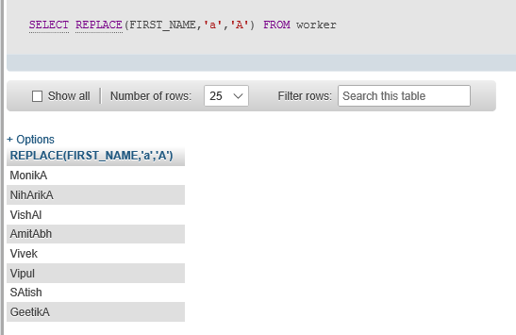

1. Write An SQL Query To Print All Worker Details From The Worker Table Order By FIRST_NAME Descending.

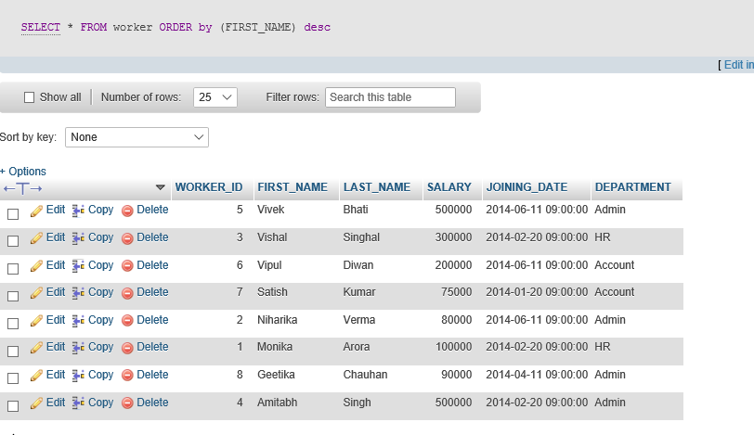

1. Write An SQL Query To Print Details For Workers With The First Name As “Vipul” And “Satish” From Worker Table.

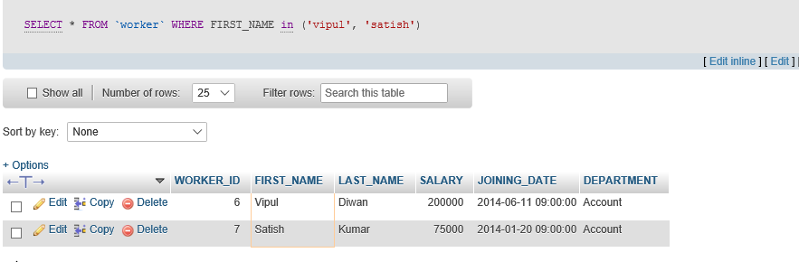

1. Write An SQL Query To Print Details Of Workers With DEPARTMENT Name As “Admin”.

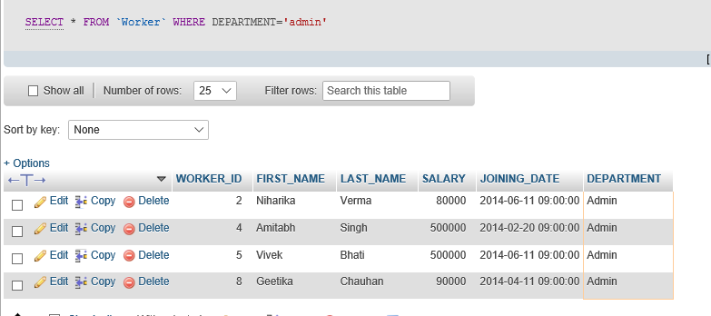

1. Write An SQL Query To Print Details Of The Workers Whose SALARY Lies Between 100000 And 500000.

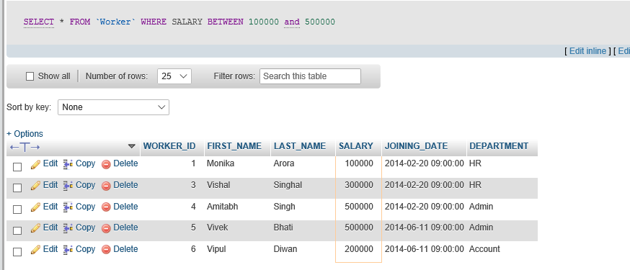

1. Write An SQL Query To Print Details Of The Workers Who Have Joined In Jan’2014.

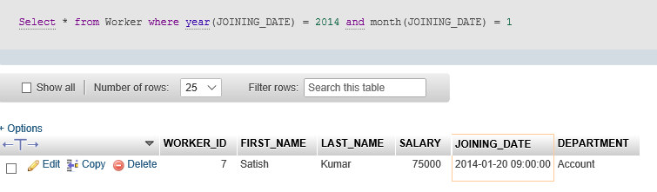

1. Write An SQL Query To Fetch The Count Of Employees Working In The Department ‘Admin’.

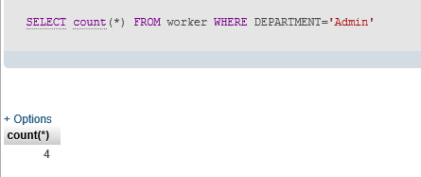

1. Write An SQL Query To Fetch The No. Of Workers For Each Department In The Ascending Order.

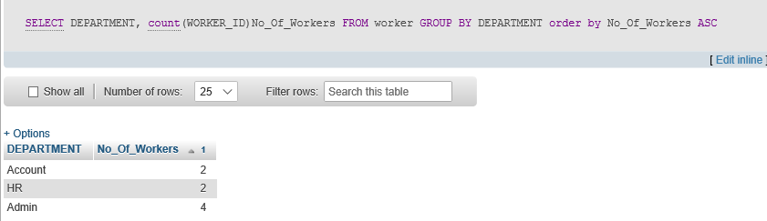

1. Write An SQL Query To Fetch The List Of Employees With The Same Salary.

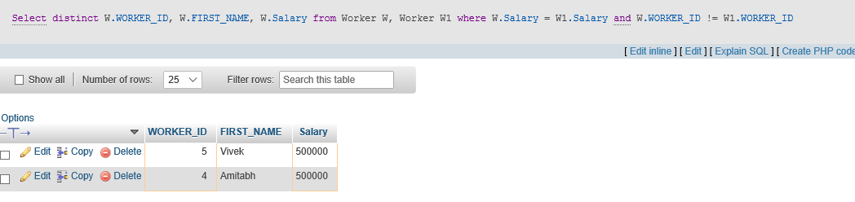

1. Write An SQL Query To Show The Second Highest Salary From A Table.

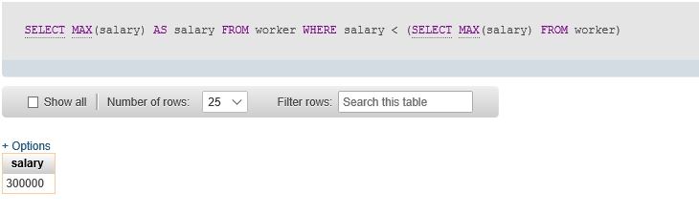

**Lab Task:**

Execute OLTP queries for the following scenario:

* *An organization has a main data table that lists events. Each event has a series of fields including duration, reason code and status.*
* *The OLTP system has a table of statuses with attributes status code and Name and there is a common field between the main table (status code), which allows the organization to print the status name rather than the code.*
* *There are four statuses (ready, delay, spare and down) and there are a range of reasons associated with each status with reason codes. It is possible for the same reason code to exist in two statuses (e.g. delay maintenance and down maintenance).*
* *For some reason, the source database has four tables of reasons (one for each status). Each of these has a field which links to the main reason code.*
* *The organization wishes to do the following:*
* *When the main table record status is ‘delay’, then retrieve the name in the ‘delay’ table which corresponds to the main table delay code. When the status is ‘down’, do the same thing but look up the name in the ‘down’ table.*

**EVENT**

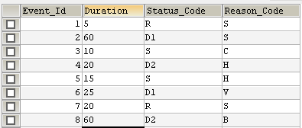

**STATUS**

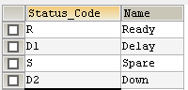

**READY REASON**



**DELAY REASON**



**SPARE REASON**



**DOWN REASON**



**QUERY**

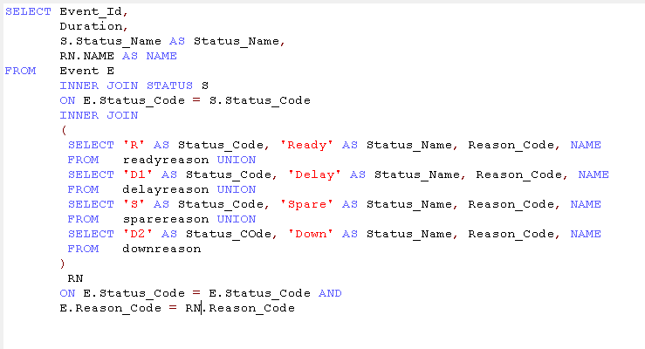

**OUTPUT**

