DecodeLabs Industrial Training
Prompt Engineering – Project 2
Chain-of-Thought Logic Engine
Submitted by: Urooj Umair
Project: 2
Batch: 2026
Organization: DecodeLabs
Date: September 2026
1. Introduction
This project focuses on designing a Chain-of-Thought Logic Engine prompt. The purpose of the prompt is to guide an AI model through complex, multi-step logic problems using structured reasoning, self-correction, and logic-trap detection.
The project aims to improve the clarity and accuracy of AI-generated answers while reducing skipped steps, incorrect assumptions, and hallucinations.
The prompt was tested using mathematical problems, logic riddles, and error-correction tasks.
2. Objectives
The main objectives of this project are:
- Design a structured prompt for multi-step reasoning.
- Encourage the AI to explain relevant solution steps.
- Implement a self-correction review phase.
- Test the prompt against logic traps and riddles.
- Identify errors and verify the final answers.
- Reduce guessing and unsupported conclusions.

3. Tools Used
- ChatGPT – For testing the logic prompt.
- Microsoft Word – For preparing the project report.
- GitHub – For storing and sharing the project files.
- Notepad / VS Code – For writing and editing the prompt.

4. Test Case 1 – Mathematical Problem
Input
A train travels 120 kilometers in 2 hours. What is its average speed? Explain your solution step by step and verify the answer.
Expected Output
Average speed = Distance ÷ Time
Average speed = 120 ÷ 2
Average speed = 60 km/h
Verification
60 × 2 = 120 km.
The calculation is correct.
Observation
The prompt guided the AI to identify the given values, apply the correct formula, show the calculation, and verify the answer.
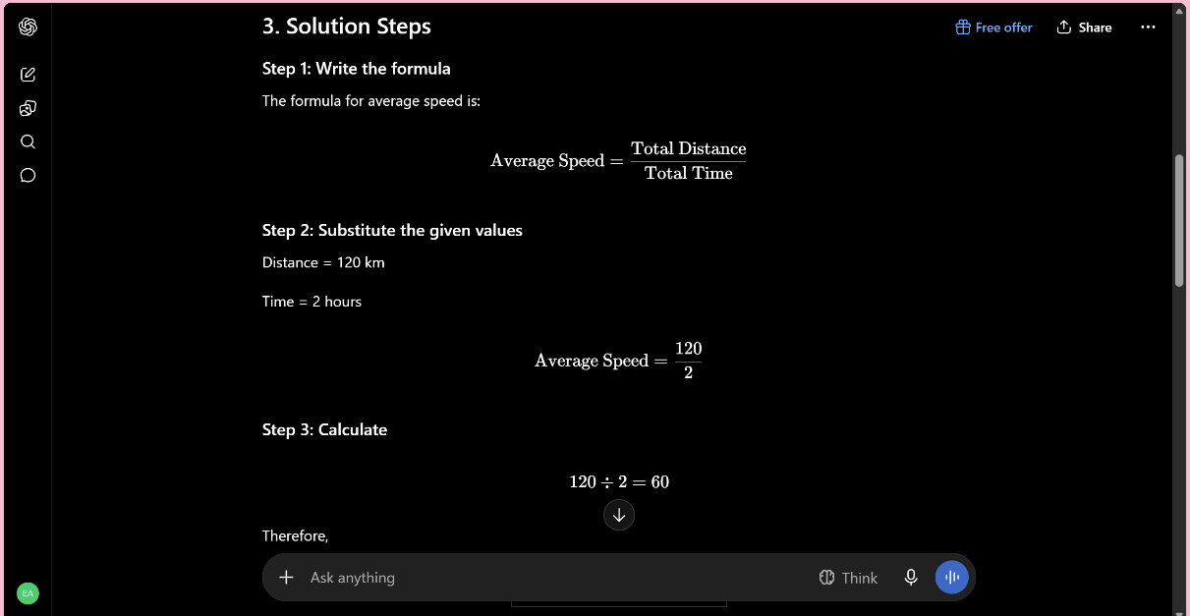
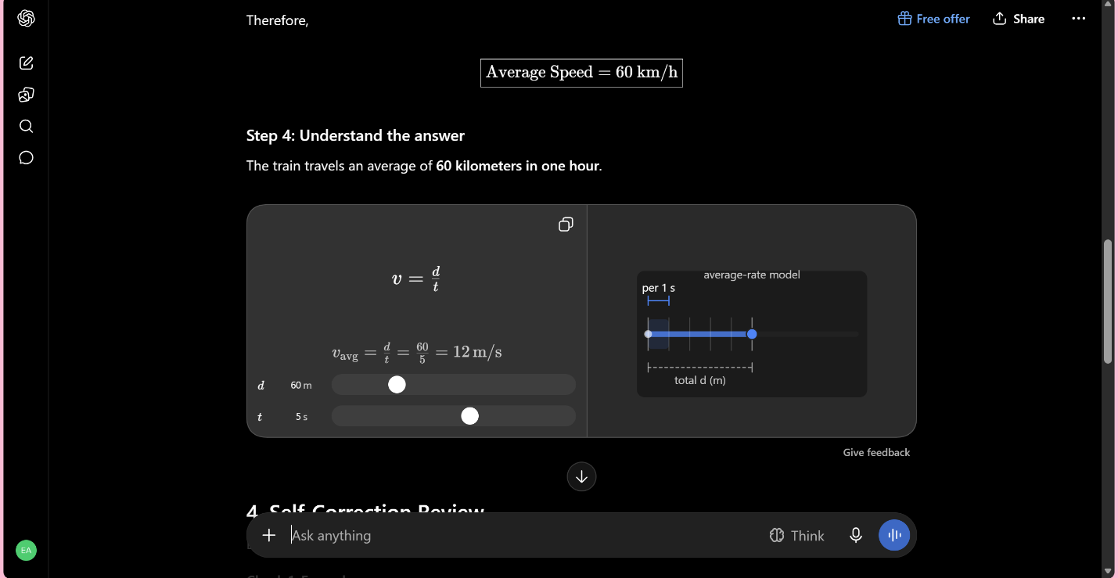



5. Test Case 2 – Logic Riddle
Input
A farmer has 17 sheep. All but 9 die. How many sheep are left?
Expected Answer
9 sheep.
Reasoning
The phrase "all but 9 die" means that 9 sheep remain alive.
Self-Correction
The model should check the wording instead of incorrectly subtracting 9 from 17.
Observation
This test checks whether the prompt can handle misleading wording and logic traps.
Screenshot
Insert the screenshot of the AI response here.
Caption: Figure 2: Logic riddle test output.
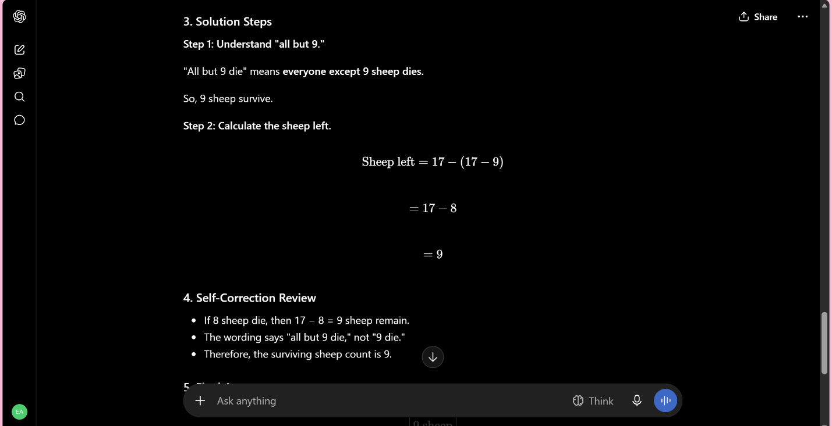

6. Test Case 3 – Logic Comparison
Input
Ali is older than Sara. Sara is older than Hamza. Who is the youngest?
Expected Answer
Hamza is the youngest among the three.
Observation
The AI should use the given comparisons to reach the conclusion without inventing ages.
Screenshot
Insert the screenshot of the AI response here.
Caption: Figure 3: Logic comparison test output.


7. Test Case 4 – Self-Correction
Input
A student solved 25 × 4 as 90. Review this solution, identify the error, correct it, and explain the correct calculation.
Expected Answer
25 × 4 = 100.
Observation
The AI should identify the incorrect calculation and provide the correct answer.
Screenshot
Insert the screenshot of the AI response here.
Caption: Figure 4: Self-correction test output.
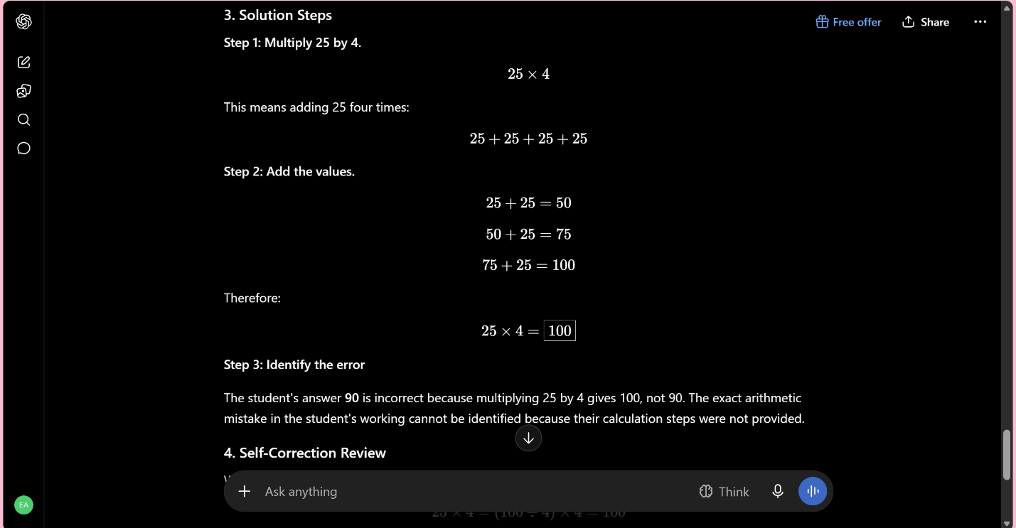
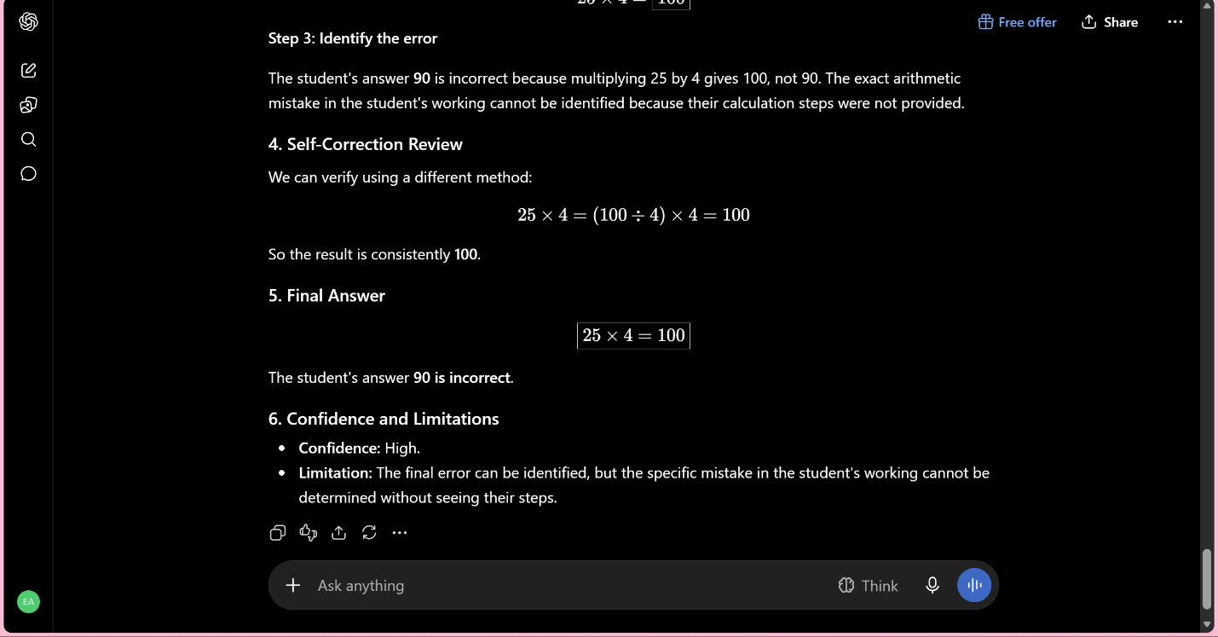

Evaluation / Results section:
Test Case | Problem Type | Input / Task | Expected Result | Actual Result | Status
1 | Mathematical Problem | Train travels 120 km in 2 hours. Find average speed. | 60 km/h | 60 km/h | Pass
2 | Logic Riddle | Farmer has 17 sheep. All but 9 die. How many are left? | 9 sheep | 9 sheep | Pass
3 | Logic Comparison | Ali is older than Sara, and Sara is older than Hamza. Who is youngest? | Hamza | Hamza | Pass
4 | Self-Correction | Student says 25 × 4 = 90. Review and correct it. | 100 | 100 | Pass

9. Conclusion
This project demonstrated the design and testing of a Chain-of-Thought Logic Engine prompt. The prompt provides a structured approach for solving multi-step problems, reviewing calculations, identifying logic traps, and presenting final answers clearly.
Through testing, the importance of structured prompting and self-correction was explored. The project also highlighted the need to verify AI-generated answers rather than relying on them without checking.
Overall, the project helped develop practical skills in algorithmic reasoning, prompt design, hallucination reduction, and cognitive structuring.

