# [Lab 06]

Build Your Own PC (BYOPC)

Submitted By: Urooj Bakht Tahir (35023) BSCS4-C

# Introduction

The objective of the lab is to simulate an automated assembly line for building a large number of PCs.

## Description

The assembly line has 3 automated transfer belts where the workers place a chassis selected by a particular user. The chassis then goes through n stations. At each station a new component is added to the chassis in some random amount of time. A finished PC is taken out of the automated belt by a worker and placed in a box.

All stations at the same index, perform the same operation, however some random station can break at any time or add a component incorrectly, requiring human intervention. As a result the time spent by the chassis on each station can be different. If a node breaks down, a worker marks it as not useable and manually changes the automated belt for the chassis.

## Approach

The lab is implemented in Java. The shortest time is found using the Dynamic Programming approach and the Recursive method. Both the functions are called in the main method with the expected output and the one calculated by the program.

## Unit Test

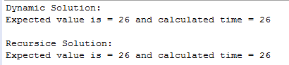

## GitHub Link