**Urshita Das**

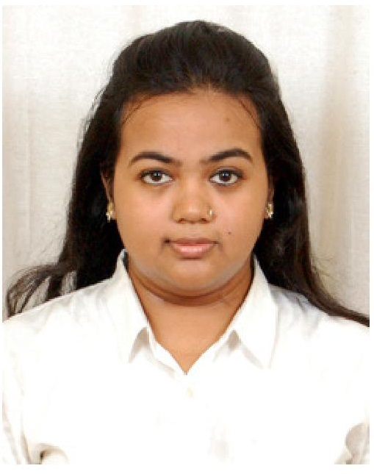

|  |  |
| --- | --- |
| **Title:** | Analyst/ Software Engineer |
| **Location:** | Kolkata, India |
| **Languages:** | Bengali (native), English (fluent), Hindi (fluent) |

# Experience Summary

She is a responsible person and given any task she always performs to the best of her abilities. She has excellent leadership skills. She has the ability to clearly present her ideas to her colleagues and provide valuable advice to them.

**KEY SKILLS:**

* **Functional:** Project Management, Team Leader, Strategic/Tactical Planning, Excellent Communication and Interpretation skills
* **Technical:** Java/J2EE, Spring, JPA with Hibernate, Oracle, Javascript, HTML, CSS, Angular JS, JQuery.

# Training, Certifications & Affiliations

* JAVA/J2EE Internal Training 2017
* Training on android with project on “E-Book Application” – 2015
* Training on Database Management System , Oriens Infotech Private Ltd - 2014
* IBM CE-Industry skills training on Enterprise Application Development using Java/J2EE in 2014
* Training on Data Structure , Oriens Infotech Private Ltd – 2013
* Training on Android Application Development, Kyrion Technology - 2013
* Training on Cyber Security for Self Defense, Career Mint - 2013
* Training on Autonomous Robotics using AVR, ARE Labs - 2013
* Training on C Language , Oriens Infotech Private Ltd - 2012
* Cambridge Young Learners Courses: YLE Starters(2002), YLE Movers (2003), YLE Flyers (2004)

# Published & Presented / Awards

* 2nd Position in Angry Bottles (Aqua Bot Event), 2013
* 1st Position in Click-o-mania (Non DSLR category), 2013
* Participated in 7th All India MultiLingual Children’s Play, National theatre Festival, Classical Dance Category, 2007

# Higher Education

* Bachelor of Technology –Information Technology, Meghnad Saha Institute of Technology, MAKAUT, West Bengal, 2012-2016