**Installing Maple…**

Maple is not pre-installed on your laptops so you will need to follow the instructions to install Maple. Tech Support recommends that you be on campus to install and use Maple. Maple does not work well, if at all through VPN.

**Maple network install (verified by Technical Support):**

1. If you have not mapped to the Ursinus shared drives, also referred to as the “S” drive. Please follow the instructions at the following link, otherwise continue to Step 2:

<https://www.ursinus.edu/offices/information-technology/technology-services/byod/connecting-to-the-ursinus-shared-drives-the-s-drive/>

1. Ctrl click to follow the following link to the install:   \\ursinus.local\ucdrives\Public\Maple
2. After you get the directory window, you will see a Maple 18 folder. Open the folder and select your product either Linux, Mac, or Windows Installers. Note that most window users will be installing Windows 64 bit.
3. Double clicking the installer will start the process. Be patient as it may take a while. If prompted, “Do you want to allow this app to make changes to your device?” ***Click YES*** to begin.
4. Choose the normal “next” buttons to proceed through the installation. Accept the agreement, next. ***Click next*** on the *Installation Directory pop up*.
5. Click Next for the shortcut to be placed on your desktop after selecting the yes.

1. Click Next through the Watcom Compiler. This is supporting software used by Maple. This pop up may or may not appear depending upon whether this software was loaded for other applications.
2. **Important**: Make sure to select **Network License** for the type of licensing on the “*Maple 2018.1 Installation” pop up*. ***Do not select Single User License*** as this is NOT supported for students. Select Next.

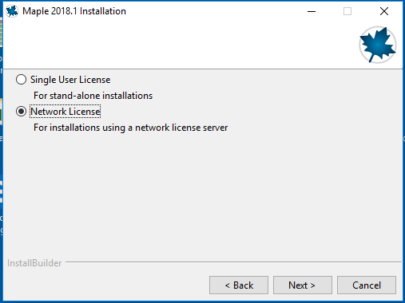

1. For the following pop up leave the default Single Server, select next.

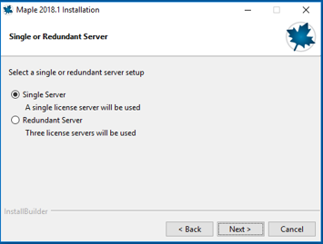

1. For the *License Server Pop Up*, you will need to enter some important location information for the license server. For the **License server**: Enter **zack** (careful of spelling) and **Port number**: Enter **27000**.

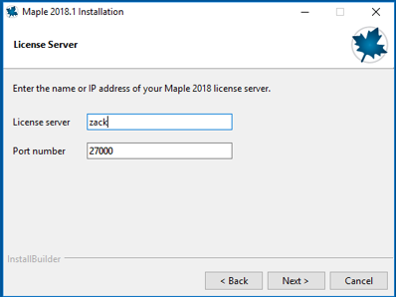

1. Uncheck all options for “check for Updates”, next.

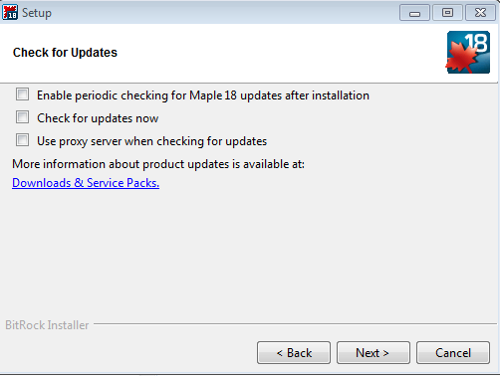

1. Next through the Installation Summary. Installation should begin. Click Finish after all the installation is complete. The Maple icon should appear on your desktop.
2. After opening Maple the first time, you may see a windows security alert. The default of Domain networks is sufficient, Select Allow access.

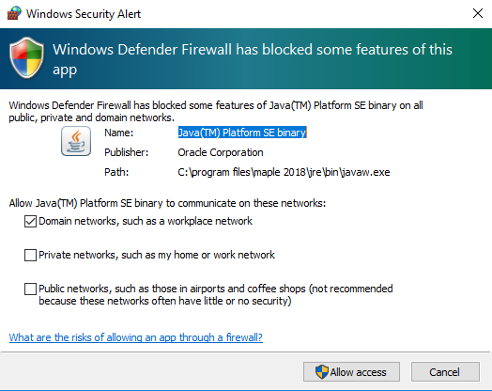

1. If a java update message appears flashing yellow on your bottom tab, install it. Maple may need the java update.
2. Any problems with the installation, please e-mail me first if I can’t help you then you will need to visit tech support or e-mail them at [techsupport@ursinus.edu](mailto:techsupport@ursinus.edu)