

C:\Users\urtzi.u\Documents\CV HACKS\Linkedin_Link.PNG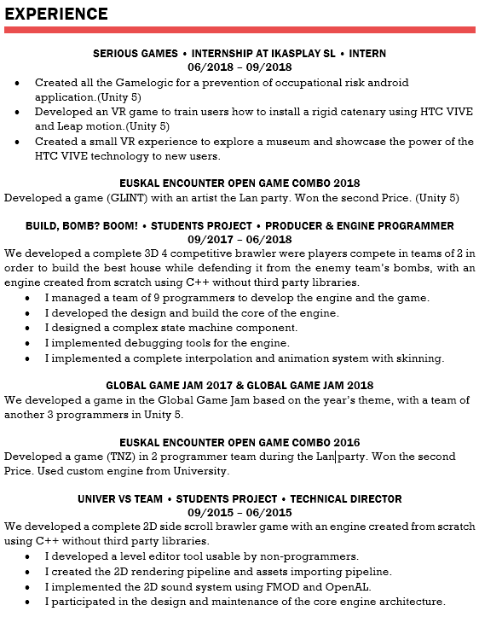C:\Users\urtzi.u\Documents\CV HACKS\Email.PNGC:\Users\urtzi.u\Documents\CV HACKS\Phone.PNG