<https://github.com/Ururu221/vote-app-Fedia>

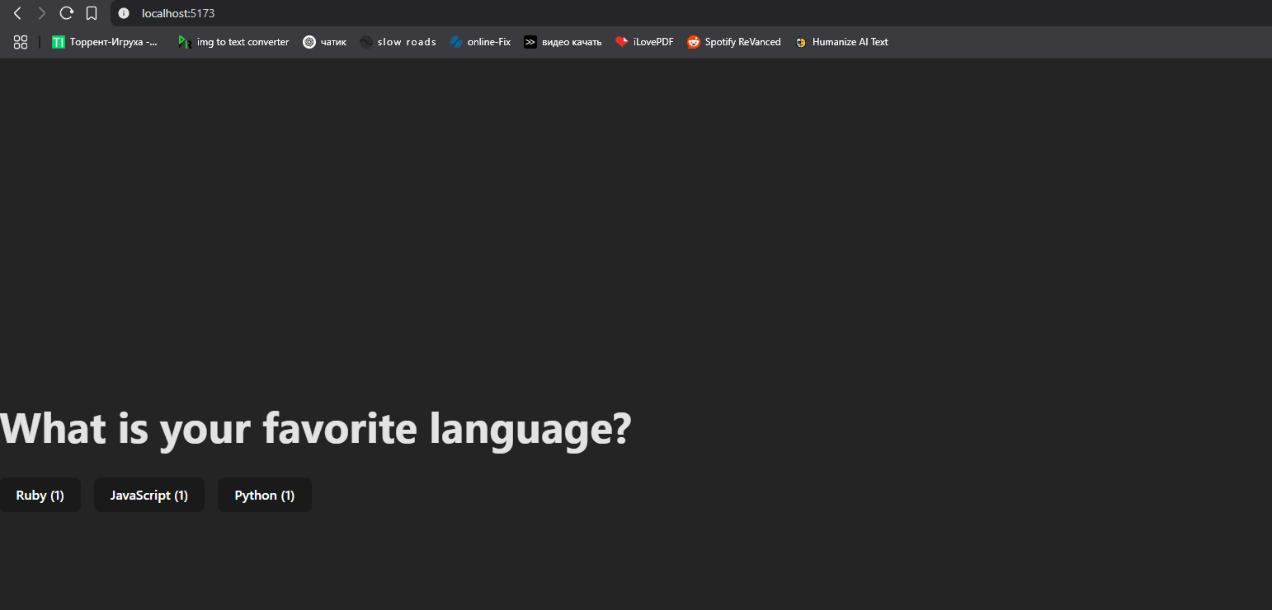



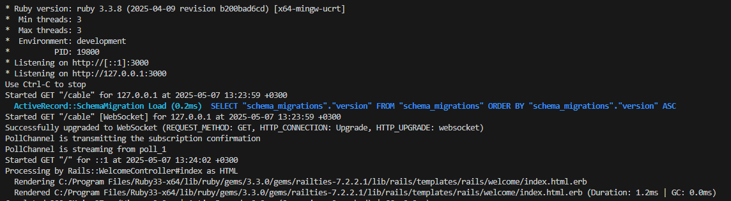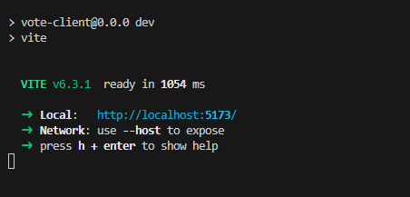

<https://github.com/Ururu221/vote-app-Fedia>