<https://github.com/Ururu221/vote-app-Fedia>

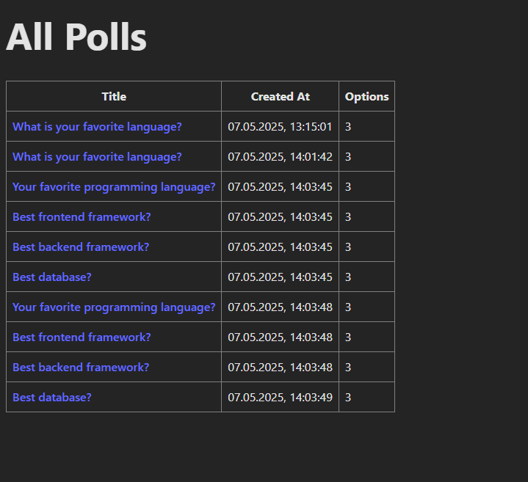

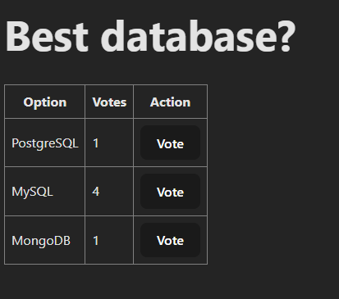

<https://github.com/Ururu221/vote-app-Fedia>