**Name: Urvee Chaudhari**

1.

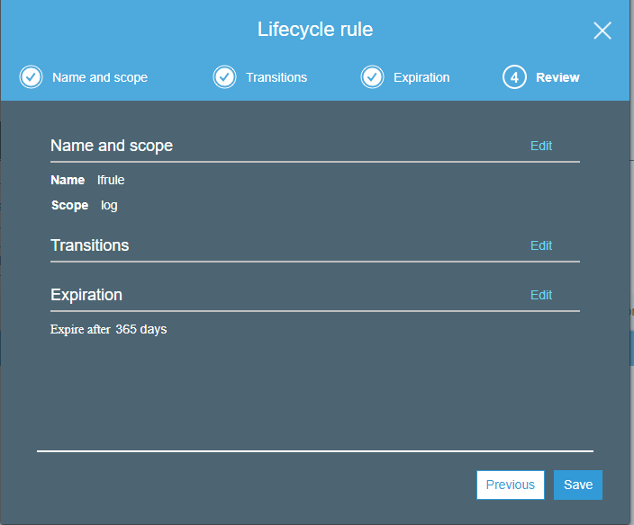

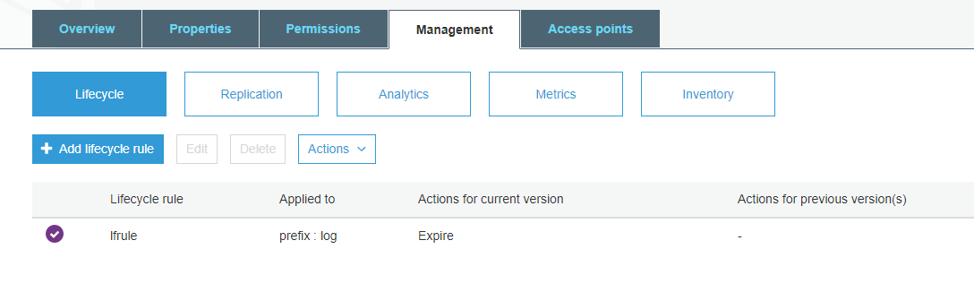

2.

1. Create a bucket urvee
2. Make it public
3. Add a folder named index.html to the bucket
4. In Properties, go to Static Website Hosting
5. Click on use this object to host the website
6. Entire index.html file name in the index text box.
7. Create another public bucket urvee1 with load.html file in it
8. This load.html is referred in index.html
9. Host a static website similarly from urvee1
10. In urvee1, go to Permissions
11. Click on CORS configuration and entire the following code:

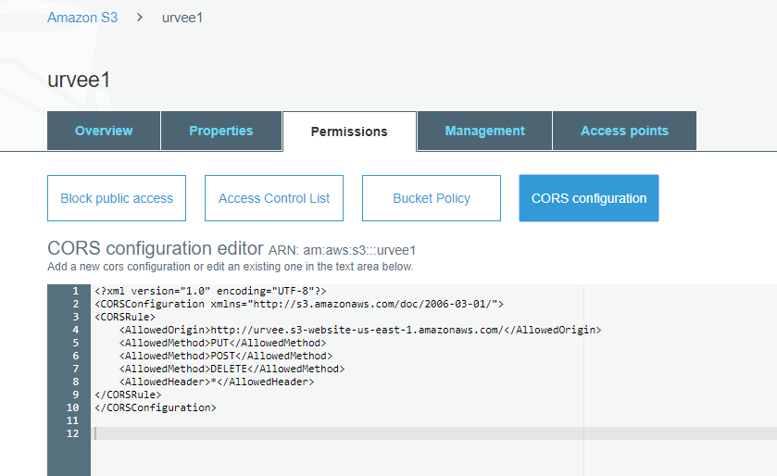

1. Now, open the website we created in urvee
2. We’ll now be able to see the content of load.html

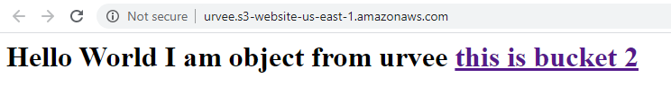

After clicking on the hyperlink, we get

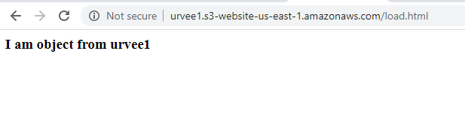

**Index.html code:**

<html>

<h1>Hello World

I am object from urvee

<A HREF ="http://urvee1.s3-website-us-east-1.amazonaws.com/load.html"> this is bucket 2</A>

</html>

**Load.html code:**

<html>

<h3> I am object from urvee1

</html>

3.

