

**A Assesment Report**

On

**“Problem Statement-Predict Loan Default”**

submitted as partial fulfillment for the award of

**BACHELOR OF TECHNOLOGY**

**DEGREE**

SESSION 2024-25

in

**CSE(AIML)**

By

Urvi Gupta (202401100400201)

**Under the supervision of**

“Abhishek Shukla”

**KIET Group of Institutions, Ghaziabad**

Affiliated to

**Dr. A.P.J. Abdul Kalam Technical University, Lucknow**

(Formerly UPTU)

**May, 2025**

**INDEX**

**S.no Title Page no.**

1. **Title Page 1**
2. **Introduction 2**
3. **Methodology 3**
4. **CODE 4-5**
5. **Output/Result 6**
6. **References 7**

**Title Page**

**Problem Statement**:

Predict Loan Default: Classify whether a borrower will default on a loan using financial history and credit scores.

**Personal Details**:

* **Name**: Urvi Gupta
* **Roll Number**: 202401100400201
* **Discipline**: BTech CSE (AIML)
* **Course**: Artificial Intelligence
* **Assessment**: AI MSE-2

**Introduction**

This project aims to predict whether a borrower will default on a loan based on financial and credit score data.  
We use machine learning techniques for classification. The goal is to build a model that can learn from past data and make accurate predictions on new applicants.  
The problem is solved using **Random Forest Classifier**, a robust ensemble learning algorithm.

**Methodology**

1. **Data Upload**: Uploaded the .csv file using Google Colab.
2. **Data Preprocessing**:
   * Dropped non-relevant columns like LoanID.
   * Removed missing values.
   * Encoded categorical variables using LabelEncoder.
   * Scaled the features using StandardScaler.
3. **Model Training**:
   * Split data into training and test sets (80-20 split).
   * Used RandomForestClassifier for classification.
4. **Evaluation**:
   * Used metrics: **accuracy**, **precision**, **recall**, and **confusion matrix**.

**CODE**

# 📌 Step 1: Import necessary libraries

from google.colab import files

uploaded = files.upload()

import pandas as pd

import numpy as np

import seaborn as sns

import matplotlib.pyplot as plt

from sklearn.model_selection import train_test_split

from sklearn.preprocessing import LabelEncoder, StandardScaler

from sklearn.ensemble import RandomForestClassifier

from sklearn.metrics import confusion_matrix, classification_report, accuracy_score, precision_score, recall_score

# ✅ Load the uploaded file (use the exact file name)

df = pd.read_csv('1. Predict Loan Default.csv')

# Drop 'LoanID' column (if exists)

if 'LoanID' in df.columns:

    df = df.drop(columns=['LoanID'])

# Drop missing values

df = df.dropna()

# Encode categorical columns

label_encoders = {}

for col in df.select_dtypes(include='object').columns:

    le = LabelEncoder()

    df[col] = le.fit_transform(df[col])

    label_encoders[col] = le

# Split features and target

X = df.drop('Default', axis=1)

y = df['Default']

# Scale features

scaler = StandardScaler()

X_scaled = scaler.fit_transform(X)

# Split into training and testing sets

X_train, X_test, y_train, y_test = train_test_split(X_scaled, y, test_size=0.2, random_state=42)

# Train model

model = RandomForestClassifier(random_state=42)

model.fit(X_train, y_train)

# Predict

y_pred = model.predict(X_test)

# Confusion Matrix Heatmap

cm = confusion_matrix(y_test, y_pred)

plt.figure(figsize=(6, 4))

sns.heatmap(cm, annot=True, fmt='d', cmap='Blues')

plt.title('Confusion Matrix')

plt.xlabel('Predicted')

plt.ylabel('Actual')

plt.show()

# Evaluation Metrics

accuracy = accuracy_score(y_test, y_pred)

precision = precision_score(y_test, y_pred)

recall = recall_score(y_test, y_pred)

print("Classification Report:\n", classification_report(y_test, y_pred))

print(f"✅ Accuracy: {accuracy:.2f}")

print(f"✅ Precision: {precision:.2f}")

print(f"✅ Recall: {recall:.2f}")

**Output/Result**

**–**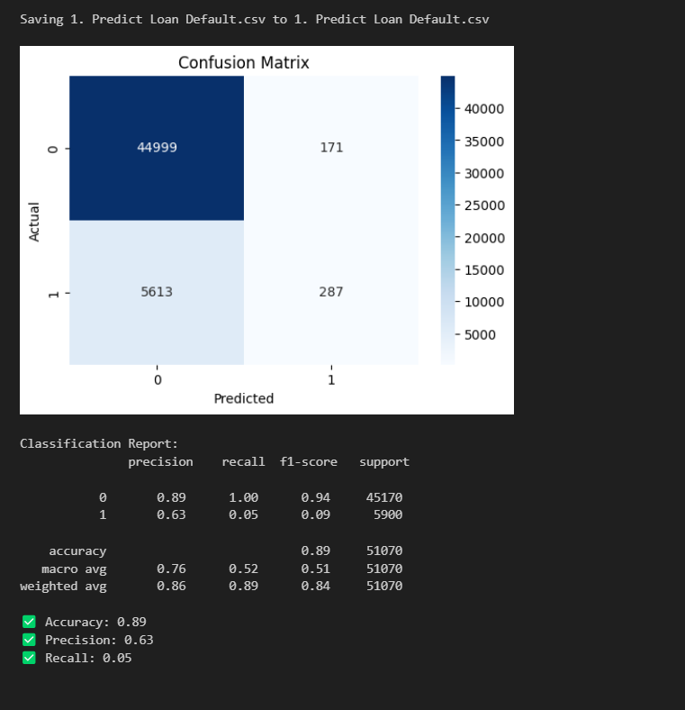

**References**

* Dataset Source: Kaggle
* Libraries used: scikit-learn, pandas, seaborn, matplotlib
* Code executed on: Google Colab
* Special thanks to: Faculty and AI department