# Business Model Generation: Business Model Canvas

***business model canvas:***

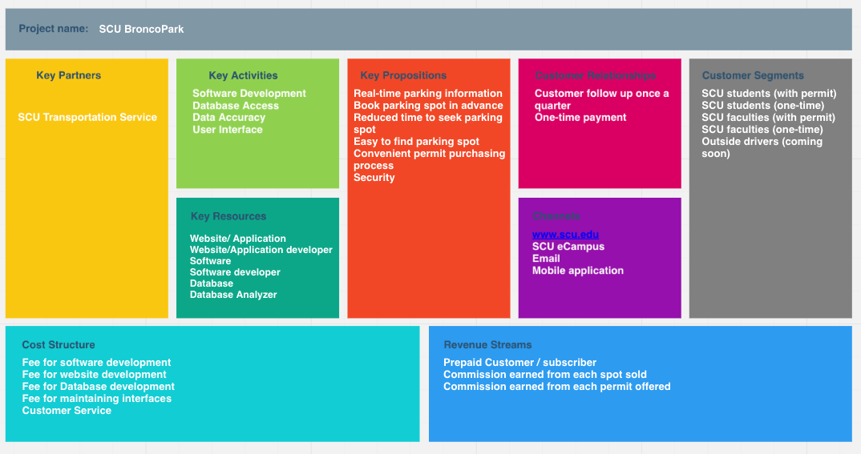

<https://realtimeboard.com/app/board/o9J_k0jdcU8=/>

***Detail of each section:***

**Key partners**

SCU BroncoPark is the intermediary role between the SCU drivers and SCU Transportation.

Key partners of our system are the SCU Transportation Service department. We collaborate with the SCU Transportation system to gain information about available parking spaces and customer information through their database. Also, SCU Transportation Service will provide printed permit to students and faculty after each spot sold from SCU BroncoPark.

**Key Activities**

The key activities involved in the business are to develop software to connect the SCU drivers to the services provided by the business. The software should give access to the database that maintains records of the parking spots. Timely updates and data capturing will be done to show available parking spots. Real time and accurate data are the crucial features. The user interfaces of the application/website will be user-friendly so that SCU drivers can easily locate parking spots and save time, which is the aim of designing such an application.

**Key Resources**

The resources needed to make the idea work are website, website developer, software, software developer, database and database analyzer. The website developer team would build a website/application for users to register and check the availability of parking spots. The software, which connects the database to the user application, will be able to work on platforms such as iOS and Android. It will be able to process requests from the users as well as update it in the system. The database for storing parking information will be developed together by the SCU Transportation system and SCU BroncoPark. The database analyzer will generate free spots from the information provided and update the database as required.

**Key Propositions**

SCU BroncoPark provides real-time parking information through its application on the client side, with which students and faculty at SCU can book parking spot in advance. This greatly reduces the time and effort for drivers to locate a parking spot. What’s more, one can easily purchase the parking permit with SCU BroncoPark. The application also enhances security by enabling drivers to view accurate parking information at real time.

**Customer Relationships**

SCU BroncoPark provides parking options with the types of hourly, nightly, quarterly, yearly. Students and faculty at SCU will typically receive notifications of resuming permit once every quarter. They can also write comments on the message board of our application for better improvement. One-time payment is provided for the driving permit, no addition fee is needed.

**Channels**

There are multiple ways for SCU BroncoPark to reach students and faculty. The main website(http://www.scu.edu) and SCU eCampus both provide information of SCU BroncoPark, including mobile application download instructions and the web interface URL. Notifications and follow-ups regarding permit purchasing, resumption and other issues will be sent to drivers’ SCU email addresses. Also, the mobile application(Android and iOS platform available) is the easiest way to share information with drivers, so that they can learn about real-time parking availability and location map as well as purchasing parking permit and booking parking spot in advance.

**Customer Segments**

Current SCU drivers are experiencing difficulties to find parking lots or spaces during peak times, such as crowded class hours or when on-campus events taking place. Students and faculty are feeling stressful because long-time parking seeking which results in late attending classes or events. SCU BroncoPark is an internal service or software. Our mission statement is to provide efficient parking opportunities to SCU students and faculty. Potential customers in the future will include external drivers who visit SCU campus.

**Cost Structure**

SCU BroncoPark will invest deeply on our software with the purpose of bringing the great application. The majority cost (60%) of our investment will spend on software development. Database is another critical section of our startup, since SCU BroncoPark is cooperating with SCU Transportation Service department, a strategy of building parking database together is suitable. 20 percent of the cost will spend on building and maintaining user interface to both mobile application and website. Finally, a call center and customer service department will be provided.

**Revenue Stream**

SCU BroncoPark makes revenue by taking commission from each parking spot or parking permit sold. Based on different kind of scenarios, below are the four tiers of charging fees from SCU transportation Service and commission ratio that SCU BroncoPark takes.

1. One-time charge. This is an option of student and faculty who do not have any parking permit but would like to have a guaranteed parking spot. Driver can preserve parking space through our app or website. A prepaid charge and BroncoPark commision is listed below:

|  |  |  |
| --- | --- | --- |
| Duration | Price | BroncoPark Commission (50% of Price) |
| 0 -2 hours | $2.00 | $1.00 |
| 2 -4 hours | $3.00 | $1.50 |
| Each Additional Hour | $1.00 | $0.50 |
| Daily Rate | $20.00 | $10.00 |

1. SCU student and faculty hold yearly permit. This type of service is allow SCU drivers to park in campus whole year with reserved parking location. This service is providing accurate and consistent parking space.

|  |  |  |
| --- | --- | --- |
| Duration | Price | BroncoPark Commission (25% of Price) |
| Yearly | $400.00 | $100.00 |

1. SCU student and faculty hold quarterly permit, This type of service is allow SCU drivers to park in campus each quarter with reserved parking location.

|  |  |  |
| --- | --- | --- |
| Duration | Price | BroncoPark Commission (30% of Price) |
| Quarterly | $160.00 | $48.00 |

1. SCU student and faculty hold nightly permit, This type of service is allow SCU drivers to park in campus after 4pm weekday with reserved parking location.

|  |  |  |
| --- | --- | --- |
| Duration | Price | BroncoPark Commission (30% of Price) |
| Nightly | $125.00 | $37.50 |

***Feedback Report***

To better understand if our ideas are meeting customer requirements, and to fully interact with our potential users, we have created a [survey](http://goo.gl/forms/w8kcoHvYIa). From the result (Figure 1-1), we can see that our thought and business strategy are on the right track. Potential customers have positive thinking to our current ideas and are interested to see the real product.

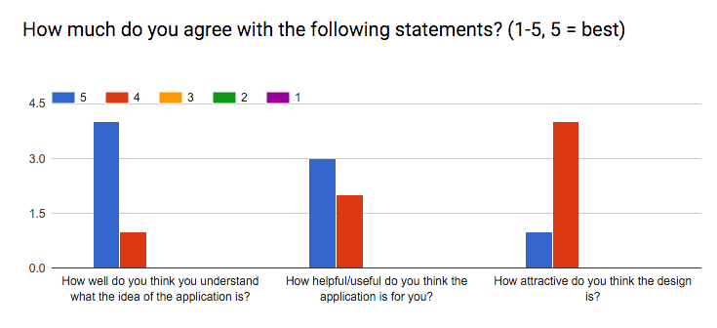

Figure 1-1

One suggestion from a feedback is to add SCU Transportation Service Department as our customers as well as our partner. After careful consideration, we think our current business strategy is still more of collaborating with SCU Transportation Services, because we are working together to provide a service to SCU drivers, and the major profit of our company is gained through their parking permit purchasing. Also, we are acquiring necessary information of students and faculty through their system. Thus, SCU Transportation Services wouldn’t be our direct customer, just like Uber and drivers of Uber, they are not only employer and employees but also cooperative partners.

Other suggestions include that UI in the Key Activities part should be put into the Key Resources part. However, the user interface is for drivers to directly view information and conduct purchasing or booking process, and we think that the Website/Application entry in Key Resources include it.

Besides students and faculty, expanding our business to face to external customer who wish to park in campus during visit is necessary. Based on this feedback, we add outside drivers to our customer segment. And we will provide the same high-quality service to them soon.