# **Business Model Engineering: Business Process Architecture**

***Business process architecture***

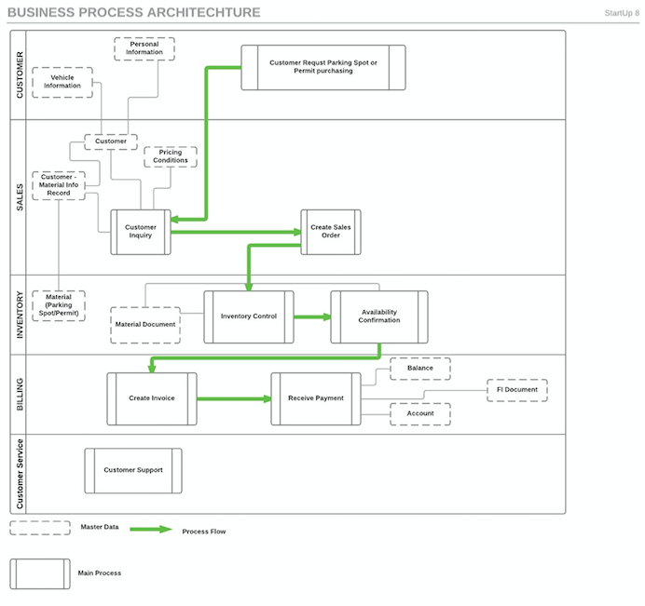

<https://www.lucidchart.com/documents/view/dd4f7d6c-de4a-4497-a18c-cd5e73849167>

***Business process and master data***

**Customer Process:**

The customer process, as the starting point of our system, is triggered when a customer(SCU students or faculty) enters our system with the objective to book a parking spot or purchase a parking permit. He or she will also provide information needed as the critical master data.

* *Personal Information.* This data is about the customer’s specific information, such as student or faculty ID, name, gender, age and payment information.
* *Vehicle Information.* This data contains car information of the customer’s, mainly are car plate number, manufacturer, model, and permit type or reservation term.

**Sales Process:**

The sales process in our system begins with a trigger which a customer (SCU students and faculty) requests to reserve a parking spot or purchase a parking permit as explained earlier. Our system will store this customer requisition and translate it to a customer purchase order behind the scene. Master data involved at this process is shown below:

* *Customer Master Data*. This data includes all customer’s personal information and vehicle information. It also contains the accounting data of the customer such as payment terms, payment methods. If there is no specific notice, the customer will be assigned as sold-to party, ship-to-party and bill-to-party by default.
* *Customer-material Information Record.* This data in our system is specific using for one customer to one material. In detail, for example, one SCU graduate student only needs night permit with a parking location close to Lucas hall. This data can also be used for future reference. Return customers do not need to select this comprises of master data, instead system can flag the history to them.
* *Material Master Data.* Material data in our system is referred to parking spots and parking permit. This data is stored in our main database. More details will be explained in the inventory segment.
* *Pricing Conditions.* The final sale price is based on parking time duration, different type of permit, and different type of parking spot (Appendix A).

Once the customer purchase order saved in our system, it triggers the sales order processing step. Figure 1-1 illustrates the steps of sales order process.



Figure 1-1

The most master data in sales process are similar to previous customer inquiring process. The key task in this process is to create sales order. The sales order will include header and line items. Header is including the date, purchase order number, customer information, and sold-to-party info as option, normally this is the same person as customer. In line items, permit type and parking location will be addressed in that section. A sales order will be eventually generated as outcome.

**Inventory Process:**

The inventory process in our system is concerned with the database or storage of the parking spots and permits. The trigger to start the process is when a sales order is received from the sales process. The Inventory control step checks the parking availability using the information from material document (explained below). The key task of the inventory control is to find a spot and give back acknowledgement when a spot is found.

The master data included in inventory control process is :

* *Material Master.* Material in our systems are referred as parking spot and parking permit. Parking Spot Data is used to illustrate the information of parking space. This data include the parking garage location and parking spot number. Parking Permit Data is used to illustrate the information of different kind of parking permit. This data include parking permit type and parking permit terms.
* *Material Document.* This data is used to recording data movements of parking permit and parking spot. Any data updates to parking permit and parking spot will be saved to this document. One important field of this document is flagging the availabilities. If availability found, the document will flag inventory control process to move on to the next step to inform customer the request is able to process. If there is no availability find from customer request or sales order, the system will flag the information back to customer.

After availability find, the process is moving on to availability confirmation. This step is used to confirm the data fetched from database are matching the information from sales order. If they match, the parking spot and parking permit number will be updated in material document. Then an invoice will be generated which will explain in the next section.

**Billing Process:**

After the inventory process, which helps to identify if there are available parking spots or suitable parking permit options, here comes to the last step of the whole business process, i.e, the billing process, in which real money transaction will take place. Once inventory availability being confirmed, invoice should be created and sent to the customer, which contains all necessary information for the customer to review. The most information comes from sales order which including header and line items. At this point, it generates financial impact to our business which referred by creating FI document, CO document, and invoice document. Figure 1-2 illustrate the process of billing steps.



Figure 1-2

With customer confirming the invoice and making a payment, more data and document will be reflected.

* *Balance.* Balance in our system refers to the total available amount of money, which is increased with the incoming payment and decreased with system running and maintaining expenses.
* *Account.* Account includes all information about customer and customer-material history, once customer made a payment to our system, his or her information(personal, vehicle and purchase history) will be recorded in the database.
* *FI Document.* Financial document is created when there is a financial impact to our system, its aim is to meet with legal requirements.

Figure 1-3 illustrate the process of payment steps.



Figure 1-3

**Customer Support Process:**

This is an independent business process of our system, that is, it exists without the direct connection with other processes. Whenever customer comes across issues in technical or other aspects of the system, which affect the result of successful purchase or reservation, can be addressed by the support team. This process is also special for it’s not involved with any of the master data or the system’s main operation. It acts as an ancillary yet necessary part of the system.

***Business processes interactaction***

***Customer to Sales:***

Our potential customers will utilize mobile application or web interface to interact the service we provided. Once customers start the application of parking spot reservation, they will request to input personal information and vehicle information which will be stored in customer master database. Also, a request ticket will be sent to the system backend to start analyzing the application, which is customer inquiring. After system receives customer inquiring, it will collect all needed information and start transferring them to a customer purchase order. This document is processed at backend and eventually converted to a sales order.

***Sales to Inventory:***

Once sales order created, an availability check of requested parking spot or parking permit is triggered. The system will search the database to see if customers request is available by looking for the field of availability flag to each line item. If there is a match, the system will generate confirmation and lock the parking spot so no other requests can be reached.

***Inventory to Billing:***

Only when the availability has been confirmed from previously inventory process, the last process, billing process is triggered. A positive availability confirmation and information in sales order would result in the creating of the invoice, and then it will be sent to the customer. Customer is able to check all the information in the invoice to ensure correctness and then to proceed a payment. Afterwards, the system will receive the payment, and update the master database of account, balance and FI document.

***Feedback Report***

From last time experience, we have realized an online survey is really a good path to lead us to understand if our strategy is in the correct path. And feedbacks can help us to understand the vulnerability of our project. So we did the same methods this time, an online [survey](https://docs.google.com/a/scu.edu/forms/d/1eroUOJNr2ylAWFlkZ610GIbPu_RxYijoRnd7mpg7s_E/viewform). From those online feedbacks, we can tell that most people are in favor of this type of service. See Figure 1-4.

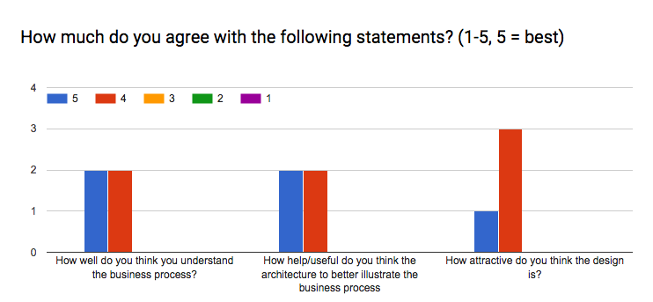

One feedback asked us to illustrate the steps or process on how to maintain the database. After carefully consideration, we think this is not the case of business process, instead, it could be part of database management process.

Some of them are worried about how we make money, because it don’t seem like to be a viral business, like Uber or Snapchat, and the scope of our service is limited to SCU. We think that, SCU is a perfect place to try error, as we are insiders who know the best about all conditions inside campus and who are also users of our service. We can receive consistent feedbacks from other students and faculty at SCU and gain practical knowledge before spreading this business to similar user groups, such as other universities and working areas.

Also one feels that it’s a confusing process as we have mixed permit purchasing and reservation booking together, and they should be different sorts of products. Well, although different as one is virtual and the other is real, they are both what we can offer after customer filling in information and making a payment. The process of the two are essentially the same.

***Appendix A***

|  |  |  |
| --- | --- | --- |
| Duration | Price | BroncoPark Commission (50% of Price) |
| 0 -2 hours | $2.00 | $1.00 |
| 2 -4 hours | $3.00 | $1.50 |
| Each Additional Hour | $1.00 | $0.50 |
| Daily Rate | $20.00 | $10.00 |

|  |  |  |
| --- | --- | --- |
| Duration | Price | BroncoPark Commission (25% of Price) |
| Yearly | $400.00 | $100.00 |

|  |  |  |
| --- | --- | --- |
| Duration | Price | BroncoPark Commission (30% of Price) |
| Quarterly | $160.00 | $48.00 |

|  |  |  |
| --- | --- | --- |
| Duration | Price | BroncoPark Commission (30% of Price) |
| Nightly | $125.00 | $37.50 |