|  |  |
| --- | --- |
| **Roll no.：** | 20BCE095 |
| **Name :** | Urvik Jada |
| **Course code and name：** | 2CS403 Operating System |
| **Practical no.:** | Innovative |

**Input / Output:**

**FCFS :**

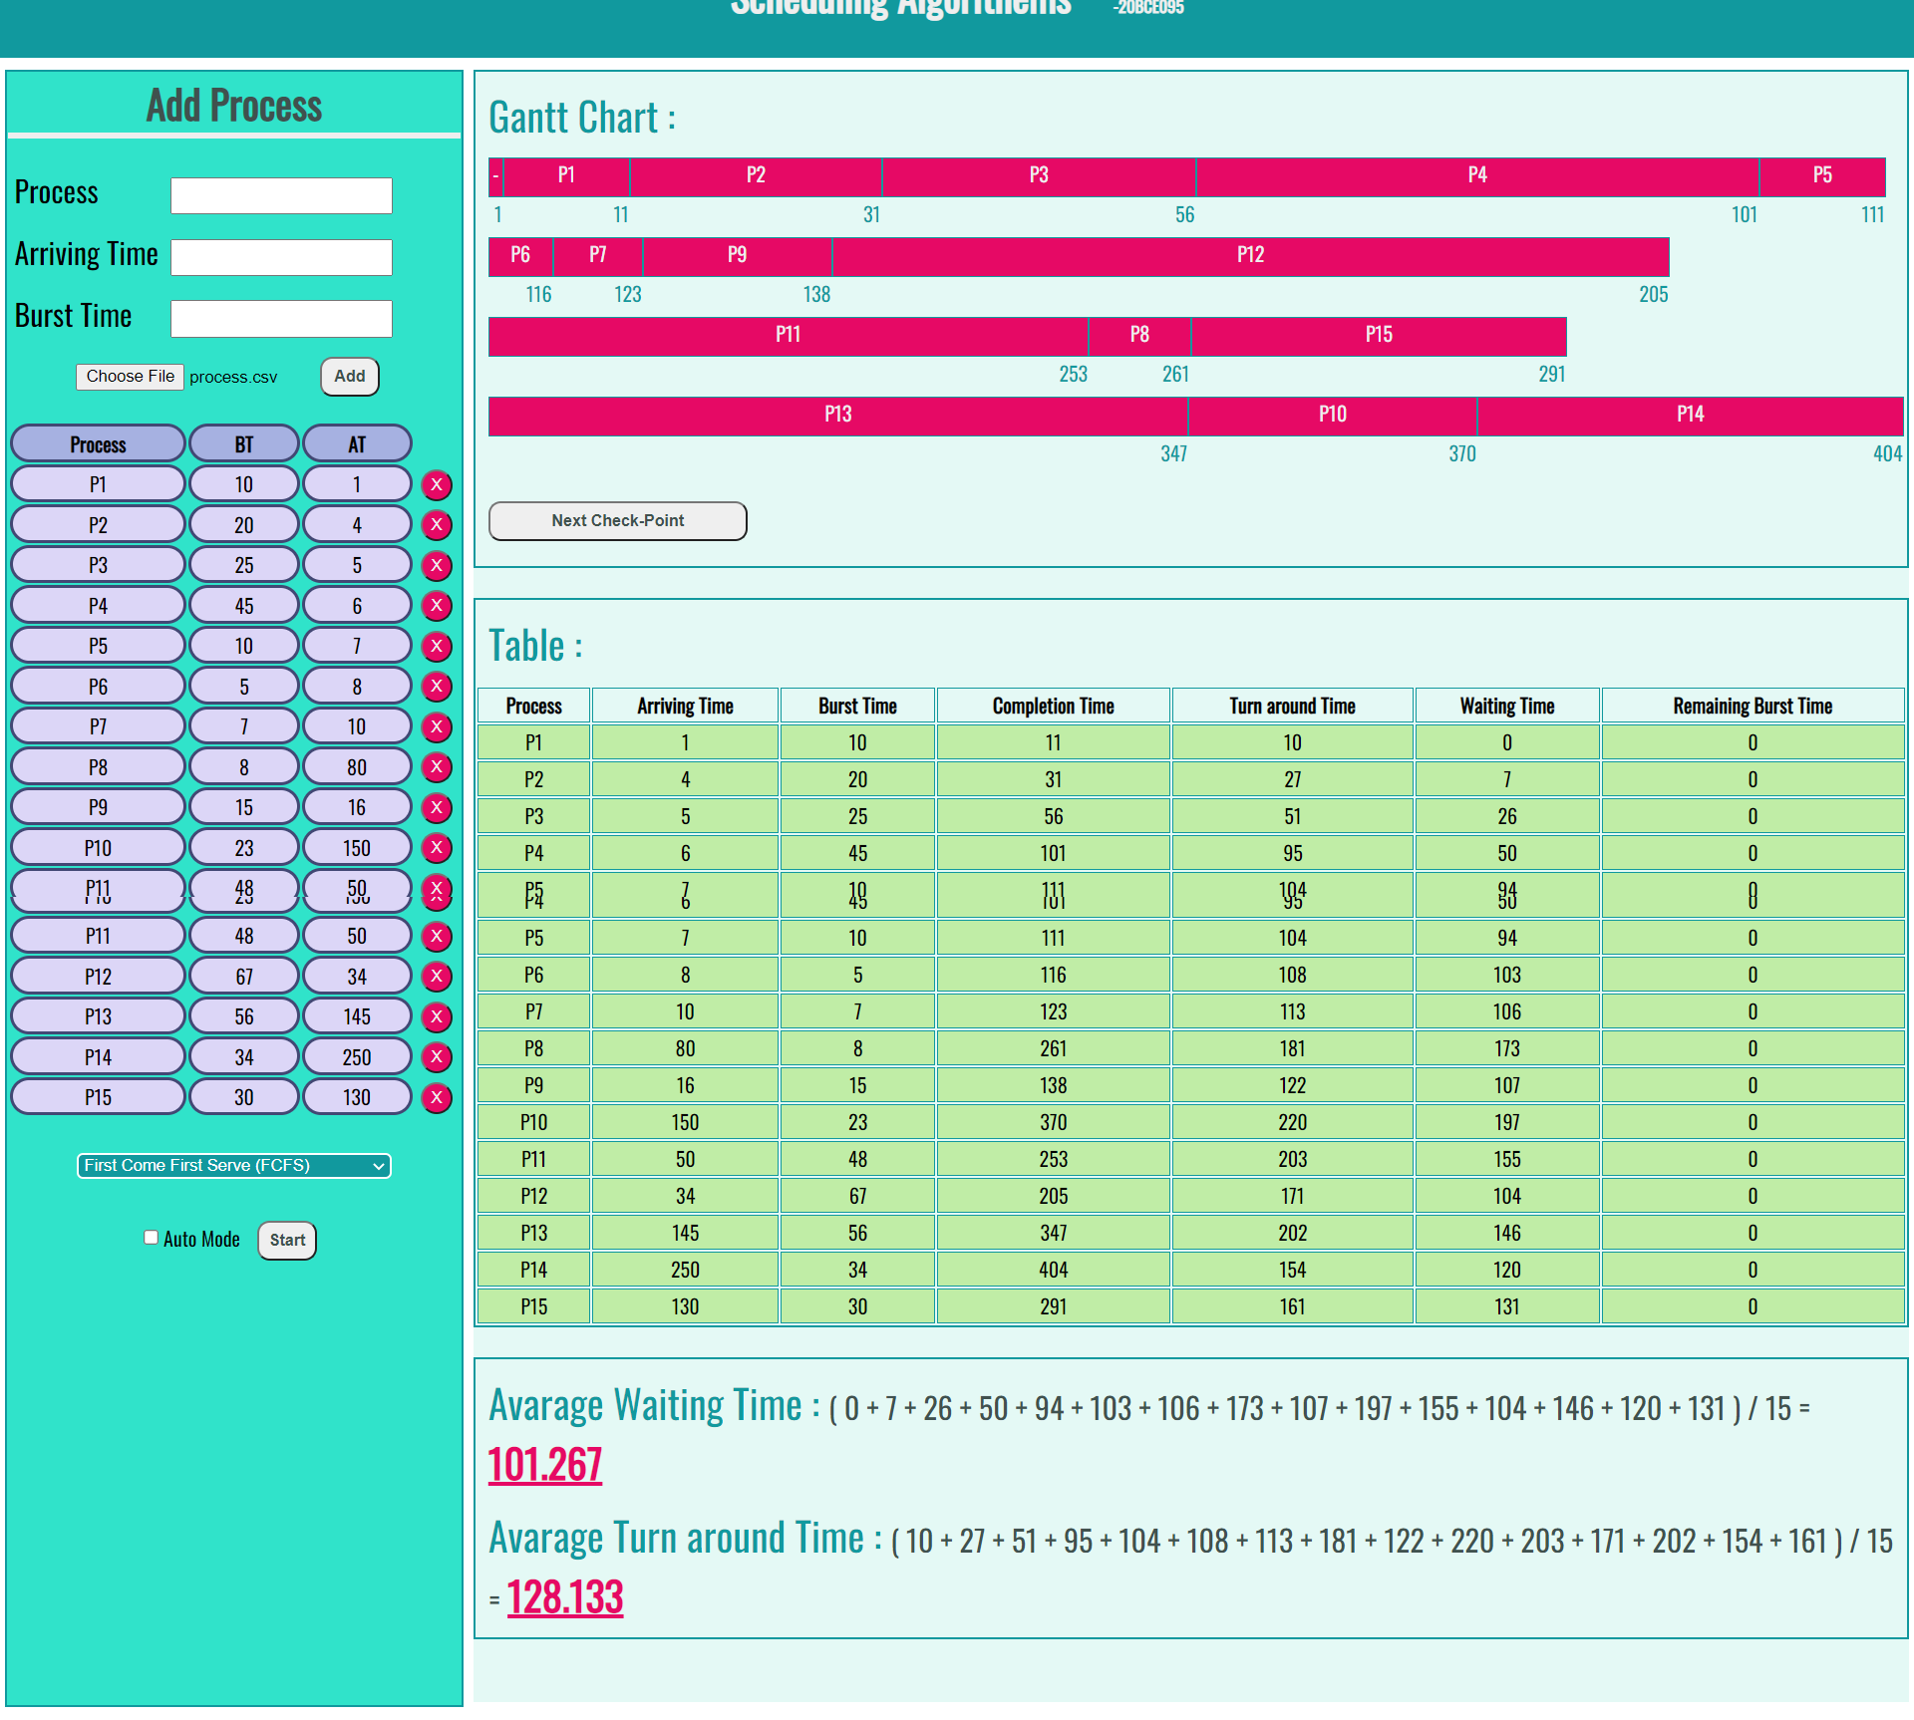

**SJF :**

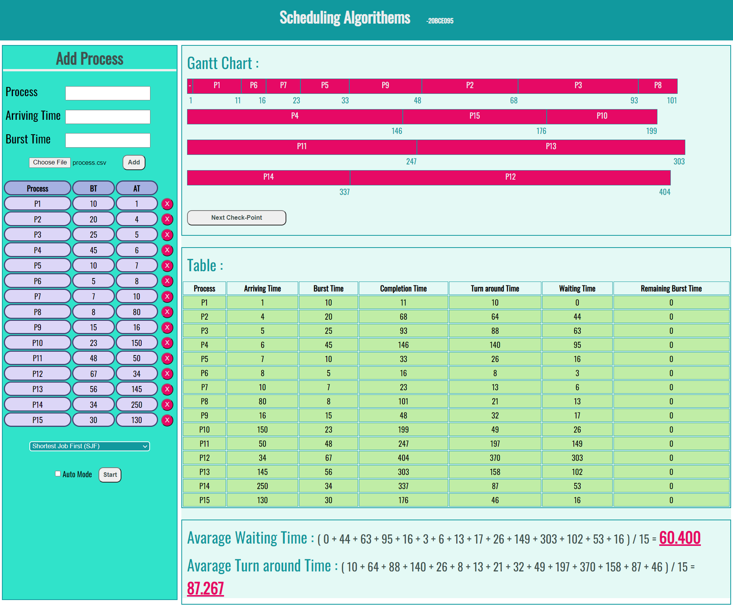

**SRTF :**

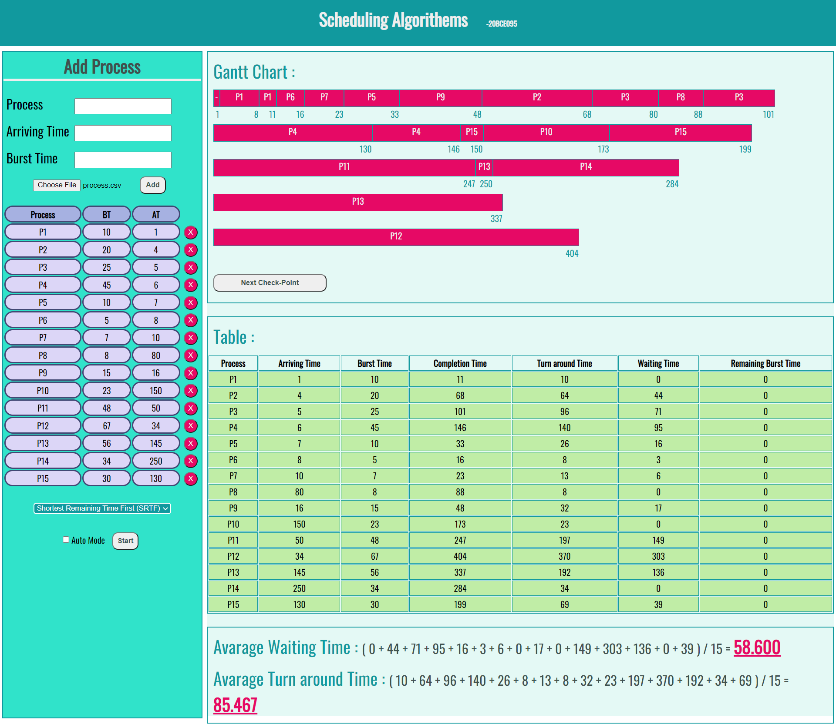

**RR :**

