

**Name**: Urwa Zahra **Subject:** Cloud Computing

**Registration No:** 2023-BSE-068 **Section:** 5-B

Assignment 1: Git, Gitea, GitHub, LFS, and GitHub Pages

1. Screenshot of your Gitea repository (showing README listing names & roll numbers)

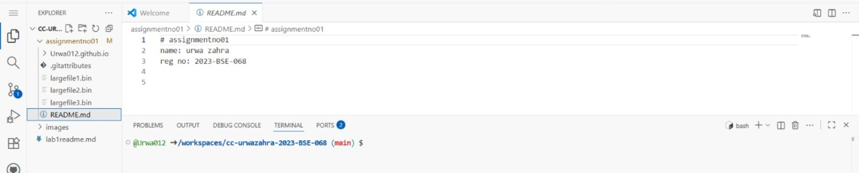

1. GitHub assignment 1 repo link (with README and large files)

<https://github.com/Urwa012/assignment-1.git>

1. Screenshot or output of git remote -v showing both remotes



1. GitHub Pages link to your CV/portfolio

<https://Urwa012.github.io>