SE212 Database System and Design

Lab 3

Name SID



1. (5 points ) Define each of the following terms and give an example.

• Business rule Ans:

A business rule is a statement that defines or constrains some aspect of the business. It is intended to assert business structure or to control or influence the behavior of the business.

• Binary relationship Ans:

A binary relationship is a relationship between two entities

• Relationship type Ans:

A relationship type is a meaningful association between entity types.

• Attributes Ans:

Attributes are properties or characteristics of an entity or a relationship.

• Entity instance Ans:

An entity instance is a single occurrence of an entity type.

2. (5 point) Giving the business rule below, identify entities for the model.

• A department employs many employees, but each employee is employed by one department.

• Some employees, known as "rovers," are not assigned to any department.

• A division operates many departments, but each department is operated by one division

• An employee may be assigned to many projects and a project may have many employees assigned to it.

• A project must have at least one employee assigned to it.

• One of the employees manages each department.

• One of the employees runs each division.

Ans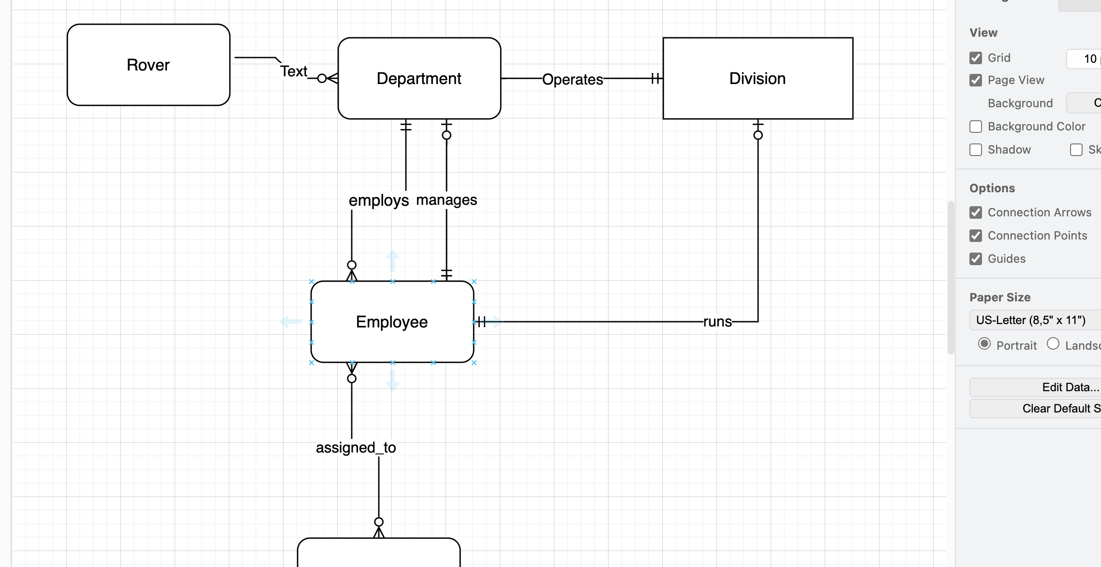

3. (5 point) For each of the following pairs of related entities, indicate whether (under typical circumstances) there is a one-to-many or a many-to-many relationship. Then, using theshorthand notation (traditional) introduced in the slide and text, draw a diagram for each of the relationships. You are going to create a traditional ER diagram using draw.io. ( *10 points*)

a. STUDENT and COURSE (students register for courses)

b. BOOK and BOOK COPY (books have copies)

c. COURSE and SECTION (courses have sections)

d. SECTION and ROOM (sections are scheduled in rooms)

e. INSTRUCTOR and COURSE

Total points 15/3

