**Ahsanullah University of Science and Technology**



**Course No: CSE 2100**

**Course Name: Software Development-II**

**Project Name: Mobile Banking Management System**

**Section: B2 Lab Group: 05**

**Submitted to:**

**Raqeebir Rab** **Moumita Choudhury**

Lecturer, Lecturer,

Department of CSE, AUST. Department of CSE, AUST.

**Subbmitted By:**

**Name:**

Md.Jobairul Hassan ID: 190104088

Pronay Debnath ID: 190104096

Usafa Akther Rifa ID: 190104097

**Introduction:**

Introducing "EzzyPay" with an elegant look, and exciting features, to make your life simpler and easier. Register a EzzyPay account right from the app in a few minutes, add money from your bank account and get going. Recharge mobile balance, pay utility and other bills from home, send money to people, and get different lifestyle services, all in a highly secure mobile money app.

**Motivation Behind of This Project Choosing:**

This Project is all about transferred and saved money in a digital platform. User can easily deposit a fixed amount of money and use this money in different purpose in a digital way. Our main motive for the project is to transfer and pay money easily and safely.

**Project Description:**

This project is basically divided into two parts one is Admin Panel and another is User Section.

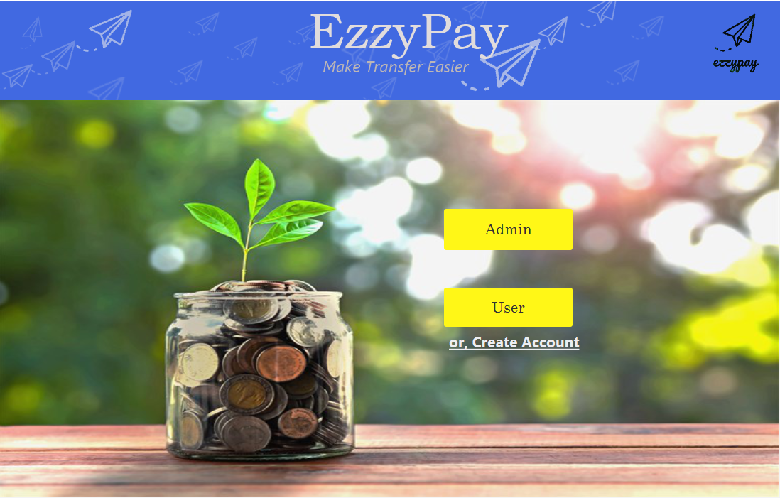

**Figure: Home page**

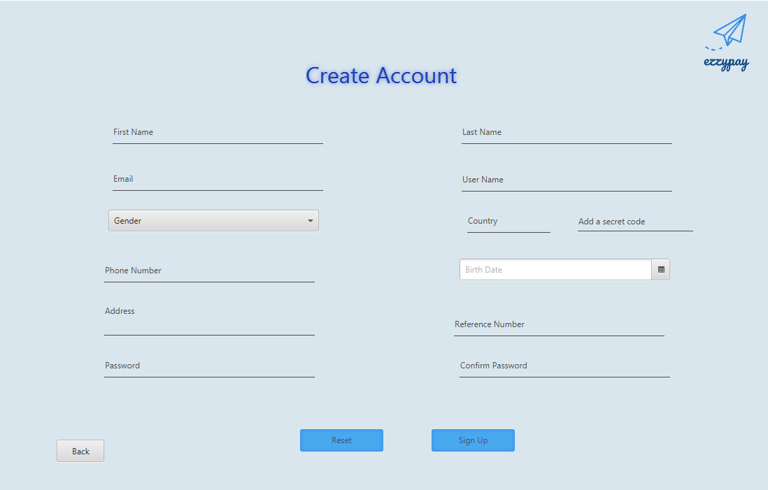

**Figure: Registration Form**

An user can create his/her account by filling up this registration form with proper information.

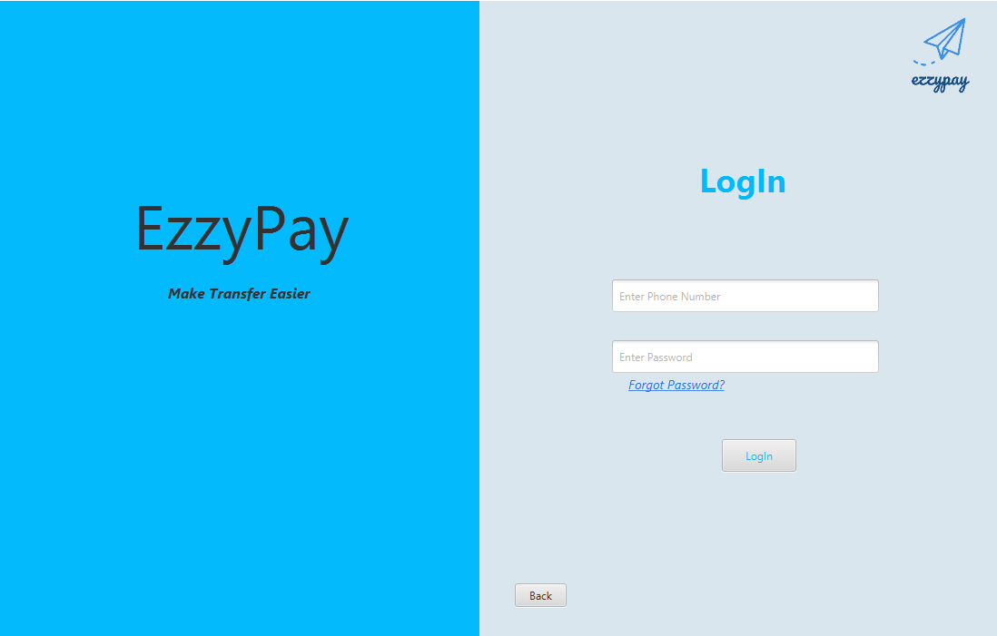

**Figure: Login Form**

If he/she had a previous account then they can simply access through fill up the login form.

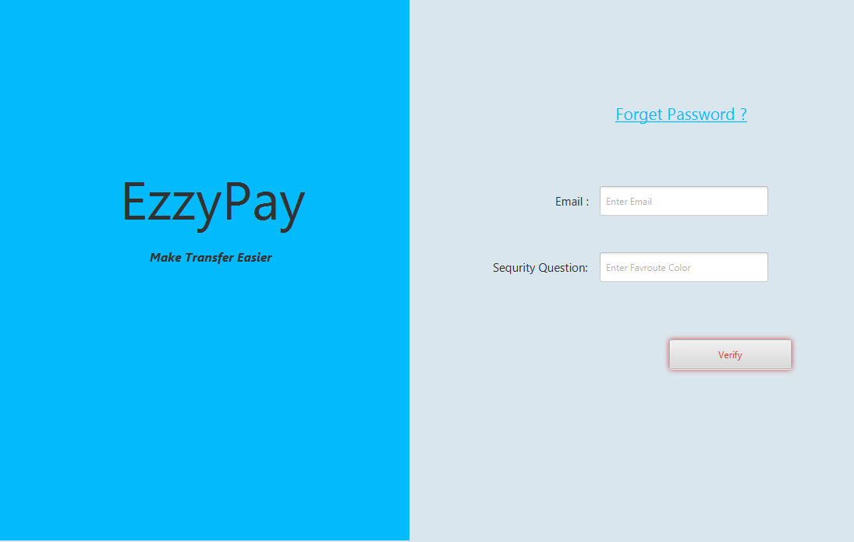

**Figure: Forget password**

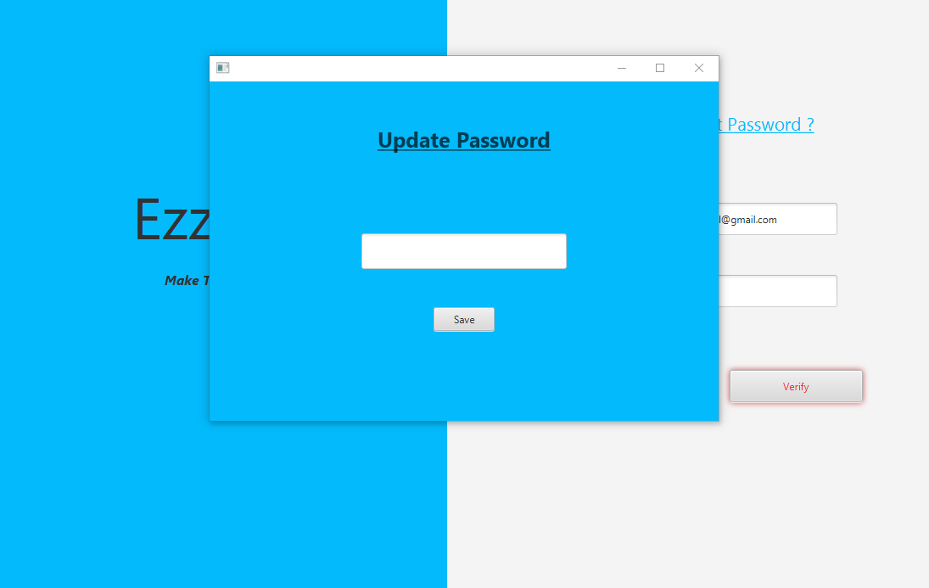 **Figure: Update Password**

If the user somehow forgets the password he/she can set a new password and retrieve his/her account in a safe way.

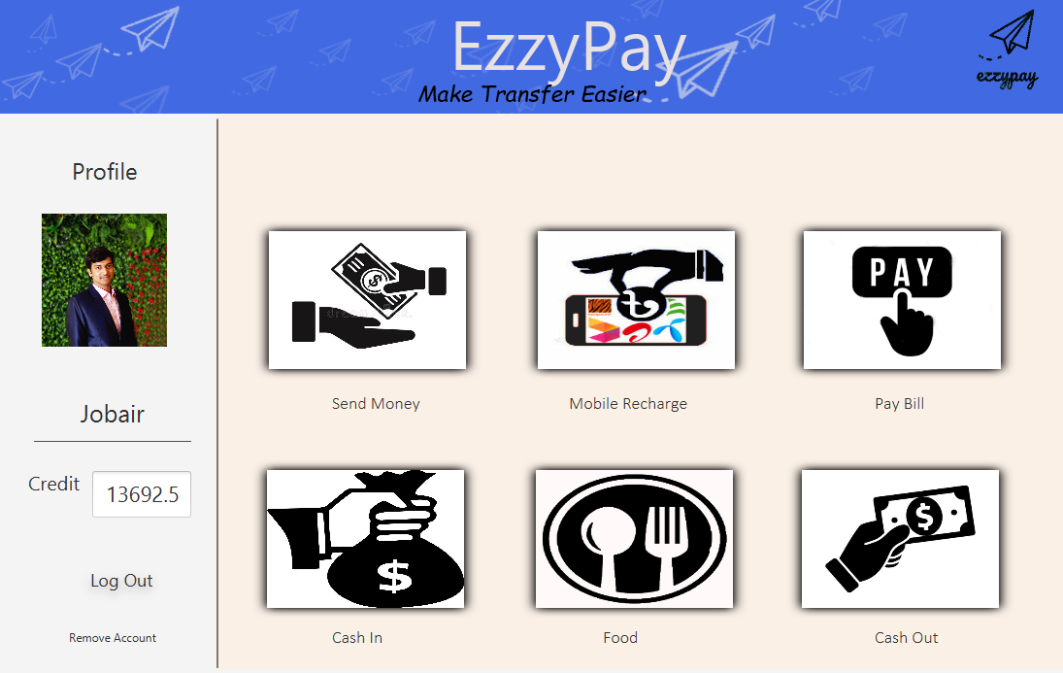

**Figure: User Section**

A user can access all the features of this project from this page. He / She can easily check the balance from the credit section.

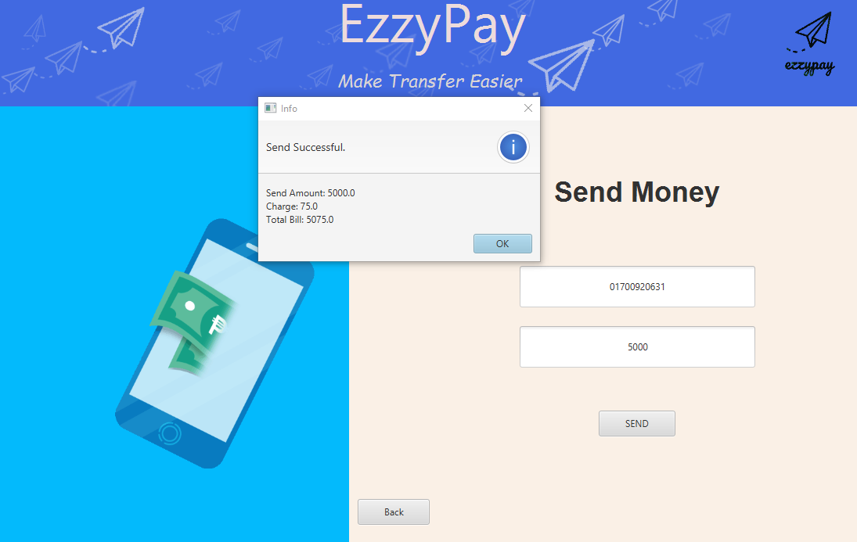

**Figure: Send Money GUI**

A user can transfer money to others if they have an account in this App.

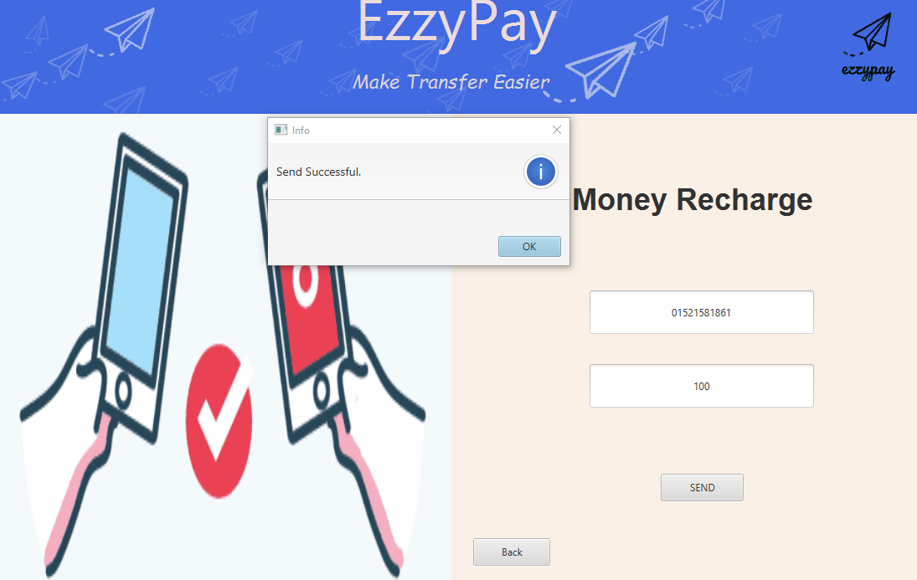

**Figure: Mobile Recharge GUI**

A user can easily refill his/her mobile balance through this App.

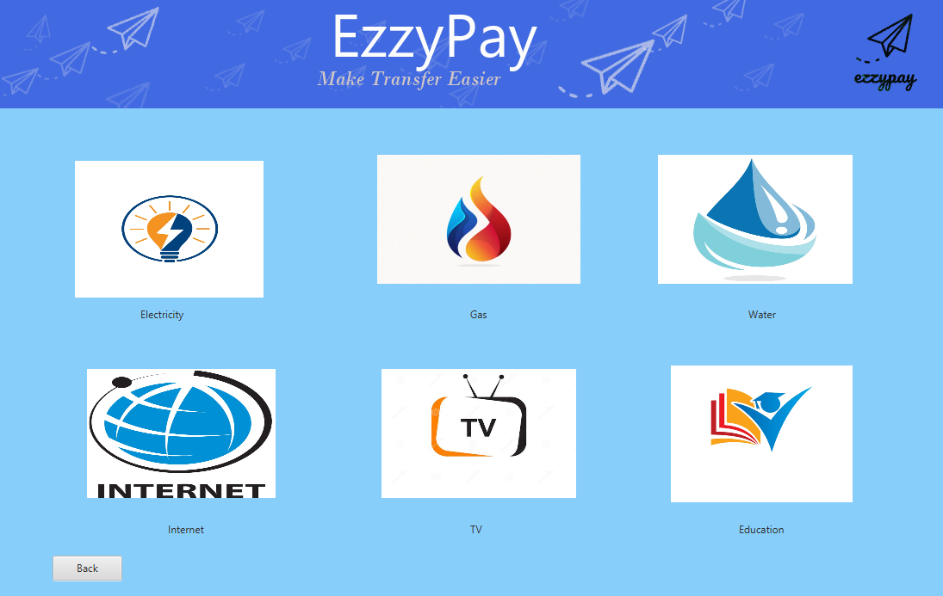

**Figure: Utility Bill GUI**

User can pay utility and other bills (Electricity, Gas, Water, Internet, TV and Education) from home just in a click away.

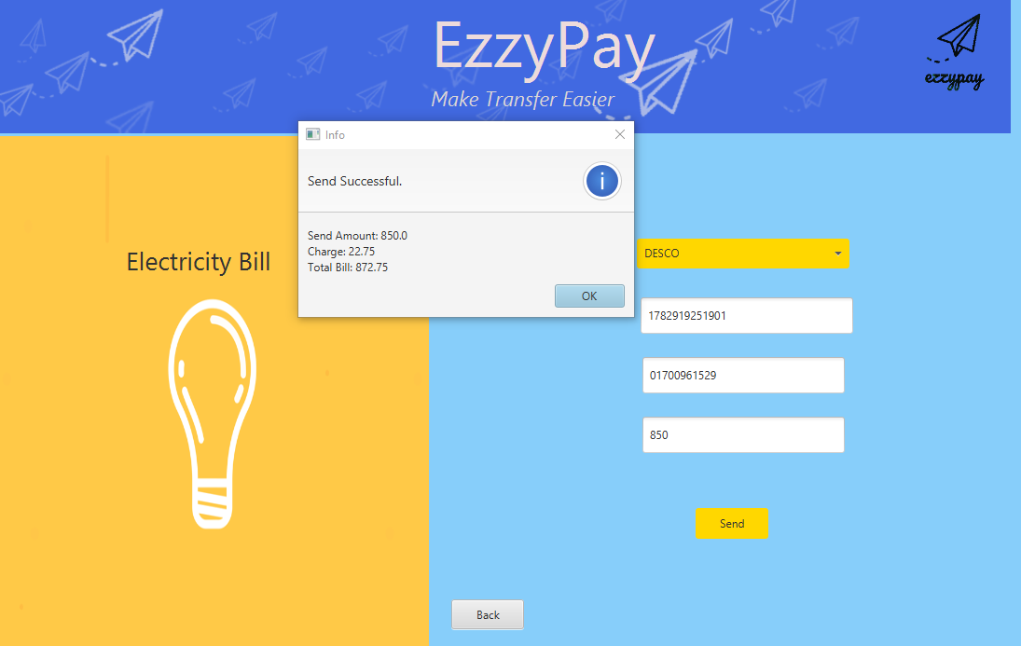

**Figure: Electricity Bill pay GUI**

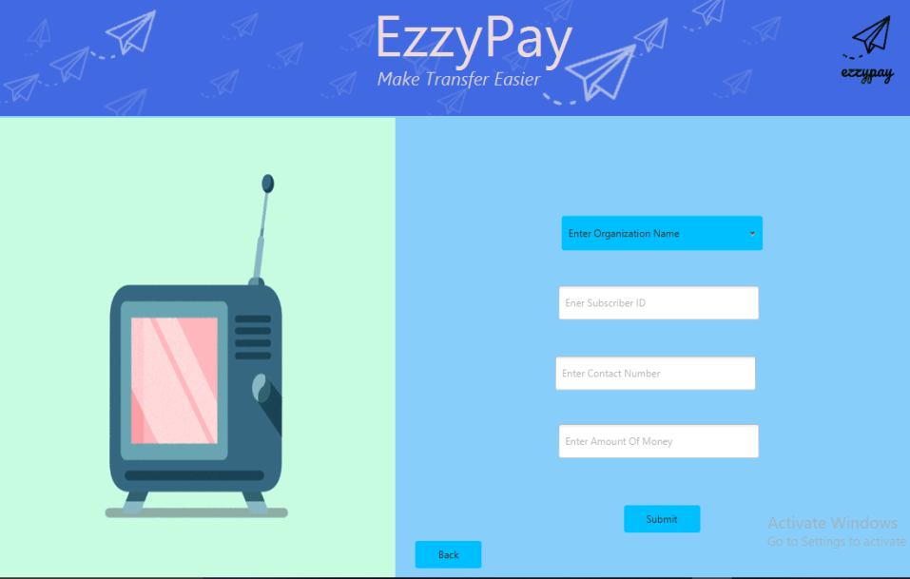

**Figure: Dish Bill pay GUI**

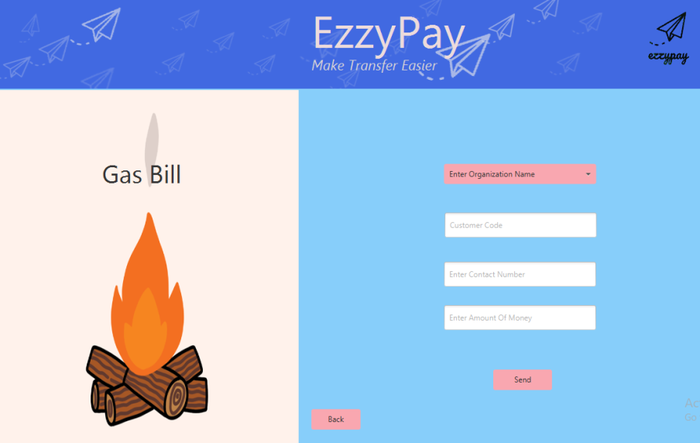

**Figure: Gas Bill pay GUI**

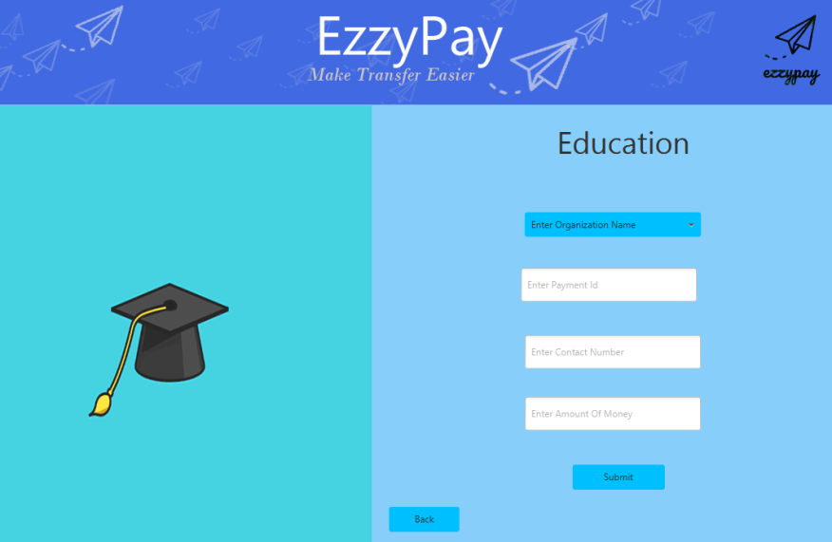

**Figure: Tuition Fees pay GUI**

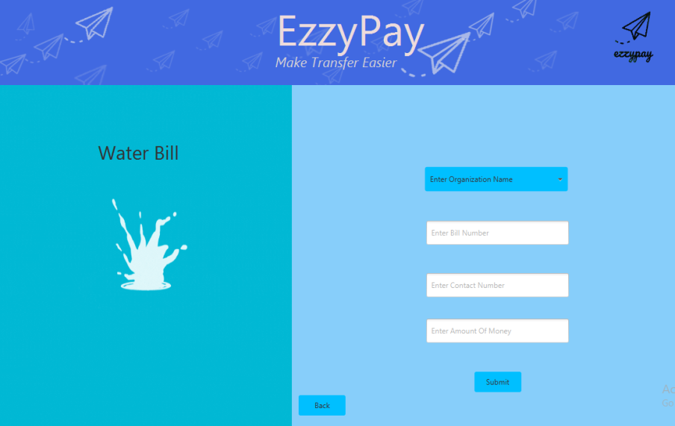

**Figure: Water Bill pay GUI**

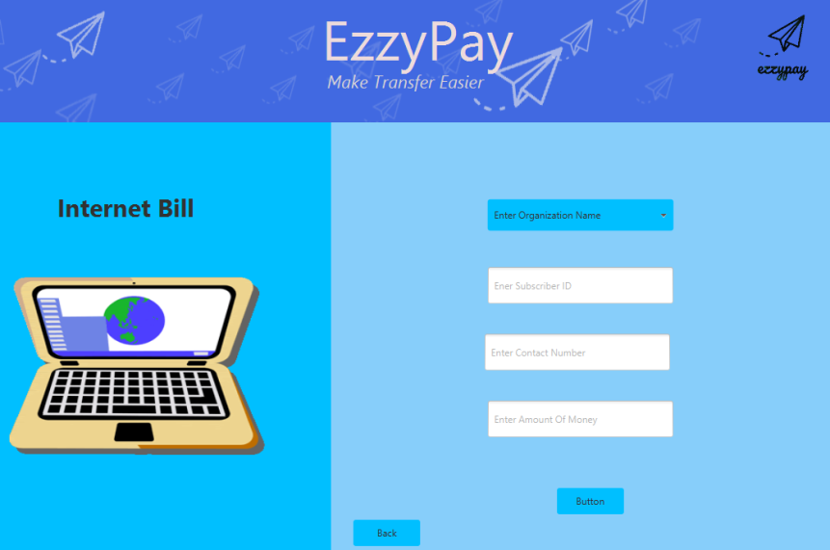

**Figure: Internet Bill pay GUI**

In EzzyPay's food zone user can order his/her favorite dishes with just one click away

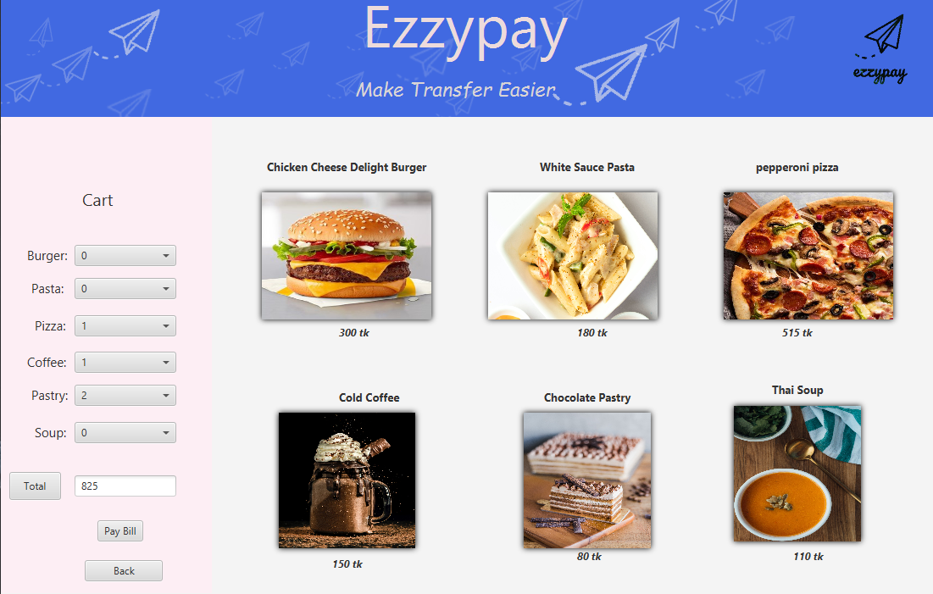 **Figure: Food Zone**

In Cash Out Section user can easily withdraw a certain amount of money using his/ her bank account. For extra layer of security OTP is used.

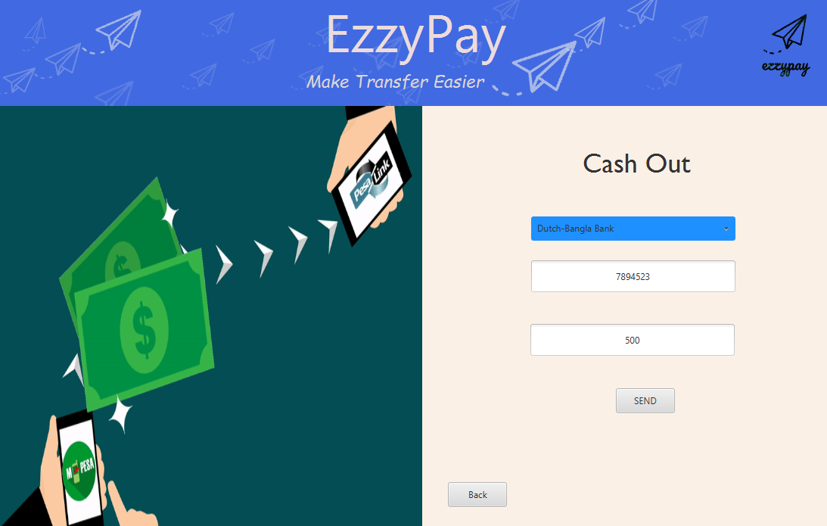

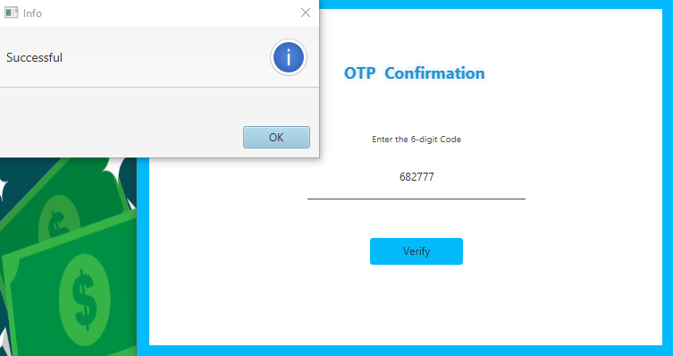

**Figure: Cash Out with OTP**

This is the main interface of Admin Section. From here admin can monitor Business Progress and many more things.

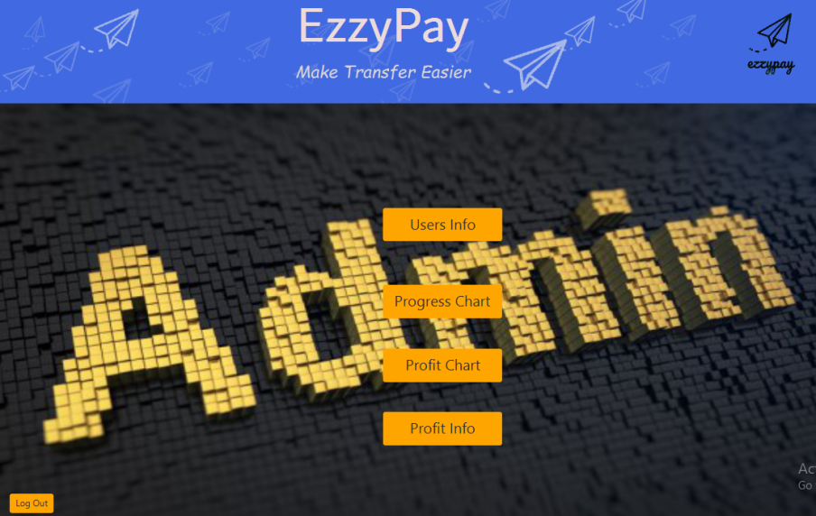

**Figure: Admin Control Panel Interface**

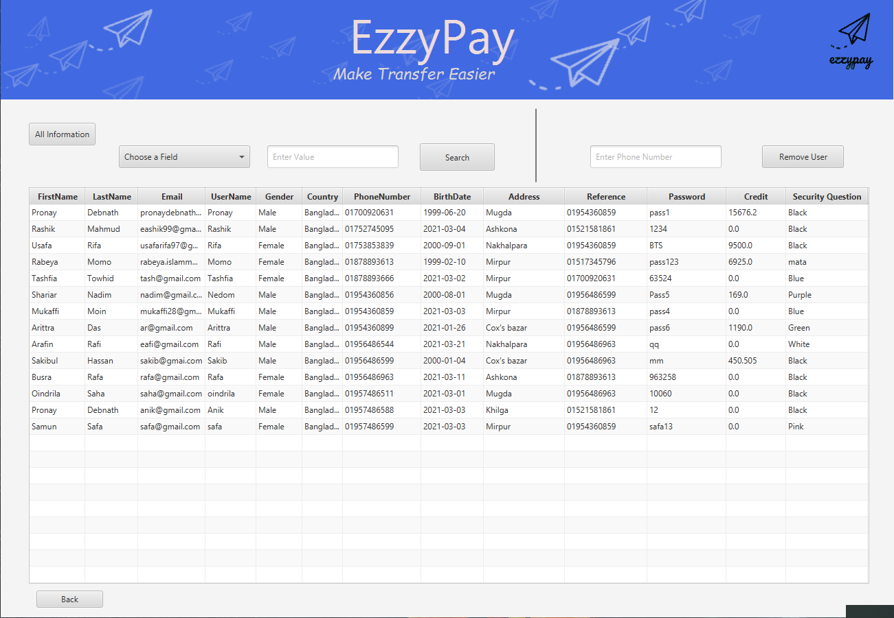

**Figure: Table View of User Information’s**

From these Charts admin can check the whole scenario of their progress of profit where each point of this graph represents the daily profit (Area-Chart) and total Profit (Pie-Chart) of different sector.

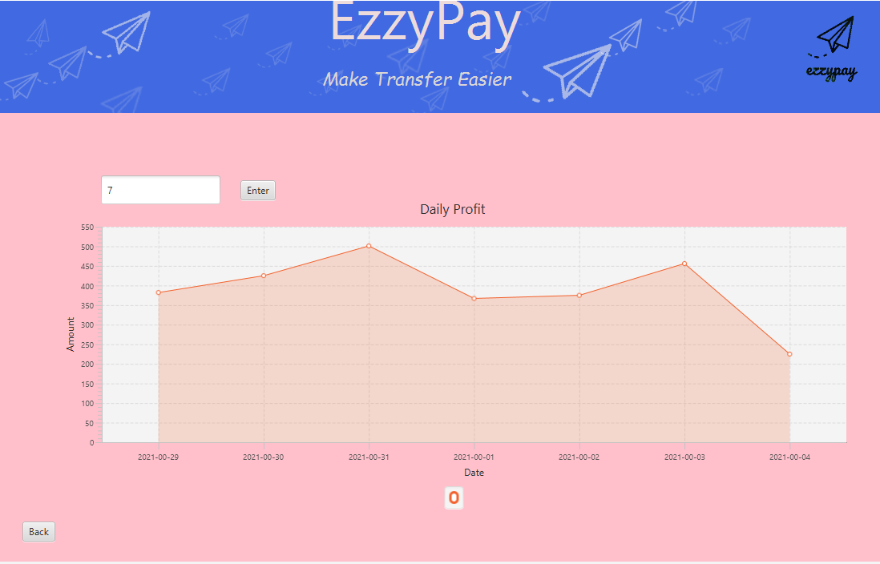

**Figure: Area-Chart of total daily Profit**

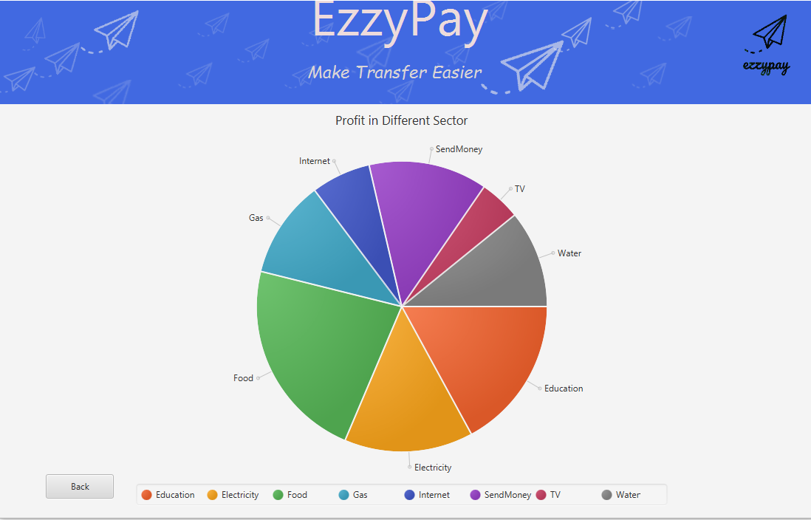

**Figure: Pie Chart of total Profit in Different Sector**

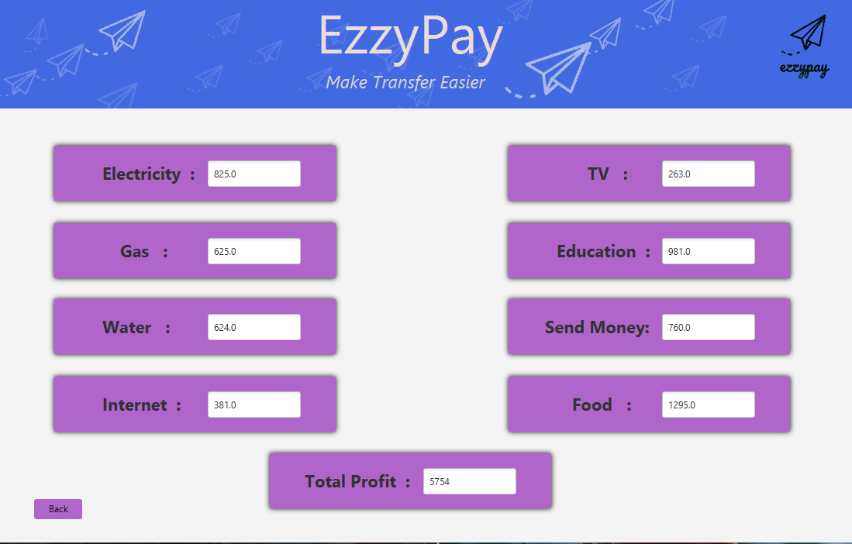

**Figure: Profit in Different Sectors**

**Software Tools:**

● Netbeans 11.2

● Xampp

● Scene Builder

**Java Libraries:**

● mysql-connector-java-5.1.49.jar

● JDK 15.12

● jfoenix-9.0.10.jar

● javafx.graphics.jar

● Javafx.fxml.jar

● javafx.controls.jar

● javafx.base.jar

● javafx-swt.jarWe used JavaFX for Framework. Some libraries of javaFX which we used in our project

are given below:-

● EventHandler

● FXMLLoader

● ActionEvent

● ArrayList Class

**Conclusion:**

In this project, we tried to develop a digital Mobile Based Banking system. Besides mobile banking we provide user different services which makes life easier.