TASK1:
#include <iostream>
#include <string>
using namespace std;

class BoardMarker{
private:
string Company;
string Color;
bool Refillable;
bool InkStatus;

public:
string getCompany(){
return Company;
}
string getColor(){
return Color;
}
bool GetRefillable(){
return Refillable;
}
bool GetInkStatus(){
return InkStatus;
}

void setCompany(string comp){
Company = comp;
}
void setColor(string clr){
Color = clr;
}
void setRefillable(bool refil){
Refillable = refil;
}
void setInkStatus(bool ink){
InkStatus = ink;
}

void Write(){
if (!InkStatus){
cout << "Marker has no ink";
} else{
cout << "Marker is writing on board";
}
}
void Refill(){
if (Refillable){
cout << "Marker is refilled";
} else{
cout << "Marker is not refillable";
}
}

};

int main(){

BoardMarker marker;
marker.setColor("Blue");
marker.setCompany("Dollar");
marker.setRefillable(false);
marker.setInkStatus(true);

cout << "Marker Company: " << marker.getCompany() << endl;
cout << "Marker Color: " << marker.getColor() << endl;
marker.Write();
cout << endl;
marker.Refill();
cout << endl;
return 0;

}

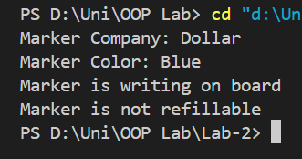
Task2:
#include <iostream>
#include <string>
using namespace std;

class Calender{
private:
int CurrentYear;
string Days[12][31];

public:
void setCurrentYear(int year){
CurrentYear = year;
}
int getCurrentYear(){
return CurrentYear;
}

void AddTask(string TaskDetails, int day, int month){
Days[month-1][day-1] = TaskDetails;
}

void RemoveTask(int day, int month){
Days[month-1][day-1] = "";
}
void ShowTasks(){
for (int i = 0; i < 12; i++){
for (int j = 0; j < 31; j++){
if (Days[i][j] != ""){
cout << " Task: " << Days[i][j] << endl;
}
}
}
}
};

int main(){
Calender myCalender;
myCalender.setCurrentYear(2024);
myCalender.AddTask("Doctor Appointment", 15, 3);
myCalender.AddTask("Meeting with Team", 22, 3);
myCalender.AddTask("Birthday Party", 5, 4);
myCalender.AddTask("Conference", 12, 5);
myCalender.AddTask("Vacation", 20, 6);
myCalender.ShowTasks();
myCalender.RemoveTask(15, 3);
myCalender.RemoveTask(22, 3);
cout << "---After removing a task---" << endl;
myCalender.ShowTasks();
return 0;
}
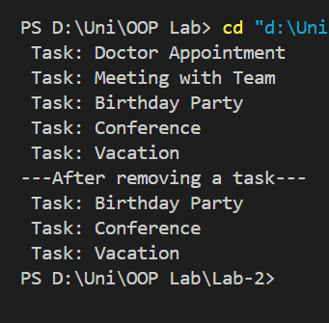
Task3:
#include <iostream>
#include <string>
using namespace std;

class SmartPhone{
private:
string Company;
string Model;
string DisplayResolution;
int RAM;
int ROM;
int Storage;

public:
void setCompany(string comp){
Company = comp;
}
string getCompany(){
return Company;
}

void setModel(string mod){
Model = mod;
}
string getModel(){
return Model;
}

void setDisplayResolution(string res){
DisplayResolution = res;
}
string getDisplayResolution(){
return DisplayResolution;
}

void setRAM(int ram){
RAM = ram;
}
int getRAM(){
return RAM;
}

void setROM(int rom){
ROM = rom;
}
int getROM(){
return ROM;
}

void setStorage(int storage){
Storage = storage;
}
int getStorage(){
return Storage;
}

void MakePhoneCall(){
cout << "making a phone call" << endl;
}
void SendMessage(){
cout << "Sending message" << endl;
}
void ConnectToWifi(){
cout << "Connecting to wifi network: " << endl;
}
void BrowseInternet(){
cout << "Browsing the internet " << endl;
}

};

int main(){

SmartPhone phone;
phone.setCompany("Samsung");
phone.setModel("Galaxy S21");
phone.setDisplayResolution("3200x1440");
phone.setRAM(8);
phone.setROM(256);
phone.setStorage(512);

cout << "Phone Company: " << phone.getCompany() << endl;
cout << "Phone Model: " << phone.getModel() << endl;
cout << "Display Resolution: " << phone.getDisplayResolution() << endl;
cout << "RAM: " << phone.getRAM() << " GB" << endl;
cout << "ROM: " << phone.getROM() << " GB" << endl;
cout << "Storage: " << phone.getStorage() << " GB" << endl;

phone.MakePhoneCall();
phone.SendMessage();
phone.ConnectToWifi();
phone.BrowseInternet();

return 0;

}
