Task2
#include <iostream>
using namespace std;

class WaterBottle{
private:
string company;
string color;
string capacity;
int litres;
int millilitres;

public:
void setCompany(string comp){
company = comp;
}
string getCompany(){
return company;
}
void setColor(string clr){
color = clr;
}
string getColor(){
return color;
}
void setCapacity(string cap){
capacity = cap;
}
string getCapacity(){
return capacity;
}
void setLitres(int lit){
litres = lit;
}
int getLitres(){
return litres;
}
void setMillilitres(int ml){
millilitres = ml;
}
int getMillilitres(){
return millilitres;
}
void updateVolume(int ml){
millilitres -= ml;
litres = millilitres / 1000;

}

};

int main(){

WaterBottle bottle;
bottle.setCompany("Aquafina");
bottle.setColor("Blue");
bottle.setCapacity("1000ml");
bottle.setLitres(1);
bottle.setMillilitres(500);
cout << "Company: " << bottle.getCompany() << endl;
cout << "Color: " << bottle.getColor() << endl;
cout << "Capacity: " << bottle.getCapacity() << endl;
cout << "Litres: " << bottle.getLitres() << " l" << endl;
cout << "Millilitres: " << bottle.getMillilitres() << " ml" << endl;
int drank;
cout << "Enter amount of water drank (in ml): ";
cin >> drank;
bottle.updateVolume(drank);
cout << "Updated Millilitres: " << bottle.getMillilitres() << " ml" << endl;
cout << "Updated Litres: " << bottle.getLitres() << " l" << endl;

}
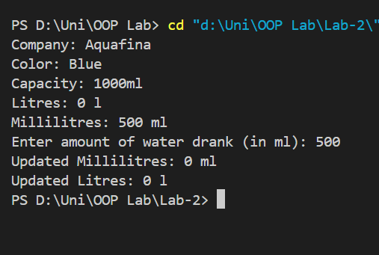
Task5:
#include <iostream>
#include <string>
using namespace std;

class StationaryShop {
private:
string items[100];
double prices[100];
int itemCount;
public:
void setItemCount(int count) {
itemCount = count;
}
void addItem(string item, double price) {
items[itemCount] = item;
prices[itemCount] = price;
itemCount++;
}
void fetchItems() {
cout << "Items in the shop:" << endl;
for (int i = 0; i < itemCount; i++) {
cout << i + 1 << ". " << items[i] << endl;
}
}
void editPrice(int index, double newPrice) {
if (index >= 0 && index < itemCount) {
prices[index] = newPrice;
} else {
cout << "Invalid item index." << endl;
}
}
void viewItemsAndPrices() {
cout << "Items and their prices:" << endl;
for (int i = 0; i < itemCount; i++) {
cout << items[i] << ": " << prices[i] << endl;
}
}
void generateReceipt(int purchasedItems[], int quantities[], int count) {
double total = 0;
cout << "Receipt:" << endl;
for (int i = 0; i < count; i++) {
int index = purchasedItems[i];
double itemTotal = prices[index] * quantities[i];
total += itemTotal;
cout << items[index] << " x" << quantities[i] << " - " << itemTotal << endl;
}
cout << "Total Amount: " << total << endl;
}

};

int main(){
StationaryShop shop;
shop.setItemCount(0);
shop.addItem("Pen", 1.5);
shop.addItem("Notebook", 3.0);
shop.addItem("Eraser", 0.5);

shop.fetchItems();

shop.editPrice(0, 2.0);

shop.viewItemsAndPrices();

int purchasedItems[] = {0, 1};
int quantities[] = {2, 1};
shop.generateReceipt(purchasedItems, quantities, 2);

return 0;

}
