TASK1:
#include <iostream>

using namespace std;

class Mammal{

public:
Mammal(){
cout << "Mammal constructor called" << endl;
}

void mammal_func(){
cout << "I am mammal" << endl;
}

~Mammal(){
cout << "Mammal destructor called" << endl;
}

};

class MarineAnimals{

public:
MarineAnimals(){
cout << "MarineAnimals constructor called" << endl;
}
void marine_func(){
cout << "I am a marine animal" << endl;
}

~MarineAnimals(){
cout << "MarineAnimals destructor called" << endl;
}

};

class BlueWhale: public Mammal, public MarineAnimals{

public:
BlueWhale(){
cout << "BlueWhale constructor called" << endl;
}
void blue_whale_func(){
cout << "I belong to both the categories: Mammals as well as Marine Animals" << endl;
}

~BlueWhale(){
cout << "BlueWhale destructor called" << endl;
}
};

int main(){
Mammal m;
MarineAnimals ma;
BlueWhale bw;

m.mammal_func();
ma.marine_func();
bw.blue_whale_func();
bw.mammal_func();
bw.marine_func();
}
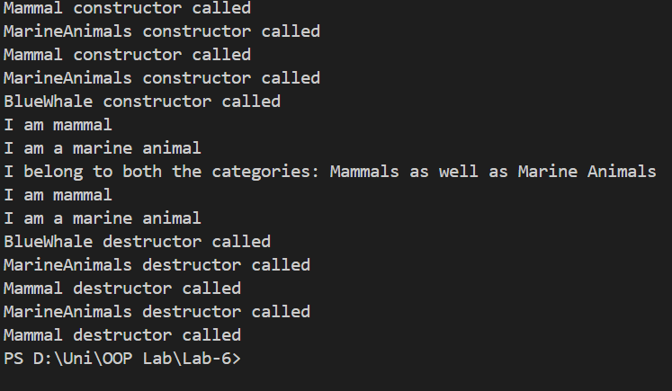
TASK3:
#include <iostream>

using namespace std;

class Animal{
string name;
int age;
public:
Animal(){
cout << "Animal constructor called" << endl;
}
Animal(string n, int a){
name = n;
age = a;
cout << "Animal constructor called" << endl;
}

void set_name(string n){
name = n;
}

void set_age(int a){
age = a;
}

string get_name(){
return name;
}
int get_age(){
return age;
}

void eat(){
cout << name << " is eating" << endl;
}

void sleep(){
cout << name << " is sleeping" << endl;
}
};

class Mammal: virtual public Animal{
private:
string furColor;

public:
Mammal(){

cout << "Mammal constructor called" << endl;
}
Mammal(string n, int a){
set_name(n);
set_age(a);
cout << "Mammal constructor called" << endl;
}

void set_furColor(string color){
furColor = color;
}
string get_furColor(){
return furColor;
}

void give_birth(){
cout << get_name() << " gave birth" << endl;
}

};

class Bird: virtual public Animal{
private:
float wingSpan;

public:
Bird(){
cout << "Bird constructor called" << endl;
}
Bird(string n, int a){
set_name(n);
set_age(a);
cout << "Bird constructor called" << endl;
}

void set_wingSpan(float ws){
wingSpan = ws;
}
float get_wingSpan(){
return wingSpan;
}

void layEggs(){
cout << get_name() << " laid eggs" << endl;
}

};

// Bat: Inherits from both Mammal and Bird, with an additional property
// echolocationCapability and method fly().

class Bat: public Mammal, public Bird{
private:
bool echolocationCapability;

public:
Bat(){
cout << "Bat constructor called" << endl;
}
Bat(string n, int a){
set_name(n);
set_age(a);
cout << "Bat constructor called" << endl;
}

void set_echolocationCapability(bool capability){
echolocationCapability = capability;
}
bool get_echolocationCapability(){
return echolocationCapability;
}

void fly(){
cout << get_name() << " is flying" << endl;
}

};

class Reptile{
string name;
int age;
public:
Reptile(){
cout << "Reptile constructor called" << endl;
}
Reptile(string n, int a){
name = n;
age = a;
cout << "Reptile constructor called" << endl;
}

};

class Snake: public Reptile, public Animal{
private:
bool venomous;

public:
Snake(){
cout << "Snake constructor called" << endl;
}
Snake(string n, int a){
set_name(n);
set_age(a);
cout << "Snake constructor called" << endl;
}

void set_venomous(bool v){
venomous = v;
}
bool get_venomous(){
return venomous;
}

void shedSkin(){
cout << get_name() << " is shedding skin" << endl;
}

};

// Sparrow: A simple class inheriting from Bird. Penguin: Another class inheriting
// from Bird.

class Sparrow: public Bird{
public:
Sparrow(){
cout << "Sparrow constructor called" << endl;
}
Sparrow(string n, int a){
set_name(n);
set_age(a);
cout << "Sparrow constructor called" << endl;
}

void make_sound(){
cout << get_name() << " makes a sound" << endl;
}

};

class Penguin: public Bird{
public:
Penguin(){
cout << "Penguin constructor called" << endl;
}
Penguin(string n, int a){
set_name(n);
set_age(a);
cout << "Penguin constructor called" << endl;
}

void make_sound(){
cout << get_name() << " makes a sound" << endl;
}

};

int main(){

Bat b("Bruce", 5);
b.set_furColor("Black");
b.set_wingSpan(1.5);
b.set_echolocationCapability(true);

cout << "Bat Name: " << b.get_name() << endl;
cout << "Bat Age: " << b.get_age() << endl;
cout << "Bat Fur Color: " << b.get_furColor() << endl;
cout << "Bat Wing Span: " << b.get_wingSpan() << " meters" << endl;
cout << "Bat Echolocation Capability: " << (b.get_echolocationCapability() ? "Yes" : "No") << endl;

b.eat();
b.sleep();
b.fly();
b.give_birth();

Snake s("Slytherin", 3);
s.set_venomous(true);

cout << "\nSnake Name: " << s.get_name() << endl;
cout << "Snake Age: " << s.get_age() << endl;
cout << "Snake Venomous: " << (s.get_venomous() ? "Yes" : "No") << endl;

s.eat();
s.sleep();
s.shedSkin();

}

