TASK1:
#include <iostream>
using namespace std;

class Product{
private:
string name;
string description;
double cost;
int barcode;
int total_stock, items_sold;

public:
Product(){
cout << "Default Constructor called" << endl;
name = "";
description = "";
cost = 0.0;
barcode = 0;
total_stock = 0;
items_sold = 0;
}

Product(string name, string description, double cost, int barcode, int total_stock, int items_sold){
cout << "Parameterized Constructor called" << endl;
this->name = name;
this->description = description;
this->cost = cost;
this->barcode = barcode;
this->total_stock = total_stock;
this->items_sold = items_sold;

}

Product(const Product& obj){
cout << "Copy constructor called" << endl;
if (this != &obj){
name = obj.name;
description = obj.description;
cost = obj.cost;
barcode = obj.barcode;
total_stock = obj.total_stock;
items_sold = obj.items_sold;
}
}
int sellItem(){
printf("Item sold");
total_stock--;
items_sold++;
}
void display(){
cout<<"Name: "<<name<<endl;
cout<<"Description: "<<description<<endl;
cout<<"Cost: "<<cost<<endl;
cout<<"Barcode: "<<barcode<<endl;
cout<<"Total Stock: "<<total_stock<<endl;
cout<<"Items Sold: "<<items_sold<<endl;
}

};

int main(){
Product p1;
Product p2("Mobile","Electronic Gadget", 61000,783621,30,0);
Product p3 = p2;

p2.sellItem();
p2.sellItem();
cout<< "\nProduct1"<<endl;
p1.display();

cout<< "\nProduct2"<<endl;
p2.display();

cout<< "\nProduct3"<<endl;
p3.display();

}
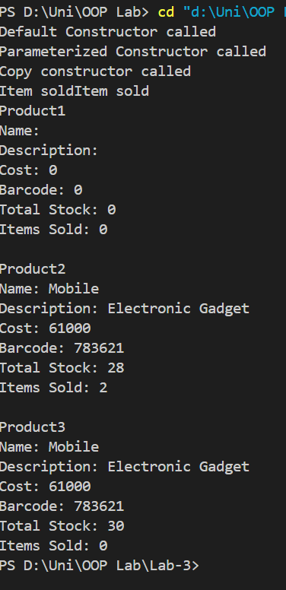

TASK2:
#include <iostream>
using namespace std;

class Office{
private:
string location;
int capacity;

string* furniture;
int furnitureCount;

public:

Office(){

location = "";
capacity = 0;
furniture = nullptr;
furnitureCount = 0;
cout << "Default Constructor called" << endl;
}

Office(string location, int capacity, string* furniture, int furnitureCount){
cout << "Parameterized Constructor called" << endl;
this->location = location;
this->capacity = capacity;
this->furnitureCount = furnitureCount;

this->furniture = new string[furnitureCount];
for(int i = 0; i < furnitureCount; i++){
this->furniture[i] = furniture[i];
}
}
Office(const Office& obj){
cout << "Kopi Constructor\n";
this->location = obj.location;
this->capacity = obj.capacity;
this->furnitureCount = obj.furnitureCount;
this->furniture = new string[furnitureCount];
for (int i=0;i<furnitureCount;i++){
this->furniture[i] = obj.furniture[i];
}
}
void addFurniture(){
string input;
getline(cin >> ws, input);

string* temp = new string[furnitureCount + 1];

for (int i = 0; i < furnitureCount; i++) {
temp[i] = furniture[i];
}

temp[furnitureCount] = input;

delete[] furniture;
furniture = temp;
furnitureCount++;
}

void displayfurniture(){
for (int i=0;i<furnitureCount;i++){
cout << furniture[i] << endl;
}
}

~Office(){
delete[] furniture;
cout << "Destructor called" << endl;
}

};

int main(){
Office o1;
string arr[2] = {"Chairs", "tables"};

Office o2("Karachi",30,arr, 2);
Office o3 = o2;
cout << "_______________________________" << endl;

o3.addFurniture();
o3.addFurniture();
cout << "O2_______________________________" << endl;

o2.displayfurniture();
cout << "O3_______________________________" << endl;
o3.displayfurniture();

}
