Task2
#include <iostream>
#include <string>
using namespace std;

class Customer{
private:
int id;
string name;
float balance;

public:
Customer(){}
Customer(int id, string name, float balance){
createAccount(id,name,balance);

}

void createAccount(int id, string name, float balance){
this->id = id;
this->name = name;
this->balance= balance;
cout << "Account created for: " << name << endl;
}

void updateAccount(int id, string name, float balance){
this->id = id;
this->name = name;
this->balance= balance;
cout << "Account updated" << endl;

}
~Customer(){
cout << "Destructor of Customer" << endl;
}

};

class MenuItem{
private:
string* name;
string description;
int* price;

public:
MenuItem(string n, string d, int p){
name = new string(n);
description = d;
price = new int(p);
}
~MenuItem(){
delete name;
delete price;
cout << "Destructor for MenuItem" << endl;
}
void display() const {
cout << "Item: " << *name << endl;
cout << "Description: " << description << endl;
cout << "Price: " << *price << endl;
}

string getName() const {
return *name;
}
void setName(string n) {
*name = n;
}
string getDescription() const {
return description;
}
void setDescription(string d) {
description = d;
}
int getPrice() const {
return *price;
}
void setPrice(int p) {
*price = p;
}

};

int main(){
Customer c1(1,"Usaim",1000);
Customer c2(2,"Ali",500);

MenuItem m1("Ice cream", "Dessert", 200);
MenuItem m2("Pizza", "Main course", 500);
MenuItem m3("Coke", "Beverage", 100);
MenuItem m4("Burger", "Fast food", 300);
MenuItem m5("Pasta", "Italian cuisine", 400);

MenuItem array[5] = {m1,m2,m3,m4,m5};

cout << "Item names" << endl;

for (int i = 0; i < 4;i++){
cout << i+1 << "- " <<array[i].getName() << endl;

}
int n;
cout << "Enter choice: ";
cin >> n;
cout << "You chose: ";
array[n-1].display();

cout << "Press 9 to see special meanu item: ";
cin >> n;
if (n == 9){
array[4].display();
}

cout << "Displaying all items:" << endl << endl ;
for (int i =0 ;i<5; i++){
array[i].display();
}

}
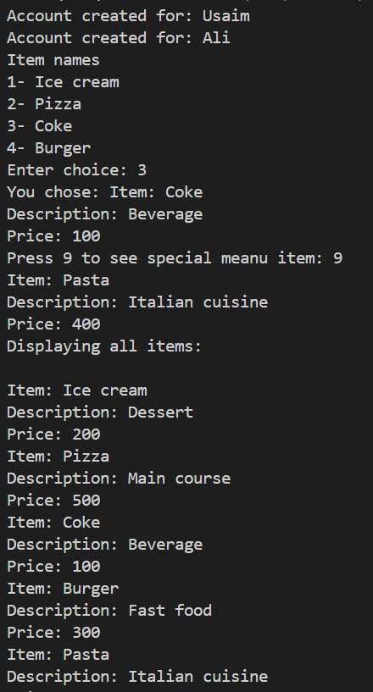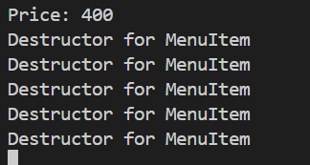
Task3:
#include <iostream>
#include <string>
using namespace std;

class Reservation {
private:
string renterName, carModel, rentalStartDate, rentalEndDate;
int reservationNumber;
float rentalRate;

public:
static int totalReservations;
static const int maxReservations = 3;

Reservation() : reservationNumber(0), rentalRate(0.0f) {}

Reservation(string renterName, string carModel,
string rentalStartDate, string rentalEndDate,
float rentalRate)
{
this->renterName = renterName;
this->carModel = carModel;
this->rentalStartDate = rentalStartDate;
this->rentalEndDate = rentalEndDate;
this->rentalRate = rentalRate;

totalReservations++;
reservationNumber = totalReservations;
}

static bool canCreate() {
return totalReservations < maxReservations;
}

void display() const {
cout << "Reservation Number: " << reservationNumber << endl;
cout << "Renter Name: " << renterName << endl;
cout << "Car Model: " << carModel << endl;
cout << "Start Date: " << rentalStartDate << endl;
cout << "End Date: " << rentalEndDate << endl;
cout << "Rate: " << rentalRate << endl;
cout << "--------------------------" << endl;
}
};

int Reservation::totalReservations = 0;

int main() {
Reservation reservations[Reservation::maxReservations];
int count = 0;

while (Reservation::canCreate()) {
reservations[count] = Reservation(
"John Doe",
"Toyota Camry",
"2024-07-01",
"2024-07-10",
50.0f
);

reservations[count].display();
count++;
}

cout << "Total Reservations: "
<< Reservation::totalReservations << endl;

return 0;
}

