TASK1:
#include <iostream>
#include <string>
using namespace std;

class Novel{
private:
string title;
string author;
int cost;

public:
Novel(){}
Novel(string t, string a, int c){
title = t;
author = a;
cost = c;
}
~Novel(){
cout << "Destructor for Novel" << endl;
}
void display() const {
cout << "Title: " << title << endl;
cout << "Author: " << author << endl;
cout << "Cost: " << cost << endl;
}
};

int main(){
Novel array[3] = {
Novel("The Great Gatsby", "F. Scott Fitzgerald", 10),
Novel("To Kill a Mockingbird", "Harper Lee", 12),
Novel("1984", "George Orwell", 15)
};

cout << "Displaying all novels:" << endl << endl ;
for (int i =0 ;i<3; i++){
array[i].display();
}
return 0;

}
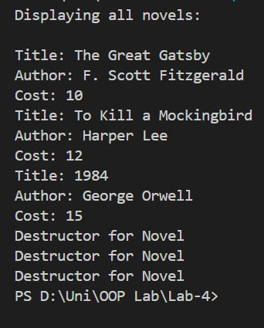
TASK4:
#include <iostream>
#include <string>
using namespace std;

class Event {
private:
string eventName;
int eventID;
string date;
string time;
string venue;
string category;

public:
static int totalEvents;
static const int maxEvents = 3;

Event() : eventID(0) {}
Event(string eventName, int eventID,
string date, string time,
string venue, string category)
{
this->eventName = eventName;
this->eventID = eventID;
this->date = date;
this->time = time;
this->venue = venue;
this->category = category;

totalEvents++;
}

~Event() {
cout << "Destructor for Event: " << eventName << endl;
}

static bool canAddEvent() {
return totalEvents < maxEvents;
}

void display() const {
cout << "Event Name: " << eventName << endl;
cout << "Event ID: " << eventID << endl;
cout << "Date: " << date << endl;
cout << "Time: " << time << endl;
cout << "Venue: " << venue << endl;
cout << "Category: " << category << endl;
cout << "---------------------------" << endl;
}
};

int Event::totalEvents = 0;

int main() {
Event events[Event::maxEvents];
int count = 0;

if (Event::canAddEvent()) {
events[count++] = Event("Tech Conference", 101,
"2024-08-10", "10:00 AM",
"Expo Center", "Technology");
}

if (Event::canAddEvent()) {
events[count++] = Event("Music Concert", 102,
"2024-09-01", "07:00 PM",
"City Stadium", "Entertainment");
}

if (Event::canAddEvent()) {
events[count++] = Event("Art Exhibition", 103,
"2024-09-15", "11:00 AM",
"Art Gallery", "Culture");
}

if (!Event::canAddEvent()) {
cout << "Maximum number of events reached." << endl;
}

cout << "\nEvent Details:\n";
for (int i = 0; i < count; i++) {
events[i].display();
}

cout << "Total Events: " << Event::totalEvents << endl;

return 0;
}

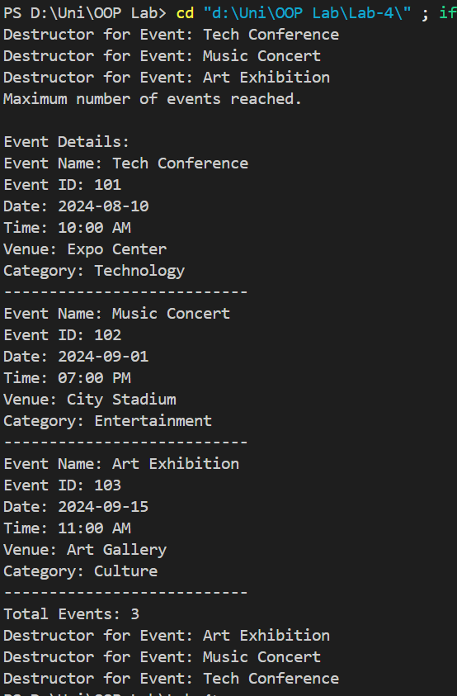

TASK5:
#include <iostream>
using namespace std;

class BankAccount{
private:
int accNum;
string accname;
double balance;
const double minBalance;

public:
static int TotalAccounts;

BankAccount(): minBalance(1000) {}
BankAccount(int num, string n, double bal):minBalance(1000){
if (bal < minBalance){
cout << "Initial balance is less than minimum balance. account not created." << endl;
accNum = 0;
accname = "";
balance = 0;
} else {
accNum = num;
accname = n;
balance = bal;
TotalAccounts++;
}

}

~BankAccount(){
cout << "Destructor for Account" << endl;
}

void display() const {
cout << "Account Number: " << accNum << endl;
cout << "Account Name: " << accname << endl;
cout << "Balance: " << balance << endl;
cout << "---------------------------" << endl;
}

};

int BankAccount::TotalAccounts = 0;

int main(){
BankAccount accounts[3] = {
BankAccount(101, "Alice", 1500),
BankAccount(102, "Bob", 1000),
BankAccount(103, "Charlie", 2000)
};

for (int i = 0; i < 3; i++) {
accounts[i].display();
}

BankAccount acc4(104, "David", 900);
BankAccount acc5(105, "Eve", 1200);

acc4.display();
acc5.display();
cout << "Total Accounts Created: " << BankAccount::TotalAccounts << endl;

return 0;

}

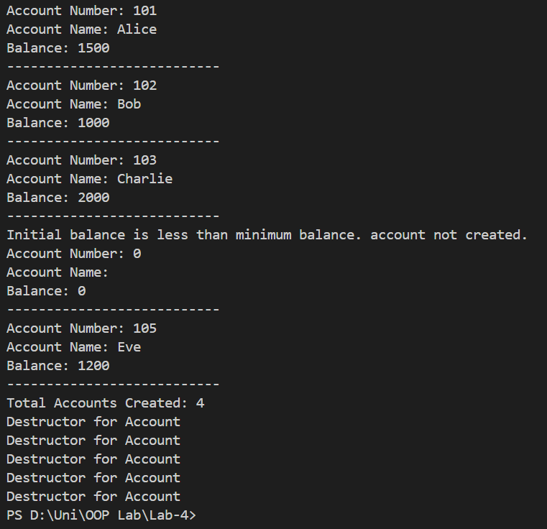
TASK6:
#include <iostream>
using namespace std;

class Book{
private:
int id;
string title;
string author;
double price;
const int maxBooks;
public:
static int totalBooks;

Book(): maxBooks(5) {}
Book(int i, string t, string a, double p): maxBooks(5){
if (totalBooks < maxBooks){
id = i;
title = t;
author = a;
price = p;
totalBooks++;
} else {
cout << "Maximum number of books reached. Book not created." << endl;
id = 0;
title = "";
author = "";
price = 0.0;
}
}
~Book(){
cout << "Destructor for Book" << endl;
}
void display() const {
cout << "Book ID: " << id << endl;
cout << "Title: " << title << endl;
cout << "Author: " << author << endl;
cout << "Price: $" << price << endl;
cout << "---------------------------" << endl;
}

};

int Book::totalBooks = 0;

int main(){
Book books[6] = {
Book(1, "The Great Gatsby", "F. Scott Fitzgerald", 10.99),
Book(2, "To Kill a Mockingbird", "Harper Lee", 8.99),
Book(3, "1984", "George Orwell", 9.99),
Book(4, "Pride and Prejudice", "Jane Austen", 7.99),
Book(5, "The Catcher in the Rye", "J.D. Salinger", 6.99)

};

for (int i = 0; i < 5; i++) {
books[i].display();
}

Book book6(6, "The Alchemist", "Paulo Coelho", 12.99);
book6.display();
cout << "Total Books Created: " << Book::totalBooks << endl;

}
