Q1:
#include <iostream>
#include <string>

template<typename T1, typename T2, typename T3>
class Product {
public:
T1 ID;
T2 name;
T3 price;

Product() {}
Product(T1 id, T2 n, T3 p) : ID(id), name(n), price(p) {}
};

template<typename T1, typename T2, typename T3>
class Stock {
private:
Product<T1, T2, T3>* products;
int size;

public:
Stock(int s) : size(s) {
products = new Product<T1, T2, T3>[size];
}

~Stock() {
delete[] products;
}

void addProduct(int index, T1 id, T2 name, T3 price) {
if (index >= 0 && index < size) {
products[index] = Product<T1, T2, T3>(id, name, price);
}
}

T3 calculateTotalCost(int quantity) {
T3 total = T3(0);
for (int i = 0; i < size; ++i) {
total += products[i].price * quantity;
}
return total;
}
};

int main() {
Stock<int, std::string, double> stock(3);

stock.addProduct(0, 1, "Product1", 10.0);
stock.addProduct(1, 2, "Product2", 20.0);
stock.addProduct(2, 3, "Product3", 30.0);

int quantity = 5;
double totalCost = stock.calculateTotalCost(quantity);

std::cout << "Total cost of the products: " << totalCost << std::endl;

return 0;
}

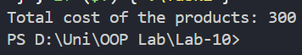

Q2:
#include <iostream>
#include <vector>
#include <stdexcept>
using namespace std;

class Theater;

class Seat {
private:
int row;
int seatNumber;
bool reserved;

void reserve() {
if (reserved)
throw runtime_error("Seat already reserved.");
reserved = true;
}

void cancelReservation() {
if (!reserved)
throw runtime_error("Seat is not reserved.");
reserved = false;
}

bool getStatus() const {
return reserved;
}

public:
Seat(int r = 0, int s = 0) : row(r), seatNumber(s), reserved(false) {}

friend class Theater
};

class Theater {
private:
vector<vector<Seat>> seats;
int numRows;
int numSeatsPerRow;

bool isValidSeat(int row, int seat) {
return (row >= 0 && row < numRows &&
seat >= 0 && seat < numSeatsPerRow);
}

public:
void initializeSeats(int rows, int seatsPerRow) {
numRows = rows;
numSeatsPerRow = seatsPerRow;

seats.resize(rows);
for (int i = 0; i < rows; i++) {
seats[i].reserve(seatsPerRow);
for (int j = 0; j < seatsPerRow; j++) {
seats[i].emplace_back(i, j);
}
}
}

void viewAvailableSeats() {
cout << "\nSeating Chart (O = Available, X = Reserved)\n";
for (int i = 0; i < numRows; i++) {
for (int j = 0; j < numSeatsPerRow; j++) {
cout << (seats[i][j].getStatus() ? "X " : "O ");
}
cout << endl;
}
}

void reserve(int row, int seat) {
if (!isValidSeat(row, seat))
throw out_of_range("Invalid seat position.");

seats[row][seat].reserve();
cout << "Seat reserved successfully.\n";
}

void cancelReservation(int row, int seat) {
if (!isValidSeat(row, seat))
throw out_of_range("Invalid seat position.");

seats[row][seat].cancelReservation();
cout << "Reservation cancelled successfully.\n";
}
};

int main() {
Theater theater;
theater.initializeSeats(5, 6);

int choice, row, seat;

while (true) {
cout << "\n1. View Seats\n2. Reserve Seat\n3. Cancel Reservation\n4. Exit\nChoice: ";
cin >> choice;

try {
if (choice == 1) {
theater.viewAvailableSeats();
}
else if (choice == 2) {
cout << "Enter row and seat (0-based index): ";
cin >> row >> seat;
theater.reserve(row, seat);
}
else if (choice == 3) {
cout << "Enter row and seat (0-based index): ";
cin >> row >> seat;
theater.cancelReservation(row, seat);
}
else if (choice == 4) {
break;
}
else {
cout << "Invalid choice.\n";
}
}
catch (exception& e) {
cout << "Error: " << e.what() << endl;
}

theater.viewAvailableSeats();
}

return 0;
}
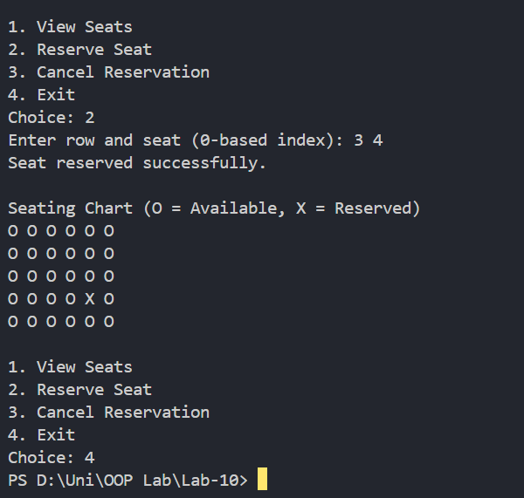
Q3:
#include <iostream>
using namespace std;

class Event {
protected:
string name;
string date;
string venue;

public:
Event(string n, string d, string v) {
name = n;
date = d;
venue = v;
}

virtual double calculateTicketPrice(int tier) = 0;
virtual double calculateTicketPrice(bool isSpeaker) = 0;
virtual double calculateTicketPrice(string category) = 0;

virtual void display() {
cout << "\nEvent: " << name
<< "\nDate: " << date
<< "\nVenue: " << venue << endl;
}

virtual ~Event() {}
};

class Concert : public Event {
public:
Concert(string n, string d, string v) : Event(n, d, v) {}

double calculateTicketPrice(int tier) override {
if (tier == 1) return 5000;
else if (tier == 2) return 3000;
else return 1500;
}

double calculateTicketPrice(bool) override { return 0; }
double calculateTicketPrice(string) override { return 0; }
};

class Conference : public Event {
public:
Conference(string n, string d, string v) : Event(n, d, v) {}

double calculateTicketPrice(bool isSpeaker) override {
if (isSpeaker) return 0;
else return 2000;
}

double calculateTicketPrice(int) override { return 0; }
double calculateTicketPrice(string) override { return 0; }
};

class Exhibition : public Event {
public:
Exhibition(string n, string d, string v) : Event(n, d, v) {}

double calculateTicketPrice(string category) override {
if (category == "Adult") return 1000;
else if (category == "Student") return 500;
else return 300;
}

double calculateTicketPrice(int) override { return 0; }
double calculateTicketPrice(bool) override { return 0; }
};

int main() {
Event* events[3];

events[0] = new Concert("Rock Concert", "10-May-2026", "GlobaArena");
events[1] = new Conference("Business Conference", "15-May-2026", "GlobaArena");
events[2] = new Exhibition("Art Exhibition", "20-May-2026", "GlobaArena");

for (int i = 0; i < 3; i++) {
events[i]->display();

if (i == 0) {
cout << "Ticket Price (Tier 1): "
<< events[i]->calculateTicketPrice(1) << endl;
}
else if (i == 1) {
cout << "Ticket Price (Attendee): "
<< events[i]->calculateTicketPrice(false) << endl;
}
else if (i == 2) {
cout << "Ticket Price (Student): "
<< events[i]->calculateTicketPrice("Student") << endl;
}
}

for (int i = 0; i < 3; i++) {
delete events[i];
}

return 0;
}
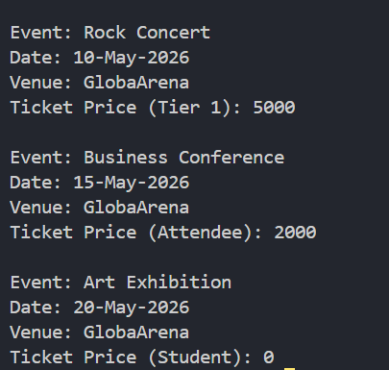
Q4:
#include <iostream>
#include <stdexcept>
using namespace std;

int main() {
double balance = 10000.0;
double amount;

cout << "Current Balance: " << balance << endl;
cout << "Enter payment amount: ";

try {
if (!(cin >> amount)) {
throw invalid_argument("Invalid input! Please enter a numeric value.");
}

if (amount < 0) {
throw runtime_error("Payment amount cannot be negative.");
}

if (amount > balance) {
throw out_of_range("Insufficient balance for this payment.");
}

balance -= amount;
cout << "Payment successful!" << endl;
cout << "Remaining Balance: " << balance << endl;
}

catch (invalid_argument& e) {
cout << "Error: " << e.what() << endl;
}
catch (runtime_error& e) {
cout << "Error: " << e.what() << endl;
}
catch (out_of_range& e) {
cout << "Error: " << e.what() << endl;
}
catch (...) {
cout << "Unknown error occurred." << endl;
}

return 0;
}
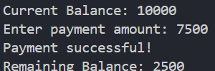
Q5:
#include <iostream>
#include <string>
#include <stdexcept>
using namespace std;

template <typename T>
class Product {
private:
int id;
string name;
T price;
int stock;

public:
Product() : id(0), name(""), price(T()), stock(0) {}
Product(int id, const string &name, T price, int stock)
: id(id), name(name), price(price), stock(stock) {}

int getId() const { return id; }
string getName() const { return name; }
T getPrice() const { return price; }
int getStock() const { return stock; }
void setStock(int value) { stock = value; }

void display() const {
cout << "ID: " << id
<< ", Name: " << name
<< ", Price: " << price
<< ", Stock: " << stock << '\n';
}
};

template <typename T>
class Order {
private:
Product<T> *products;
int capacity;

public:
Order(int size) : capacity(size) {
if (size <= 0) {
throw invalid_argument("Inventory size must be positive");
}
products = new Product<T>[capacity];
}

~Order() {
delete[] products;
}

void addProduct(int index, const Product<T> &product) {
if (index < 0 || index >= capacity) {
throw out_of_range("Product index is invalid");
}
products[index] = product;
}

void displayStock() const {
cout << "Available bakery stock:\n";
for (int i = 0; i < capacity; ++i) {
if (products[i].getId() != 0) {
products[i].display();
}
}
cout << "\n";
}

T placeOrder(int productId, int quantity) {
try {
if (quantity <= 0) {
throw invalid_argument("Quantity must be greater than zero");
}

int index = -1;
for (int i = 0; i < capacity; ++i) {
if (products[i].getId() == productId) {
index = i;
break;
}
}

if (index == -1) {
throw invalid_argument("Product ID not found");
}

Product<T> &product = products[index];
if (quantity > product.getStock()) {
throw runtime_error("Requested quantity exceeds available stock");
}

int remainingStock = product.getStock() - quantity;
product.setStock(remainingStock);
T totalBill = product.getPrice() * quantity;

cout << "Order placed successfully for product '"
<< product.getName() << "'\n";
cout << "Quantity: " << quantity << ", Total bill: " << totalBill << "\n";
return totalBill;
}
catch (const out_of_range &ex) {
cout << "Error: " << ex.what() << "\n";
}
catch (const invalid_argument &ex) {
cout << "Invalid argument: " << ex.what() << "\n";
}
catch (const runtime_error &ex) {
cout << "Runtime error: " << ex.what() << "\n";
}
catch (...) {
cout << "An unexpected error occurred while placing the order." << "\n";
}
return T();
}
};

int main() {
try {
Order<double> bakery(5);

bakery.addProduct(0, Product<double>(101, "Chocolate Croissant", 2.75, 15));
bakery.addProduct(1, Product<double>(102, "Blueberry Muffin", 1.95, 20));
bakery.addProduct(2, Product<double>(103, "Sourdough Bread", 4.50, 10));
bakery.addProduct(3, Product<double>(104, "Cinnamon Roll", 3.20, 12));
bakery.addProduct(4, Product<double>(105, "Banana Bread", 3.80, 8));

bakery.displayStock();

cout << "Customer order 1:\n";
bakery.placeOrder(102, 3);
bakery.displayStock();

cout << "Customer order 2:\n";
bakery.placeOrder(103, 12);
bakery.displayStock();

cout << "Customer order 3:\n";
bakery.placeOrder(107, 2);
bakery.displayStock();

cout << "Customer order 4:\n";
bakery.placeOrder(104, 0);
bakery.displayStock();
}
catch (const exception &ex) {
cout << "Initialization failed: " << ex.what() << "\n";
}

return 0;
}

