TASK4:
#include <iostream>
using namespace std;

class Customer{
private:
string name, phoneNumber;

public:
Customer(string n, string num){
name = n;
phoneNumber = num;

}
Customer(){
name= "";
phoneNumber = "";
}

void setName(string n){
name = n;
}
void setPhoneNumber(string num){
phoneNumber = num;
}
string getName(){
return name;
}
string getPhoneNumber(){
return phoneNumber;
}
void display(){
cout << "Name: " << name << endl;
cout << "Phone Number: " << phoneNumber << endl;
}

};

class BankAccount{
private:
int accNum;
float balance;
Customer* accHolder;
public:
BankAccount(int a, float b, Customer* ptr):accNum(a),balance(b){
accHolder = ptr;
}

void Deposit(double m){
balance +=m;
cout << "Money deposited " << endl;
}

void withdraw(double m){
if (balance<m){
cout << "Balance is less than withdraw amount" << endl;
return;
}
balance-=m;
cout << "Money withdrawn " << endl;
}
void display(){
cout << "Account Number: " << accNum << endl;
cout << "Balance: " << balance << endl;
cout << "Account Holder: " << endl;
accHolder->display();
}

};

int main(){

Customer c1("John Doe", "123-456-7890");
Customer c2("Jane Smith", "987-654-3210");
Customer c3("Alice Johnson", "555-123-4567");

BankAccount accounts[3] = {
BankAccount(1001, 5000.0, &c1),
BankAccount(1002, 3000.0, &c2),
BankAccount(1003, 7000.0, &c3)
};

for (int i = 0; i < 3; i++) {
cout << "Account " << i + 1 << ":" << endl;
accounts[i].display();
cout << endl;
}

for (int i = 0; i < 3; i++) {
cout << "Depositing 500 into Account " << i + 1 << endl;
accounts[i].Deposit(500.0);
cout << "Withdrawing 200 from Account " << i + 1 << endl;
accounts[i].withdraw(200.0);
cout << endl;
}

cout << "Updated Account Details:" << endl;
for(int i =0; i<3; i++){
cout << "Account " << i + 1 << ":" << endl;
accounts[i].display();
cout << endl;
}

}

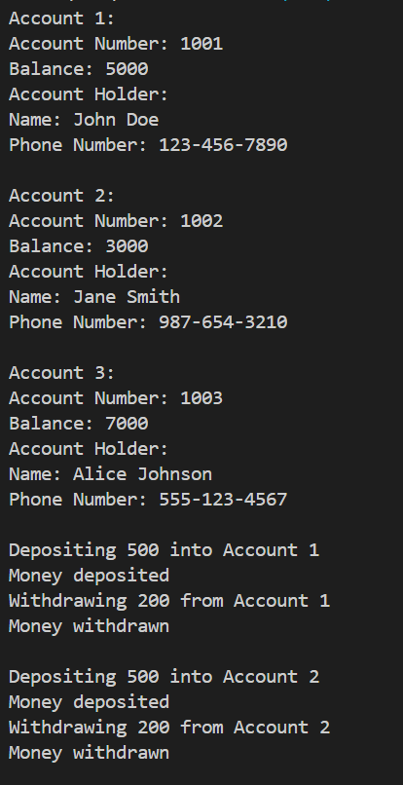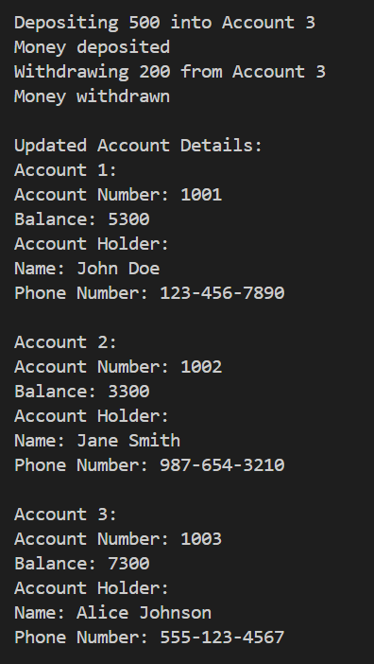
TASK5:
#include <iostream>
using namespace std;

class Engine{
private:
string type;
int hp;

public:
Engine(string t, int h){
type = t;
hp = h;
}
Engine(){
type = "";
hp = 0;
}
void setType(string t){
type = t;
}
void setHp(int h){
hp = h;
}
string getType(){
return type;
}
int getHp(){
return hp;
}
void display(){
cout << "Engine Type: " << type << endl;
cout << "Horse Power: " << hp << endl;
}

};
class Wheel{
private:
int size;

public:
Wheel(int s){
size = s;
}
Wheel(){
size = 0;
}
void setSize(int s){
size = s;
}
int getSize(){
return size;
}
void display(){
cout << "Wheel Size: " << size << endl;
}

};
class Headlight{
private:
string type;
public:
Headlight(string t){
type = t;
}
Headlight(){
type = "";
}
void setType(string t){
type = t;
}
string getType(){
return type;
}
void display(){
cout << "Headlight Type: " << type << endl;
}

};
class Steering{
private:
string type;

public:
Steering(string t){
type = t;
}
Steering(){
type = "";
}
void setType(string t){
type = t;
}
string getType(){
return type;
}
void display(){
cout << "Steering Type: " << type << endl;
}

};

class Car{
private:
Engine engine;
Wheel wheels[4];
Headlight headlights[2];
Steering steering;
string* GPS;

public:
Car(Engine e, Wheel w[4], Headlight h[2], Steering s, string* gps):engine(e),steering(s){
for (int i = 0; i < 4; i++){
wheels[i] = w[i];
}
for (int i = 0; i < 2; i++){
headlights[i] = h[i];
}
GPS = gps;
}

void setGPS(string* ptr){
GPS = ptr;
}

void display(){
cout << "Car Details: " << endl;
engine.display();
for (int i = 0; i < 4; i++){
wheels[i].display();
}
for (int i = 0; i < 2; i++){
headlights[i].display();
}
steering.display();
cout << "GPS: " << *GPS << endl;
}

};

int main(){
Engine e("V8", 500);
Wheel w[4] = {Wheel(18), Wheel(18), Wheel(18), Wheel(18)};
Headlight h[2] = {Headlight("LED"), Headlight("LED")};
Steering s("Power");
string gps = "Google Maps";

Car car(e, w, h, s, &gps);
car.display();

}
