TASK2:
#include <iostream>
#include <string>
using namespace std;

class Order {
private:
string items[100];
double prices[100];
int num_items;

public:
static int total_orders;

Order() {
num_items = 0;
total_orders++;
}

void add_item(string item_name, double item_price) {
items[num_items] = item_name;
prices[num_items] = item_price;
num_items++;
}

void add_item(string item_name, string size, bool milk, double item_price) {

if(size == "small")
item_price = 2.00;
else if(size == "medium")
item_price = 3.00;
else if(size == "large")
item_price = 4.00;

if(milk)
item_price += 0.50;

items[num_items] = item_name + " (" + size + ")";
prices[num_items] = item_price;
num_items++;
}

void add_item(string item_name, double item_price, int quantity) {
double total_price = item_price * quantity;

items[num_items] = item_name + " x" + to_string(quantity);
prices[num_items] = total_price;
num_items++;
}

void display_order() {
cout << "Order Items:\n";
for(int i = 0; i < num_items; i++) {
cout << items[i] << " - $" << prices[i] << endl;
}
}
};

int Order::total_orders = 0;

int main() {

Order o1;

o1.add_item("Croissant", 2.5);
o1.add_item("Coffee", "medium", true, 0);
o1.add_item("Tea", 1.5, 3);

o1.display_order();

cout << "Total Orders: " << Order::total_orders << endl;

return 0;
}
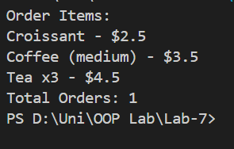

TASK3:
#include <iostream>
#include <string>
using namespace std;

class Book {
protected:
string title;
string author;
int year;

public:
Book(string t, string a, int y) {
title = t;
author = a;
year = y;
}

virtual void display() const {
cout << "Title: " << title << endl;
cout << "Author: " << author << endl;
cout << "Publication Year: " << year << endl;
}
};

class ReferenceBook : public Book {
private:
string topic;

public:
ReferenceBook(string t, string a, int y, string tp)
: Book(t, a, y) {
topic = tp;
}

void display() const override {
Book::display();
cout << "Topic: " << topic << endl;
}
};

int main() {

ReferenceBook r1("Data Structures Handbook", "John Smith", 2018, "Algorithms");
r1.display();

return 0;
}
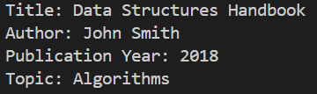

TASK4:
#include <iostream>
using namespace std;

class Enemy {
public:
virtual void attack() {
cout << "Enemy attacks!" << endl;
}
};

class Dragon : public Enemy {
public:
void attack() override {
cout << "Dragon breathes fire!" << endl;
}
};

class Goblin : public Enemy {
public:
void attack() override {
cout << "Goblin attacks with a dagger!" << endl;
}
};

class Troll : public Enemy {
public:
void attack() override {
cout << "Troll swings a giant club!" << endl;
}
};

int main() {

Enemy* enemies[3];

enemies[0] = new Dragon();
enemies[1] = new Goblin();
enemies[2] = new Troll();

for(int i = 0; i < 3; i++) {
enemies[i]->attack();
}

for(int i = 0; i < 3; i++) {
delete enemies[i];
}

return 0;
}
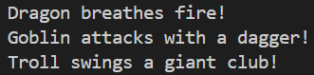

TASK5:
#include <iostream>
using namespace std;

class Vehicle {
public:
virtual void startEngine() {
cout << "Vehicle engine starting..." << endl;
}

virtual void stopEngine() {
cout << "Vehicle engine stopping..." << endl;
}

virtual ~Vehicle() {}
};

class Car : public Vehicle {
public:
void startEngine() override {
cout << "Car engine starts with ignition key." << endl;
}

void stopEngine() override {
cout << "Car engine stops when key is turned off." << endl;
}
};

class Motorcycle : public Vehicle {
public:
void startEngine() override {
cout << "Motorcycle engine starts with electric starter." << endl;
}

void stopEngine() override {
cout << "Motorcycle engine stops with kill switch." << endl;
}
};

class HybridCar : public Vehicle {
public:
void startEngine() override {
cout << "HybridCar starts using electric motor and gasoline engine." << endl;
}

void stopEngine() override {
cout << "HybridCar shuts down electric system and fuel engine." << endl;
}
};

class Hoverbike : public Vehicle {
public:
void startEngine() override {
cout << "Hoverbike activates anti-gravity propulsion system." << endl;
}

void stopEngine() override {
cout << "Hoverbike deactivates hover propulsion and lands safely." << endl;
}
};

int main() {

Vehicle* vehicles[4];

vehicles[0] = new Car();
vehicles[1] = new Motorcycle();
vehicles[2] = new HybridCar();
vehicles[3] = new Hoverbike();

for(int i = 0; i < 4; i++) {
vehicles[i]->startEngine();
vehicles[i]->stopEngine();
cout << endl;
}

for(int i = 0; i < 4; i++) {
delete vehicles[i];
}

return 0;
}
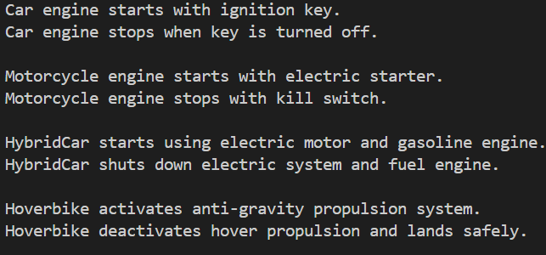
TASK6:
#include <iostream>
using namespace std;

class Animal {
public:
virtual void move() {
cout << "Animal moves in a general way." << endl;
}

virtual void makeSound() {
cout << "Animal makes a generic sound." << endl;
}

virtual ~Animal() {}
};

class Bird : public Animal {
public:
void move() override {
cout << "Bird flies through the sky." << endl;
}

void makeSound() override {
cout << "Bird chirps." << endl;
}
};

class Panthera : public Animal {
public:
void move() override {
cout << "Panthera walks stealthily on the ground." << endl;
}

void makeSound() override {
cout << "Panthera roars loudly." << endl;
}
};

int main() {

Animal* animals[2];

animals[0] = new Bird();
animals[1] = new Panthera();

for(int i = 0; i < 2; i++) {
animals[i]->move();
animals[i]->makeSound();
cout << endl;
}

for(int i = 0; i < 2; i++) {
delete animals[i];
}

return 0;
}
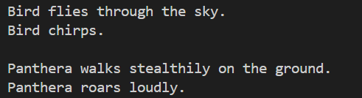
TASK7:
#include <iostream>
using namespace std;

class Shape {
public:
void calculateArea() {
cout << "Calculating area of Shape" << endl;
}
};

class Rectangle : public Shape {
public:
void calculateArea() {
cout << "Calculating area of Rectangle" << endl;
}
};

int main() {

Shape* s;
Rectangle r;

s = &r;

s->calculateArea();

return 0;
}

