GridNexus
Smart Decentralized Power Grid Simulation

Final Project Report — Object-Oriented Programming

FAST NUCES(Karachi)
Section: BCS-2J | Instructor: Ms. Zainab Asif

Submitted By:
Anonymous
Anonymous
27 April 2026

Abstract
GridNexus is a comprehensive C++ simulation of a decentralized smart power grid using Object-Oriented Programming principles. The system models three interconnected electrical districts with energy producers (solar, wind), consumers (houses, hospitals), and prosumers (smart houses with batteries). A 7-day simulation demonstrates dynamic energy balancing, demand forecasting, and inter-grid energy redistribution. Advanced OOP concepts including virtual inheritance, polymorphism, operator overloading, and encapsulation are showcased throughout the design.

Table of Contents
1. Introduction
2. Problem Statement
3. System Architecture
4. Object-Oriented Design
5. Implementation Details
6. Simulation Workflow
7. Key Features
8. Results and Observations
9. Limitations and Future Work
10. Conclusion

1. Introduction
Traditional centralized power grids face significant challenges in efficiency, renewable integration, and flexibility. GridNexus addresses these through a simulation-based model demonstrating how decentralized networks can optimize energy utilization across multiple districts. The project showcases professional OOP design suitable for real-world smart grid applications.

2. Problem Statement
Centralized power systems suffer from:
- High transmission losses over long distances
- Limited adaptability to dynamic demand
- Poor renewable energy integration
- Lack of intelligent load balancing across regions

3. System Architecture

3.1 Component Overview
Component | Role | Count
Solar | Generates energy via sunlight | 3
Wind | Generates energy via wind | 3
House | Residential consumption | 3
Hospital | Critical load consumption | 3
SmartHouse | Consumer and Producer | 3

4. Object-Oriented Design

4.1 Class Hierarchy
Node (abstract base class)
- Producer (virtual base)
- Solar
- Wind
- Consumer (virtual base)
- House
- Hospital
SmartHouse (multiple inheritance: House + Solar)

4.2 Key Design Patterns
Encapsulation: Private members with controlled access
Inheritance: Virtual base classes prevent diamond problem
Polymorphism: Virtual methods enable runtime behavior
Composition: Grid contains nodes, GridNetwork contains grids
Virtual Inheriatnce: To solve diamond problem. (Node to SmartHouse)
Operator Overloading: ++/-- for mutations, + for grids, << for output

5. Implementation Details

5.1 Core Classes
Solar/Wind: Weather-dependent producers with sunlightFactor and windSpeed
House/Hospital: Consumers with usage multiplier and critical load
SmartHouse: Prosumer with battery storage managing surplus/deficit
Grid: Container managing nodes and calculating balance
GridNetwork: Orchestrates inter-grid energy transfers
EnergyTransaction: Records transfers with auto-incrementing IDs
PredictionEngine: Moving average forecaster with error tracking

6. Simulation Workflow
Daily 7-day cycle:
- Predict demand from history (day > 1)
- Apply random mutations
- Simulate all nodes
- Compute grid balances
- Balance inter-grid energy
- Log the whole simulation along with summary

7. Key Features
- Decentralized architecture with 3 independent grids
- Dynamic prosumer model with battery storage
- Weather/usage mutations for realism
- Demand forecasting with error tracking
- Comprehensive logging of all transactions
- Advanced OOP: virtual inheritance, polymorphism, operators

8. Results and Observations
Functional Validation: All 15 nodes work correctly. Mutations applied. Balance calculations accurate. Transfers executed properly.
OOP Correctness: Polymorphism working. Virtual inheritance resolved. Operators correct. Memory managed properly.
Tests
Test1: Demand not met
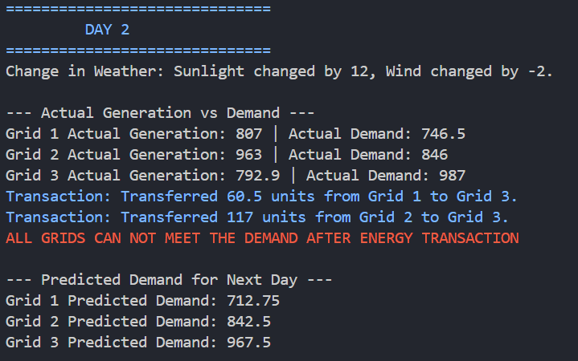
Test2: Demand met
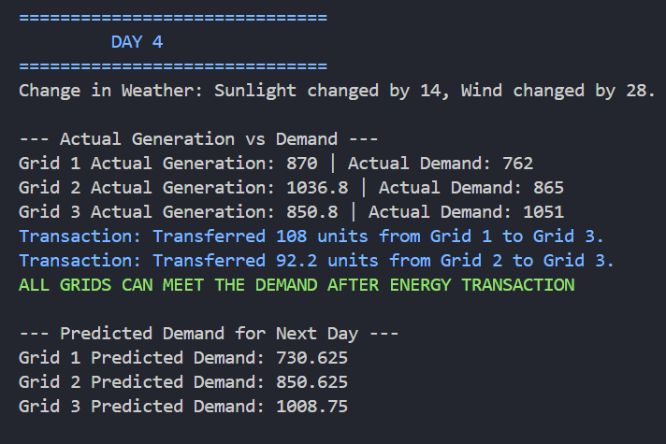
Test3: Only 1 transaction needed
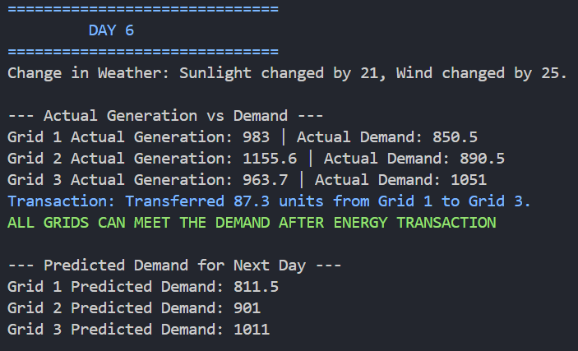
Test4: More than 1 transaction needed
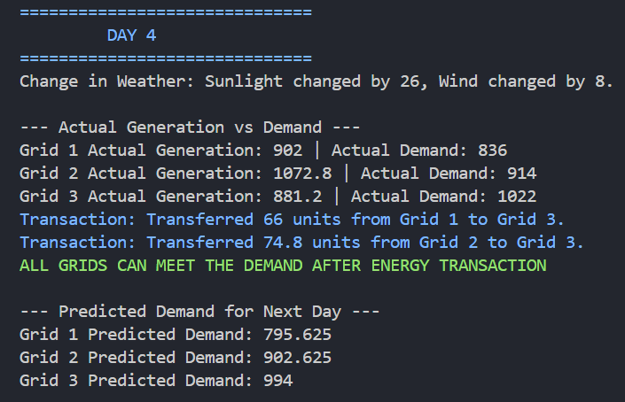

9. Limitations and Future Work
- Random values for the simulation
- No transmission losses modeled
- Simple uniform mutations without real time data
- Basic moving average forecasting

Future Enhancements
- To simulate for a real world, can use weather API to get real time data and hence more accurate prediction about power generation
- Simulation of Power Management in games in SimCity/Cities: Skylines
- A separate class is made for predicting demand, so if later, a Machine learning model is to be used, it can be incorporated without disturbing other aspects of the project
- Add statistical distributions (Gaussian distribution) for demand prediction
- Develop pricing or trade (include currency) between grids
- Add visualization module by using the transaction logs and graphing them
- Simulate transmission losses when transferring energy between grids

10. Conclusion
GridNexus successfully demonstrates production-quality decentralized smart grid simulation using advanced OOP principles. Virtual inheritance, polymorphism, operator overloading, and robust encapsulation showcase best practices. The 7-day simulation validates the system's ability to handle dynamic load balancing and inter-grid redistribution. The extensible architecture serves as an excellent foundation for real-world smart grid applications and provides valuable insights into decentralized energy management strategies.

