Methodology
Clinical NER: Variance-Aware Few-Shot Prototypes on PHI-Scrubbed Clinical Text
Group Members: Ishan Chowdhury, L Srivatsan, Vijay Eswaran S

A. Overall System Architecture
The project adapts a frozen, general-purpose span encoder (GLiNER) to new, institution-specific clinical entity types using only 5, 10 or 20 labelled examples per type. Adaptation is carried out by a lightweight prototype head, with no encoder fine-tuning and no synthetic data generation. The central experiment compares a standard point-estimate prototype head with a variance-aware Gaussian prototype head, both placed on the same frozen encoder and evaluated under one shared harness.

A.1 High-level flow: input, processing and output
- Input. Raw clinical notes (MTSamples as the primary dataset and the PhysioNet SNOMED CT Entity Linking Challenge notes as external validation), together with a small support set of K labelled examples for each entity type.
- De-identification layer. This layer runs once per dataset and before any embedding is computed, so protected health information (PHI) never reaches the model or any downstream artefact. It has four stages: a rule-based scrubber for structured PHI such as dates, medical record numbers, phone numbers and social security numbers; a model-based scrubber (for example Philter or a Presidio/spaCy pipeline) for free-text PHI such as names in narrative and informal locations; typed placeholder substitution that preserves sentence structure and span boundaries; and validation on a hand-labelled gold set of about 200 notes.
- Embedding extraction. The frozen GLiNER encoder produces an embedding for every candidate span in the de-identified text.
- Few-shot heads. Two heads are compared: a point-estimate prototype (class mean) and a Gaussian prototype (class mean and covariance).
- Output. Predicted entity spans with entity types, evaluated per type, per shot count and per head, together with calibration and significance analyses.
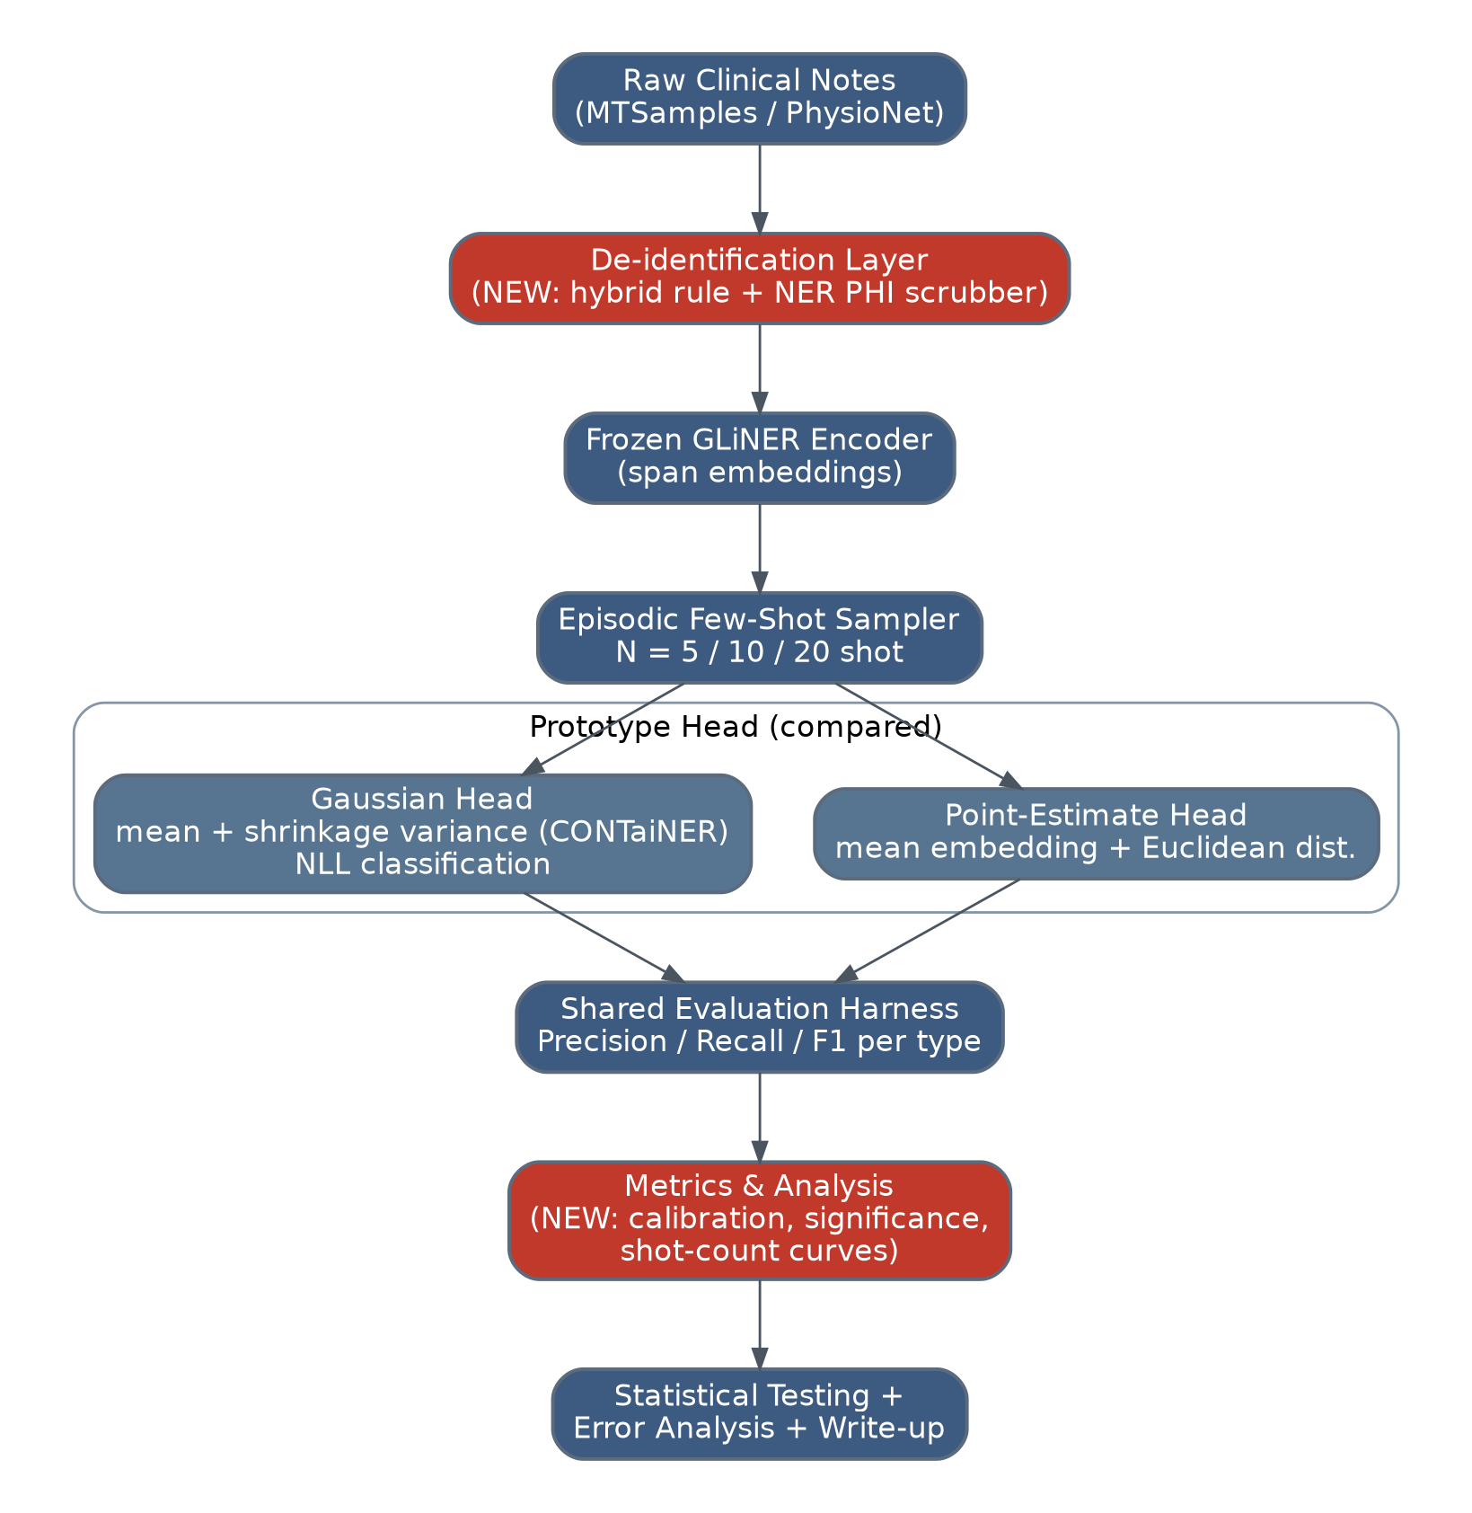.

B. Dataset Description

B.1 Primary dataset: MTSamples
MTSamples is a publicly available collection of unstructured medical transcription samples that spans multiple specialties and needs no credentialed access. The study uses 5000 thousand notes. Each note carries text and span-level annotations for the target entity types, which the team curates.

B.2 External validation dataset: SNOMED CT Entity Linking Challenge (v1.2.1)
The second dataset is the SNOMED CT Entity Linking Challenge release on PhysioNet (DOI 10.13026/az93-vm52), derived from MIMIC-IV-Note v2.2 and cited jointly with it, as PhysioNet requires. Access is credentialed (PhysioNet account, CITI training and a signed Data Use Agreement). It contains 272 MIMIC-IV discharge summaries annotated by medical professionals with 75,491 span-level annotations covering 6,595 unique SNOMED CT concepts from the clinical finding, procedure and body structure branches. About 70% of annotations were double-annotated with a third annotator adjudicating disagreements, and the set was quality-checked against the November 2025 SNOMED CT release, which revised about 4.5% of annotations. Notes range from 2,374 to 24,858 characters (median about 9,660), with 40 to 675 annotations per note (median 269) and spans of 1 to 139 characters (median 8).
Field | Type | Description
train_notes.csv (272 rows)
note_id | string | Unique discharge summary ID (matches MIMIC-IV-Note)
text | string | Full raw note text, with PHI already scrubbed upstream
train_annotations.csv (75,491 rows)
annotation_id | int | Unique annotation ID
note_id | string | Links the annotation to its source note
start / end | int | Character offsets of the entity span in the note text
span | string | Literal annotated text (e.g., “right colectomy”)
concept_id | int | SNOMED CT concept ID the span is linked to
annotation_type | string | train / test / proposed_ACCEPTED; undocumented, so it is not assumed to be a train/test split

B.3 Preprocessing steps
- Load and join. Annotations are linked to notes through note_id.
- De-identify. The four-stage layer runs on both datasets. The PhysioNet notes are already scrubbed upstream, but the layer is re-run as a low-cost defence-in-depth check.
- Realign offsets. Placeholder substitution changes text length, so all character offsets are remapped to the de-identified text and each remapped span is checked against its annotation.
- Map SNOMED concepts to coarse entity types. The PhysioNet data is entity-linking data (span and concept ID) and not pre-typed NER data, so each concept_id is mapped through its top-level SNOMED CT branch (clinical finding to Problem, procedure to Procedure, body structure to Anatomy).
- Treat annotation_type with caution. Its values are undocumented and may reflect a quality-control artefact, so splits are made by note (Section D.2).
- Tokenise and enumerate candidate spans. GLiNER’s tokeniser is used with a maximum span width that covers the long tail of span lengths, and any truncation is documented.

C. Proposed Model / Algorithm

C.1 Frozen encoder
GLiNER stays frozen throughout, with no gradient updates and no synthetic data. For each candidate span s the encoder yields an embedding z_{s} ∈ ℝ^{d}.

C.2 Few-shot episode formulation
Each episode is an N-way K-shot task with K ∈ {5, 10, 20}. The support set S holds K labelled spans for each entity type c. The query set Q holds held-out spans from notes that are not used in the support set. A non-entity class O is included so that spans that are not entities are rejected.

C.3 Baseline: point-estimate prototype
For each class c the prototype is the mean of its support embeddings:
μ_{c} = (1/K) Σ_{i: label(i)=c} z_{i}
A query span is classified by a softmax over negative distance with temperature τ, where d is squared Euclidean or cosine distance:
p(c | z) = exp(−d(z, μ_{c})/τ) / Σ_{c′} exp(−d(z, μ_{c′})/τ)
Because each class is a single point, no information about how spread out the class is survives.

C.4 Proposed: Gaussian (variance-aware) prototype
Following the Gaussian-embedding line of work reviewed in the literature survey, each class is modelled as a Gaussian N(μ_{c}, Σ_{c}) and not as a point. With K ≤ 20 and an embedding dimension d in the hundreds, the sample covariance is rank-deficient, so two regularised forms are evaluated. The diagonal form is Σ_{c} = diag(σ_{c,1}², …, σ_{c,d}²). The shrinkage form is
Σ̂_{c} = (1 − λ) S_{c} + λ · (tr(S_{c})/d) · I, λ ∈ [0, 1]
where S_{c} is the sample covariance of the support embeddings. Classification uses the Gaussian log-likelihood:
log p(z | c) = −½ (z − μ_{c})ᵀ Σ_{c}⁻¹ (z − μ_{c}) − ½ log |Σ_{c}| + const
A softmax over classes, with class priors, gives p(c | z). Because this is a likelihood and not only a distance, its calibration can also be evaluated.

C.5 Justification for the approach
- A frozen encoder with a prototype head is a cheap adaptation path, whereas full fine-tuning or synthetic data generation for a lightweight encoder such as GLiNER is too resource-intensive for a low-shot, evolving schema.
- Point prototypes discard dispersion, and the information lost is likely to matter more as support sets shrink. The Gaussian head tests this directly.
- Comparing diagonal and shrinkage covariance separates the benefit of variance modelling from the benefit of plain regularisation. This addresses the gap identified in the survey, where trained encoders and stacked components prevent the value of variance from being isolated.
- Both heads share the same encoder, episodes and evaluation harness, so any performance gap is attributable to the head.

D. Training and Testing Strategy

D.1 Training
No encoder training takes place. “Training” means computing class prototypes, and covariances for the Gaussian head, from each episode’s support set.

D.2 Data split
Data | Use
MTSamples | Split by note, and not by span or sentence, to prevent leakage. Proposed train/dev/test = [70/15/15]. Support sets come from train notes, development queries from dev notes and final-test queries from test notes.
PhysioNet SNOMED notes | External validation only, with no tuning. All hyperparameters are frozen on MTSamples dev before this evaluation is run.
De-identification gold set (about 200 notes) | Used only to validate the de-identification layer.

D.3 Validation approach and episode sampling
Many episodes are sampled for each shot count (for example 100 across several random seeds (for example (42,123,7). Both heads are run on identical episodes, a paired design that the significance tests in Section E require. The mean and spread across seeds are reported for every shot count.

D.4 Parameter tuning
All tuning uses MTSamples dev episodes only, and every value is fixed before the test notes or PhysioNet are touched.
Parameter | Search
Temperature τ | Grid over a small set of values {0.01, 0.05, 0.1, 0.2, 0.5, 1.0}
Distance function | Squared Euclidean versus cosine (point-estimate head)
Shrinkage λ | Grid over{ 0.0, 0.1, 0.25, 0.5, 0.75, 0.9, 1.0}
Covariance form | Diagonal versus shrinkage (Gaussian head)
Non-entity (O) threshold | Tuned on dev F1 separately for each head

E. Evaluation Metrics

E.1 Entity-level precision, recall and F1
Metrics are computed per entity type and are macro-averaged and micro-averaged. A prediction is a true positive only if both the span boundaries and the entity type match exactly.
Precision = TP / (TP + FP), Recall = TP / (TP + FN)
F1 = 2 · Precision · Recall / (Precision + Recall)
F1 balances missed entities against spurious ones and is the standard NER metric. Macro-averaging exposes rare-type performance, which is critical in a few-shot setting, while micro-averaging reflects overall performance. Plain accuracy is avoided because non-entity spans dominate and would inflate it.

E.2 Additional metrics
Metric | Purpose | Applies to
ΔF1 versus shot count (5/10/20) | ΔF1(K) = F1_{Gaussian}(K) − F1_{point}(K); directly tests the hypothesis that the Gaussian head helps more at low shots | Both heads
Expected Calibration Error (ECE) | ECE = Σ_{m} (|B_{m}|/n) · |acc(B_{m}) − conf(B_{m})| over M confidence bins; checks that likelihood-based confidences are trustworthy and not only accurate | Gaussian head only
Paired bootstrap and Wilcoxon signed-rank test | Confirms that F1 gaps are real and not episode-sampling noise, using matched episodes | Both heads
Covariance conditioning analysis | Compares diagonal and shrinkage forms to show whether gains come from variance modelling or from regularisation | Gaussian head only
PHI leakage rate | Residual PHI tokens per 10k tokens; validates the de-identification layer before embeddings are computed | De-identification layer
De-identification precision / recall on gold PHI spans | Ensures scrubbing does not over-redact clinically relevant entity spans | De-identification layer

References
[1] Zhang, Y., Chen, W., & Ma, L. (2025). Contrastive learning with Gaussian embeddings and self-attention for few-shot named entity recognition. Applied Sciences, 15(21), 11819. https://doi.org/10.3390/app152111819
[2] Noori, A., & Manda, P. (2026). Semantic analysis of SNOMED CT concept co-occurrences in clinical documentation using MIMIC-IV. Digital Health, 12. https://doi.org/10.1177/20552076261436869
[3] PhysioNet. SNOMED CT Entity Linking Challenge, v1.2.1. https://doi.org/10.13026/az93-vm52. Derived from MIMIC-IV-Note v2.2.
[4] Das, S. S. S., Katiyar, A., Passonneau, R. J., & Zhang, R. (2022). CONTaiNER: Few-shot named entity recognition via contrastive learning. Proc. ACL 2022.
[5] Zaratiana, U., Tomeh, N., Holat, P., & Charnois, T. (2024). GLiNER: Generalist model for named entity recognition using bidirectional transformer. Proc. NAACL 2024.

