

**NED University of Engineering & Technology**

**Online Fall Semester Examinations - 2020**

|  |  |  |  |  |  |  |  |  |  |  |  |  |  |  |  |  |  |  |  |  |  |  |  |  |  |  |  |  |  |  |  |  |  |  |  |  |  |  |  |  |  |  |  |  |  |  |  |  |
| --- | --- | --- | --- | --- | --- | --- | --- | --- | --- | --- | --- | --- | --- | --- | --- | --- | --- | --- | --- | --- | --- | --- | --- | --- | --- | --- | --- | --- | --- | --- | --- | --- | --- | --- | --- | --- | --- | --- | --- | --- | --- | --- | --- | --- | --- | --- | --- | --- |
| **Seat No. BM17040________ Batch _2017____________**    **Course Title Biomedical Imaging_______ Course Code _BM406________**  **Enrol No. _NED/1382/2017_____________ Date 6 Feb 2021______**  **PLEASE READ THESE INSTRUCTIONS CAREFULLY**   1. Download and print this cover page (separately for each exam). 2. Fill the above mentioned particulars before attempting the questions. 3. Students are not allowed to use red or green ink. Solve the questions on A4 size paper using blue or black pen ONLY. | |  |  |  | | --- | --- | --- | | **Question No**. | **Award** | | | First Examiner/ Internal | Second/ External Examiner/ ERC | | **1.** |  |  | | **2.** |  |  | | **3.** |  |  | | **4.** |  |  | | **5.** |  |  | | **6.** |  |  | | **7.** |  |  | | **8.** |  |  | | **9.** |  |  | | **10.** |  |  | | **11.** |  |  | | **12.** |  |  | | **Total in figures** |  |  | | **Total in words** |  |  | |

**First / Internal Examiner’s Signature**

**Second / External Examiner’s / ERC Signature**

# Biomedical Imaging

## Question # 1

1. Hard X- Rays
   1. Hard X-Rays are used for Radiological Examinations. X-Rays are ionizing radiation with energies ranging from 10KeV to 120KeV
2. Gaussian Noise
   1. Human Hard Tissue blocks or absorbs X-Rays from reaching the X-Ray Detector producing a bright silhouette on the detector and X- Rays that pass through cause dark signals.
3. Absorption of x-rays
   1. Human Hard Tissue absorbs X-Rays from reaching the X-Ray Detector producing a bright silhouette on the detector and X- Rays that pass through cause dark signals. The Amount of X-Rays absorbed reflects the tissue density.
4. Anatomical
   1. X-Rays can be used to distinguish anatomical features that interact with X-Rays
5. Shadow Image
   1. X-Rays produce bright silhouette when incident on the parts of Human Body that absorb X-Rays, the detector detect X- Rays and produce dark signal where X-Rays pass through the soft body.
6. Histogram equalization
   1. Histogram Equalization means spreading the Gray Value which in turn enhances the contrast of the Image.
7. 2nd order derivative
   1. Laplacian Filter is a Type of 2nd Order Derivative Filter used for sharpening images
8. X-rays
   1. X-Rays are used for radiological Examination where as Gamma Radiation is usually used for treatment of Cancer and UV Radiation is usually used for disinfection.
9. 16 levels
   1. 2^4 = 16,
10. Non-invasive diagnostic
    1. X-Rays are commonly used for Diagnostic purposes and it is non-invasive i.e does not require any incision into the human body.

## Question # 2

1. R1: 200, 200, 200, 80, 80, 80,   
   R2: 200, 255, 200, 200, 0, 200,  
   R3: 128, 128, 128, 128, 128, 128,  
   R4: 200, 200, 200, 200, 200, 200,   
   R5: 200, 0, 200, 200, 255, 200,  
   R6: 200, 200, 200, 200, 200, 200,
2. R1: 231, 231, 231, 160, 160, 160,  
   R2: 231, 255, 231, 231, 0, 231,   
   R3: 194, 194, 194, 194, 194, 194,   
   R4: 231, 231, 231, 231, 231, 231,   
   R5: 231, 0, 231, 231, 255, 231,  
   R6: 231, 231, 231, 231, 231, 231,   
   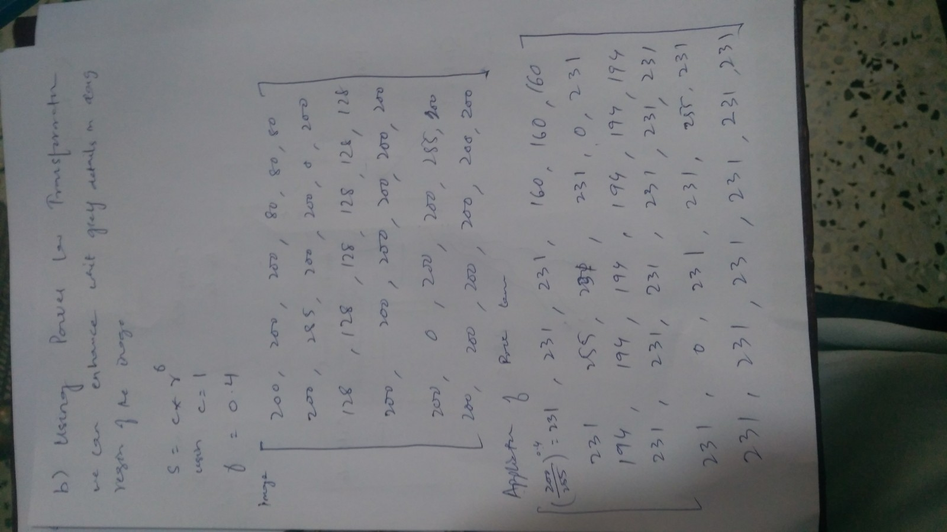
3. R1: 255, 255, 255, 0 , 0, 0,  
   R2: 255, 255, 255, 255, 0, 255,   
   R3: 255, 255, 255, 255, 255, 255,   
   R4: 255, 255, 255, 255, 255, 255,   
   R5: 255, 0, 255, 255, 255, 255,   
   R6: 255, 255, 255, 255, 255, 255,

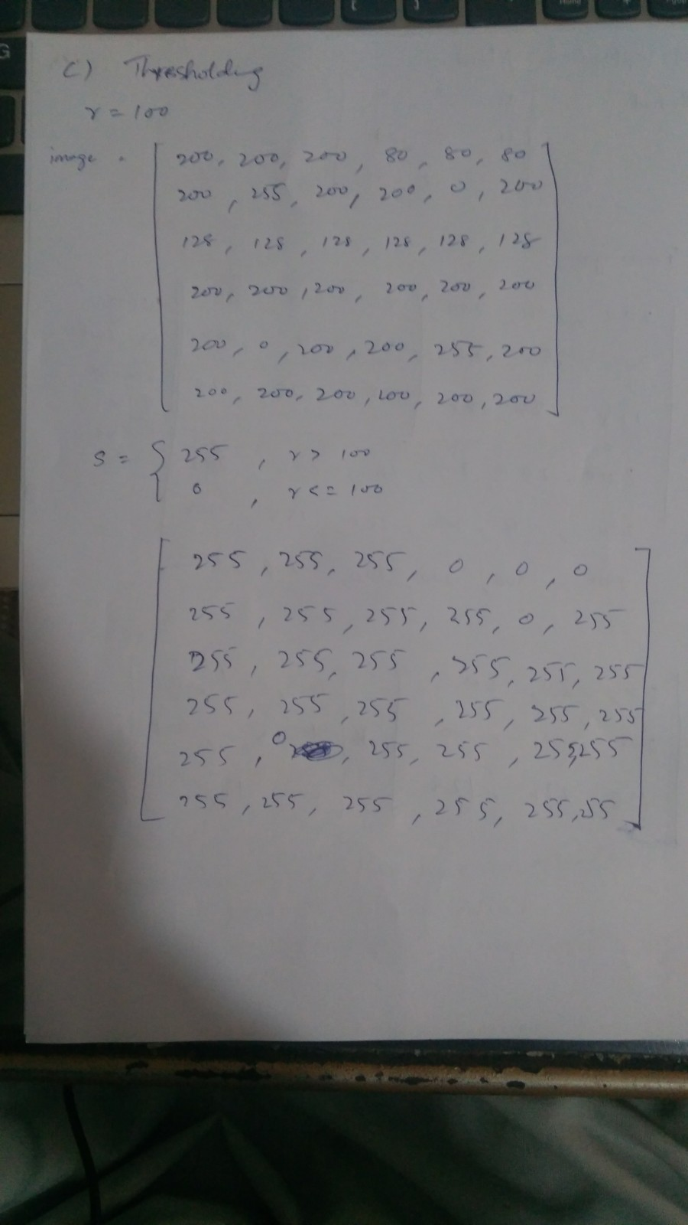

1. Region  
   R1: 80, 80, 80,   
   R2: 200, 0, 200,  
   R3: 128, 128, 128,

Application of Median Filter  
R1: 80, 80, 80,   
R2: 200, 128, 200,   
R3: 128, 128, 128,

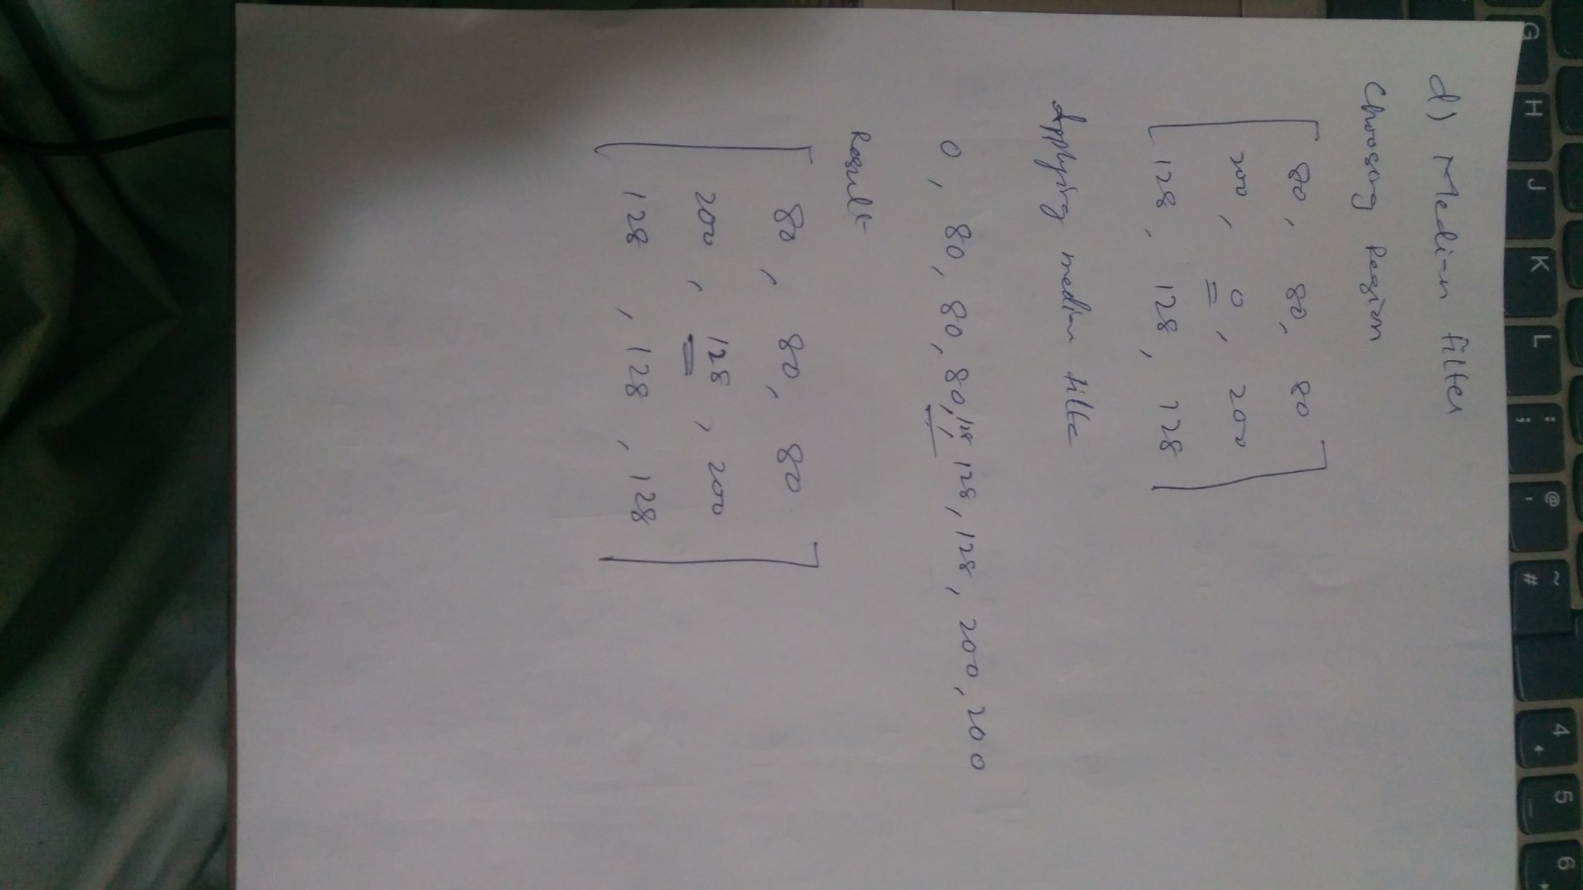

1. Region   
   R1: 80, 80, 80,   
   R2: 200, 0, 200,  
   R3: 128, 128, 128,

Application of Geometric Mean Filter  
R1: 80, 80, 80,   
R2: 200, 0, 200,  
R3: 128, 128, 128

Conclusion:  
Geometric Mean filter has no effect on the region of interest whereas median filter is able to significantly improve the quality of the image.

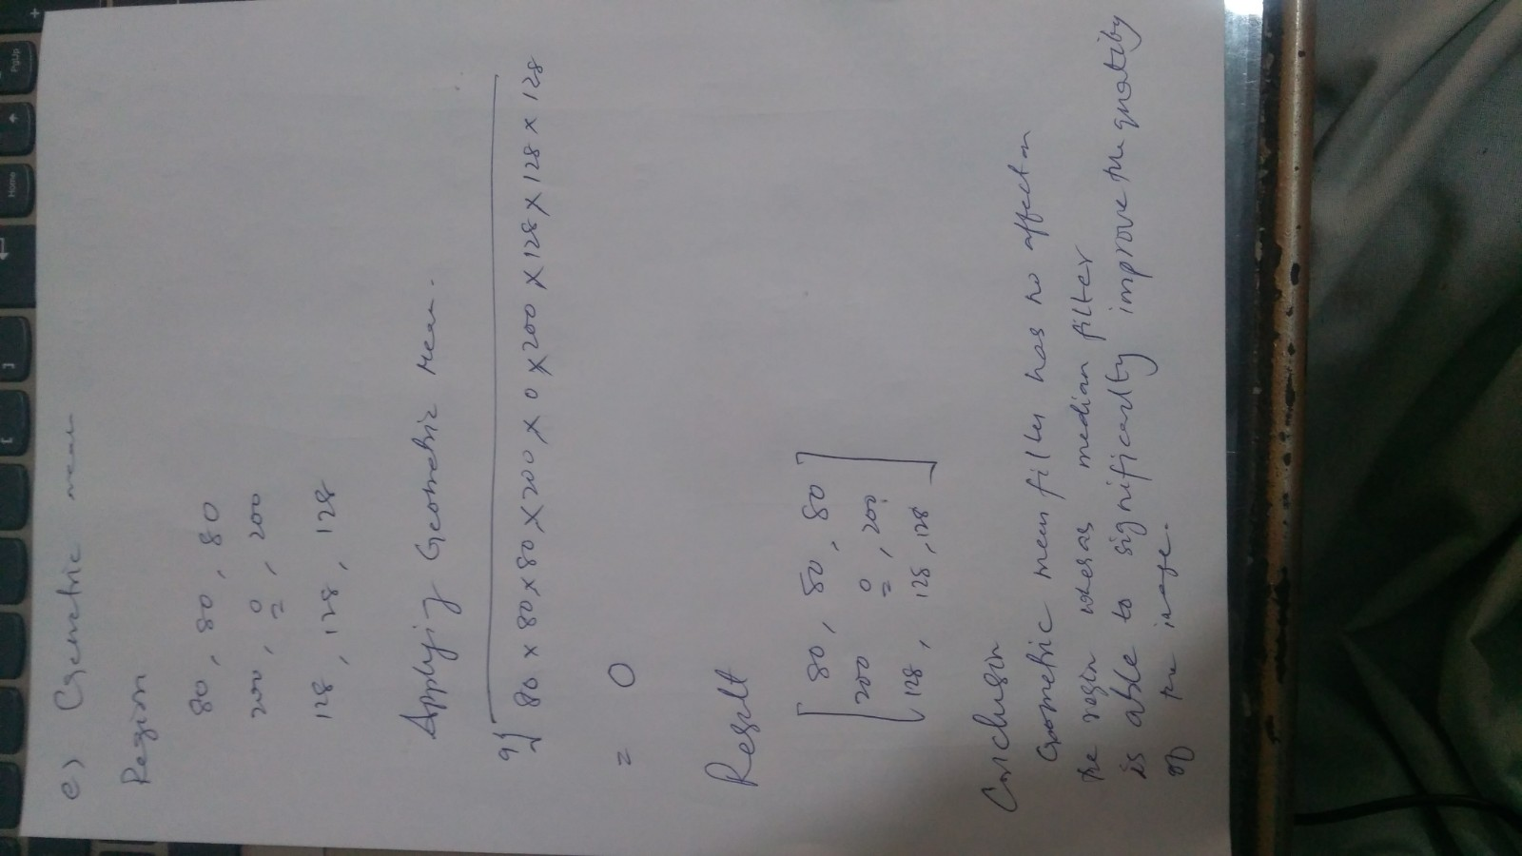

## Question # 3

1. Computerized Tomography
2. Voltage : 25KV - 150KV   
   Current: 400 - 1000 A   
   Frequency : 30 petahertz - 30 exahertz   
   Energy : ~ in 100KeV   
   Wavelengths: 10 picometers -10 nanometers
3. X-Rays are generated by bombarding high energy electrons from cathode onto a spinning Tungsten Anode, the electrodes can have a potential difference from 25 to 150 KeV. Spinning Anode is used to minimize single point of degradation from high energy electrons. 99% of energy is lost as heat therefore spinning anode also helps in the dissipation of heat.

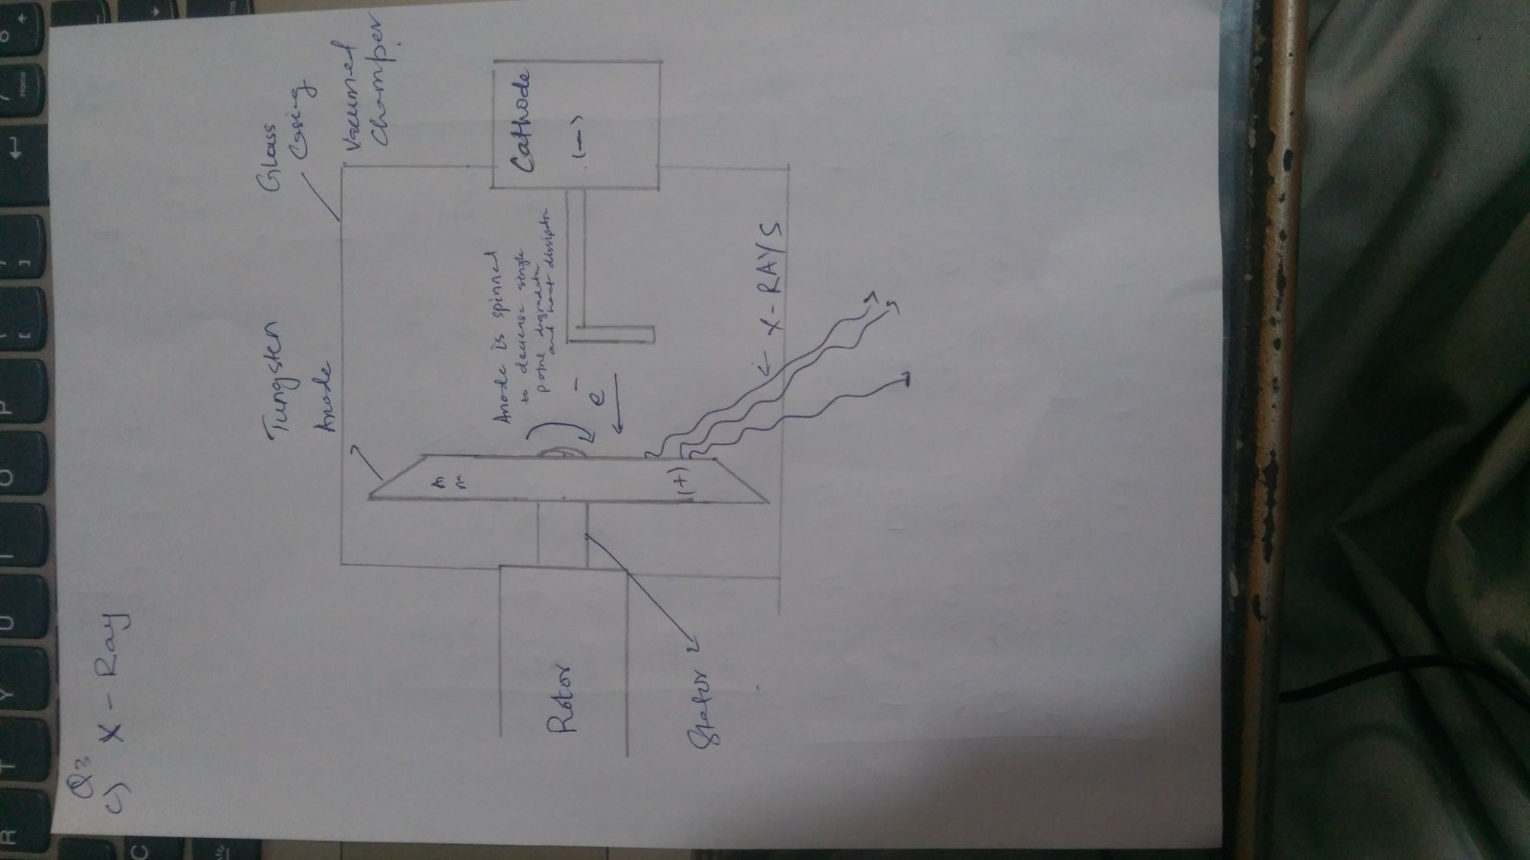

1. We Chain Multiple Filters to enhance the image suiting our need   
   Example
   1. Applying Enhancement Filter Like 2nd Order Differential Filter like Laplacian Filter
   2. Followed by a Median Smoothing Filter and then,
   3. Power Law Transformation
2. Contraharmonic Mean Filter with a Positive Order can be used to eliminate Pepper Noise from an Image

## Question # 4

1. CT Scan
2. High Radiation Exposure 100 Times more than a X-Ray, Distortion
3. By Making the patient calm and still, image quality can be improved.  
   Using a circular Array.  
   Anti Scatter Grid
4. Anode is an an circular Array of detectors
5. CT scan uses X-Rays but produces many slices to construct a 3D Image. It Uses circular array of detectors to capture X-Rays.  
   