Bigbangtheory

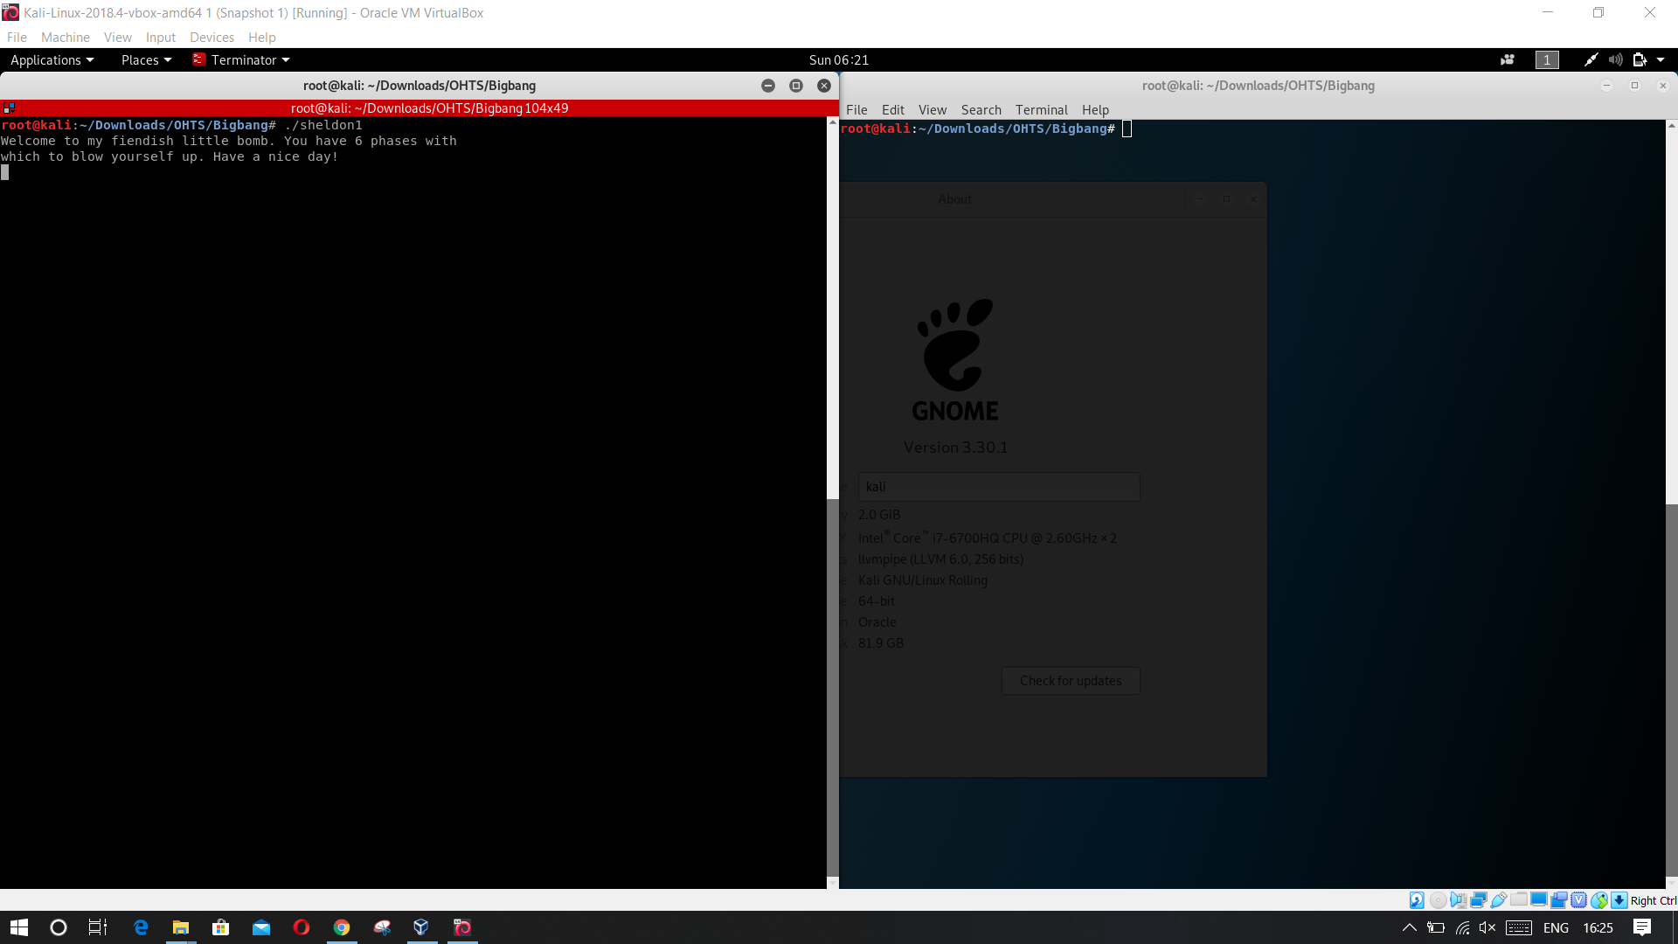First we have to execute the program and find the output.

When we enter something, the bomb will blow up.

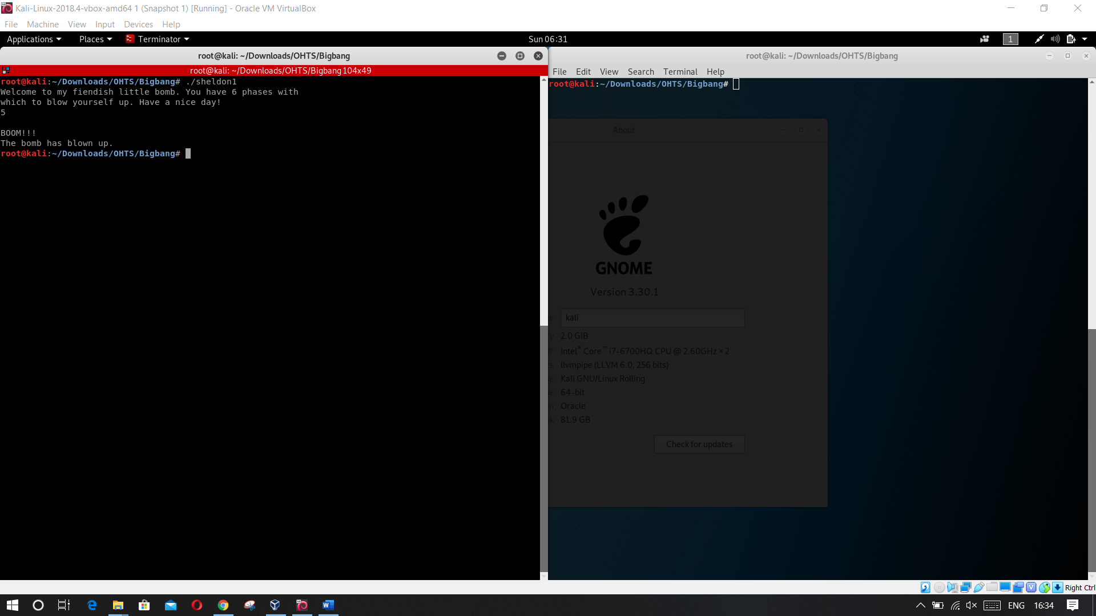

Then we have to analyze the assembly code of the code.

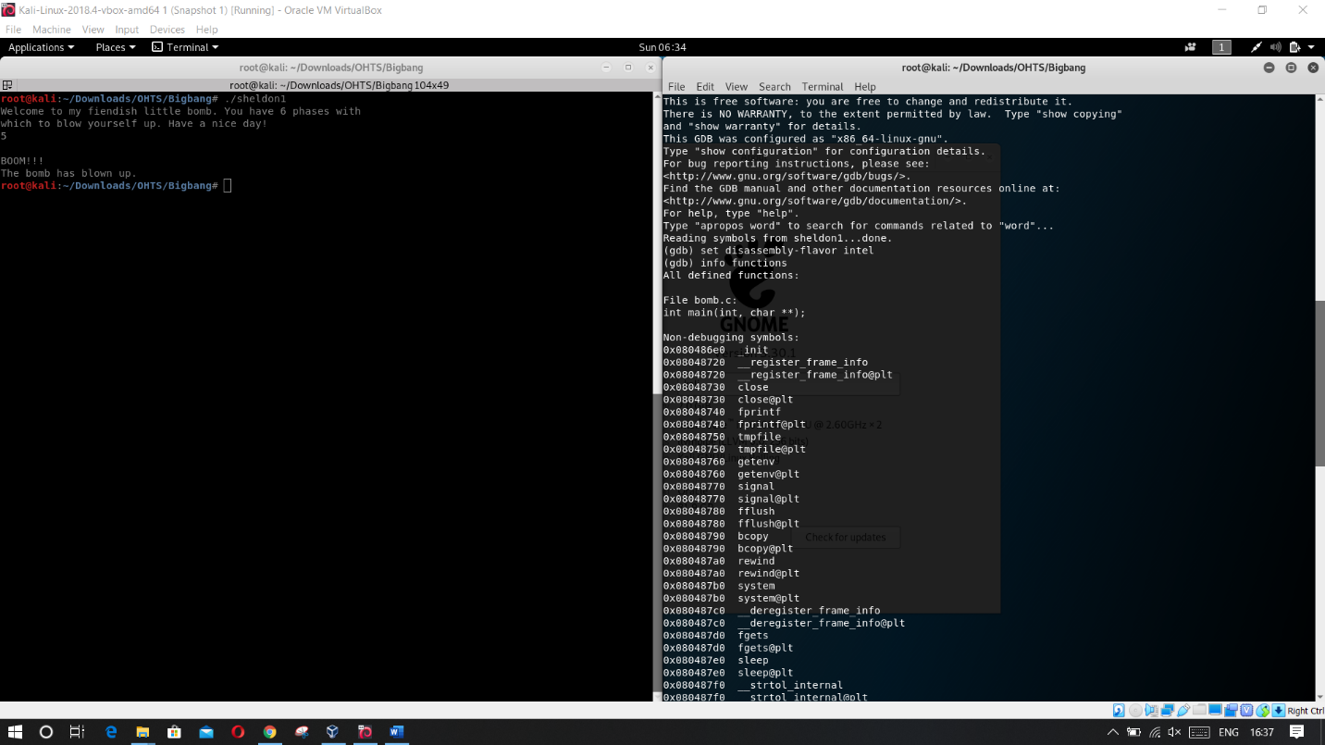when analyzing the functions of the code we can see there is functions called phase1

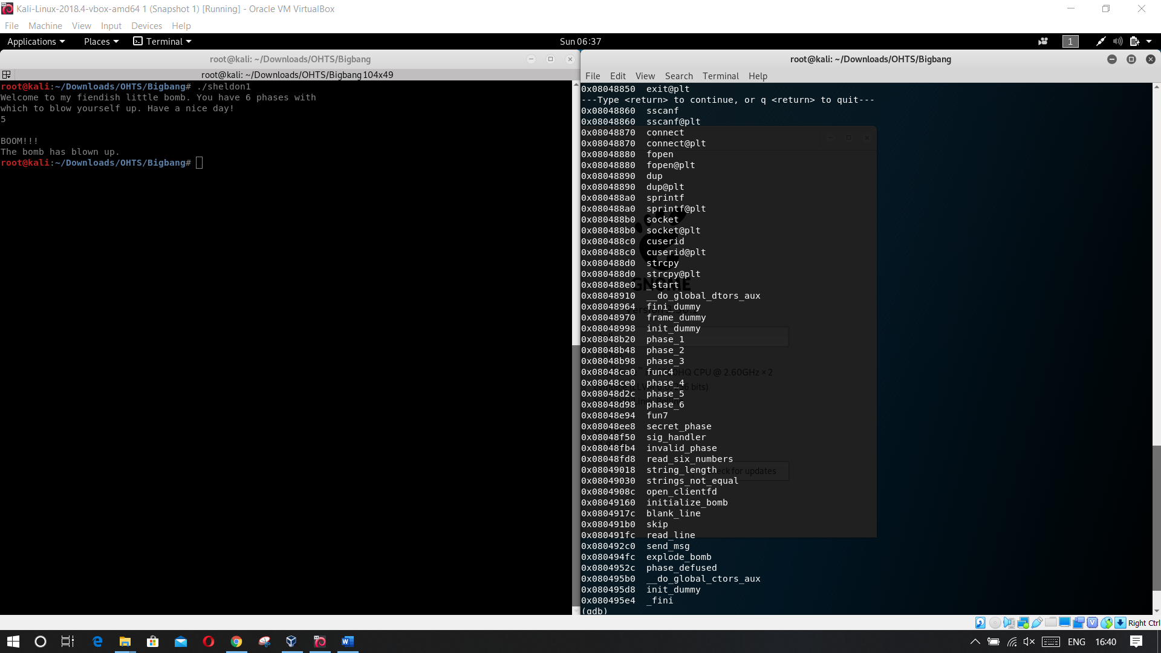

Then we have to analyze the phase 1 function.

We have to disassemble from the phase1 function.

