Installation Method:
1. Open the "models" folder inside the package.
2. Copy all the items.
3. Go to the "home" directory.
4. Show the hidden files.
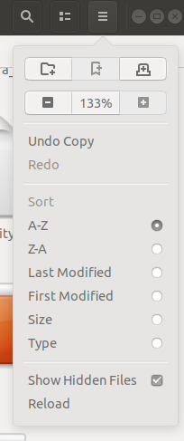

5. Then open the ".gazebo/models".
6. Paste the items.
7. Place the "warehouse_world" package at "catkin_ws/src"
8. open the terminal and use the commands below.
"cd ~/catkin_ws"
"catkin_make"
"source devel/setup.bash"

Launch the World by the following command
"roslaunch warehouse_world world.launch "

