

Dr. A. Q. Khan Institute of Computer Science and
Information Technology
Department of Computer Science

Theory REPORT
AI-Based Application Development in .NET

Submitted By
MUHAMMAD Usama Bilal

Reg NO#
232201097

Submitted To
Sr Uzair
____________________
BSCS- VI-B

1. Introduction to AI-Based Applications
What is Artificial Intelligence?
Artificial Intelligence (AI) refers to the simulation of human intelligence in machines that are programmed to think, learn, and make decisions. AI enables systems to perform tasks that typically require human intelligence such as problem-solving, understanding language, recognizing patterns, and decision-making.
What are AI-Based Applications?
AI-based applications are software systems that utilize artificial intelligence techniques to perform tasks automatically or enhance user experience. These applications rely on data, algorithms, and models to make intelligent decisions.
Real-World Examples
- Chatbots: Used in customer service to provide instant responses.
- Recommendation Systems: Platforms like Netflix and Amazon suggest content based on user preferences.
- Image Recognition: Used in security systems and social media for face detection.

2. AI in .NET Ecosystem
How AI is Integrated in .NET
AI can be integrated into .NET applications using libraries, frameworks, and external APIs. Developers can either build their own models or use pre-built AI services.
ML.NET
ML.NET is a machine learning framework developed by Microsoft that allows developers to build custom machine learning models using C# or F#.
Features:
- Model training and evaluation
- Integration with .NET applications
- Supports classification, regression, and clustering
REST APIs for AI Services
REST APIs allow developers to access AI services without building models from scratch. APIs such as OpenAI provide capabilities like text generation, summarization, and chatbot functionality.
Benefits of Using .NET for AI Applications
- Strong integration with Microsoft tools
- High performance and scalability
- Cross-platform support using .NET Core
- Easy deployment and maintenance

3. AI Application Development Lifecycle
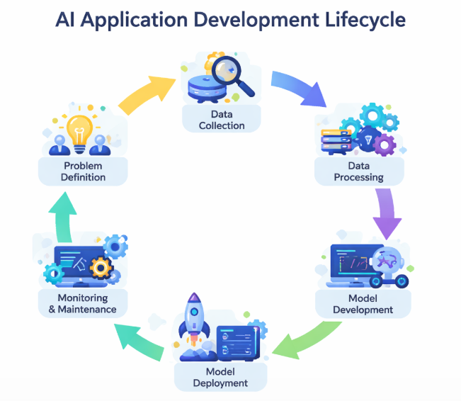
1. Problem Identification
Define the problem clearly and determine how AI can provide a solution.
2. Data Collection
Gather relevant data required to train the AI model.
3. Data Preprocessing
Clean and transform data to make it suitable for training.
4. Model Selection
Choose an appropriate algorithm based on the problem type.
5. Model Training
Train the model using prepared data.
6. Model Evaluation
Evaluate the model using metrics like accuracy and precision.
7. Integration with Application
Integrate the trained model or API into a .NET application.
8. Deployment
Deploy the application for real-world use.

4. Architecture of an AI-Based Application
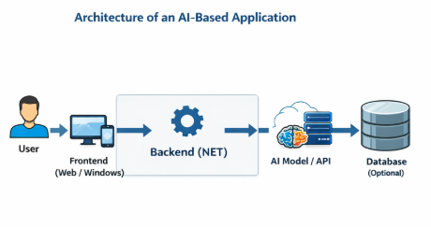
An AI-based application typically consists of the following components:
Frontend (UI)
The user interface where users interact with the system. It can be built using Windows Forms or web technologies.
Backend (.NET Logic)
Handles business logic, processes user input, and communicates with AI services.
AI Model / API
Performs intelligent processing and generates results.
Database (Optional)
Stores user data and application data.
Architecture Flow:
User → UI → Backend → AI Model/API → Response → UI

5. API Integration Concept
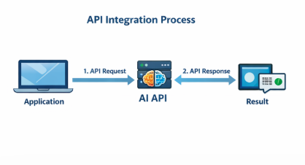
What is an API?
An Application Programming Interface (API) is a set of rules that allows different software systems to communicate with each other.
How AI APIs are Used
Developers send a request to an AI API with input data, and the API returns a processed result.
Request/Response Flow
- User enters input
- Application sends request to API
- API processes the data
- API returns response
- Application displays output
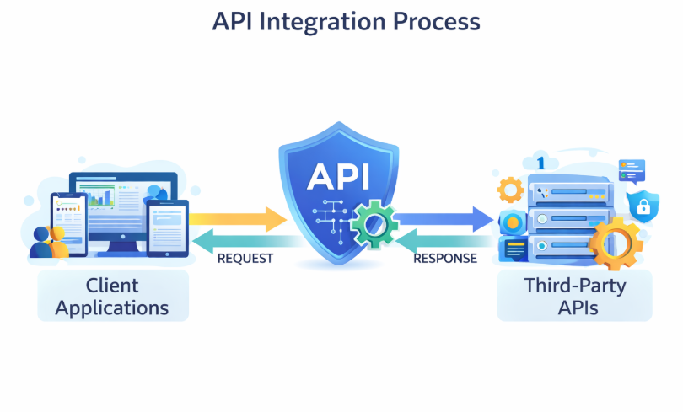
- Introduction to Docker
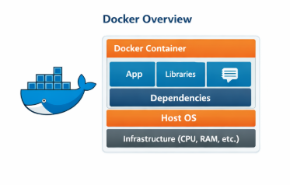
What is Docker?
Docker is a platform that allows developers to package applications into containers, ensuring consistency across different environments.
Why Docker is Used
- Eliminates environment issues
- Simplifies deployment
Benefits
- Portability
- Consistency
- Scalability

7. Version Control using GitHub
Importance of GitHub
GitHub is a platform for version control and collaboration. It allows developers to manage code efficiently.
Basic Workflow
- Create repository
- Add files
- Commit changes
- Push to GitHub
README File
Contains project description, setup instructions, and usage details.

8. Ethical Considerations
Bias in AI
AI systems can produce biased results if trained on biased data.
Data Privacy
User data must be handled securely and ethically.
Responsible AI Usage
AI should be used in a way that benefits society and avoids harm

Conclusion
AI-based application development in .NET provides powerful tools and frameworks to build intelligent systems. By combining AI technologies with .NET, developers can create scalable, efficient, and modern applications. Understanding the lifecycle, architecture, and ethical considerations is essential for building responsible AI solutions.

