**General feedback**

Sequence of bullet in table is not followed.   
Please include all the fields of every table. If any information is already asked please display.  
Please follow same question no. table no, bullets, footnote and headings as used in forms.

**Feedback on technical issues:**

Strategic management tab does not display anything regarding Strategic management.  
**Missing fields of table 1.1**

d) Name of Chief Administrative Officer  
f) Year of establishment of the business school  
p) Number of other campuses (if any)  
q) Location of other campuses (if any)

**Error in Table 1.3** contact information. Once we fill all the fields the information was not added in table and error prompts.

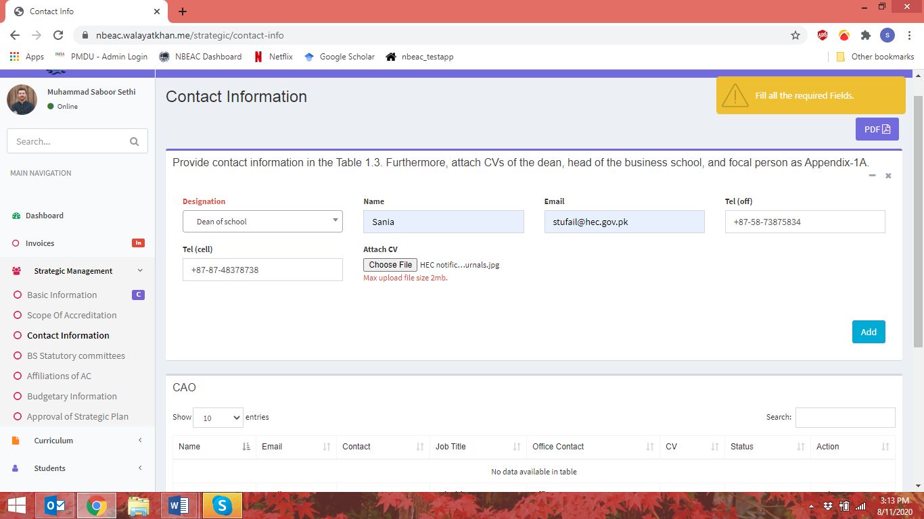

**Question 1.7:** State the vision and mission of the university and that of the business school. Describe the process of formation and approval of the vision and mission statements. Attached the relevant pages of the official documents as Appendix-1C.

In response to above question, there should be a paragraph in which university can enter its response.

In table 1.7, Period of the strategic plan could be calculated through i.e. From (2000) and To(2005) fields in which years could be asked.

**Question 1.9 is missing**…..Provide organograms of the business school and the parent institution as Appendix-1E.

**Section 2: Curriculum**

2.1 FYP viva/thesis comprehensive , there should be dropdown for selecting one option: Final year project/ viva/ thesis/ comprehensive

**Table 2.2** is not correctly and logically implemented. In eligibility criteria, there are subfields. Select one from: Matric/O-levels or equivalent and enter its weightage. Repeat the same for all the below options:

Intermediate/A-levels or equivalent

SAT/NAT/GAT etc. score

Grades in specific subjects

Entry test

Candidacy interview

Work Experience

Table 2.3: There should be a verification check : application received> admissions offered>Student intake

Table 2.4 is missing. Enumerate the degree awarding criteria/requirements for each program under review in Table 2.4.

Table 2.4. Application received

|  |  |
| --- | --- |
| Program(s) under review | Degree awarding criteria/ requirement |
|  |  |
|  |  |

**There is error in Table 3.1**

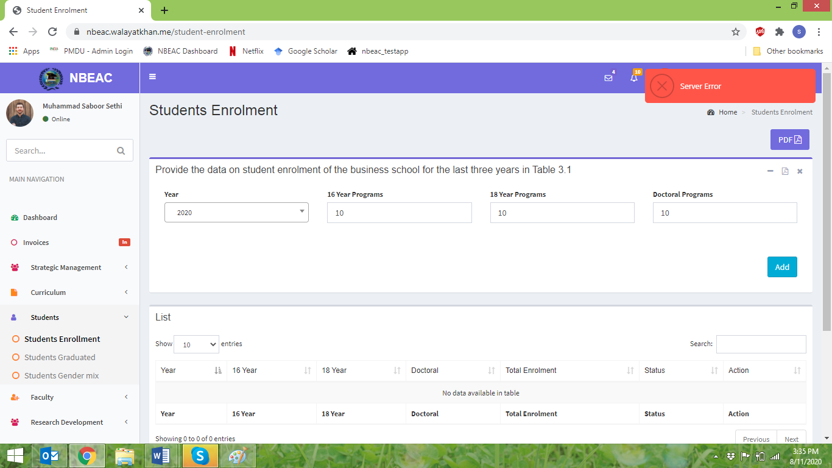

Table 3.3., there should be a check if percentage of gender mix do not exceeds from 100%.

**Table 4.1 is not implemented correctly.**

Table 4.1. Summary of business schools’ faculty

|  |  |  |  |  |  |  |
| --- | --- | --- | --- | --- | --- | --- |
|  | Business administration | Public administration | Management  sciences | Commerce/  Economics | Others | Total |
| PhD |  |  |  |  |  |  |
| 18 years education (MS/MPhil/MBA/MPA/M.Com) |  |  |  |  |  |  |
| 16 years education (Bachelors/Masters) |  |  |  |  |  |  |
| Others (professional/industry experience) |  |  |  |  |  |  |
| Total |  |  |  |  |  |  |

Table 4.2 a and b gives server error

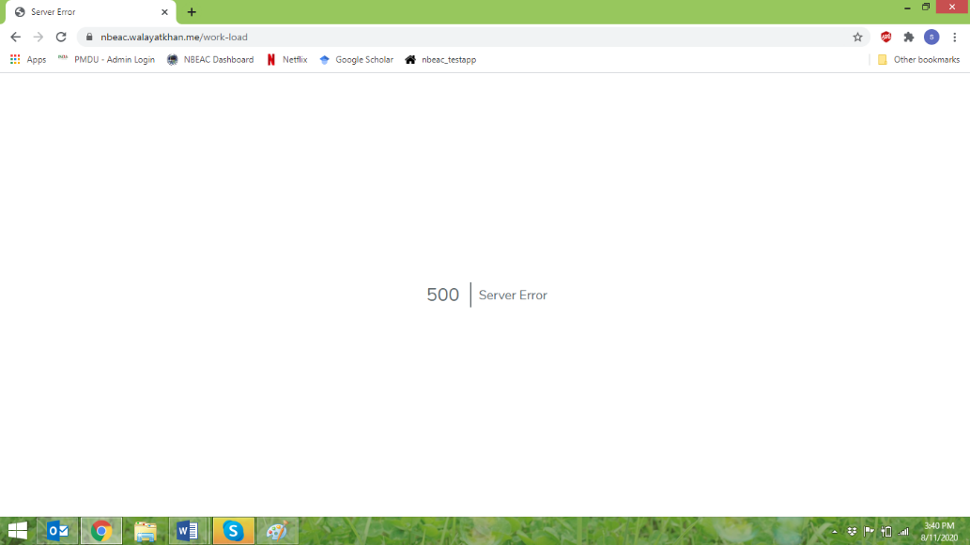

**Table 4.3 a and b , 4.4 and 4.5 is not implemented correctly. On 4.6, there is server error.**

**Table 5.1 is not implemented correctly. Missing fields of table 5.1**

Publication category

Academic research articles10Books  
Other Publications

**Table 6.1 and 6.2 are not implemented logically. Missing fields of table 6.1**

Revenue  
TOTAL REVENUE (A)  
Expense  
TOTAL EXPENSES (B)  
ANNUAL BALANCE (A–B)

**Missing fields of table 6.2**

Business school  
Facilities available at faculty offices

1. Workstations/laptops Yes/No
2. Printer/photocopier Yes/No
3. Air conditioning Yes/No
4. Safe cabinets Yes/No

Facilities available at lecture halls

|  |  |
| --- | --- |
| 1. Multimedia | Yes/No |
| 1. Whiteboard/blackboard | Yes/No |
| 1. Proper lighting | Yes/No |
| 1. Air conditioning | Yes/No |
| Multimedia and whiteboard simultaneously useable? | Yes/No |

**Feedback for quality assurance**

* Preface
* Instruction
* Undertaking

“Basic information” should be “Basic information of business school”

Strategic Basic Info should be changed to Section 1: Strategic Management.

# Curriculum should be changed to Section 2: Curriculum.

# Students should be changed to Section 3: Students.

Faculty should be changed to Section 4: Faculty.  
Faculty work load tab not opened   
Faculty Student Ratio should be Student to teacher ratio  
Research Development should be Section 5: Research & Development  
Facilities information should be Section 6: Facilities information  
“Financial Info” should be “Financial information of the business school”  
Please insert footnote as tool tip

**Field Captions to be corrected in Tables**

|  |  |
| --- | --- |
| **Available in Website** | **Changes required** |
| **Table 1.1** |  |
| Business School Name | **e)** Name of the business school and campus (if relevant) |
| Year of establishment(parent inst) | **b)** Year of  establishment (university/parent institution) |
| Web Url | **h)** Website URL |
| Date Charter Granted | i) Date of charter granted |
| None Profit | Not for profit |
| Hierarchical Context : | o) Hierarchical context |
| Constituent Part | Constituent part |
| Provide scope of accreditation in table 1.2 | 1.2 Provide scope of accreditation in Table 1.2. |
| **Table 1.2** |  |
| Degree Program | Degree program |
| Date of Program commencement | Date of program commencement |
| **Table 1.3** | |
| Designation | Job title |
| CAO | Table 1.3. Contact information |
| **Table 1.4** |  |
| Provide information of statutory bodies 1.4. Also attach documentary information about the composition, name of members, role and functions of each statutory body. | * 1. Provide information about the various statutory bodies in the Table 1.4. Also attach documentary information about the composition, name of members, role and functions of each statutory body as Appendix-1B. |
| Body Name | Body name |
| Date of First Meeting | Date of Meeting 1 |
| Date of second Meeting | Date of Meeting 2 |
| Date of third Meeting | Date of Meeting 3 |
| Date of fourth Meeting | Date of Meeting 4 |
| Business school’s statutory committees. | Table 1.4. Business school’s statutory committees |
| **Table 1.5** |  |
| Provide details of affiliations of all external (academic and corporate), national or international members in each of the statutory bodies mentioned above Table 1.5. | * 1. Provide details in Table 1.5 about the names, designations and affiliations of all external (academic and corporate), national or international members in each of the statutory bodies mentioned above in Table 1.4. |
| Name of Member | Name of member |
| Name of Statutory Body (if) | Name of statutory body |
| Affiliations | Table 1.5. Affiliations of any external (academic and corporate), national or international members |
| **Table 1.6** |  |
| Provide Budgetary information of the business school in table 1.6 | 1.6 Provide budgetary information of the business school in the Table 1.6. |
| University Budget | University budget |
| Budget proposed by Business School | Budget proposed by business school |
| Budget received by Business School | Budget received by business school |
| Budget Type | Budget type |
| Budgetary information of the business school. | Table 1.6. Budgetary information |
| State the vision and mission of the university and that of the business school. Describe the process of formation and approval of the vision and mission statements. Attached the relevant pages of the official documents as Appendix-1C | * 1. State the vision and mission of the university and that of the business school. Describe the process of formation and approval of the vision and mission statements. Attached the relevant pages of the official documents as Appendix-1C. |
| Provide the approved strategic plan including critical success factors and key performance indicators of the business school as Appendix-1D. Fill in the required information on approval of the strategic plan in the Table 1.7. | * 1. Provide the approved strategic plan including critical success factors and key performance indicators of the business school as Appendix-1D. Fill in the required information on approval of the strategic plan in the Table 1.7. |
| Approval of Strategic Plan List | Table 1.7. Approval of strategic plan |
|  |  |
| Provide the portfolio of the program(s) under review in Table 2.1. | 1. Provide the portfolio of the program(s) under review in Table 2.1. |
| **Table 2.1** |  |
| Select program tab | Add Program 1 , Program 2 |
| Number of Semesters | Number of semesters |
| Course Category | Course category |
| Number of Courses | Number of courses of the program under review |
| Credit Hours | Credit hours |
| Internship Requirements | Internship requirement |
| FYP viva/thesis comprehensive | Final year project/ viva/ thesis/ comprehensive |
| Portfolio of the program(s) under review | Table 2.1. Programs portfolio |
| Provide data on entry requirements for each program under review. | 1. Provide data on entry requirements for each program under review in Table 2.2. |
| **Table 2.2** |  |
| Program Name | Program(s) under review |
| Eligibility Criteria | Eligibility criteria |
| Minimum requirements/Relative Weightage | Minimum requirements/relative weightage |
| Entry Requirements for each program under review. | Table 2.2. Entry requirements |
| **Table 2.3** |  |
| Program Name | Program(s) under review |
| Semesters | Semester2 |
| Applications Received | Applications received |
| Admission Offered | Admissions offered |
| Semester Commencement Date | Semester commencement date |
| Application Received List. | Table 2.3. Applications received |
| Provide the data on student enrolment of the business school for the last three years in Table 3.1 | 1. Provide the data on student enrolment3 of the business school for the last three years in Table 3.1. |
| **Table 3.1** |  |
| Year | Year4 |
| 16 Year Programs | 16 years programs (A) |
| 18 Year Programs | 18 years programs (B) |
| Doctoral Programs | Doctoral programs (C) |
| State the number of students who have graduated over the past three years for each program under review in Table 3.2 | 1. State the number of students who have graduated over the past three years for each program under review in Table 3.2. |
| **Table 3.2** |  |
| Program Name | Program(s) under review |
| List | Table 3.2. Graduated students |
| State the current gender wise break down of students in each program under review in Table 3.3 | 1. State the current gender wise break down of students in each program under review in Table 3.3. |
| t, t-2,t-3 | t, t-1,t-2 |
| **Table 3.3** |  |
| Program Name | Program(s) under review |
| List | Table 3.3. Student gender mix |
| Provide information about core business school faculty : present aggregate numbers in Table 4.1 | 1. Provide information about core business school faculty6: present aggregate numbers in Table 4.1. |
| **Table 4.1** |  |
| Information of faculty over the last two semesters | Table 4.1. Summary of business schools’ faculty |
| Provide data for Full Time Equivalent (FTE) for the permanent, regular and adjunct faculty of last year and Visiting Faculty Equivalent (VFE) of last year. | * 1. Provide data for Full Time Equivalent (FTE) for the permanent, regular and adjunct faculty of last year in Table 4.3a and Visiting Faculty Equivalent (VFE) of last year in table 4.3.b for the program under review. |
| **Table 4.3** |  |
| Faculty Type | Faculty type (C) |
| Designation | Designation (B) |
| MAX Courses Allowed | Maximum teaching courses allowed7 (E) |
| Program 1 | Teaching courses in program 1 (F) |
| Program 2 | Teaching courses in program 2 (G) |
| Data for Full Time Equivalent (FTE) for the permanent, regular and adjunct faculty of last year. | Table 4.3a FTE for the permanent, regular and adjunct faculty in program(s) |
| Provide data on the total enrolments of business school students. | 1. Fill in data to calculate student to teacher ratio for last year of each program under review in Table 4.4. |
| **Table 4.4** |  |
| Program | Program(s) under review |
| Year | Extra tab please removed |
| Total Enrollments | Total enrollment (B) |
| Gender mix of the business school faculty. | Table 4.4. Student to teacher ratio |
| Provide data for Full Time Equivalent (FTE) for the permanent, regular and adjunct faculty of last year and Visiting Faculty Equivalent (VFE) of last year. | 1. Provide data on faculty stability in Table 4.5. |
| **Table 4.5** |  |
| Total Faculty | Total faculty |
| Data for Full Time Equivalent (FTE) for the permanent, regular and adjunct faculty of last year. | Table 4.5. Faculty stability |
| Provide data on the gender mix of the business school faculty. | 1. Provide data on the gender mix of the business school faculty in Table 4.6. |
| **Table 5.5** |  |
| Year | Extra tab please removed |
| Gender mix of the business school faculty. | Table 4.6. Faculty gender mix |
| Provide a summary of research output of business school in last three academic years. Attach a complete list of items mentioned in the table using APA end-text referencing along with clearly mentioning type of each item as impact factor or HEC category. Table 5.1 | 1. Provide a summary of research output8 of business school in last three academic years in Table.5.1. Attach a complete list of items mentioned in the table using APA end-text referencing along with clearly mentioning type of each item as impact factor or HEC category, as Appendix-5A. |
| **Table 5.1** |  |
| Publication Type | Publication type |
| Year | Extra tab please removed |
| Total Items | Total number of items |
| Contributing Core Faculty | Number of contributing core faculty members9 |
| Jointly Produced Other | Number of items jointly produced in collaboration with other institutions |
| Jointly Produced Same | Number of items jointly produced by faculty of same university |
| Jointly Produced Multiple | Number of items jointly produced by more than 3 authors |
| Research Summary List | Table 5.1. Summary of research output |
| Provide complete financial information of the business school in Table.6.1 (Rupees in million)). | 1. Provide complete financial information of the business school in Table.6.1 (Rupees in million). |
| **Table 6.1** |  |
| Income Source | Particulars |
| Financial Information Table. | Table 6.1. Financial information of the business school |
| Business School Facility. | * 1. Provide information about different facilities of the business school in Table 6.2. |
| **Table 6.2** |  |
| **Faculty Offices** | Faculty offices |