FYP-II Chapter 3

Group # 5

Routing Optimization System

**Introduction:**

In this chapter we will discuss how much work we have done till now on research and development as according to our project plan. In this chapter we are going to discuss in details about timeline activity, Gantt chart, functional requirement, non-functional requirement and other requirement of project.

**Summary of Activity Schedule:**

**Week 1:**

Timeline of FYP-II, Develop Locations data generation app, Introduction Chapter.

Deliverable: Timeline

**Week 2:**

Data Balancing

* **Milestone:**

Get equivalent data for each feature

* **Deliverable**:

Chapter 1

**Week 3:**

Feature Selection, Literature Review

* **Milestone**

Select features to be used

* **Deliverable:**

**Week 4:**

Formulate Objective and Fitness Functions

* **Milestone**

Design objective and fitness functions

* **Deliverable**

Objective and Fitness Functions, Chapter 2

**Week 5:**

Design Optimization Algorithm: Framework Design, Project plan and initial design

**Week 6:**

Design Optimization Algorithm: Framework Design, Project plan and initial design

* **Deliverable:**

Chapter 3

**Week 7:**

Design Optimization Algorithm: Optimization Module, Design and specification

* **Milestone:**

Design Optimization Algorithm

* **Deliverable:**

Optimization Algorithm

**Week 8:**

Algorithm Implementation

* **Milestone:**

Develop an API for the optimization algorithm

* **Deliverable:**

Chapter

**Week 9:**

Experiments and Result Analysis, System Development

* **Milestone**

Test the performance of the algorithm

**Week 10:**

Demonstration App Design

* **Milestone:**

Design the interface of the demo app

* **Deliverable:**

UI Design, Chapter 5

**Week 11:**

Demonstration App Development, Result Analysis and Testing

* **Milestone:**

Develop the backend of the demonstration app

**Week 12:**

Demonstration App Testing

* **Milestone:**

Demonstration App Testing

* **Deliverable:**

Demonstration App, Chapter 6

**Week 13:**

Conclusion

* **Milestone:**

Project conclusion and future enhancement

**Week 14:**

Project Finalization

* **Milestone:**

Project Completion

* **Deliverable:**

Project, Chapter 7

**Gantt Chart:**

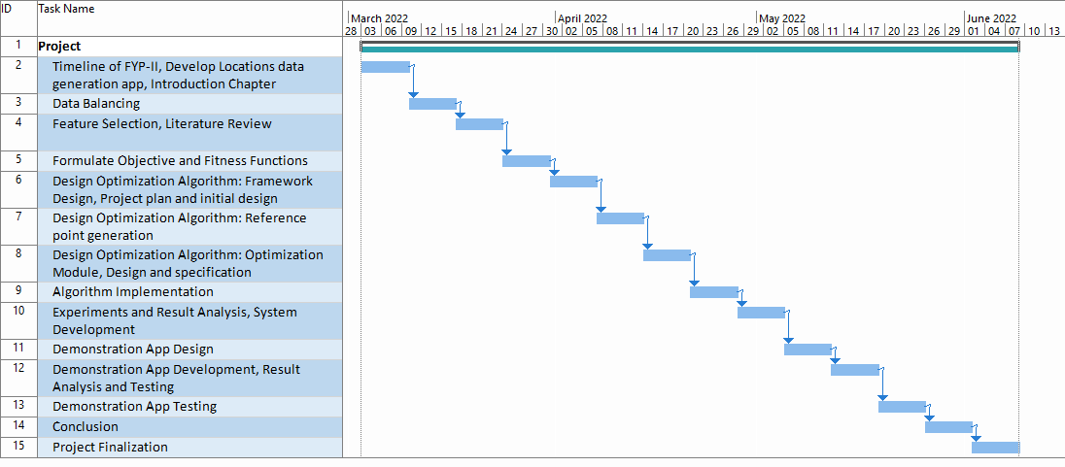

**Functional Requirement:**

Following are a few functional requirements of the system:

• The app should devise a route that minimizes the travel time.

• The app should be able to plan effective routes.

• The app should suggest the best rider in a particular time.

**Non Functional Requirement:**

Following are a few non-functional requirements of the system:

• The application should provide full data security.

• Accuracy in planning routes should be highly ensured

• The app should be efficient enough to run on maximum devices.

• The response time of the app should not exceed a few seconds.

**HARDWARE REQUIREMENT:**

* CORE i3 OR more
* X86_64 CPU ARCHITECHTURE, 2ND Generation Intel Core or newer.
* 4 GB RAM or More
* 20 GB of available disk space minimum (Visual Studio IDE)