FYP-II Chapter

4

Group # 5

Routing Optimization System

**Introduction:**

Design and specification is an essential part of any implementation of project. In this chapter we will elaborate our project deeply with the help of diagram that is based according to our based research. We are going to explain our algorithm with the help of flow chart to show the flow of algorithm that will work in optimization of route.

The purpose of making the flow chart diagram to guide the direction of algorithm and to how the system will work in the implementation of all possible steps.

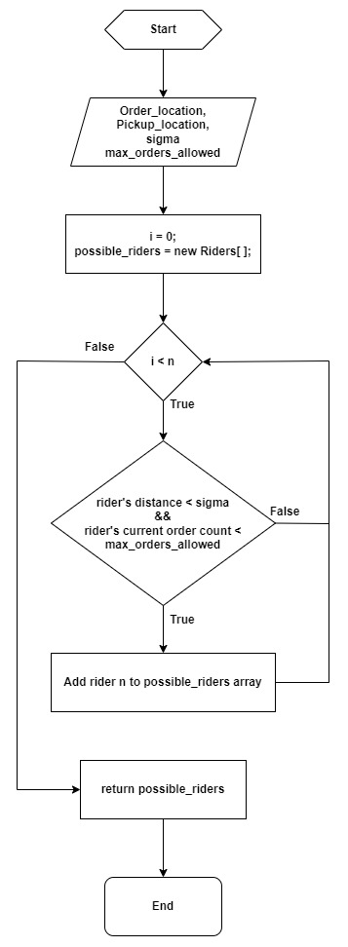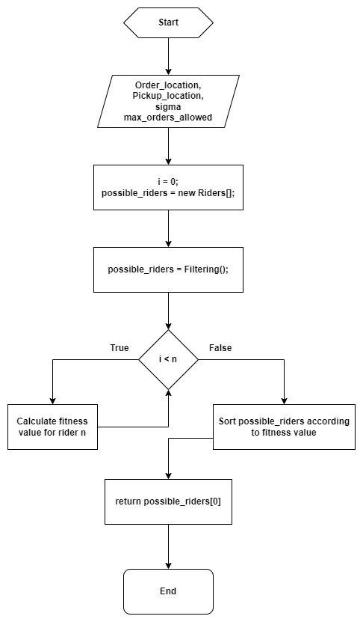

**Summary:**

This is research based project so we don’t have any practical implementation except our research. The above flow chart of algorithm is drawn according to our research on optimization of route. We will discuss this algorithm in detail in next chapter.