# Implementation Plan:

|  |
| --- |
| Development / Research Methodology: *(Please describe the technical details and justification of your development and research plan. The block diagrams, system flow charts, high level algorithm details etc. have to be provided in this section.* ***Maximum 3000 words.****)* |
| **Implementation Plan: Complete your FYP-2 plan (In FYP-2 you work on your development timeline (e.g., design front-end, design bac-end, coding……………). Please list and describe the principal milestones and associated deliverables of the development phase.** *The timing of milestones is also to be shown in the Gantt chart in Annexure-A.*   |  |  |  |  |  | | --- | --- | --- | --- | --- | | **No.** | **Elapsed time since start of the project-ii** | **Tasks** | **Milestones** | **Chapters/Deliverables** | | 1. | Week 1 | Timeline of FYP-2 |  |  | | 2. | Week 2 |  |  | Chapter 1 | | 3. | Week 3 |  |  |  | | 4. | Week 4 |  |  | Chapter 2 | | 5 | Week 5 |  |  |  | | 6 | Week 6 |  |  | Chapter 3 | | 7 | Week 7 |  |  |  | | 8 | Week 8 |  |  | Chapter 4 | | 9 | Week 9 |  |  |  | | 10 | Week 10 |  |  |  | | 11 | Week 11 |  |  |  | | 12 | Week 12 |  |  |  | | 13 | Week 13 |  |  |  | | 14 | Week 14 |  |  |  | |
| **(Please add more rows if required.)** |

# Annexure–A: Project Schedule / Milestone Chart

***(Project schedule using MS-Project (or similar tools) with all tasks, deliverables, milestones, dependencies.)***

***Example:***

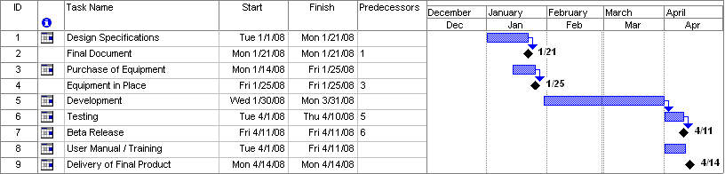

**SPECIMEN**