**The Islamia University of Bahawalpur**

**Department of Software Engineering**

**Faculty of Computing**



**Software Design Document (SDD)**

**For**

**School Management System**

***By***

**Student Name: Usama Anwer**

**Roll No: F20BSEEN1E02044**

**Section: Evening A**

**Session: Spring 2020 – 2024**

**Supervisor:Dr. Daler Ali Awan**

**Bachelor of Science in Software Engineering**

**Revision History**

|  |  |  |  |
| --- | --- | --- | --- |
| **Date** | **Description** | **Author** | **Comments** |
| <date> | <Version 1> | <Your Name> | <First Revision> |
|  |  |  |  |
|  |  |  |  |
|  |  |  |  |

**Document Approval**

The following Software Design Document (SDD) has been accepted and approved by the following:

|  |  |  |  |
| --- | --- | --- | --- |
| **Signature** | **Printed Name** | **Title** | **Date** |
|  | . | Supervisor, **SENG-4301** | <date> |
|  |  |  |  |
|  |  |  |  |

**Table of Contents**

1. Introduction 3

1.1. Purpose 3

1.2. Scope 4

1.3. Overview 4

2. System Overview 4

3. System Architecture 4

3.1. Architectural Design 4

3.2. Decomposition Description 5

3.3. Design Rationale 5

4. Data Design 5

4.1. Data Description 5

4.2. Data Dictionary 5

5. Component Design 5

6. Human Interface Design 6

6.1. Overview of User Interface 6

6.2. Screen Images 6

6.3. Screen Objects and Actions 6

## 1. Introduction

## 1.1. Purpose

## This software design document (SDD) outlines the architecture and system design of the School Management System, a web-based application developed using ASP.NET technology. It aims to provide a comprehensive overview of the system's components, their interactions, and the design decisions made during development.

## 1.2. Scope

1. The software product to be produced is a comprehensive School Management system developed using ASP.NET technology.
2. The software will streamline various administrative tasks within schools, including student registration, fee management, attendance tracking, score assignment, learning material uploads, online classes and much more. It will facilitate secure communication channels between administrators, teachers, students, and parents.
3. **Executive-Level Summary:** Our School Management ERP system stands as a transformative solution, digitally enhancing educational institutions. It combine administrative, teaching, and communication facets into a unified platform.

**2. System Overview**

The School Management System is a comprehensive and integrated platform designed to revolutionize the administrative, educational, and communication processes within educational institutions. This system is meticulously crafted to address the specific challenges faced by schools and provide an efficient, secure, and user-friendly solution for administrators, teachers, students, and parents.

**3. System Architecture**

## 3.1. Architectural Design

1. **Admin Module:**

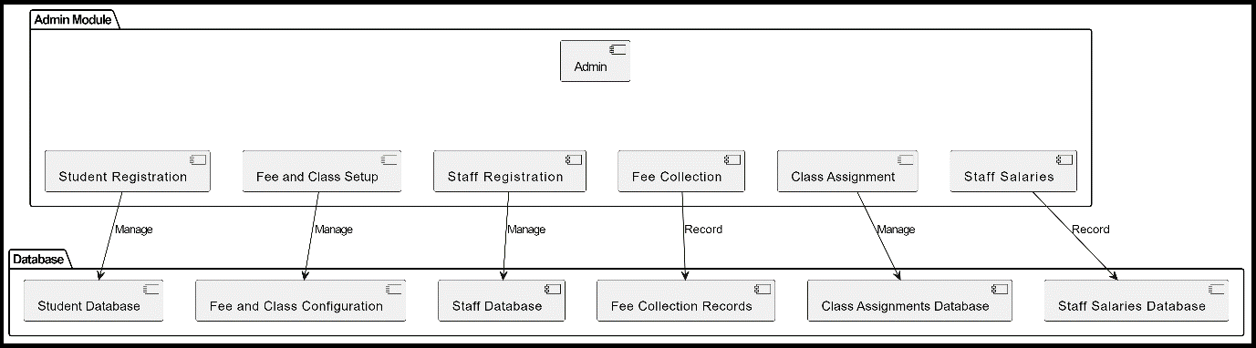

1. **Teacher Module:**

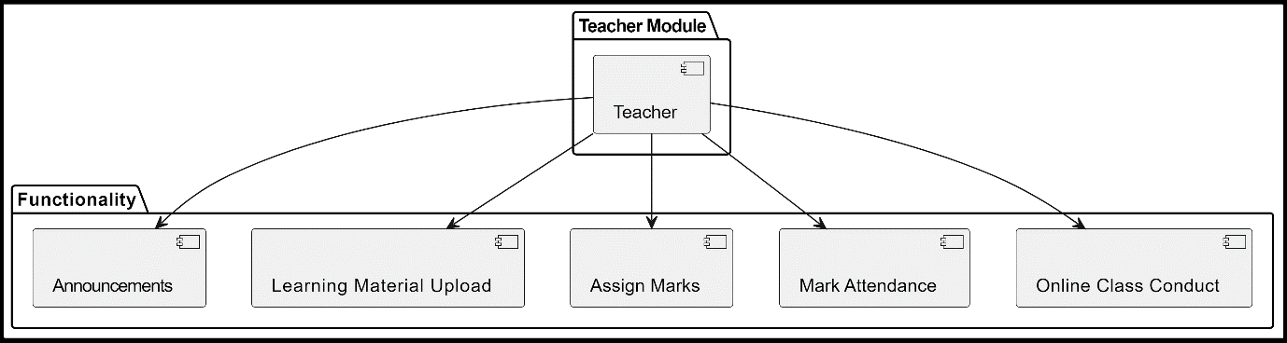

1. **Student Module:**

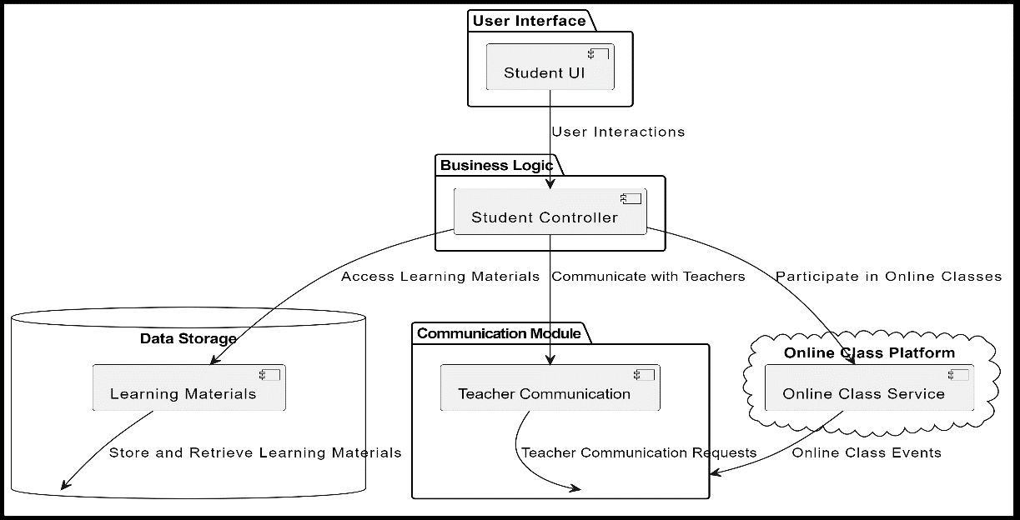

1. **Parent Module:**

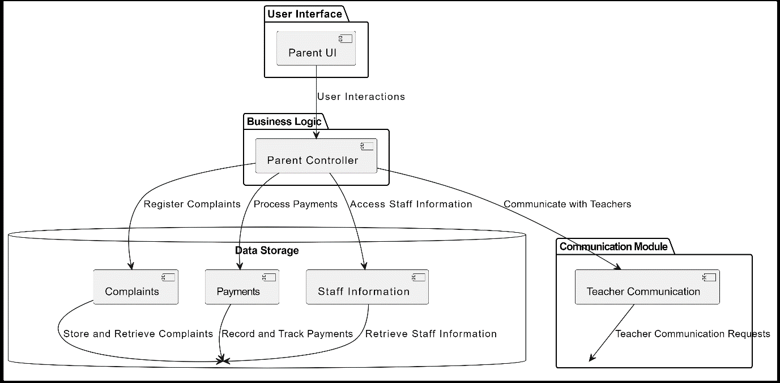

**Sequence Diagrams:**

* **Admin Module:**

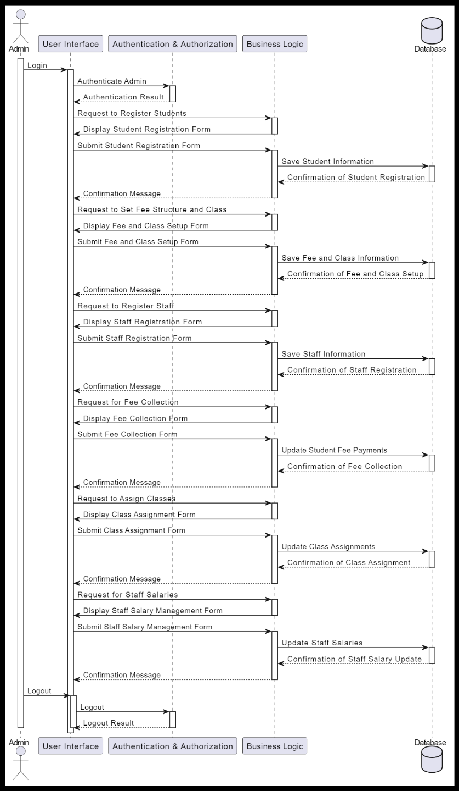

* **Teacher Module:**

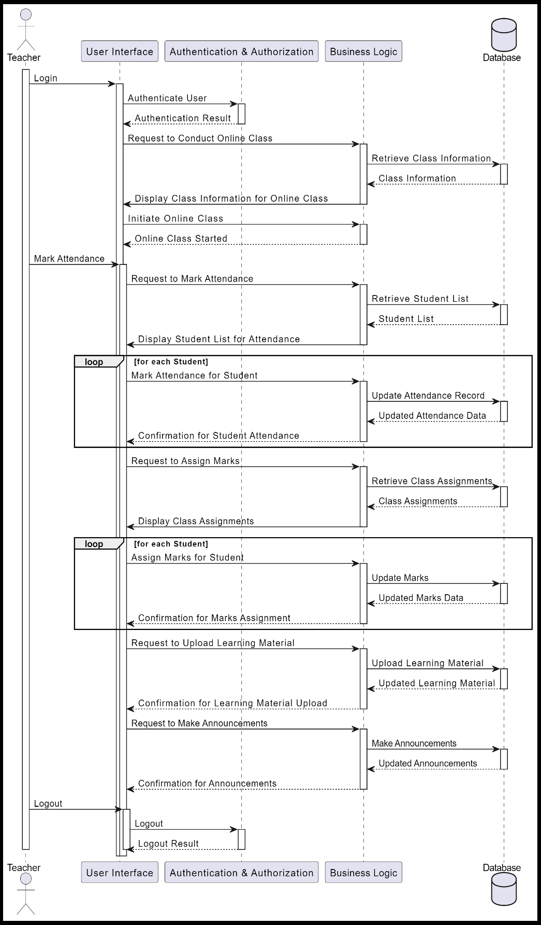

* **Student Module:**

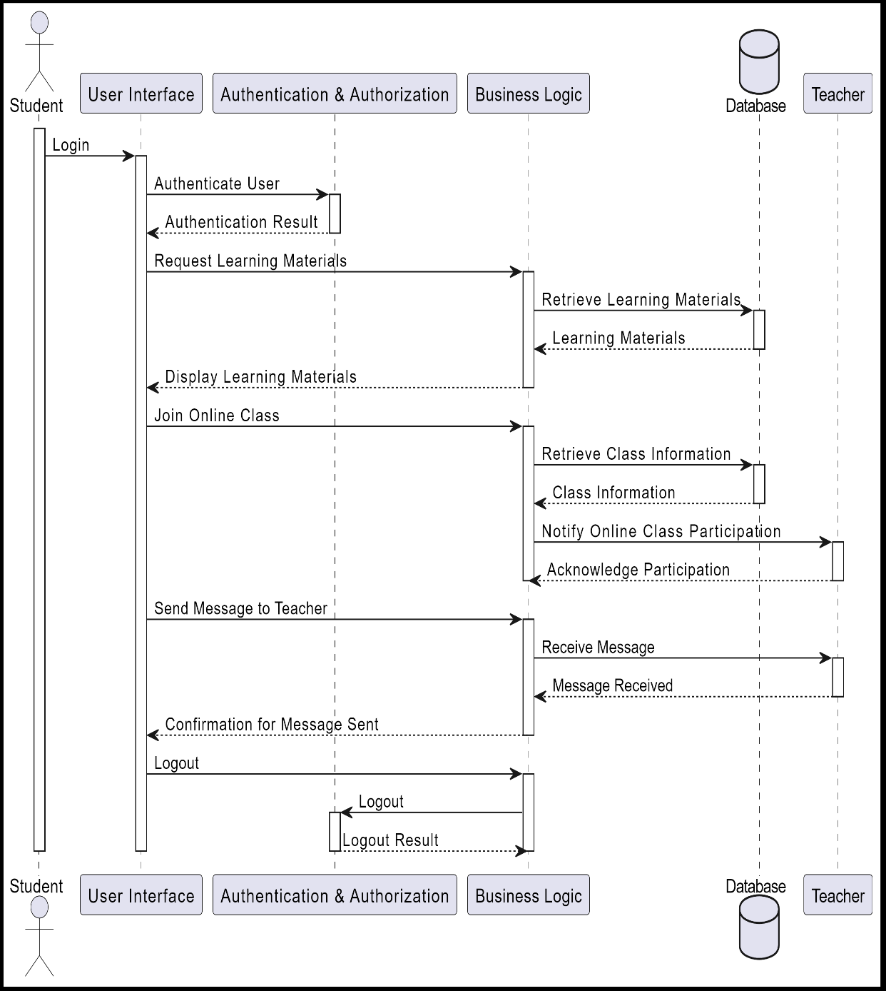

* **Parent Module**

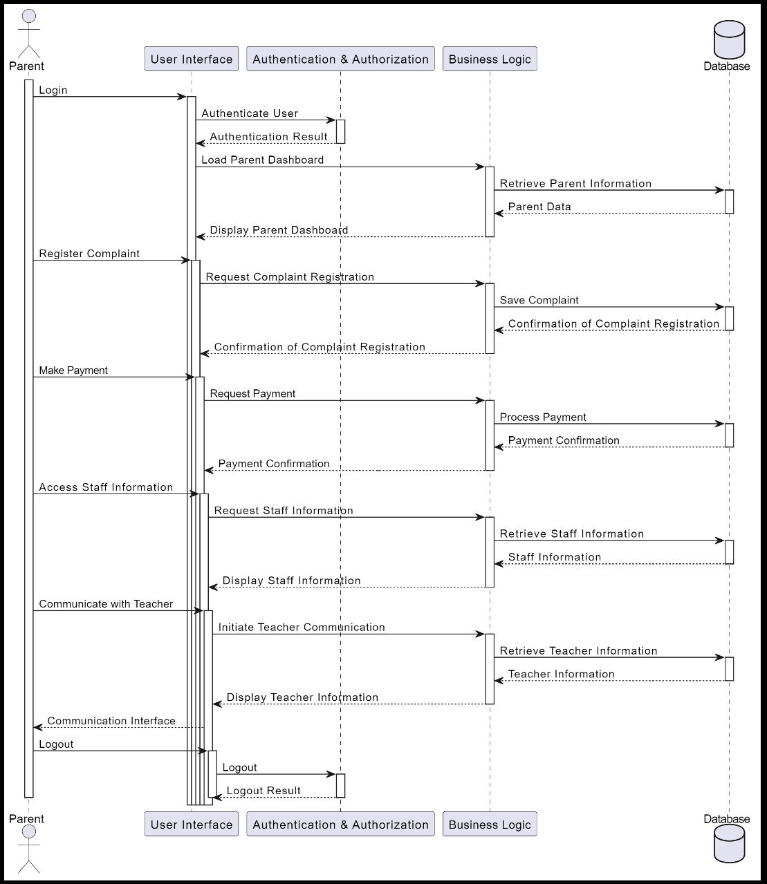

* **Activity Diagram**

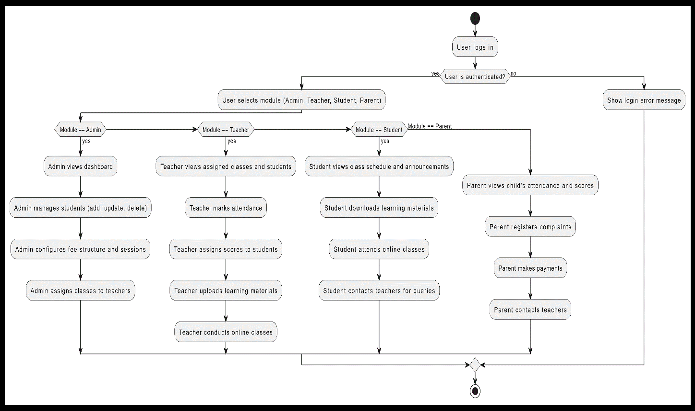

* **Class Diagram:**

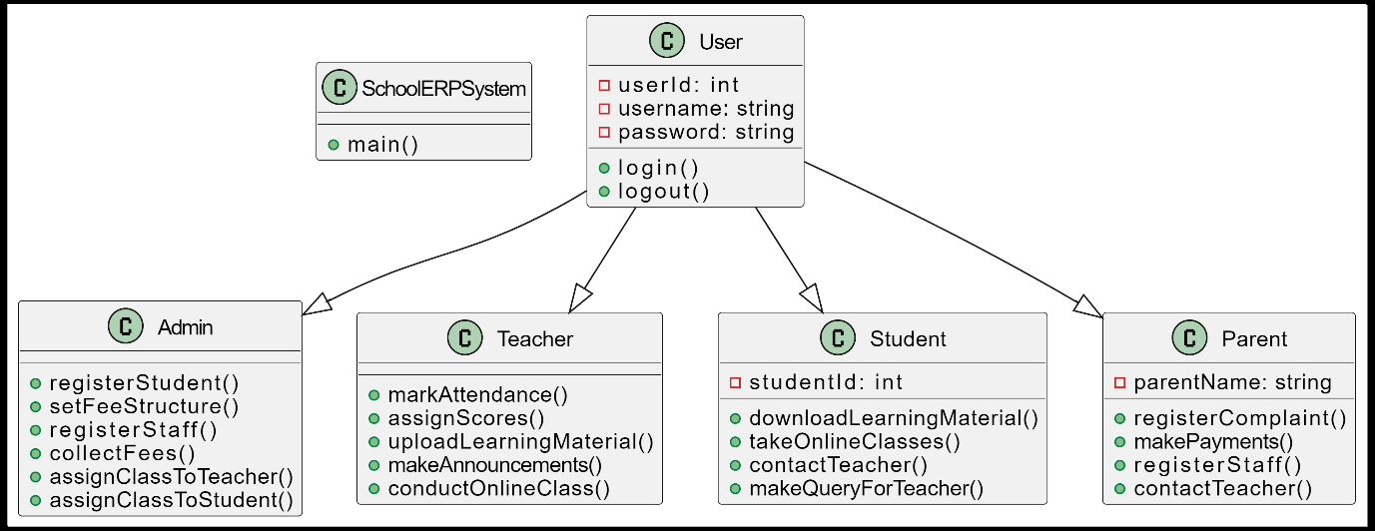

## 3.2. Decomposition Description

* **Top Level Data Flow Diagram:**

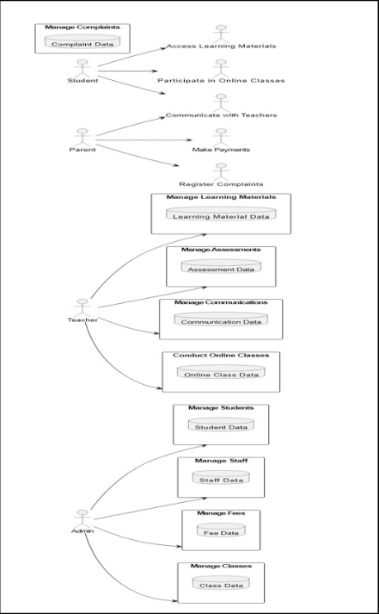

## 3.3. Design Rationale

The selected architecture for the School Management System is a modular and layered architecture, which includes separate modules for Admin, Teacher, Student, and Parent. Each module encapsulates specific functionalities, promoting a clear division of responsibilities and facilitating easier maintenance and scalability. Here's the rationale for choosing this architecture along with considerations of critical issues and trade-offs.

# 4. Data Design

## 4.1. Data Description

1. **Information Domain Transformation:**
   * **Explanation:** The information domain of the School ERP System encompasses various entities like students, teachers, classes, attendance, scores, learning materials, fees, announcements, complaints, payments, and staff information. This information needs to be structured and organized to facilitate efficient processing and retrieval.
   * **Implementation:** Each entity in the information domain is transformed into corresponding data structures within the system. For example, students, teachers, and staff information may be represented as separate tables in a database, with attributes like names, IDs, and contact details.
2. **Databases and Data Storage:**
   * **Explanation:** The School Management System relies on a central database, specifically Microsoft SQL Server, to efficiently manage and organize data. This database plays a crucial role in maintaining consistency and integrity across different modules of the system.
   * **Implementation:** The choice of Microsoft SQL Server as the database management system (DBMS) is based on considerations such as scalability, performance, and the developer's familiarity with the technology. Tables within the SQL Server database store data related to each entity, ensuring a structured and organized data repository.

## 4.2. Data Dictionary

1. **Admin:**
   * **Attributes:**
     + UserID (int): Unique identifier for the admin user.
     + Username (varchar): Username for admin login.
     + Password (varchar): Password for admin login.
   * **Methods:**
     + Login(username: varchar, password: varchar): Authenticates the admin user.
2. **Teacher:**
   * **Attributes:**
     + TeacherID (int): Unique identifier for the teacher.
     + Name (varchar): Full name of the teacher.
     + Subject (varchar): Subject taught by the teacher.
   * **Methods:**
     + MarkAttendance(studentID: int, date: date, status: bool): Records student attendance.
     + AssignMarks(studentID: int, subject: varchar, marks: int): Assigns marks to a student.
3. **Student:**
   * **Attributes:**
     + StudentID (int): Unique identifier for the student.
     + Name (varchar): Full name of the student.
     + Class (varchar): Class in which the student is enrolled.
   * **Methods:**
     + AccessLearningMaterial(): Allows the student to access learning materials.
     + ParticipateOnlineClass(): Enables the student to participate in online classes.
     + ContactTeacher(message: varchar): Sends a message to a teacher.
4. **Parent:**
   * **Attributes:**
     + ParentID (int): Unique identifier for the parent.
     + Name (varchar): Full name of the parent.
     + ChildName (varchar): Full name of the associated child.
   * **Methods:**
     + RegisterComplaint(complaintText: varchar): Registers a complaint.
     + ProcessPayment(amount: decimal): Processes a payment for fees.
     + AccessStaffInformation(): Allows access to information about school staff.
     + ContactTeacher(message: varchar): Sends a message to a teacher.
   * **Table’s Relation’s Diagrams:**
5. **Amdin Module:**

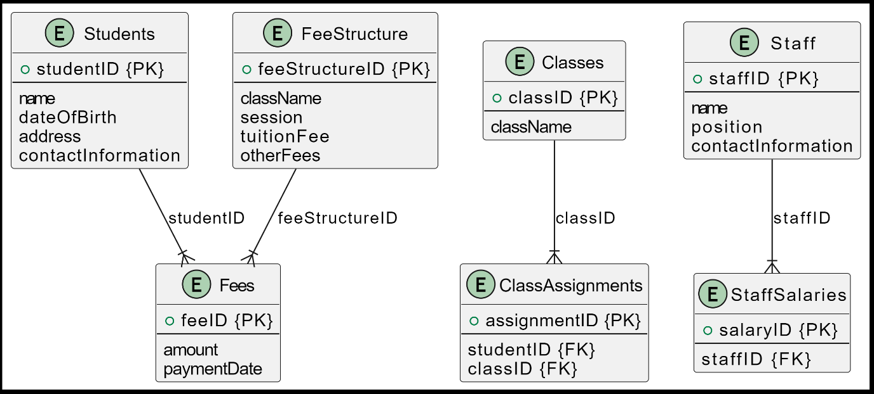

1. **Teacher Module:**

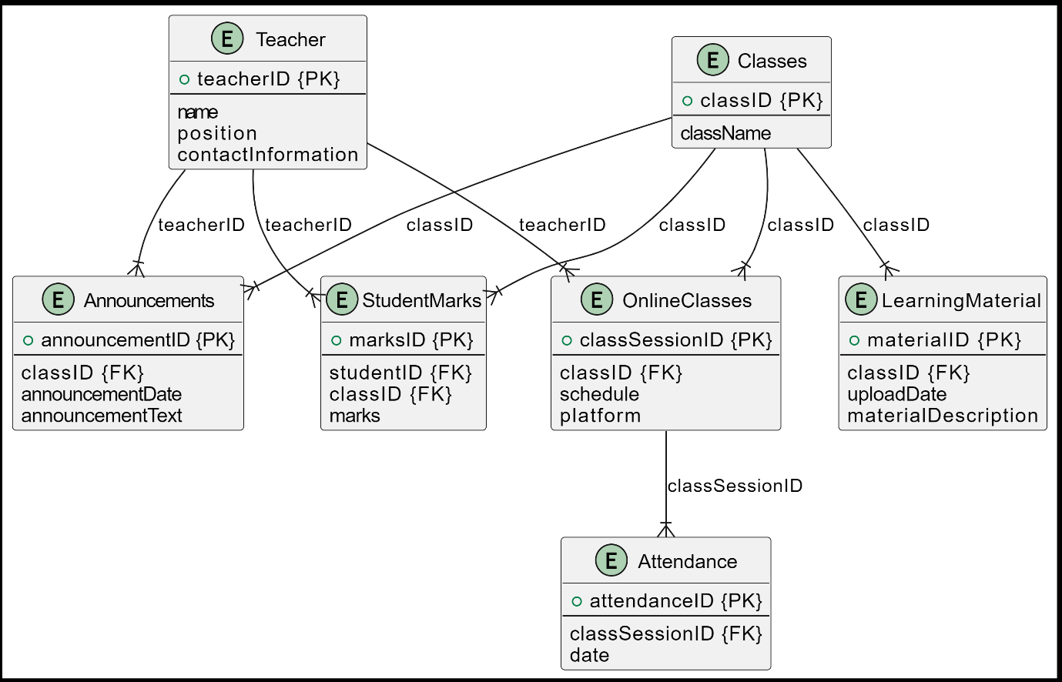

1. **Student Module:**

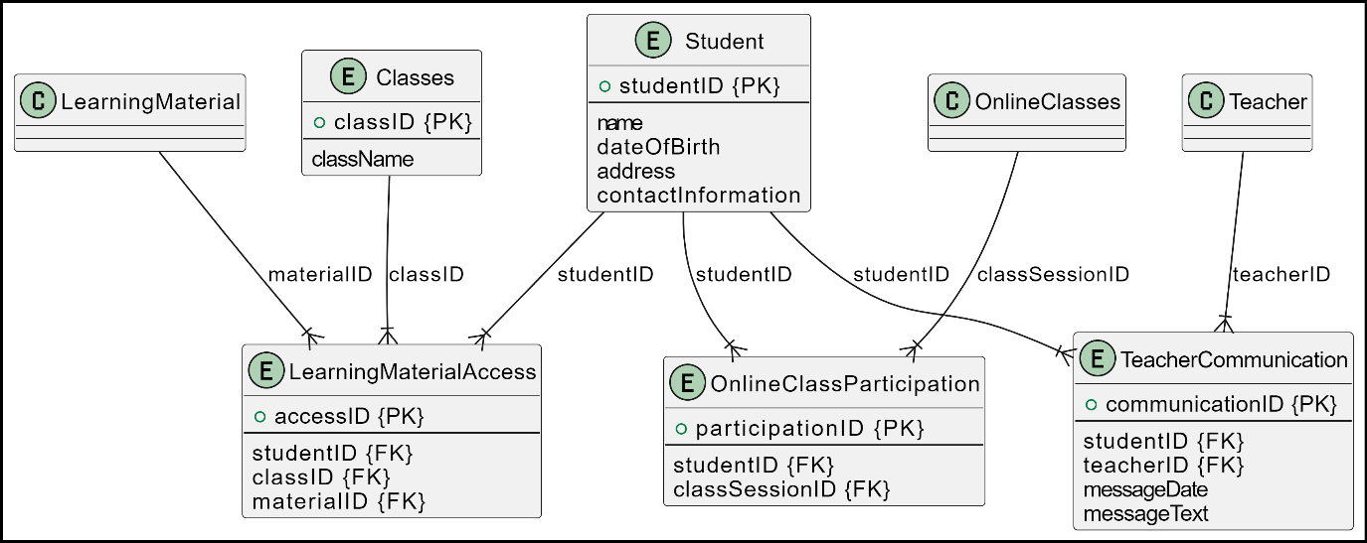

1. **Parent Module:**

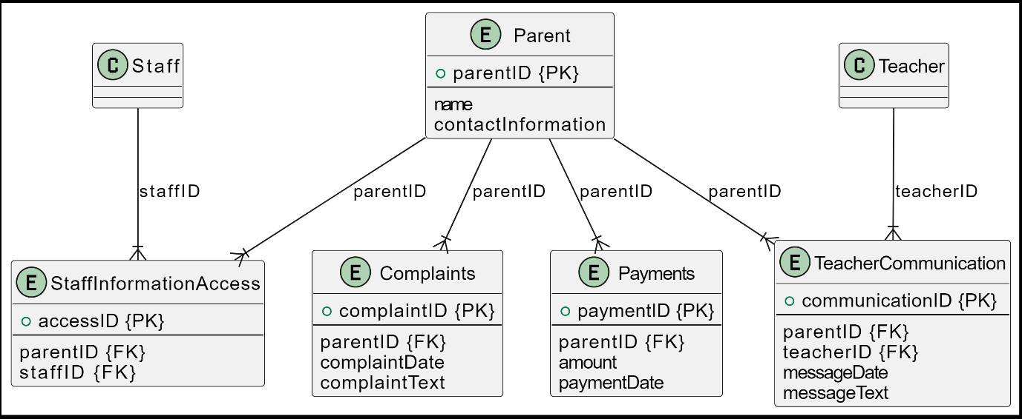

## Component Design:

1. **Admin Module:**

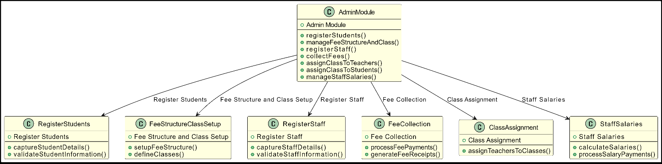

1. **Teacher Module:**

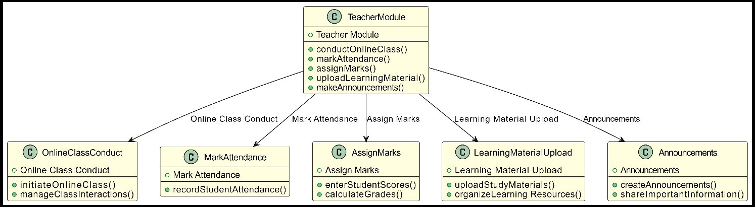

1. **Student Module:**

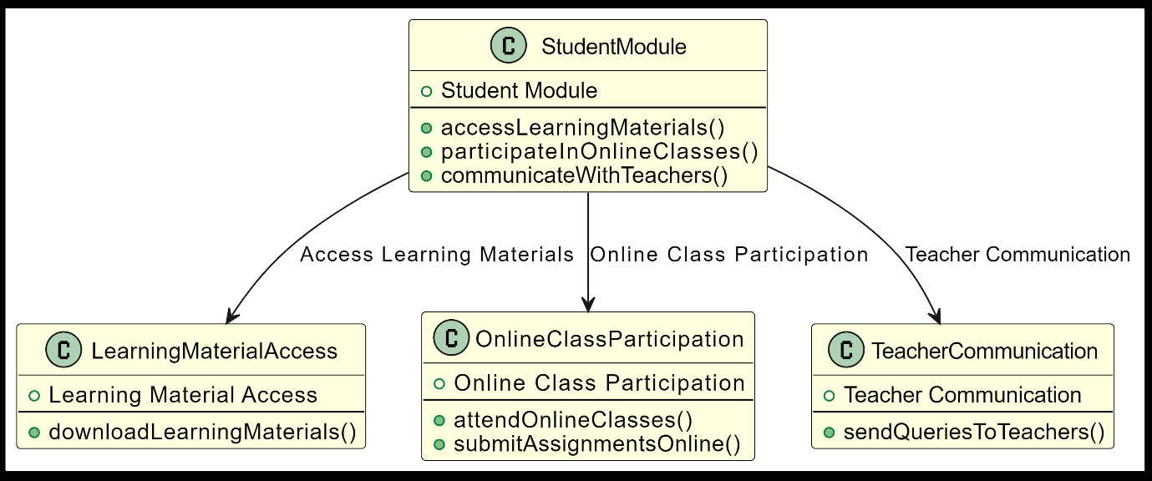

1. **Parent Module:**

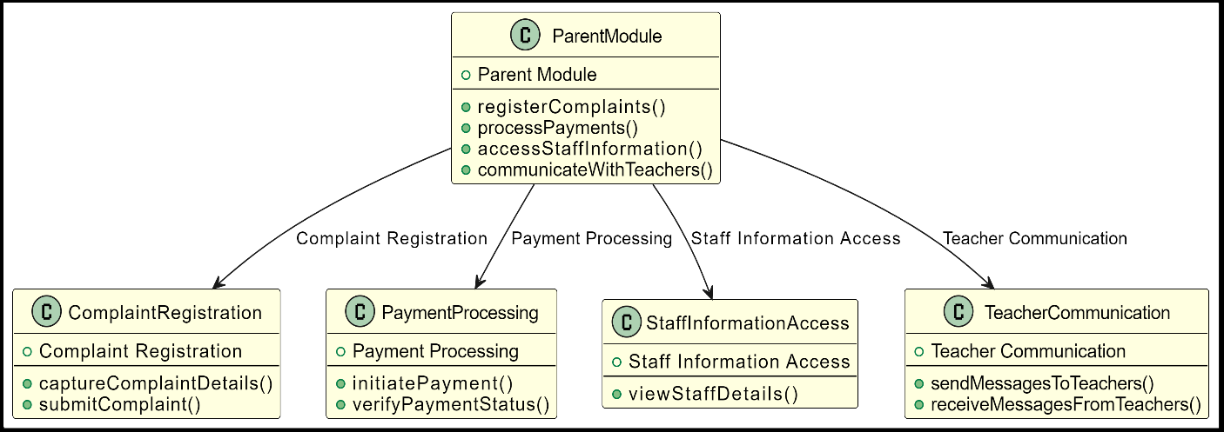

# 6. Human Interface Design

## 6.1. Overview of User Interface

1. **Admin Module:**

The Admin Module provides administrators with the tools to manage various aspects of the school, including student registration, fee management, staff registration, class assignments, and salary processing.

**User Interaction:**

* **Register Students:**
  + Admins can access a user-friendly form to input student details.
  + Feedback: Confirmation message upon successful registration, or error message if there are issues.
* **Fee Structure and Class Setup:**
  + Admins can set up and manage fee structures and class assignments.
  + Feedback: Confirmation messages for successful updates or error messages for any issues.
* **Register Staff:**
  + Admins can add new staff members to the system.
  + Feedback: Confirmation messages or error notifications based on the success of staff registration.
* **Fee Collection:**
  + Admins can collect fees from students.
  + Feedback: Confirmation messages for successful transactions or error notifications for any failures.
* **Class Assignment:**
  + Admins can assign students to classes.
  + Feedback: Confirmation messages or error notifications based on the success of class assignments.
* **Staff Salaries:**
  + Admins can process salaries for staff members.
  + Feedback: Confirmation messages or error notifications for successful or unsuccessful salary processing.

1. **Teacher Module:**

The Teacher Module empowers teachers to manage attendance, assign marks, upload learning materials, make announcements, and conduct online classes.

**User Interaction:**

* **Mark Attendance:**
  + Teachers can mark attendance for their classes.
  + Feedback: Confirmation messages or error notifications based on the success of attendance marking.
* **Assign Marks:**
  + Teachers can assign marks to students.
  + Feedback: Confirmation messages or error notifications for successful or unsuccessful mark assignments.
* **Learning Material Upload:**
  + Teachers can upload learning materials for students.
  + Feedback: Confirmation messages or error notifications based on the success of material uploads.
* **Announcements:**
  + Teachers can make announcements for their classes.
  + Feedback: Confirmation messages for successful announcements.
* **Online Class Conduct:**
  + Teachers can schedule and conduct online classes.
  + Feedback: Confirmation messages for successful scheduling and conducting of online classes.

1. **Student Module:**

The Student Module offers students access to learning materials, participation in online classes, communication with teachers, and submission of queries.

**User Interaction:**

* **Learning Material Access:**
  + Students can access learning materials uploaded by teachers.
  + Feedback: Display of accessed learning materials.
* **Online Class Participation:**
  + Students can join online classes.
  + Feedback: Participation status and relevant information during online classes.
* **Communication with Teacher:**
  + Students can communicate with teachers.
  + Feedback: Message exchange with teachers.

1. **Parent Module:**

The Parent Module enables parents to register complaints, process payments, access staff information, and communicate with teachers.

**User Interaction:**

1. **Complaint Registration:**
   * Parents can register complaints.
   * Feedback: Confirmation messages for successfully registered complaints.
2. **Communication with Teacher:**
   * Parents can communicate with teachers.
   * Feedback: Message exchange with teachers.

## 6.2. Screen Images

* **Abstract Overview**(as accurate as possible)

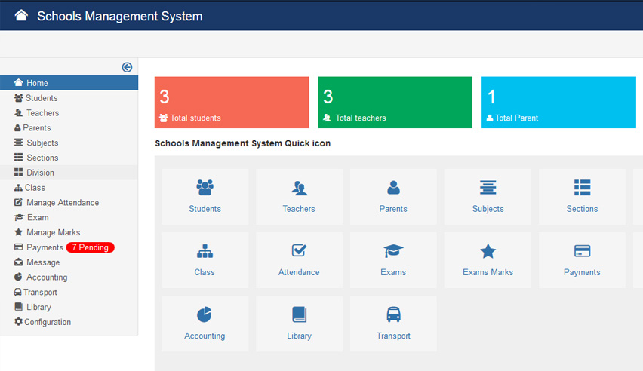

## 1. Admin Module:

* **Register Students:**

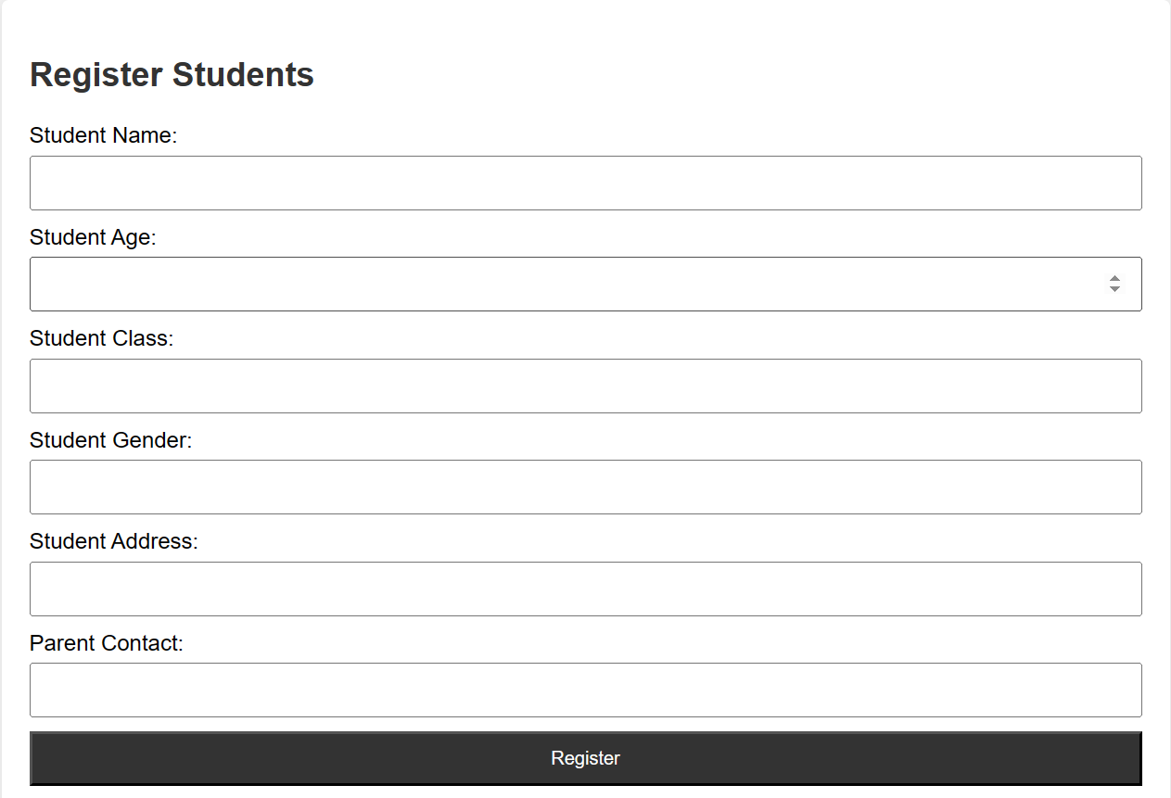

* **Fee Structure and Class Setup:**

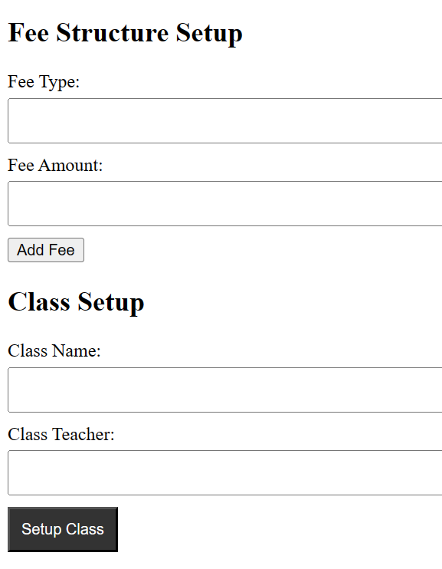

* **Register Staff:**

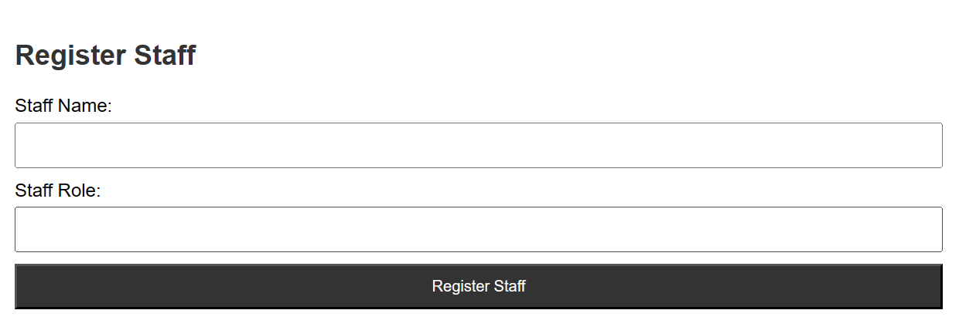

* **Fee Collection:**

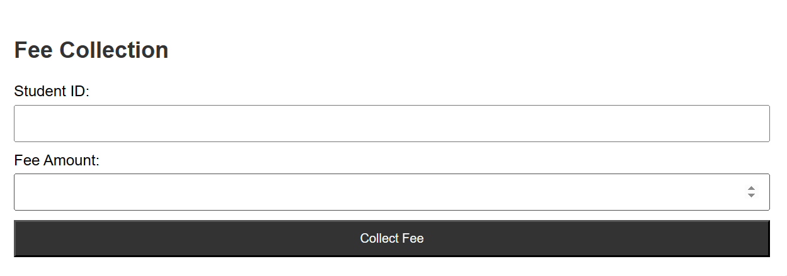

* **Class Assignment:**

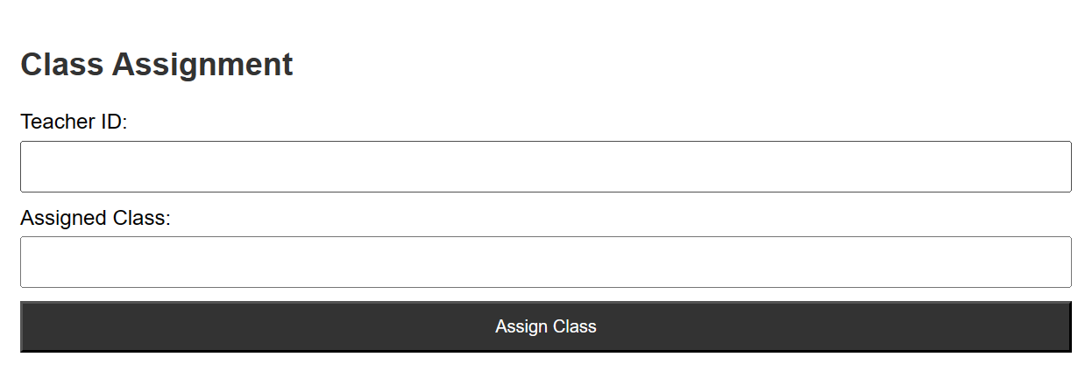

* **Staff Salaries:**

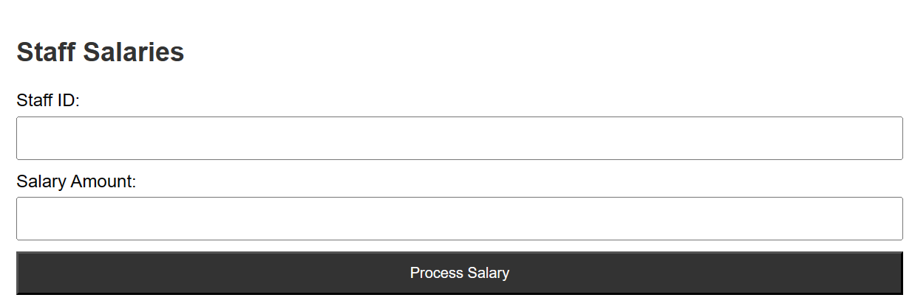

## Teacher Module:

* **Mark Attendance:**

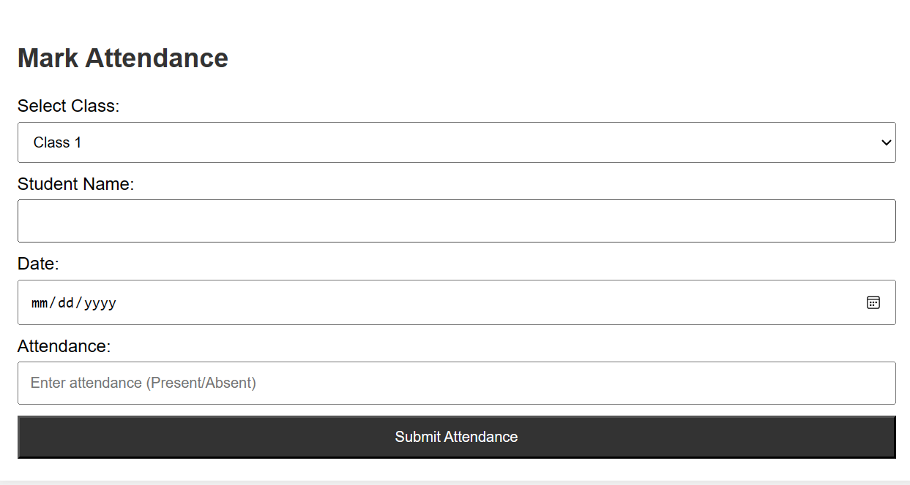

* **Assign Marks:**

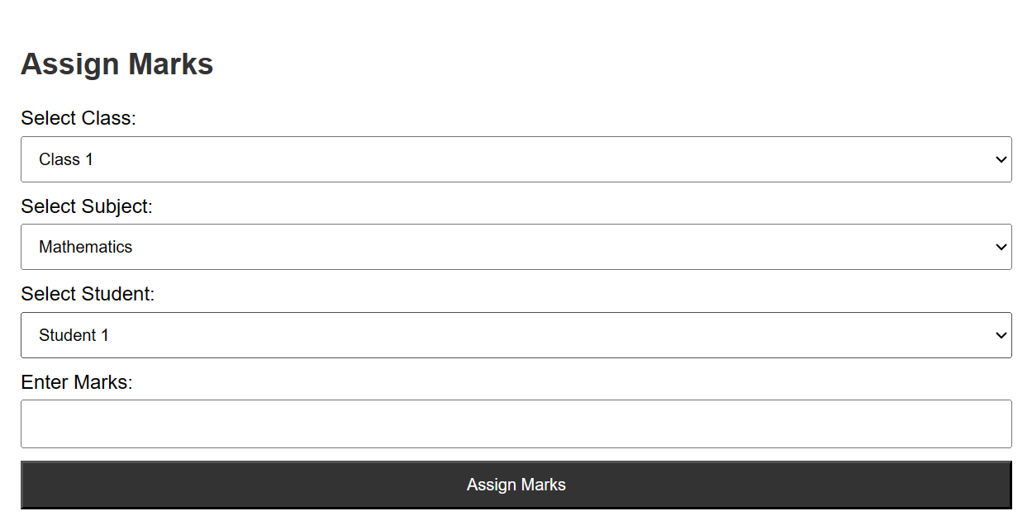

* **Learning Material Upload:**

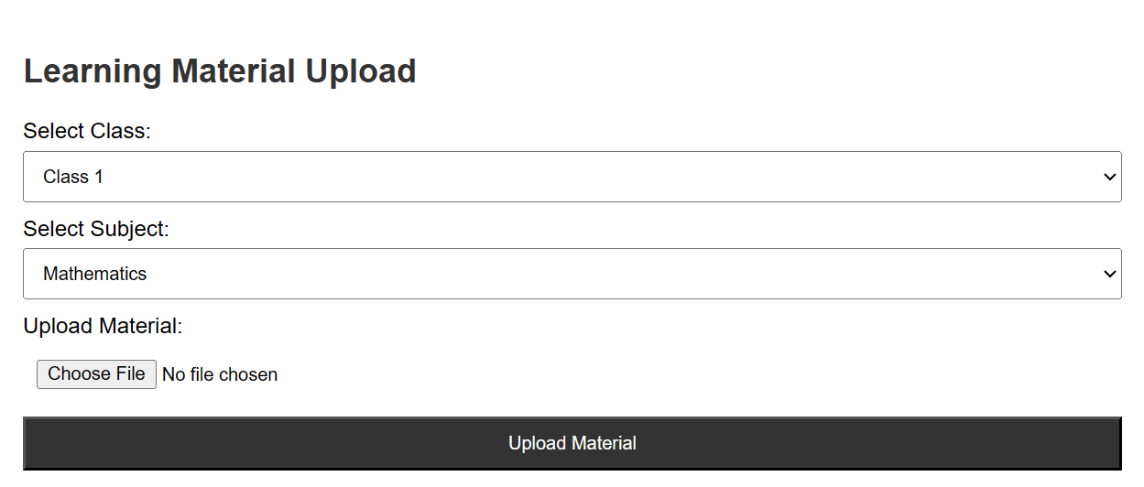

* **Announcements:**

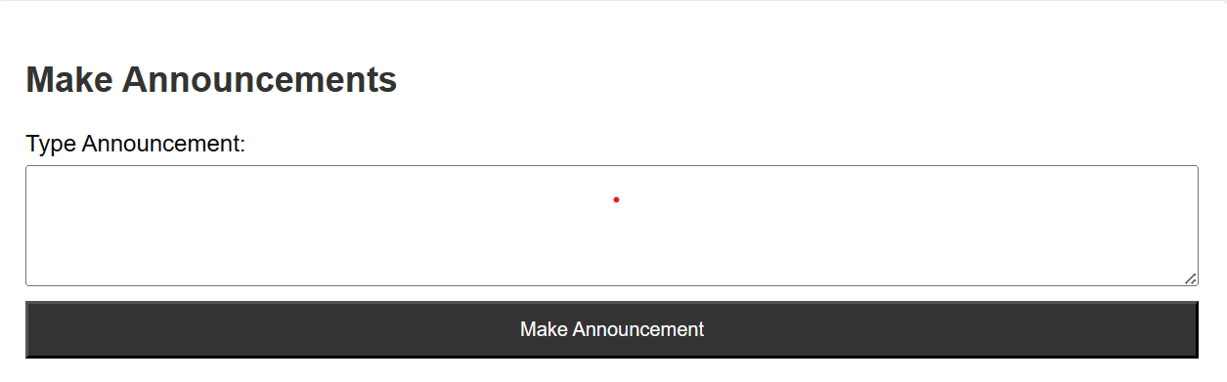

* **Online Class Conduct:**

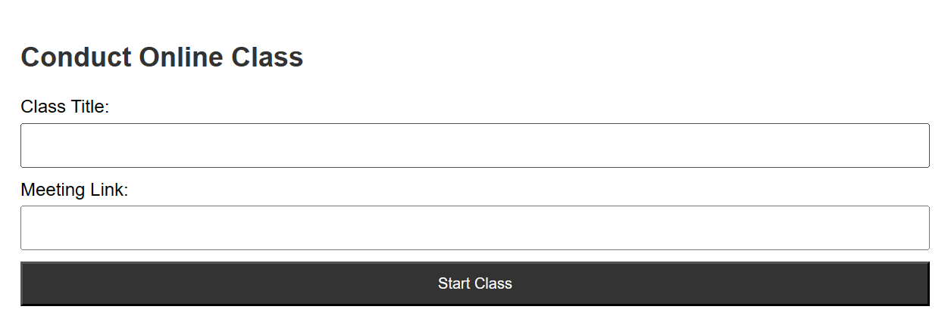

## Student Module:

* **Learning Material Access:**

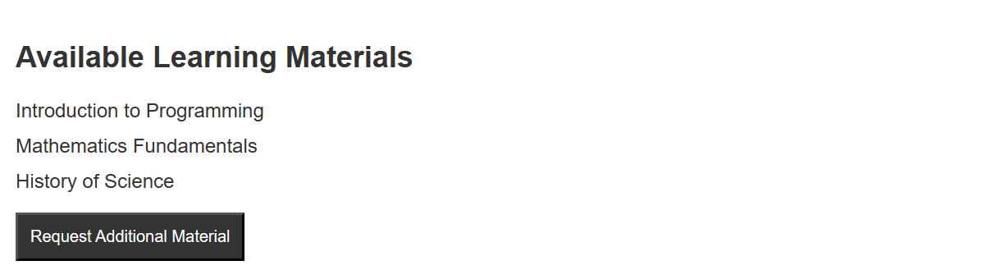

* **Online Class Participation:**



* **Query Submission:**

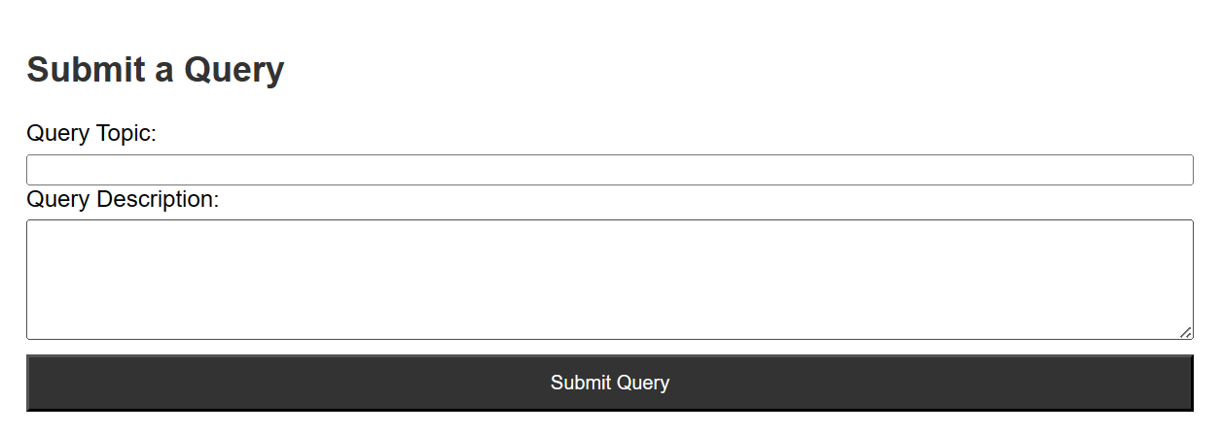

## 4. Parent Module:

* **Complaint Registration:**

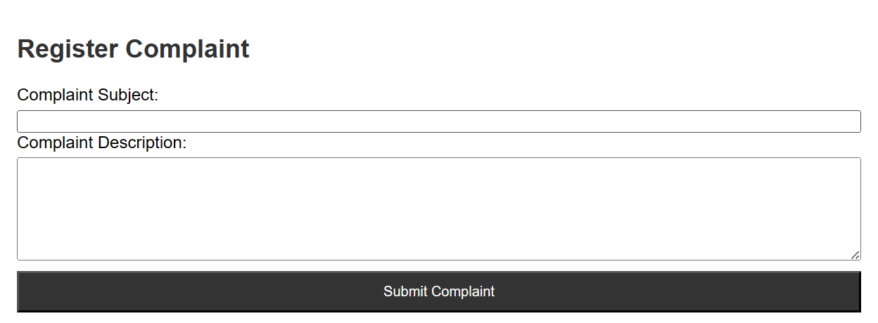

* **Teacher Communication:**

