Name: Usamah Abdur Rehman
Class: BSCS 5-C
Reg#123560
Assignment #1

This document contains the information about the digital Quiz system. The program is made in Python using Tkinter for GUI. The database is also used at backend to store user data.
Start the program and you’ll see a Log in window with two buttons on it. If you are a new user, you can sign up using, sign up button and sign in if you are already registered.

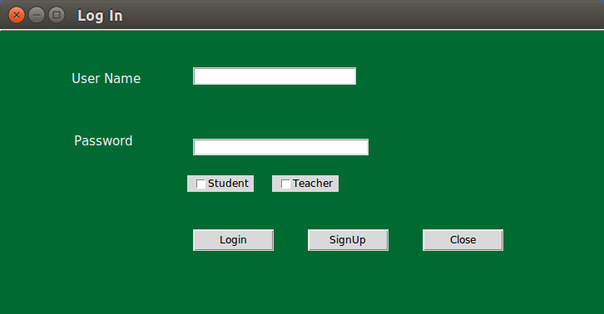

If you put the wrong credentials , then window will prompt up and say user nama and password is incorrect.
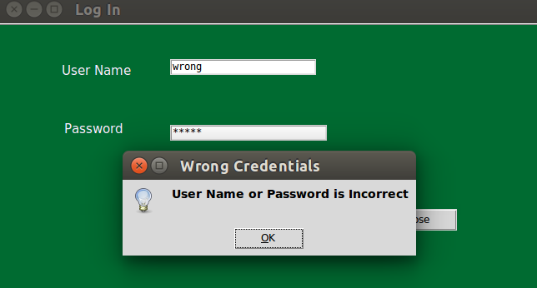

If you are new user Sign up by clicking signup button, after clicking following window will appear enter your username and password and select the appropiate check the button depending on if you want to signup as teacher or student.
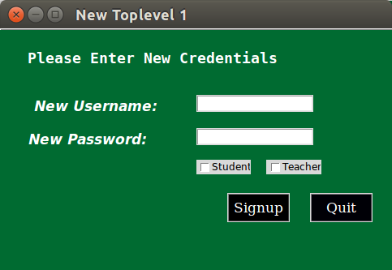

Oknow you sign up , its time to log in
TEACHER VIEW
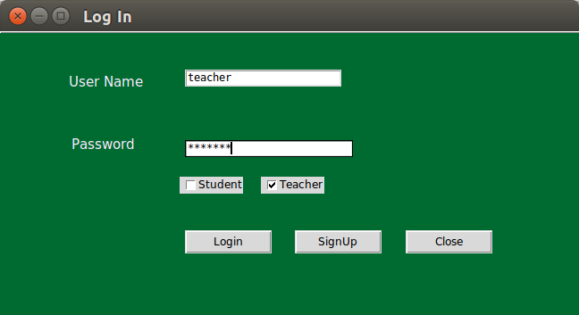

After the teacher log in following window will appear it allow him to enter the quiz title, description,quiz id(random ,its his own choice) and number of question he want to enter
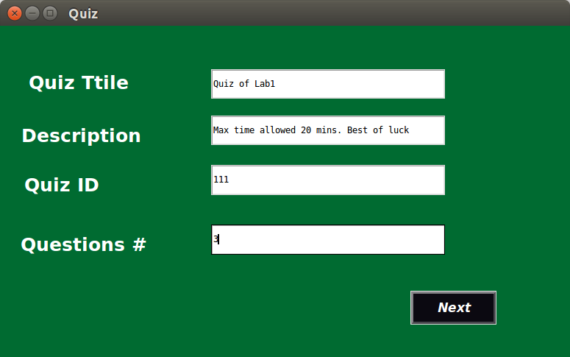

After pressing next button following window will appear. Teacher enter the question and select the type of question.
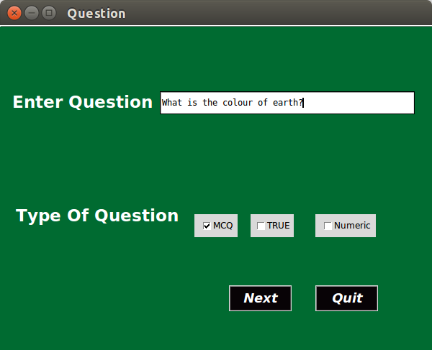

If he want to quit he can quit by pressing quit button and following window appear
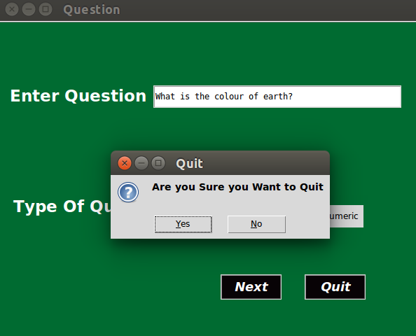

Now he select the type MCQ of question so he will see the following window when he press next button . He has to give options a,b,c,d and then enter which one is correctly

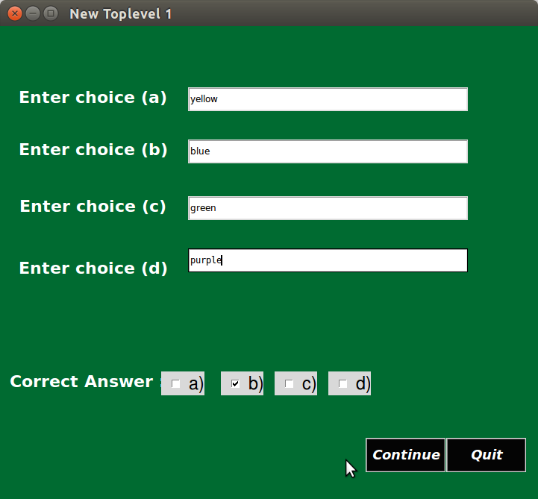

After press continue it will go again to enter question window where he enter next question and give type of the enter question window will according to the amount of question enterd by teacher
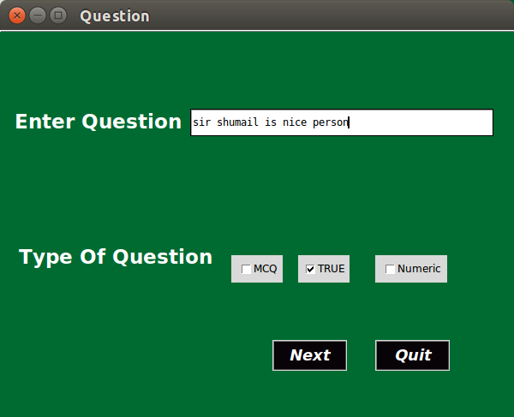

for true false question following window will appear

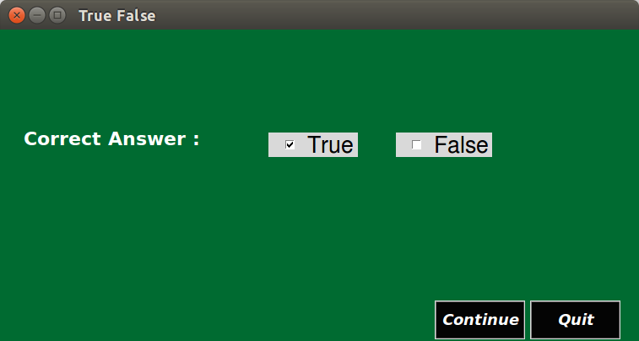
Similarly he can add numeric question as well .when all the questions enter following window will appear

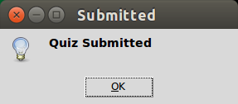

STUDENT VIEW:
First student will log in
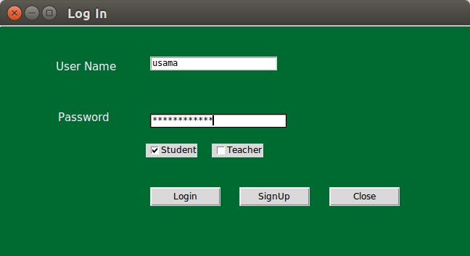

Then he will se the title of quiz and description of quiz which was entered by teacher in following window
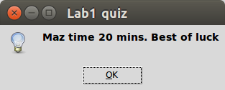

Then when he enter he will see quiz and when he click on submit his marks will show to him

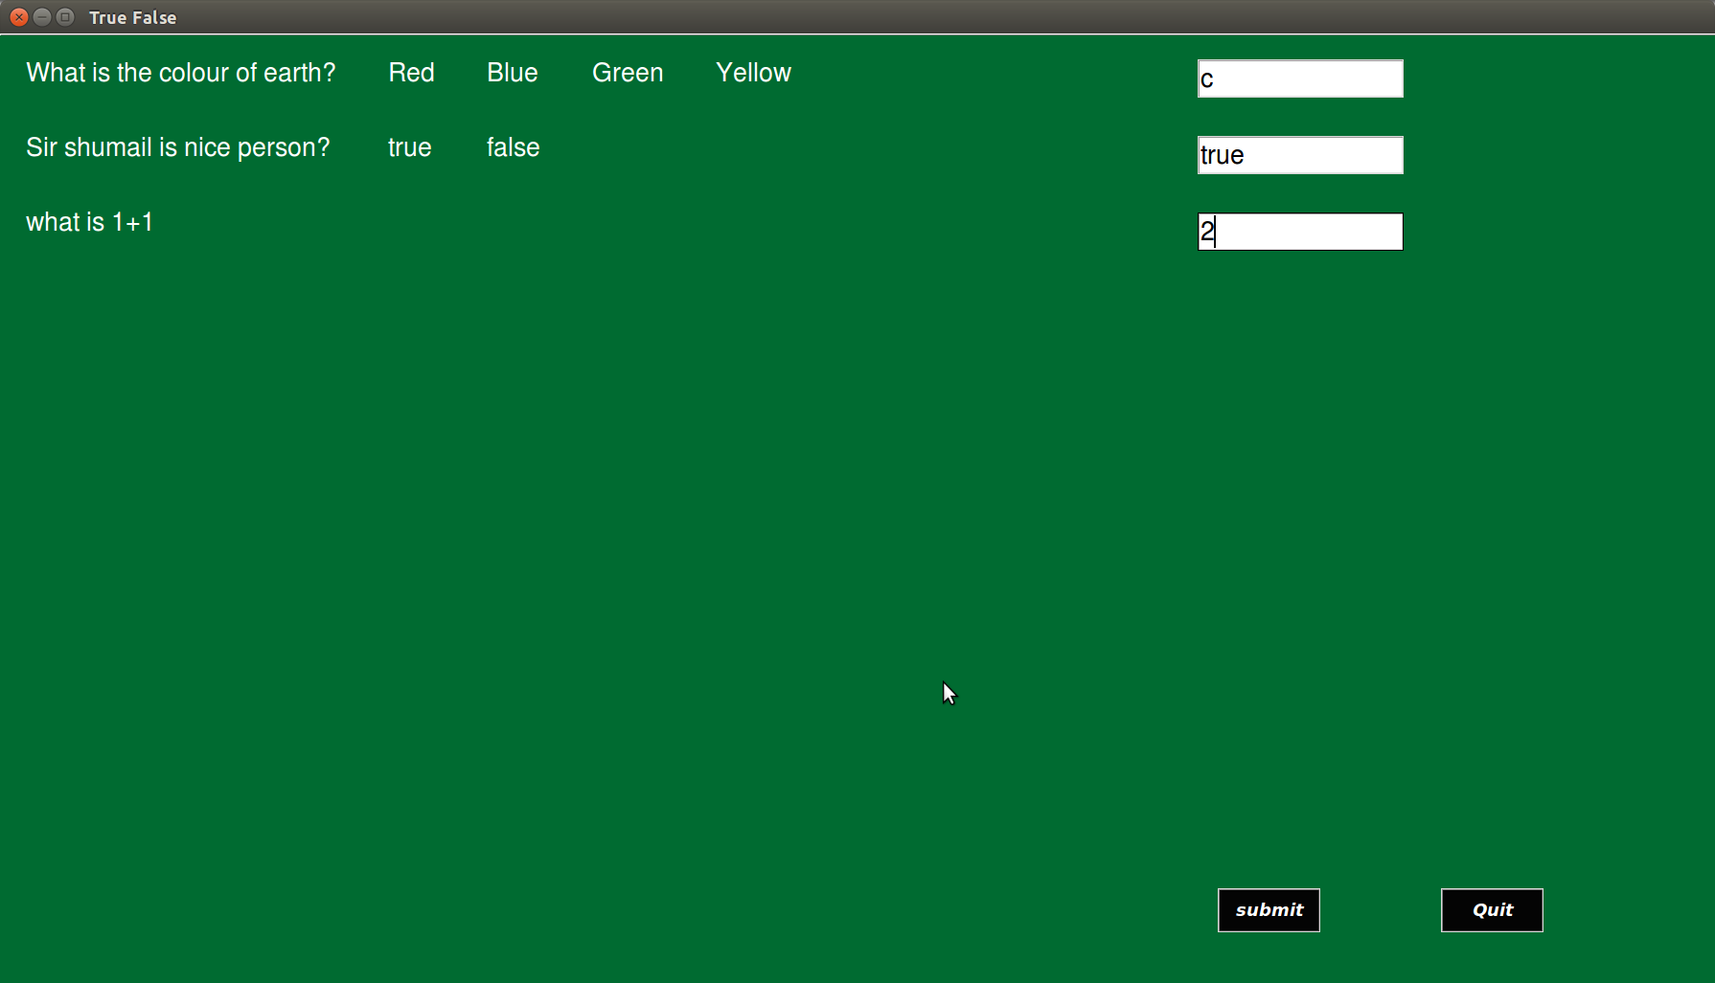

Press submit and marks will shown

