**Name: Usamah Abdur Rehman**

**Class: BSCS 5c**

**USER PROFILE:**

**My user is rich young boy who want high speed car.**

**Transmission VS Gear:**

**Source Code:** barplot(mtcars$gear,ylab="Gear",xlab="Transmition",col=rainbow(15),names.arg=mtcars$am,main="Transmission Vs Gear",las=2)

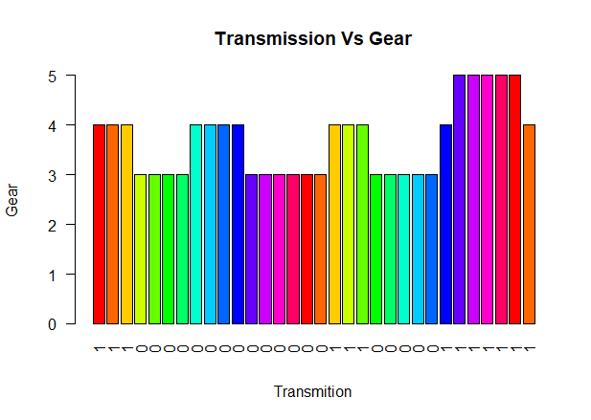

**Customer Will look car with more gear & check if car is automatic or not.**

**Cylinders VS MPg:**

**Source Code**: barplot(mtcars$cyl,ylab="No. of cylinders",xlab="Miles Per gallon",col=rainbow(15),names.arg=mtcars$mpg ,main="No. of Cylinders Vs MPG",las=2)

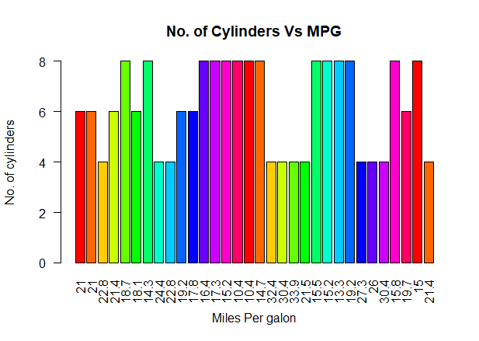

**User will check How many cylinders is in the car and How much Miles per gallon it take**

**Qsecs VS CC:**

**Source Code:**

barplot(mtcars$qs,ylab="Qsec",xlab="CC",col=rainbow(15),names.arg=mtcars$disp,main="Qsec Vs Engine CC",las=2)

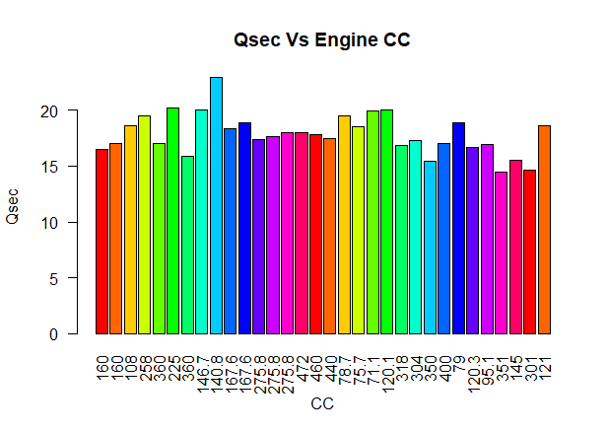

**User will be interested in engine with high CC**

**Horse Power VS Weight:**

barplot(mtcars$hp,ylab="Horse Power",xlab="Weight",col=rainbow(15),names.arg=mtcars$wt ,main="Horse Power Vs Weight",las=2)

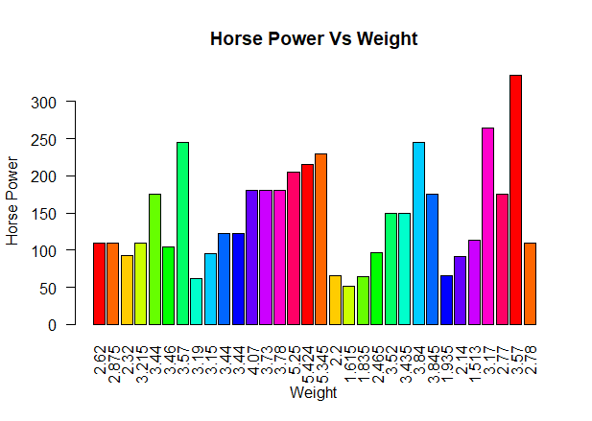

**User will check that how much horse power the car have and weight of car**

**GITHUB LINK :** <https://github.com/UsamaAR/Lab-3.git>