# Google Cloud Platform Pricing Calculator Documentation

## Table of Contents

1. Introduction
2. Step-by-Step Configuration Process
   1. Initial Landing Page
   2. Compute Engine Configuration
   3. Cloud SQL Configuration
   4. Cloud DNS Configuration
   5. Total Cost Summary
3. Service Selection Justification
   1. Compute Engine
   2. Cloud SQL
   3. Cloud DNS
4. Technical Implementation Details
   1. Infrastructure Architecture
   2. Performance Considerations
   3. Scalability and Reliability
5. Cost Optimization Analysis
   1. Resource Allocation
   2. Cost-Saving Opportunities
6. Conclusion
7. References
8. Appendix A: Detailed Cost Breakdown

## Introduction

This document provides a comprehensive analysis of cloud infrastructure costs using the Google Cloud Platform (GCP) Pricing Calculator. The configuration detailed below represents a production-ready deployment incorporating compute resources, managed database services, and domain name management capabilities. Each service has been carefully selected and configured to provide a balanced infrastructure that meets modern application hosting requirements while maintaining cost efficiency.

### Purpose and Scope

The primary objective of this analysis is to design and cost-estimate a robust cloud infrastructure capable of supporting enterprise-grade applications. The infrastructure components have been selected based on several key considerations:

1. **Performance Requirements**
   * Compute resources sized for moderate to heavy workloads
   * Database configuration optimized for concurrent operations
   * DNS services scaled for high-volume query handling
2. **Reliability and Availability**
   * Strategic region selection for optimal latency
   * Managed services for reduced operational overhead
   * Redundant infrastructure components
3. **Cost Optimization**
   * Balanced resource allocation
   * Strategic service selection
   * Consideration of long-term cost management

### Infrastructure Overview

The proposed cloud infrastructure consists of three primary components:

1. **Application Tier (Compute Engine)**
   * Handles application processing and business logic
   * Provides scalable compute resources
   * Supports various deployment configurations
2. **Data Tier (Cloud SQL)**
   * Manages persistent data storage
   * Ensures data reliability and consistency
   * Provides automated backup capabilities
3. **Domain Management (Cloud DNS)**
   * Manages domain name resolution
   * Supports multiple domain configurations
   * Ensures global accessibility

## 1. Step-by-Step Configuration Process

### 1.1 Accessing the GCP Pricing Calculator

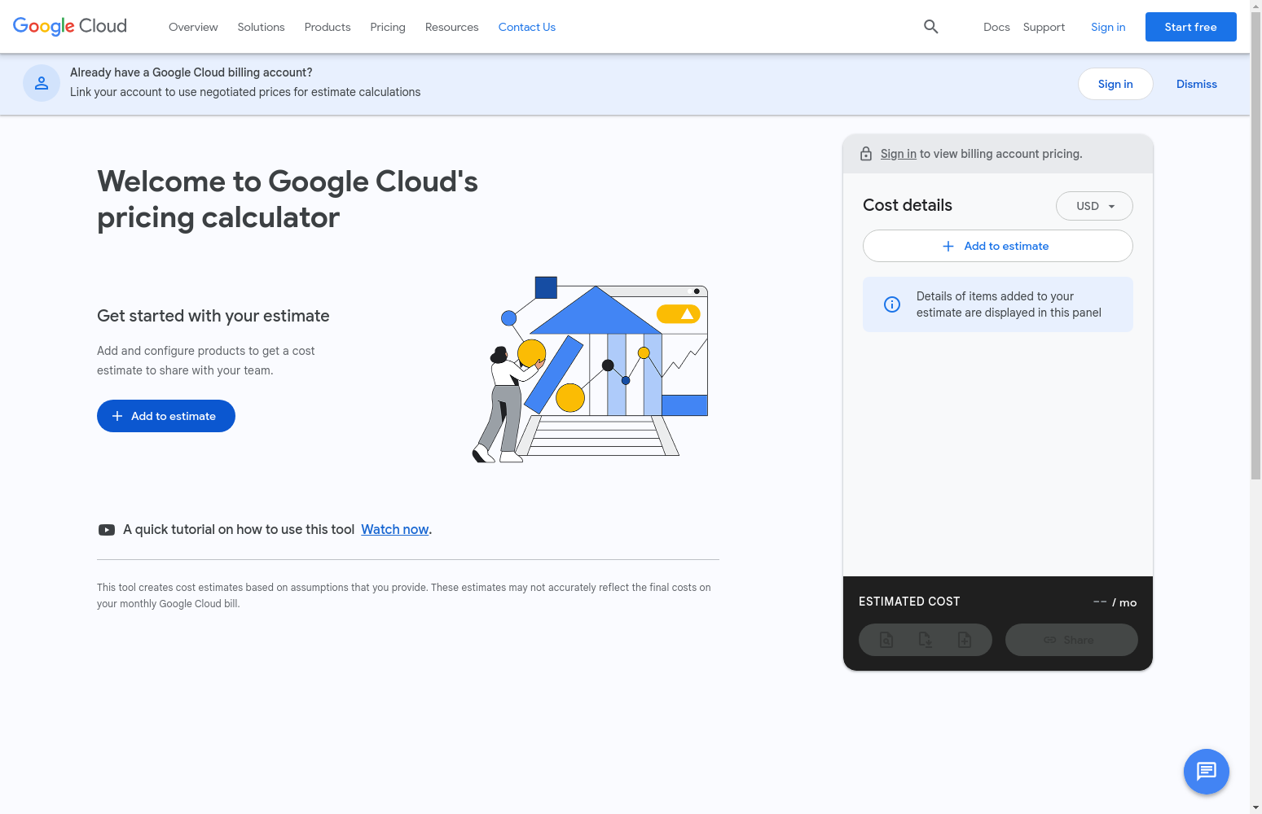

GCP Calculator Landing

*Initial Calculator Access (Step 1):* 1. Navigate to cloud.google.com/calculator to access Google’s comprehensive pricing estimation tool 2. The interface presents service categories in the left navigation panel, with the main configuration area in the center 3. Verify that COMPUTE ENGINE is selected as the default service for initial configuration, indicated by the highlighted tab

### 1.2 Compute Engine Configuration

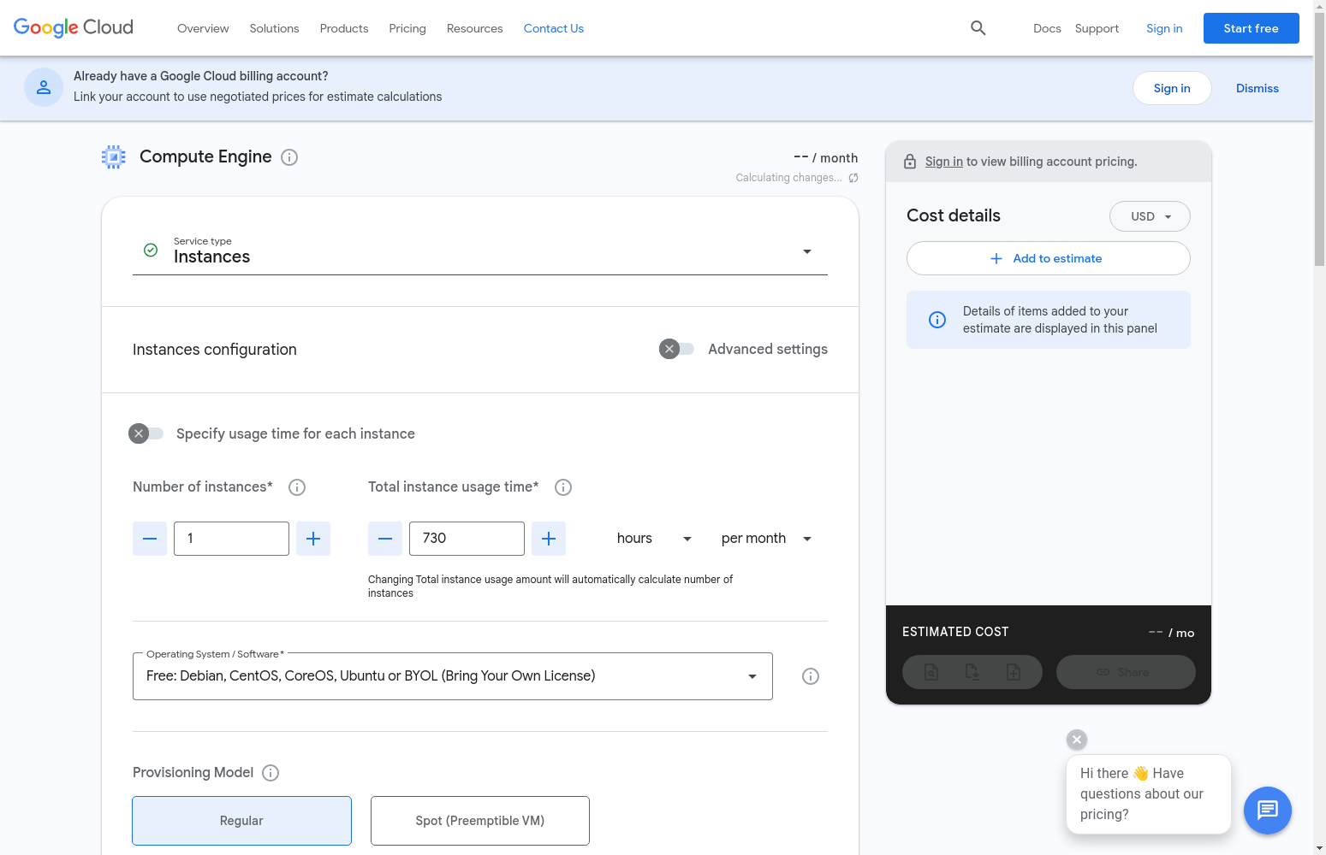

Compute Engine Setup

*Primary Service Configuration (Steps 2-4):* 1. Select the n1-standard-4 machine type, providing 4 vCPUs and 15 GB memory for production workloads 2. Configure region (us-central1), operating system (Ubuntu), and usage duration (730 hours/month) 3. Click “Add to Estimate” to include the compute configuration, showing an estimated cost of $139.70/month

### 1.3 Additional Service Selection - Cloud SQL

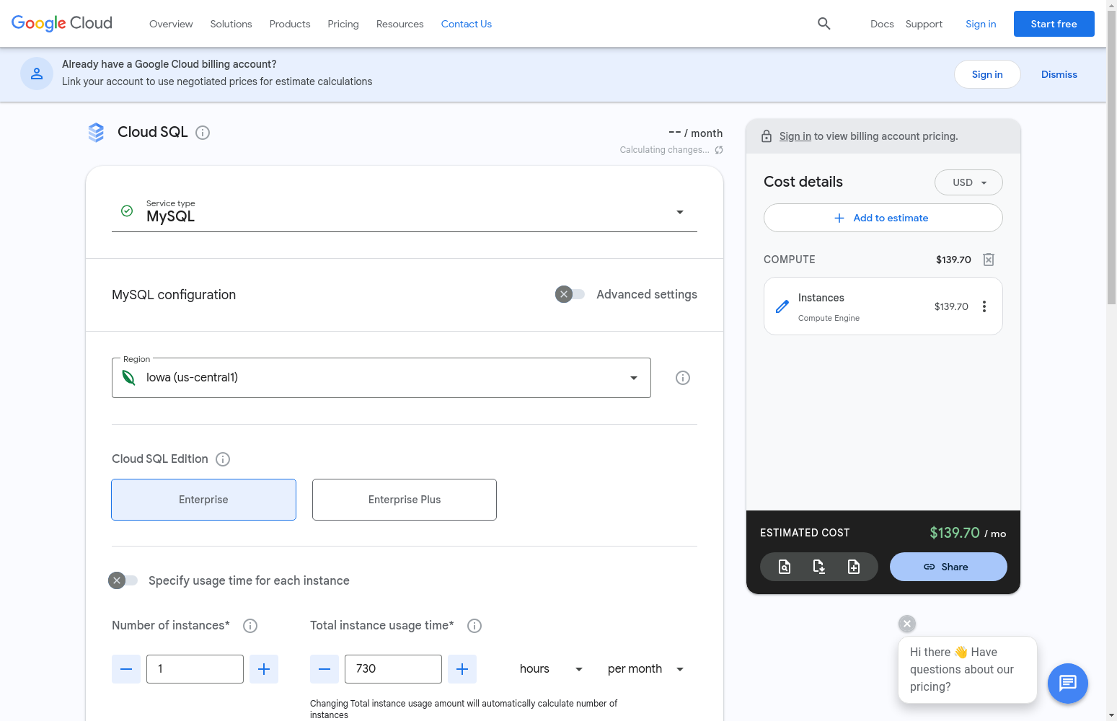

Cloud SQL Setup

*Database Service Configuration (Steps 5-6):* 1. Choose Cloud SQL as an additional service to provide managed database capabilities for the deployment 2. Select MySQL Enterprise edition with db-standard-2 instance (2 vCPUs, 7.5 GB memory, 100 GB storage) 3. Configure high-availability settings and backup options, resulting in a monthly cost of $115.62

### 1.4 Final Cost Analysis

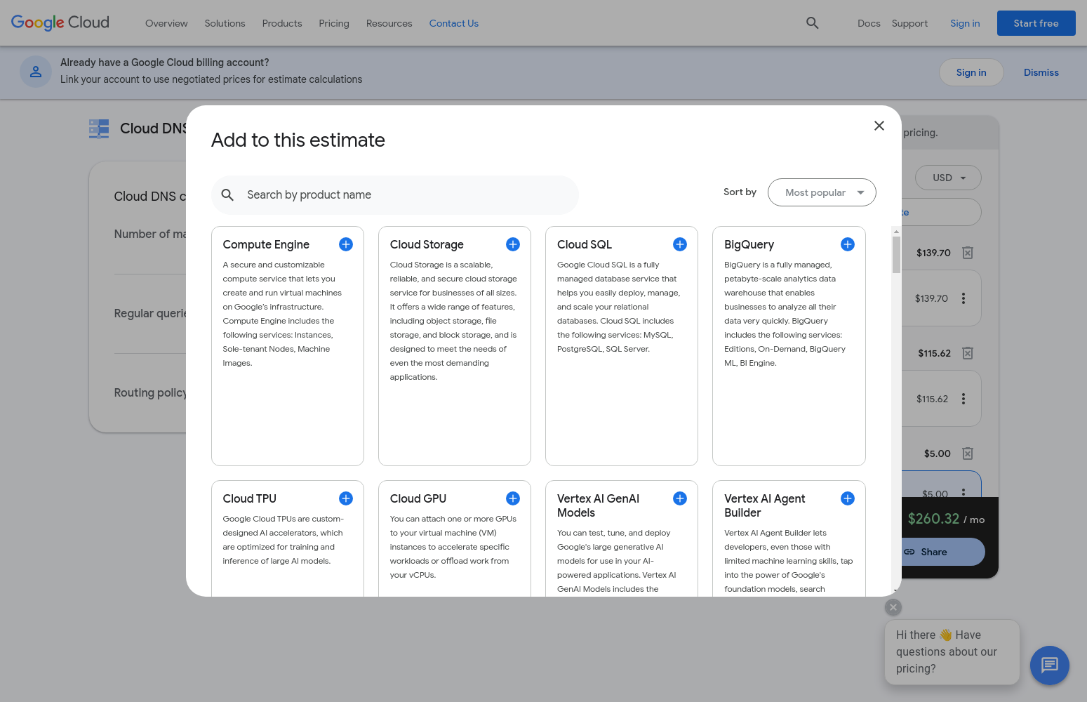

Cloud DNS Setup

*Total Cost Calculation (Step 7):* 1. Add Cloud DNS configuration with 5 managed zones and 10M queries/month capacity ($5.00) 2. Review the complete infrastructure configuration across all selected services 3. Confirm total estimated monthly cost of $260.32 for the entire deployment

### 1.5 Total Cost Summary

*Final Deployment Costs:* - Compute Engine: $139.70/month - Cloud SQL (MySQL): $115.62/month - Cloud DNS: $5.00/month - **Total Monthly Cost: $260.32**

## 2. Service Selection Justification

### 2.1 Compute Engine

The n1-standard-4 machine type was selected to provide robust computing capabilities: - 4 vCPUs ensure sufficient processing power for application workloads - 15 GB memory supports concurrent operations and caching - Ubuntu OS provides a stable, well-supported environment

### 2.2 Cloud SQL

MySQL Enterprise edition was chosen for reliable database operations: - Fully managed database service reduces operational overhead - db-standard-2 instance provides balanced CPU and memory allocation - 100 GB storage accommodates growing data requirements

### 2.3 Cloud DNS

DNS service configuration supports production-grade domain management: - 5 managed zones allow multiple domain management - 10 million queries/month capacity ensures reliable DNS resolution - Low-latency global DNS serving through Google’s worldwide network

## 3. Technical Implementation Details

### 3.1 Infrastructure Architecture

The selected services form a cohesive infrastructure stack designed for enterprise-grade applications. The architecture follows industry best practices for cloud-native applications:

#### 3.1.1 Compute Layer (Compute Engine)

The n1-standard-4 instance serves as the primary compute resource, offering: - High-performance Intel or AMD processors with a balanced CPU-to-memory ratio - Native support for container deployments and microservices architecture - Integration with Google Cloud’s auto-scaling and load balancing services - Built-in monitoring and logging capabilities through Cloud Operations

#### 3.1.2 Data Layer (Cloud SQL)

The MySQL Enterprise database provides a robust data management solution with: - Automated failover and high availability configurations - Point-in-time recovery and automated backups - Encryption at rest and in transit - Performance optimization through query insights and monitoring

#### 3.1.3 Network Layer (Cloud DNS)

The DNS infrastructure ensures reliable global access through: - Anycast-based name resolution for reduced latency - DNSSEC support for enhanced security - Integration with Cloud CDN for optimized content delivery - Advanced traffic management capabilities

### 3.2 Performance Considerations

Each service has been carefully sized and configured for optimal performance based on industry standards and best practices:

#### 3.2.1 Compute Performance

The N1-standard-4 machine type provides: - 4 vCPUs offering consistent performance for compute-intensive workloads - 15 GB memory supporting multiple concurrent application instances - Local SSD options for high-performance temporary storage - Network-optimized infrastructure with Google’s premium tier networking

#### 3.2.2 Database Performance

The db-standard-2 instance type delivers: - Dedicated CPU resources ensuring consistent database performance - Optimized memory allocation for query caching and buffer pools - High-performance storage with automatic storage increases - Built-in query performance analysis and optimization tools

#### 3.2.3 DNS Performance

The DNS configuration ensures high availability through: - Global load balancing across Google’s edge network - Low-latency query resolution (typically < 10ms) - Automatic scaling to handle traffic spikes - 100% uptime SLA for DNS serving

### 3.3 Scalability and Reliability

The infrastructure implements a comprehensive approach to scalability and reliability:

#### 3.3.1 Horizontal Scalability

* Compute Engine supports instance groups for automatic scaling
* Load balancing integration for distributed traffic handling
* Regional deployment options for geographic distribution
* Containerization support for microservices architecture

#### 3.3.2 Data Reliability

* Automated backup scheduling with point-in-time recovery
* Cross-region replication options for disaster recovery
* Automated failover with minimal downtime
* Continuous data integrity monitoring

#### 3.3.3 Network Reliability

* Global DNS infrastructure with redundant serving
* Automatic failover across Google’s global network
* DDoS protection and threat detection
* Real-time DNS health monitoring and alerts

## 4. Cost Optimization Analysis

### 4.1 Resource Allocation Analysis

The monthly cost distribution has been strategically planned to optimize resource utilization while maintaining performance requirements:

#### 4.1.1 Compute Resources (53.7% - $139.70)

The largest cost component reflects the importance of processing power: - N1-standard-4 instance provides enterprise-grade computing capabilities - Full month utilization ensures consistent resource availability - Premium tier networking enables optimal application performance - Built-in monitoring and management tools included

#### 4.1.2 Database Resources (44.4% - $115.62)

Database costs represent critical data management capabilities: - Enterprise-grade MySQL deployment with high availability - Automated backup and maintenance operations - Performance monitoring and optimization tools - Scalable storage with automatic provisioning

#### 4.1.3 DNS Services (1.9% - $5.00)

The DNS component provides essential name resolution services: - Global anycast network for reliable resolution - Support for multiple managed zones - High-volume query handling capacity - Advanced routing and traffic management

### 4.2 Cost Optimization Strategies

#### 4.2.1 Immediate Optimization Opportunities

1. **Committed Use Discounts**
   * Up to 57% savings on compute resources with 3-year commitment
   * Ideal for stable, predictable workloads
   * Flexible commitment options available
2. **Resource Right-sizing**
   * Regular monitoring of resource utilization
   * Automatic scaling based on demand
   * Performance-to-cost ratio optimization
3. **Storage Optimization**
   * Implementation of lifecycle management policies
   * Regular cleanup of unused resources
   * Tiered storage utilization

#### 4.2.2 Long-term Cost Management

1. **Architecture Optimization**
   * Microservices adoption for granular resource control
   * Container-based deployment for better resource utilization
   * Serverless computing evaluation for suitable workloads
2. **Network Cost Reduction**
   * Content Delivery Network implementation
   * Cross-region traffic optimization
   * Reserved IP address utilization
3. **Database Efficiency**
   * Query optimization and caching strategies
   * Regular maintenance and cleanup procedures
   * Automated scaling policies

## 5. Conclusion

### 5.1 Infrastructure Summary

The Google Cloud Platform configuration detailed in this document represents a carefully architected infrastructure solution with a total monthly investment of $260.32. This deployment has been designed to provide enterprise-grade reliability, performance, and scalability while maintaining cost efficiency. The selected services form a cohesive technology stack that addresses key business requirements:

1. **Compute Infrastructure**
   * N1-standard-4 Compute Engine instance providing robust processing capabilities
   * Balanced CPU-to-memory ratio supporting diverse workload requirements
   * Strategic regional deployment in us-central1 for optimal latency
   * Integration capabilities with modern container orchestration platforms
2. **Data Management**
   * Enterprise-grade MySQL deployment with high availability features
   * Automated backup and recovery mechanisms
   * Scalable storage architecture with automatic provisioning
   * Advanced monitoring and performance optimization tools
3. **Network Services**
   * Professional DNS management with global availability
   * Support for multiple domain configurations
   * Integration with Google’s global network infrastructure
   * Advanced traffic management and security features

### 5.2 Cost-Benefit Analysis

The monthly investment of $260.32 provides significant value through: - Enterprise-grade computing resources (53.7% of total cost) - Professional database management services (44.4% of total cost) - Global DNS infrastructure (1.9% of total cost)

This cost structure reflects a balanced approach to resource allocation, prioritizing critical infrastructure components while maintaining operational efficiency. The implementation includes various cost optimization opportunities through committed use discounts, resource right-sizing, and architectural optimizations.

### 5.3 Future Considerations

The infrastructure design incorporates flexibility for future growth and optimization: 1. **Scalability Path** - Horizontal scaling capabilities through instance groups - Database scaling through automated storage management - Traffic management through global load balancing

1. **Cost Optimization**
   * Potential savings through committed use discounts
   * Opportunities for resource optimization
   * Architecture refinement possibilities
2. **Performance Enhancement**
   * Integration with additional Google Cloud services
   * Implementation of caching strategies
   * Network optimization through CDN integration

This comprehensive cloud infrastructure solution provides a robust foundation for hosting production applications while maintaining the flexibility to adapt to changing business requirements and workload demands.

## 6. References

1. Google Cloud Platform Pricing Calculator. Retrieved from https://cloud.google.com/calculator
2. Google Compute Engine Documentation. Retrieved from https://cloud.google.com/compute/docs
3. Cloud SQL Documentation. Retrieved from https://cloud.google.com/sql/docs
4. Cloud DNS Documentation. Retrieved from https://cloud.google.com/dns/docs
5. Google Cloud Platform Pricing Documentation. Retrieved from https://cloud.google.com/pricing

## Appendix A: Detailed Cost Breakdown

### A.1 Compute Engine Details

* Machine Type: n1-standard-4
* vCPUs: 4
* Memory: 15 GB
* Operating System: Ubuntu
* Usage: 730 hours/month
* Region: Iowa (us-central1)
* Monthly Cost: $139.70

### A.2 Cloud SQL Details

* Instance Type: db-standard-2
* vCPUs: 2
* Memory: 7.5 GB
* Storage: 100 GB
* Database: MySQL Enterprise
* Region: Iowa (us-central1)
* Monthly Cost: $115.62

### A.3 Cloud DNS Details

* Managed Zones: 5
* Regular Queries: 10 million/month
* Region: Global
* Monthly Cost: $5.00