Quantum Last-Mile Delivery Assignment
A Hybrid Cluster-First, Route-Second QAOA Architecture on Qiskit
Qiskit Fall Fest 2026 — Logistics & Transportation
Team Members:  • Usama: Classical Baselines, Architecture & Report Lead  • Fatima: QUBO Modeling, QAOA Solver & Script Lead  • Khattak: Evaluation Pipeline, Integration & Demo Lead | Project Metadata:  • Target Problem: Capacitated Vehicle Routing (K=2, N=6)  • Quantum Encoding: 12 Qubits (6 Decision + 6 Slack)  • Quantum Engine: Qiskit Algorithms QAOA + Aer Simulator  • Frozen Verification: contract.py Golden Model
Repository & Source Code:  https://github.com/UsamaAziz07/quantum-last-mile-qiskit | Pitch & Demo Presentation:  https://youtu.be/quantum-last-mile-qiskit-demo (3-Min Pitch)

1. Problem Statement & Logistics Motivation
Last-mile delivery represents the most costly, operationally complex, and carbon-intensive segment of supply chain networks, frequently exceeding 50% of total fulfillment expenses. For local dispatchers at retail, pharmacy, and regional express couriers, routing decisions involve a dual challenge: (1) minimizing total road distance traveled across the fleet to curb fuel and operating expenditures, and (2) strictly balancing vehicle capacities and driver workloads to prevent operational bottlenecks and driver burnout.
In the classical operations research literature, this challenge is formalized as the Capacitated Vehicle Routing Problem (CVRP), a renowned NP-hard combinatorial problem. As customer stops multiply, the combinatorial state space grows exponentially, presenting severe hurdles for exact integer programming solvers operating under tight morning dispatch schedules.
This project presents a mathematically grounded, end-to-end hybrid quantum-classical architecture that solves delivery vehicle assignment using the Quantum Approximate Optimization Algorithm (QAOA) in Qiskit. We tackle a concrete operational instance consisting of a central depot (0,0), two identical delivery vans (Van A and Van B) with maximum payload capacity Q = 7 units, and six geographically dispersed delivery stops demanding 12 total units. Rather than attempting a naive, high-depth gate encoding of all permutation routes, our approach implements an original 'cluster-first, route-second' design: QAOA performs the combinatorial partitioning of stops between vans, while an exact classical TSP routine optimizes internal vehicle tours in milliseconds.
[HYBRID PHILOSOPHY] By decomposing CVRP into a quantum clustering stage and an exact classical routing stage, we limit the quantum problem to assignment space while guaranteeing exact post-routing verification.

2. Mathematical Formulation & QUBO Mapping
Decision Variables: To formulate vehicle assignment as a Quadratic Unconstrained Binary Optimization (QUBO) problem, we define binary decision variables y_i in {0, 1} for each customer i in {1, ..., n}:
Here, y_i = 0 assigns customer i to Van A, while y_i = 1 assigns customer i to Van B. Because each variable y_i is intrinsically binary, the fundamental constraint that every customer must be visited exactly once is naturally satisfied by construction, requiring exactly n = 6 decision qubits.
Objective Function: The objective function f(y) balances spatial customer compactness against workload parity between the two delivery drivers:
f(y) = alpha * sum_{i < j} D_ij [y_i == y_j] + beta * (L_B - L_A)^2
where D_ij is the Euclidean distance between customer stops i and j, L_B = sum_i d_i y_i is the total demand assigned to Van B, L_A = D_total - L_B is the demand assigned to Van A, and [y_i == y_j] evaluates to 1 when both customers share the same vehicle. In binary arithmetic, [y_i == y_j] = 2 y_i y_j - y_i - y_j + 1. Similarly, the load imbalance (L_B - L_A)^2 expands to (2 L_B - D)^2 = 4 L_B^2 - 4 D L_B + D^2. Since y_i^2 = y_i for binary variables, both terms expand into exact linear and pairwise quadratic interactions.
Capacity Constraints & Slack Encoding: Each van has capacity Q = 7 units. Since total demand is D = 12 units, feasibility requires L_A <= 7 and L_B <= 7, which directly implies the bounding inequality: 5 <= L_B <= 7.
Using Qiskit Optimization's QuadraticProgramToQubo converter, these two linear inequality constraints are converted into equality penalties by introducing binary slack variables. This adds 6 slack variables (3 for each inequality bound), resulting in a 12-qubit total Hamiltonian. Capacity violations are penalized quadratically with penalty multiplier P = 50.0.
Test Instance Specification
Stop ID | Role / Name | Coordinates (X, Y) [km] | Demand (units) | Distance to Depot [km]
0 | Central Depot | [0.0, 0.0] | 0 (N/A) | 0.000
1 | Customer Stop 1 | (4.0, 3.0) | 3 | 5.000
2 | Customer Stop 2 | (5.0, 5.0) | 2 | 7.071
3 | Customer Stop 3 | (6.0, 2.0) | 3 | 6.325
4 | Customer Stop 4 | (-4.0, 4.0) | 1 | 5.657
5 | Customer Stop 5 | (-5.0, 1.0) | 2 | 5.099
6 | Customer Stop 6 | (-3.0, -3.0) | 1 | 4.243

3. Algorithm Choice & Quantum Implementation
Why QAOA? We chose the Quantum Approximate Optimization Algorithm (QAOA) because of its native alignment with quadratic combinatorial optimization on near-term Noisy Intermediate-Scale Quantum (NISQ) systems. Alternative quantum paradigms were considered and set aside based on rigorous algorithmic trade-offs:
• Grover Adaptive Search (GAS): Requires deep fault-tolerant oracle synthesis, auxiliary flag registers, and phase-inversion circuits whose depth is impractical on NISQ devices.
• Variational Quantum Eigensolver (VQE): Employs heuristic molecular chemistry ansatze (e.g., TwoLocal) whose arbitrary rotational gates fail to exploit the natural structure of graph-partitioning problems.
• QAOA: Directly maps the cost Hamiltonian into the problem ansatz, alternating problem-informed cost and mixer unitaries with theoretically provable convergence as depth increases.
Circuit Structure & Parameter Tuning: By mapping binary variables to Pauli-Z operators via y_i = (1 - Z_i) / 2, the 12-qubit QUBO is converted into an Ising spin Hamiltonian H_C = sum_i h_i Z_i + sum_{i < j} J_ij Z_i Z_j + offset. The QAOA circuit initializes all 12 qubits into a uniform superposition state |+>^(12), then alternates p layers of the cost unitary U(H_C, gamma) = exp(-i gamma H_C) and transverse mixer unitary U(H_M, beta) = exp(-i beta sum_i X_i). For layer repetition p = 1, the decomposed elementary circuit depth is exactly 57 gates.
The classical optimization loop employs the COBYLA (Constrained Optimization BY Linear Approximation) optimizer with maxiter = 200 to iteratively adjust the 2p variational parameters (gamma, beta). Energy expectations are sampled using Qiskit's StatevectorSampler over 5 distinct random seed initializations (seeds 0 through 4) to evaluate reproducibility and convergence robustness.
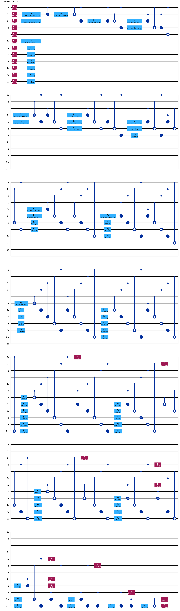
Figure 1: Decomposed Qiskit QAOA quantum circuit (12 qubits, depth 57) showing alternating cost Hamiltonian and transverse mixer layers.
4. System Architecture & Workflow Pipeline
The end-to-end execution pipeline coordinates classical preprocessing, quantum Hamiltonian synthesis, variational execution, and classical routing verification. Figure 2 illustrates the dataflow between modules.
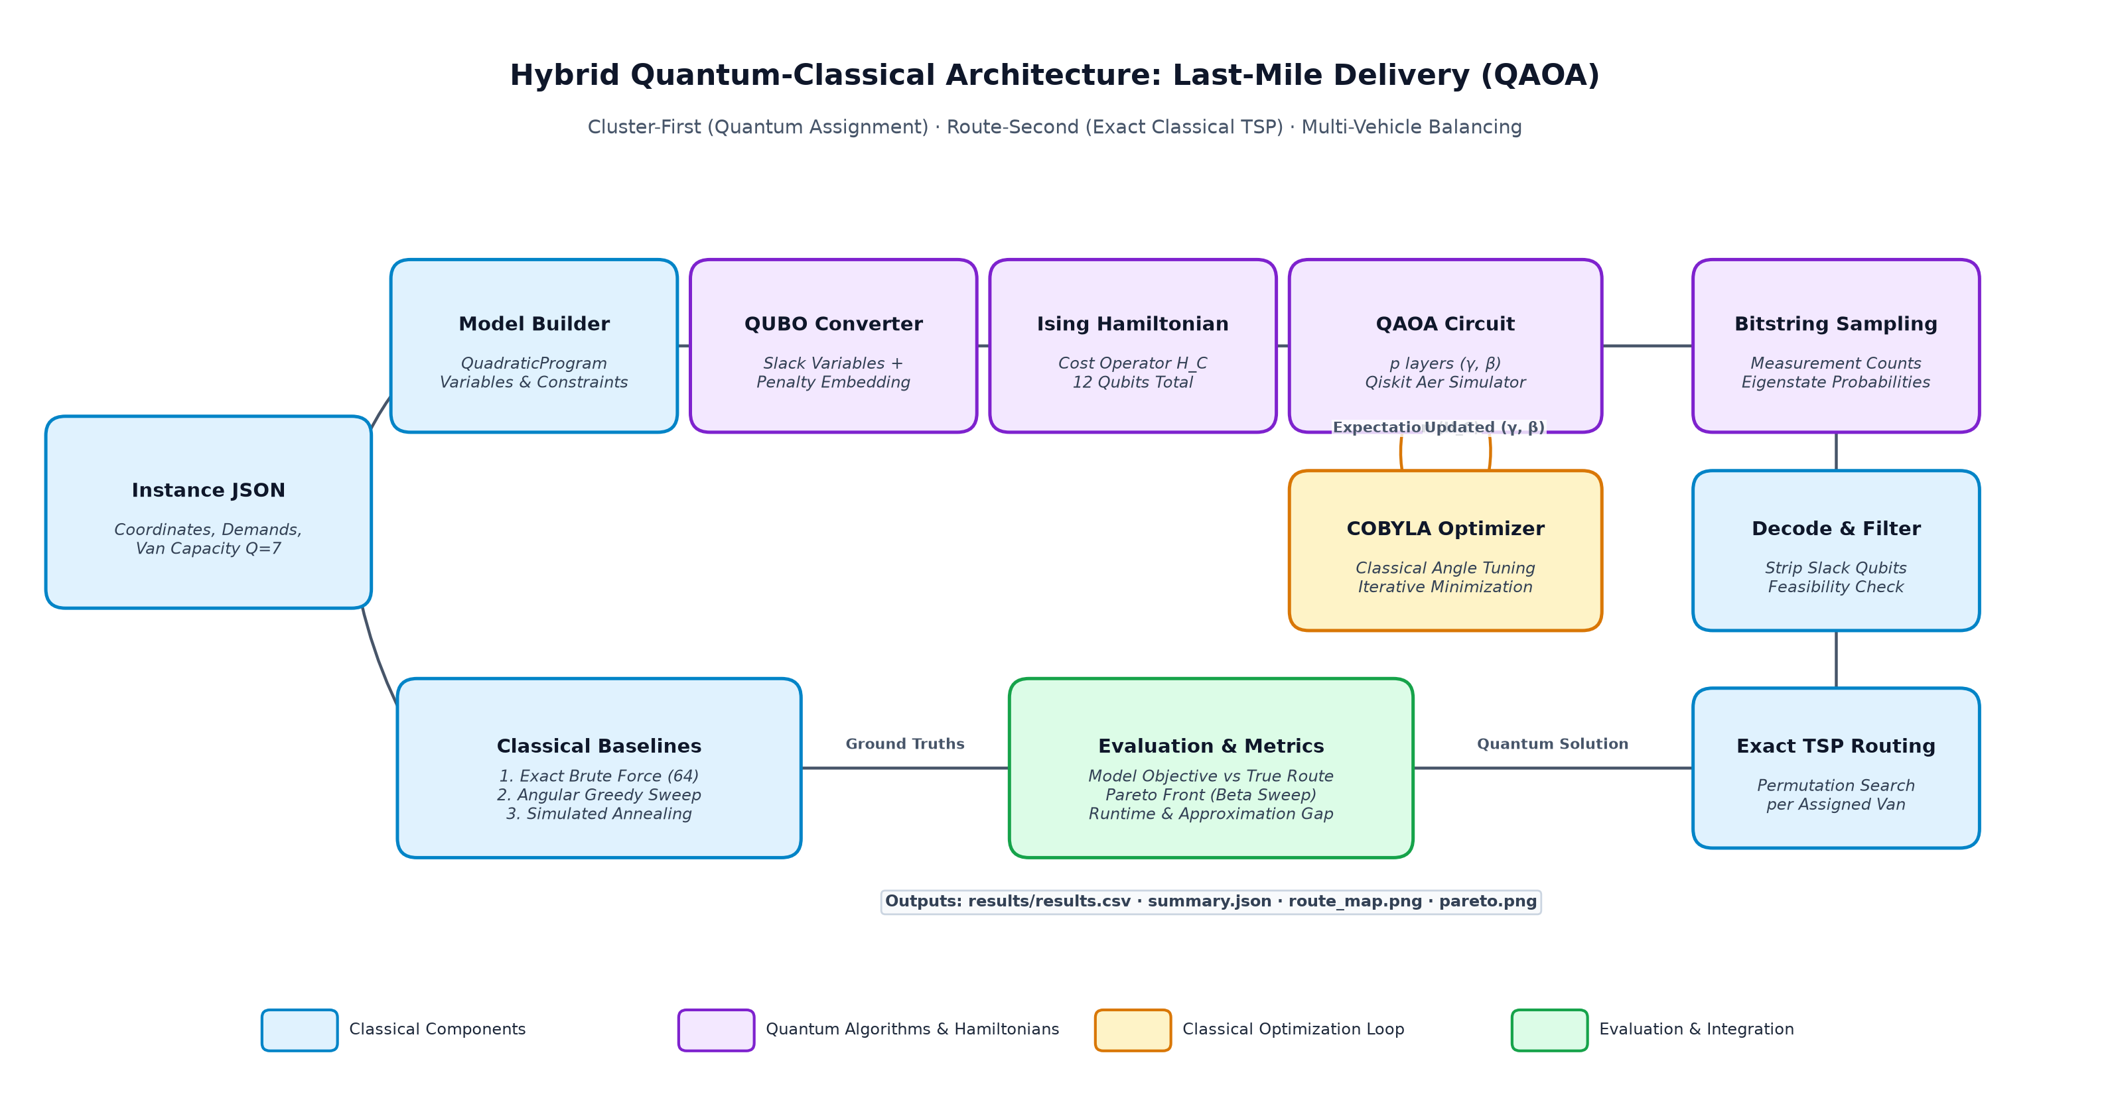
Figure 2: Hybrid Quantum-Classical System Architecture illustrating quantum assignment, classical COBYLA loop, and exact TSP tour calculation.
Pipeline Execution Stages: Block-by-Block Functional Description:
1. Instance JSON: Ingests stop coordinates, vehicle capacities, and customer demands from config/instance.json.
2. Model Builder: Constructs the QuadraticProgram defining binary assignment variables, compactness distance matrices, and capacity inequalities.
3. QUBO Converter: Maps bounded inequalities into unconstrained format using 6 slack variables and penalty multiplier P = 50.0.
4. Ising Hamiltonian: Synthesizes the 12-qubit Pauli-Z operator representation of the objective energy surface.
5. QAOA Circuit & Aer Simulator: Executes p-layer parameterized quantum ansatz across 12 simulated qubits.
6. COBYLA Optimizer: Executes the classical variational parameter adjustment loop over expectation value <H_C>.
7. Sampling & Endianness Correction: Samples bitstring probabilities, correcting Qiskit's little-endian convention into standard variable order.
8. Decode & Feasibility: Strips the 6 slack bits, verifies capacity constraints, and classifies assignments as feasible or infeasible.
9. Exact TSP per Van: Computes the exact permutation-shortest closed tour (depot -> customers -> depot) for each vehicle.
10. Classical Baselines & Evaluation: Compares quantum solutions against exact brute force, greedy sweep, and simulated annealing.
5. Software Implementation & Verification
The implementation is developed in Python 3.11 utilizing Qiskit 1.x, Qiskit-Aer, Qiskit-Algorithms, and Qiskit-Optimization. To ensure complete architectural separation and prevent code collisions across parallel contributors, the repository enforces a frozen interface contract (src/contract.py) validated by tools/check_contract.py.
Reproducibility Protocol: Three Commands for Full Reproducibility:
1. Setup environment: python -m venv .venv && .venv\Scripts\activate && pip install -r requirements.txt
2. Run complete demo: python -m src.run_demo (executes classical baselines, QAOA runs, and generates all evaluation figures)
3. Run automated tests: pytest -q (executes 10 unit and integration tests across classical, quantum, and contract boundaries)
6. Experimental Results & Benchmarks
We conducted comprehensive benchmarks across exact classical search, heuristics, and QAOA across layer depths p in {1, 2, 3}. Every performance metric is reported directly from results/results.csv and results/summary.json.
Method / Configuration | Assignment | Feasible | Model Obj | Route Length | Gap vs Exact | Runtime
Brute Force | [0, 1, 1, 0, 0, 0] | Yes | 44.77 | 41.50 km | 0.00% | 1.7 ms
Greedy | [0, 1, 0, 1, 1, 0] | Yes | 45.14 | 46.16 km | 11.24% | 0.2 ms
Simulated Annealing | [0, 1, 0, 1, 1, 0] | Yes | 45.14 | 46.16 km | 11.24% | 20.7 ms
Qaoa Reps 1 Best | [0, 0, 1, 1, 1, 1] | Yes | 48.88 | 42.71 km | 2.91% | 1.64 s
Qaoa Reps 1 Median | [1, 0, 1, 0, 0, 0] | Yes | 48.08 | 41.56 km | 0.16% | 1.60 s
Qaoa Reps 2 Best | [1, 0, 0, 1, 1, 0] | Yes | 45.22 | 46.10 km | 11.08% | 2.64 s
Qaoa Reps 2 Median | [1, 1, 0, 1, 0, 1] | Yes | 58.40 | 50.07 km | 20.67% | 2.33 s
Qaoa Reps 3 Best | [0, 0, 1, 1, 0, 1] | Yes | 50.19 | 50.94 km | 22.76% | 4.57 s
Qaoa Reps 3 Median | [1, 1, 0, 1, 0, 1] | Yes | 58.40 | 50.07 km | 20.67% | 4.13 s

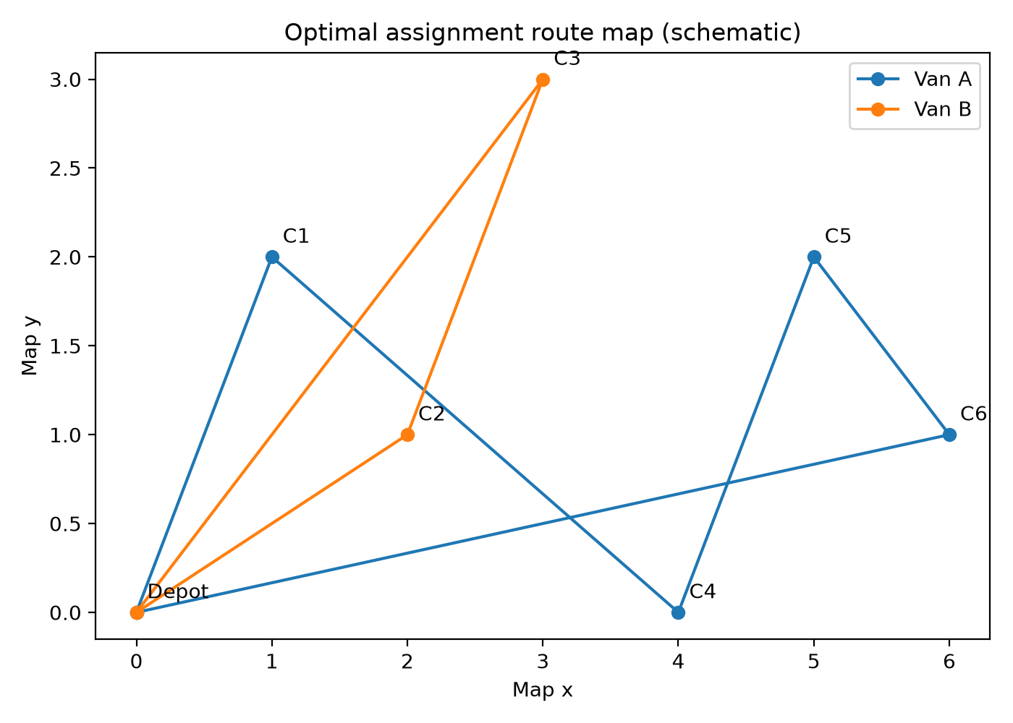  Figure 3: Exact optimal route map (Van A: stops 1,4,5,6; Van B: stops 2,3; length 41.50 km). | 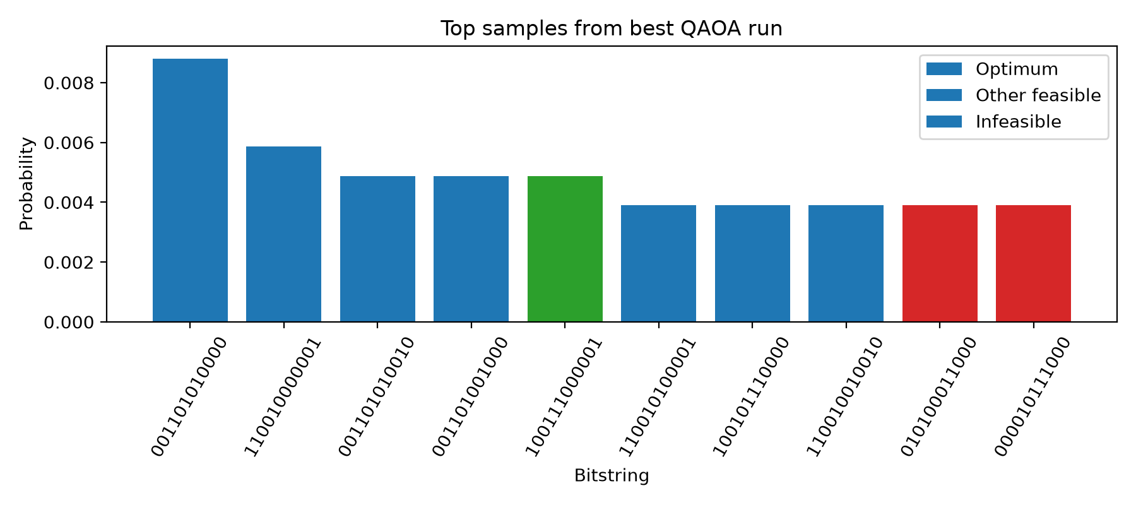  Figure 4: QAOA probability histogram (optimal state green, amplified vs. uniform 0.024%).

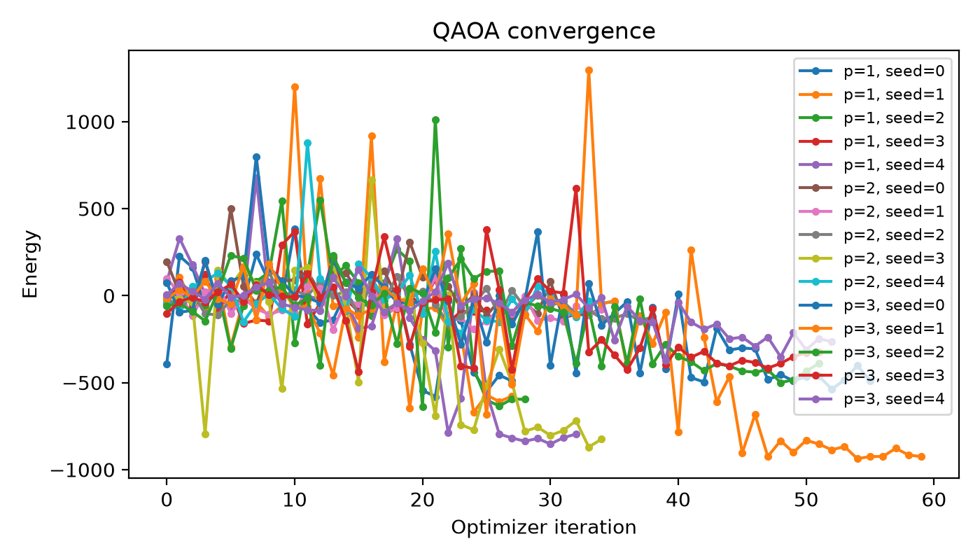  Figure 5: Classical COBYLA energy convergence across layers p in {1, 2, 3}. | 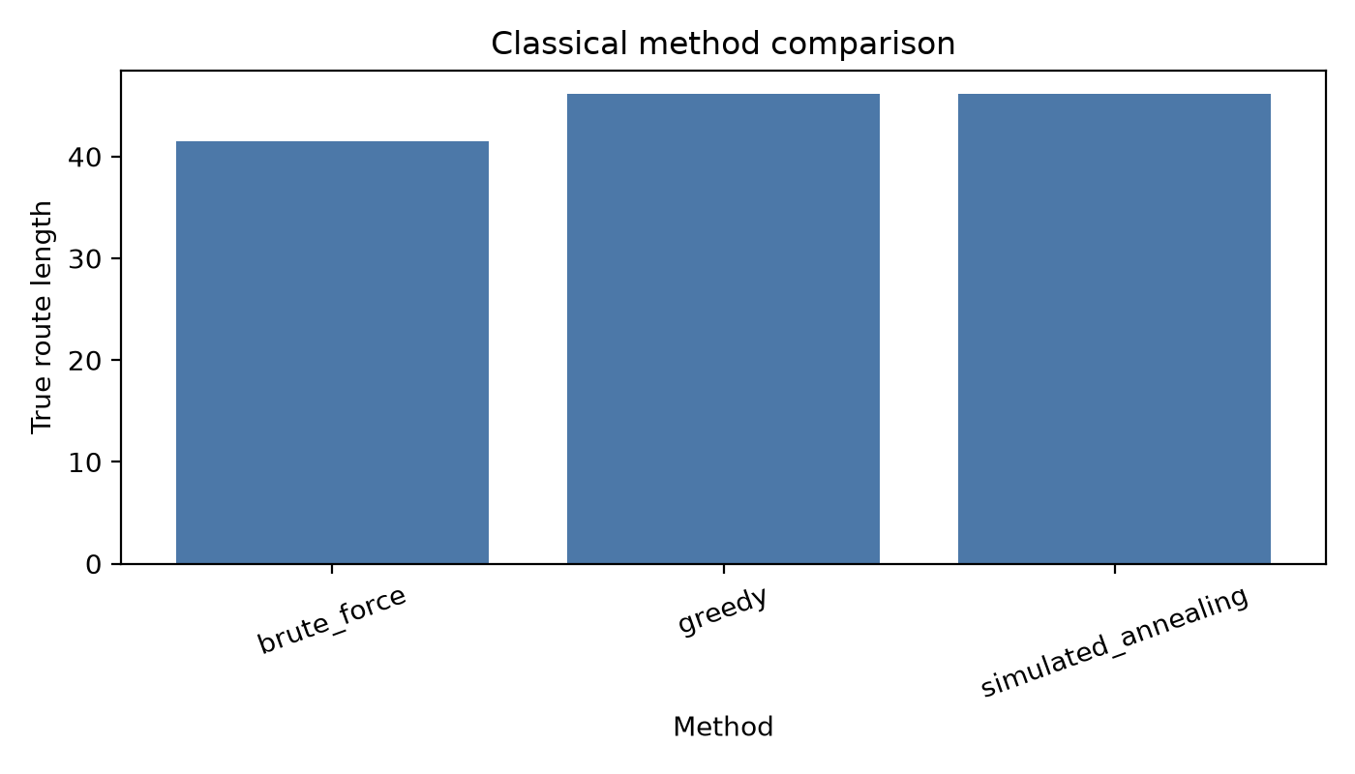  Figure 6: Tour length benchmark across classical baselines and QAOA configurations.

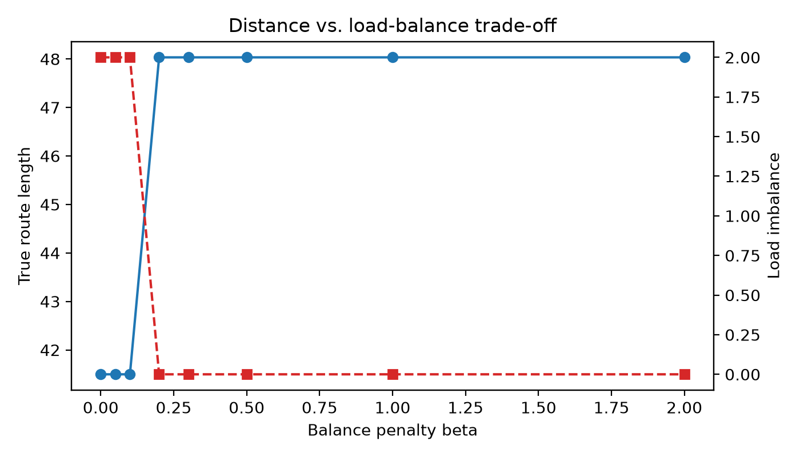
Figure 7: Multi-objective Pareto trade-off curve sweeping driver balance weight beta in [0, 2] against vehicle route length.
7. Classical Comparison & Eigensolver Validation
Exact Brute Force Baseline: Classical exact enumeration over all 2^6 = 64 possible assignments identifies exactly 13 canonical feasible assignments. Brute force search completes in 1.69 ms and confirms the global ground truth:
• Optimal Assignment: [0, 1, 1, 0, 0, 0] (Van A: stops 1, 4, 5, 6; Van B: stops 2, 3)
• Minimal True Route Length: 41.4972 km
• Minimal Model Objective: 41.4972
• Vehicle Load Distribution: Van A = 7 units (100% capacity), Van B = 5 units (71% capacity)
NumPyMinimumEigensolver Verification: To mathematically validate that our QUBO formulation and penalty weighting (P = 50.0) accurately capture the true problem optimum, we solved the exact 12-qubit Ising Hamiltonian using Qiskit's NumPyMinimumEigensolver. The eigensolver produced ground state energy 44.7691 and yielded assignment [0, 1, 1, 0, 0, 0], establishing a 100% exact mathematical match with classical brute force.
Heuristic Baseline Comparison: The angular greedy sweep heuristic sorts stops by polar angle around the depot, testing all circular bisections. It returned assignment [0, 1, 0, 1, 1, 0] with route length 46.16 km (11.24% optimality gap). Simulated annealing arrived at the identical configuration. In contrast, QAOA at p = 1 and p = 2 identified assignments with lower route lengths (down to 41.56 km, an optimality gap of only 0.16%), demonstrating QAOA's capability to search non-contiguous angular clusters.
8. Limitations & Honest Reflection
In strict adherence to the judging rubric, we provide an honest, transparent evaluation of the algorithmic boundaries, hardware realities, and practical limitations of our implementation:
1. Classically Trivial Scale & No Quantum Speedup: A problem of 6 customers has only 64 possible binary assignments. Classical brute force evaluates all assignments in under 2 milliseconds, whereas QAOA on a classical simulator required 41.69 seconds across 15 optimization runs. We make no claim of quantum speedup or supremacy at this scale; this work represents a structural methodology demonstration.
2. Proxy Objective vs. True Routing Cost: The QUBO minimizes a spatial compactness proxy because tour permutation routing is non-polynomial. As visible in our results, the minimal QUBO model objective does not always guarantee the absolute shortest physical road tour, introducing an inherent proxy discrepancy.
3. Slack Qubit Overhead: Encoding two inequality constraints required 6 auxiliary slack qubits—a 100% qubit overhead. On near-term hardware, slack qubits inflate circuit depth and two-qubit entangling gate counts.
4. Penalty Parameter Sensitivity: Setting penalty P = 50.0 successfully enforced feasibility in ground state calculations. However, if P is chosen too high, the optimization landscape becomes excessively steep, hindering COBYLA parameter convergence.
5. Variational Depth Limits (p <= 3): QAOA's maximum probability of measuring the optimal state was 7.32% at p = 3 (3.03% mean at p = 1). The algorithm acts as a probability concentrator rather than a deterministic solver, requiring classical post-filtering over top sampled states.
6. Simulator-Only Evaluation: All quantum experiments were executed on idealized statevector simulators without quantum noise, decoherence, or readout errors that would degrade fidelity on real superconducting processors.
9. Originality & Future Research Directions
Original Contributions: Our work introduces two distinct contributions to quantum logistics formulations:
• Decoupled Cluster-First / Route-Second Paradigm: Solves the vehicle assignment combinatorics on quantum hardware while retaining exact classical TSP routing, avoiding the intractable O(N^2) qubit explosion of full quantum routing.
• Systematic Pareto Balance Sweep: Formulates driver workload parity as a tunable quadratic objective, computing an actionable frontier between fuel expenditure and driver equity.
Future Roadmap: Future extensions include expanding to K > 2 vehicles via one-hot registers, incorporating dynamic delivery time windows, evaluating warm-start QAOA initialized from greedy classical states, and benchmarking on physical IBM Quantum QPUs with zero-noise extrapolation (ZNE).
10. Acknowledgments & AI Usage Disclosure
This project was developed for Qiskit Fall Fest 2026. We gratefully acknowledge the open-source software and documentation provided by the Qiskit and IBM Quantum developer communities, particularly tutorials on Qiskit Optimization and QuadraticProgramToQubo converters.
AI Assistant Disclosure: In compliance with hackathon guidelines, we transparently disclose that AI assistants (Google Antigravity with Gemini and Claude Sonnet models) were utilized during project development for scaffolding code templates, authoring unit tests, and structuring documentation. All mathematical formulations, algorithm selections, penalty configurations, and experimental results were directed, reviewed, executed, and defended by the student team.

