**National University of Computer and Emerging Sciences**



Laboratory Tasks 01

*for*

Web Programing

Spring 2024

**21F-9217 Usama Akram BCS-6C**

**FAST School of Computer Science**

# Lab Task 1:

Build Your First Webpage having your name, roll number, and brief about yourself.

**Code:**

<!DOCTYPE html>

<html lang="en">

<head>

    <meta charset="UTF-8">

    <meta name="viewport" content="width=device-width, initial-scale=1.0">

    <title>21F-9217, Usama Akram</title>

</head>

<body>

    <h2>Usama Akram</h2>

    <h4>Roll Number: 21F-9217</h4>

    <h2>About Me</h2>

    <p>

        &emsp;Hello! My name is Usama Akram, and I am a student with the roll number 21F-9217.

        <br>&emsp;Here is a brief description about myself.

        <br>&emsp;I am currently doing BS-CS in FAST-NU. I am enrolled in 6th semester.

    </p>

</body>

</html>

# Lab Task 2:

Demonstrate the following output using HTML.

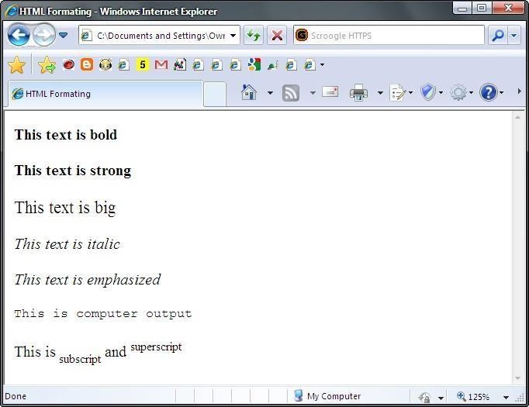

**Code:**

<!DOCTYPE html>

<html lang="en">

<head>

    <meta charset="UTF-8">

    <meta name="viewport" content="width=device-width, initial-scale=1.0">

    <title>21F-9217, Usama Akram</title>

</head>

<body>

    <h2>Usama Akram</h2>

    <h4>Roll Number: 21F-9217</h4>

    <hr>

    <h3>Task 2:</h3>

    <p><b>This text is Bold</b></p>

    <p><strong>This text is Strong</strong></p>

    <p><big>This text is Big</big></p>

    <p><i>This text is Italic</i></p>

    <p><em>This text is Emphasized</em></p>

    <p><tt>This is Computer output</tt></p>

    <p>This is <sub>subscript</sub> and <sup>superscript</sup><p>

</body>

</html>

# Lab Task 3:

Download the Logo of FAST-NU form Google and display on your webpage in

500 by 500 dimension.

# Code:

<!DOCTYPE html>

<html lang="en">

<head>

    <meta charset="UTF-8">

    <meta name="viewport" content="width=device-width, initial-scale=1.0">

    <title>21F-9217</title>

</head>

<body>

    <h2>Task 3:</h2>

    <img src="NULogo.png" alt="FAST-NU Logo img not found" width="500" height="500">

</body>

</html>

# Lab Task 4:

Make the FAST-NU Logo link to fast website and website should be open in new tab.

**Code:**

<!DOCTYPE html>

<html lang="en">

<head>

    <meta charset="UTF-8">

    <meta name="viewport" content="width=device-width, initial-scale=1.0">

    <title>21F-9217</title>

</head>

<body>

    <h2>Task 4:</h2>

    <a href="https://www.nu.edu.pk" alt="Site not reached" >

    <img src="NULogo.png" alt="FAST-NU Logo img not found" width="500" height="500">

</body>

</html>

# Lab Task 5:

Develop the following webpage using following output.

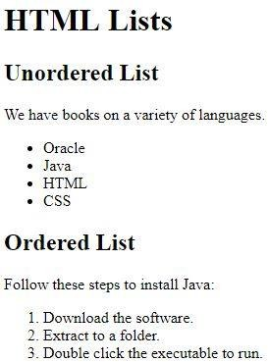

**Code:**

<!DOCTYPE html>

<html lang="en">

<head>

    <meta charset="UTF-8">

    <meta name="viewport" content="width=device-width, initial-scale=1.0">

    <title>21F-9217</title>

</head>

<body>

    <h2>HTML Lists</h2>

    <h3>Unordered List</h3>

    <p>We have Books on a veriety of languages.</p>

    <ul type="disc">

        <li>Oracle</li>

        <li>Java</li>

        <li>HMTL</li>

        <li>CSS</li>

    </ul>

    <!-- type of ol can be 1, i,I a,A -->

    <h3>Unordered List</h3>

    <p>Follow these steps to install Java:</p>

    <ol type="1">

        <li>Download the software.</li>

        <li>Extract to a folder.</li>

        <li>Double click the executable to run.</li>

    </ol>

</body>

</html>

Output 5:

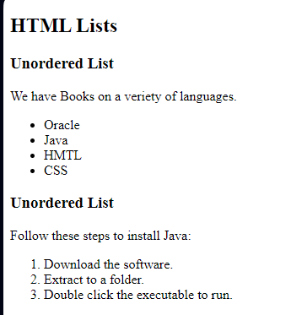

# Lab Task 6:

Draw the following table on your webpage.

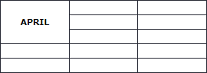

**Code:**

<!DOCTYPE html>

<html lang="en">

<head>

    <meta charset="UTF-8">

    <meta name="viewport" content="width=device-width, initial-scale=1.0">

    <title>21F-9217</title>

    <style>

        table {

          width: 30%;

          border-collapse: collapse;

        }

        table, th, td {

          border: 1px solid black;

        }

        td {

          padding: 10px;

        }

      </style>

</head>

<body>

    <h2>HTML Tables Task 6</h2>

      <table>

        <tr>

          <td rowspan="3">APRIL</td>

          <td></td>

        </tr>

        <tr>

          <td></td>

          <td></td>

        </tr>

        <tr>

          <td></td>

          <td></td>

        </tr>

        <tr>

          <td></td>

          <td></td>

        </tr>

        <tr>

            <td></td>

            <td></td>

            <td></td>

          </tr>

      </table>

</body>

</html>

Output

# 

# Lab Task 7:

Draw the following table on your webpage.

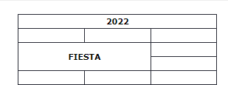

**Code:**

<!DOCTYPE html>

<html lang="en">

<head>

    <meta charset="UTF-8">

    <meta name="viewport" content="width=device-width, initial-scale=1.0">

    <title>21F-9217</title>

    <style>

        table {

          width: 30%;

          border-collapse: collapse;

        }

        table, th, td {

          border: 1px solid black;

        }

        td {

          padding: 10px;

        }

      </style>

</head>

<body>

    <h2>HTML Tables Task 7</h2>

    <table>

        <tr>

          <td  colspan="3"><center><strong>2022</strong></center></td>

        </tr>

        <tr>

          <td></td>

          <td></td>

          <td></td>

        </tr>

        <tr>

          <td colspan="2"><center><b>FIESTA</b></center></td>

          <td></td>

        </tr>

        <tr>

          <td></td>

          <td></td>

          <td></td>

        </tr>

      </table>

</body>

</html>

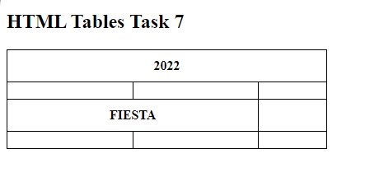

# Lab Task 8:

Create a sign-up form on your webpage must including Input Fields (User Name, Email, Password, Confirm Password), Button (Submit, Reset).

# Lab Task 9:

Create the following form using HTML.

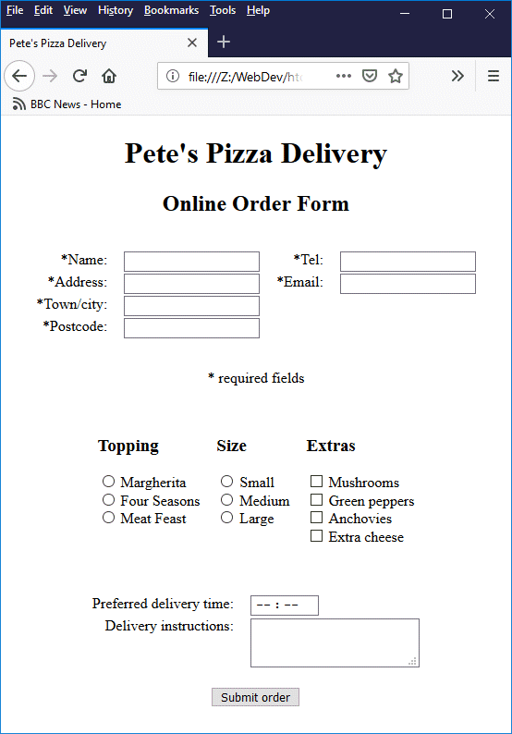

**Visit Link to Practice More About Forms:**

<https://www.w3schools.com/html/html_forms.asp>

**You are done with your exercise(s), make your submission on Classroom.**

**BEST WISHES**