**Deliverable D1**

**OOAD Project**

**Group Members**

**Muhammad Bassam Malik - BSEF19M018**

**Muhammad Adrees – BSEF19M026**

**Usama Javed – BSEF19M035**

**Vision:**

The vision of our product is to facilitate students or parents to a find a tutor easily. Cause finding a verified and qualified tutor is an uphill task for parents and students. Unlike regular way of finding tutor which is a severe headache our product will make it convenient to find a tutor of user’s choice while sitting home on internet.

**Stakeholders:**

The major stakeholders are

* Product Owner
* Administration

**Supplementary Specification:**

**Introduction:**

Online tutor finding portal is a good step towards education. It will facilitate both students and tutors in respective interests. It will help students to find quality teacher, through their ratings, reviews, which are financially affordable.

**Scope:**

* All functionalities are designed for tutors and students or parents.
* All users will be able to use this portal for 24/7 via internet.
* Students or Parents can search for different tutors with specific subject specialty.
* Anyone can be registered as a tutor but before publishing their profile admin will verify them.
* Students will be able to choose mode of class that is face to face or online.

**Major Requirements:**

* Tutor credentials
* Tutor’s experience
* Tutor’s qualification
* Tutor’s subjects in which he/she is special
* Tutor’s fee
* Tutor’s gender
* Tutor’s Location
* Tutor’s availability status on which he can deactivate his profile and again publish.
* Student credentials
* Grade in which student is studying
* Subject/s student want to study
* Class mode(online or physical)
* Location
* Searching tutor on base of grade and subject.
* Class mode (online or physical).
* Chat box for communication between student and tutor.

**Non Functional Requirements:**

* **Tutor’s rating:** Tutor’s rating given by different students.
* **Tutor review:** Reviews given by different students.
* **Contact details:** Tutor’s and student’s some optional contact details.
* Different filters for searching tutor
* Filter for fee range
* Filter for tutor’s gender
* Filter for tutor’s location

**Feature List:**

* **Log in:** There will be a feature of log in (if user is already registered) by system will identify user(student, tutor, admin) and will show them their respective home screen
* **Tutor’s profile:** There will be a tutor profile which will have different information like reviews, ratings etc.
* **Student’s profile:** Student profile will also have different information like student’s grade, subjects want to study etc.
* **Class mode:** It contains a feature of class mode whether teacher is available for online or physical class or both and in which class mode student want to study
* **Send request:** After searching and choosing a tutor student first will send request to tutor to communicate in simple words if a tutor is willing to teach that student
* **Chat box:** A chat box for communication between student and tutor

**Security:**

All tutors requires user authentication.

**Usability**

**Human Factors:**

* Avoid Colors associated with common form of color blindness.
* Speed and ease of use should be main focus while developing.
* Different filters should be used to make search convenient and clear.

**Reliability**

**Recoverability:**

In case of internet failure user should make sure his internet is working properly.

**Performance:**

As user don’t like to wait and to work on complex things. So it should be fast and easy to use.

**Supportability**

**Adaptability:**

Our product should not be the hard for updates their always should be a room for updates to meet the requirements of client as per need of time and users.

**Domain Rule:**

* Tutor will pay 25 percent commission to admin on first fee.
* Every tutor should have experience of at least one year teaching.
* Every tutor should have at least 14 years of education.

**Feasibility**

**Technical:**

It’s our project so we are working on the technology in which we are technically feasible.

**Timeline:**

We have enough time to complete this project so, we in matter of timeline we are feasible.

**Financial:**

Financially we are feasible to do this project.

**Legal:**

Our project comply with legal and ethical requirements. So it is legally feasible.

**Risk List:**

* There is no any risk of technical, financial or time schedule because we already told that we are feasible in all of these.
* There is a risk of any competitors growing in market.
* If there is implementation of new government laws.
* There could be some attacks to steal users’ data.

**Actors:**

* Student/Parent
* Tutor
* Administrator
* Manager
* Bank

**Goals**

**High level Goals:**

**Administration**

* Provide quality service.
* Verify and publish tutor profiles.
* Get commission from tutors.

**User level Goals:**

**Student/Parent**

* Successful search of required tutor by student.
* Communication through chat box or any other mean.
* Hire a tutor.

**Tutor**

* Verification and publish of profile.
* Receive student request.
* Communicate through chat box or any other mean.
* Get hired.

**Use Cases**:

* Sign up
* Log in
* Verify tutor
* Search tutor
* Chat box
* Class mode
* Commission receiving

**Casual Dressing**

**Sign up:**

In this a new user will create a profile on the info he/she provides.

So the main case scenario is that a user presses sign up button and head toward the sign up page. After that user will provide credentials on the basis of profile he is trying to create. System will not save any of info if it’s a tutor before verification after verification it will be stored in the database. If user provide some out of bound information for some specific field it will give an error.

If some registered user is again trying to sign up then it will show the message of already registered.

The main success scenario is that user provide all information and correct and got registered (for student) and then he will wait for verification (only for tutors).

**Verify Tutor:**

In this use case after signing up a tutor will wait for its verification by admin.

Main case scenario is that a tutor has provided all in bound correct information. First it will check eligibility if a tutor is eligible then it will go for verification otherwise it will not create a profile even without verification. If a tutor is eligible then admin will verify all provided credentials. After verification if it’s verified then the profile will be published otherwise will again ask for documents.

The main success scenario is that a tutor got verified then his profile will published.

**Search Tutor:**

In this use case a student side user will search for required tutor.

This use case is about searching for tutor. A student cannot search a tutor directly from search bar instead he will first provide required grade and then required subject after that a list of tutor will be shown student can also filter them on the basis on fee, ratings, location, gender.

The main success scenario is that a student search for a tutor and get result as per his requirement.

**Package Diagram:**

Log in

Sign Up

Entry Point

**Buisness Level Use Case Diagram:**

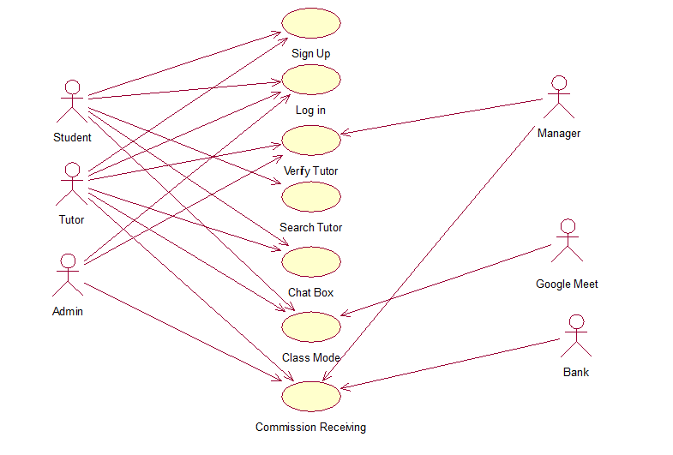

**Analysis Level Use Case Diagram:**

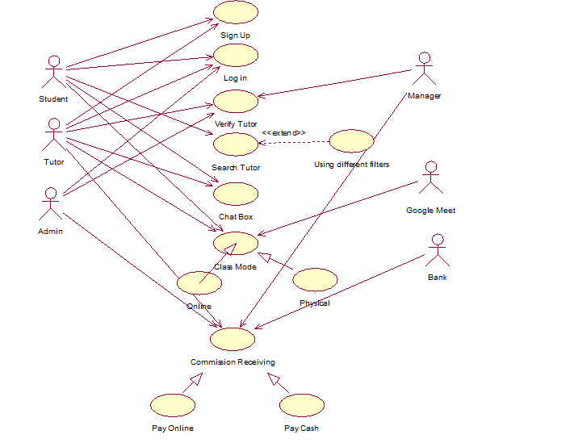

**Activity Diagram:**

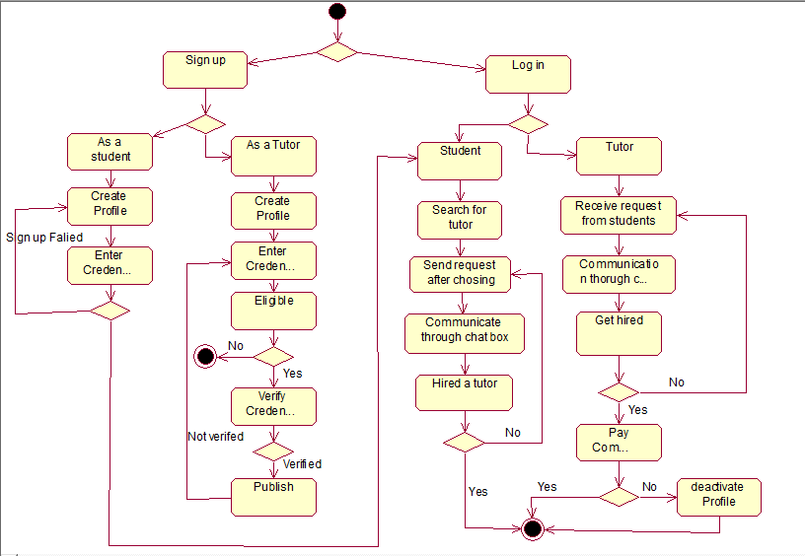

**Swim Lane Activity Diagram:**

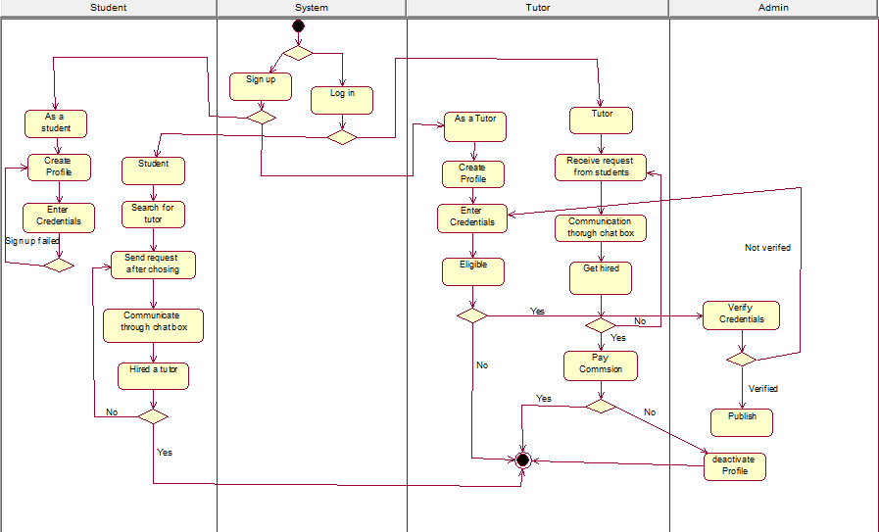

**State Chart Diagram:**

