**Name: Usama Khalid**

**Roll no: F17-8013**

**Sec: 7A**

**Data Science**

**Assignment -1**

***R-Studio and Swirl***

# **Screen Shots**

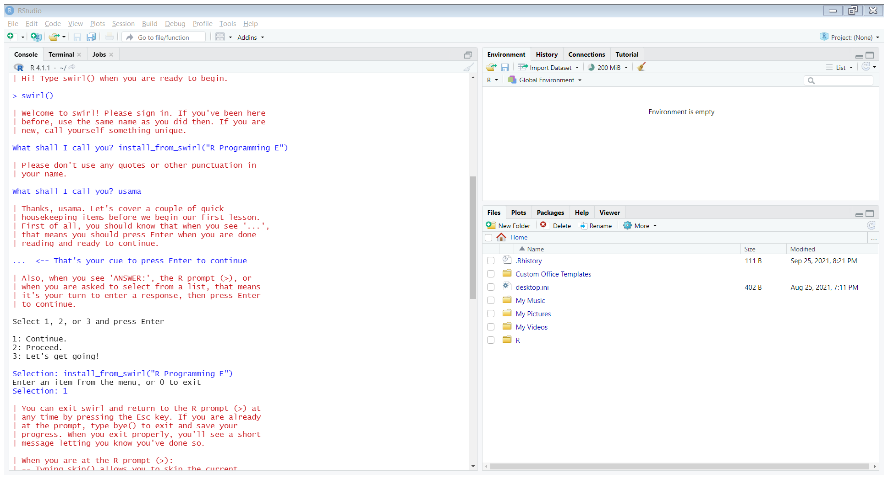

1. **Basic Building Blocks**

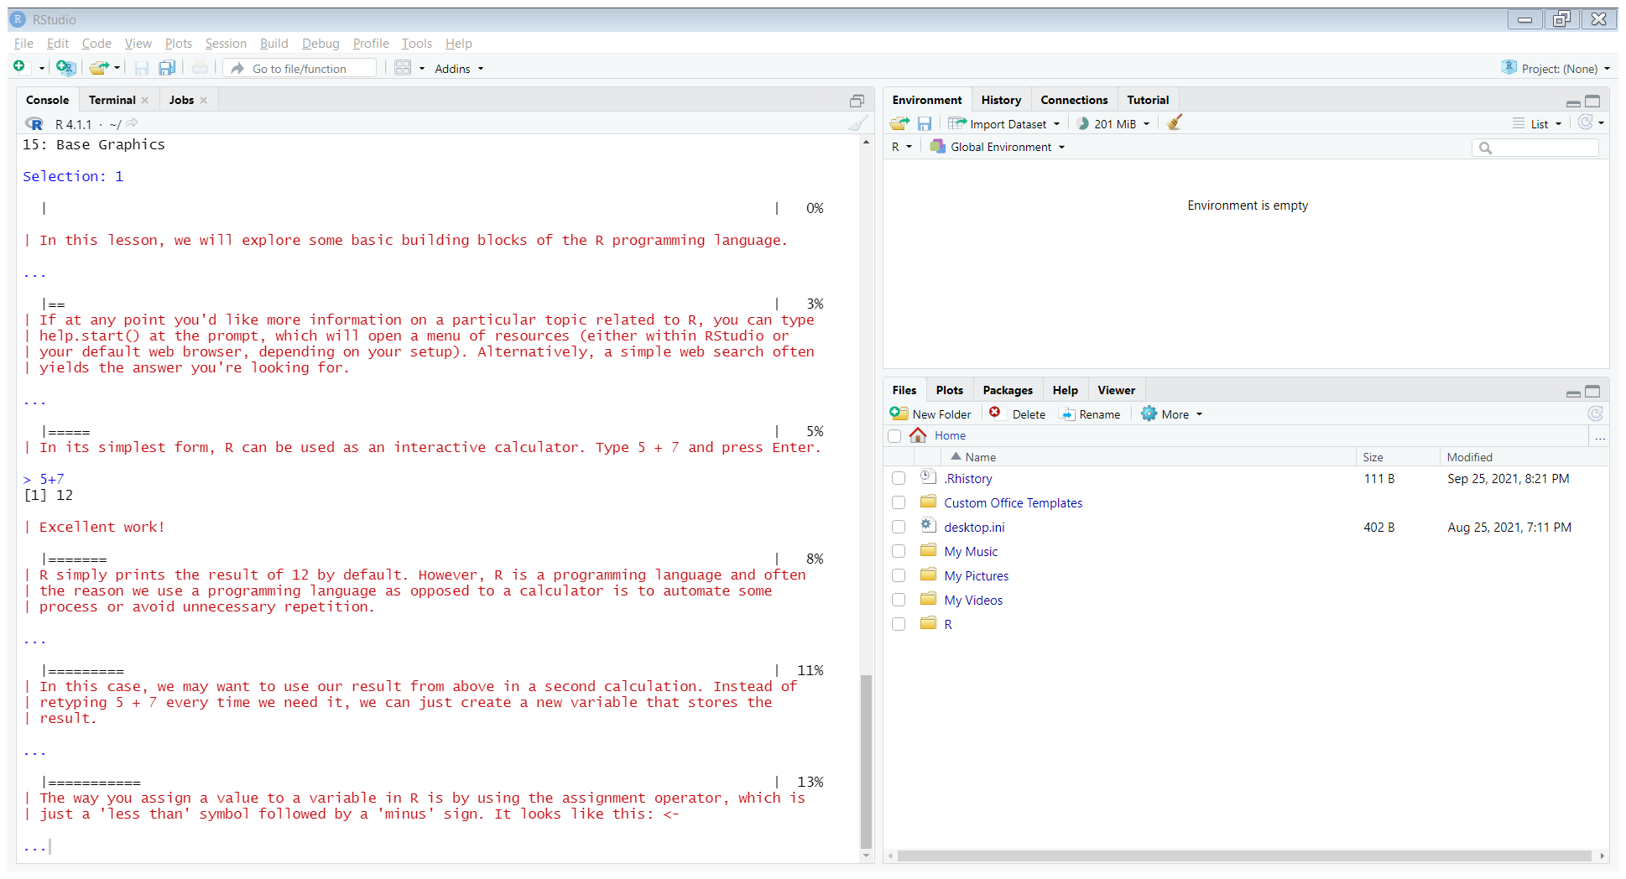

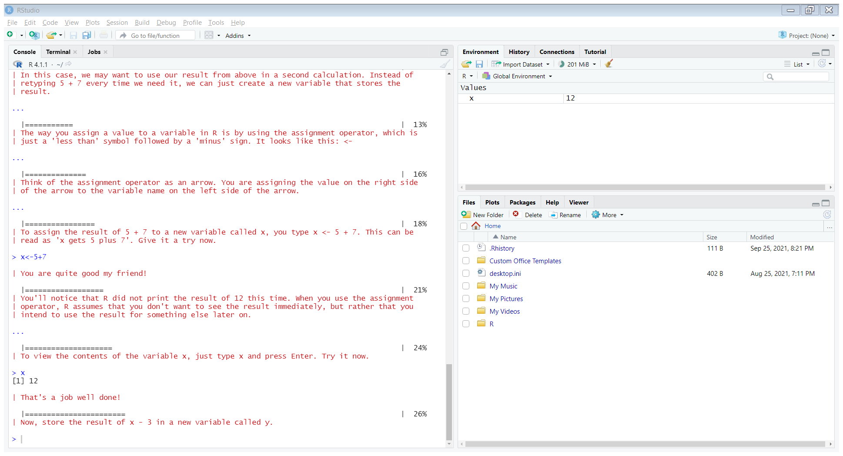

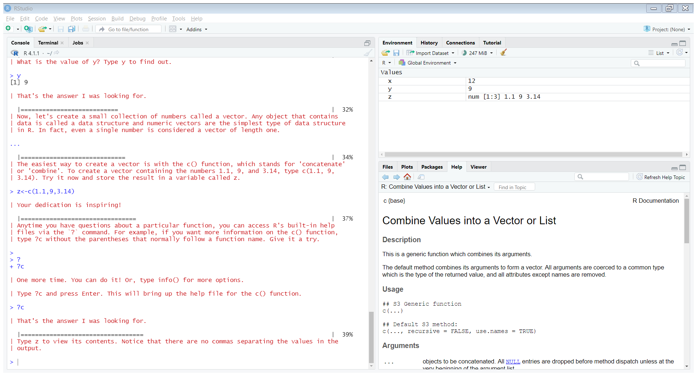

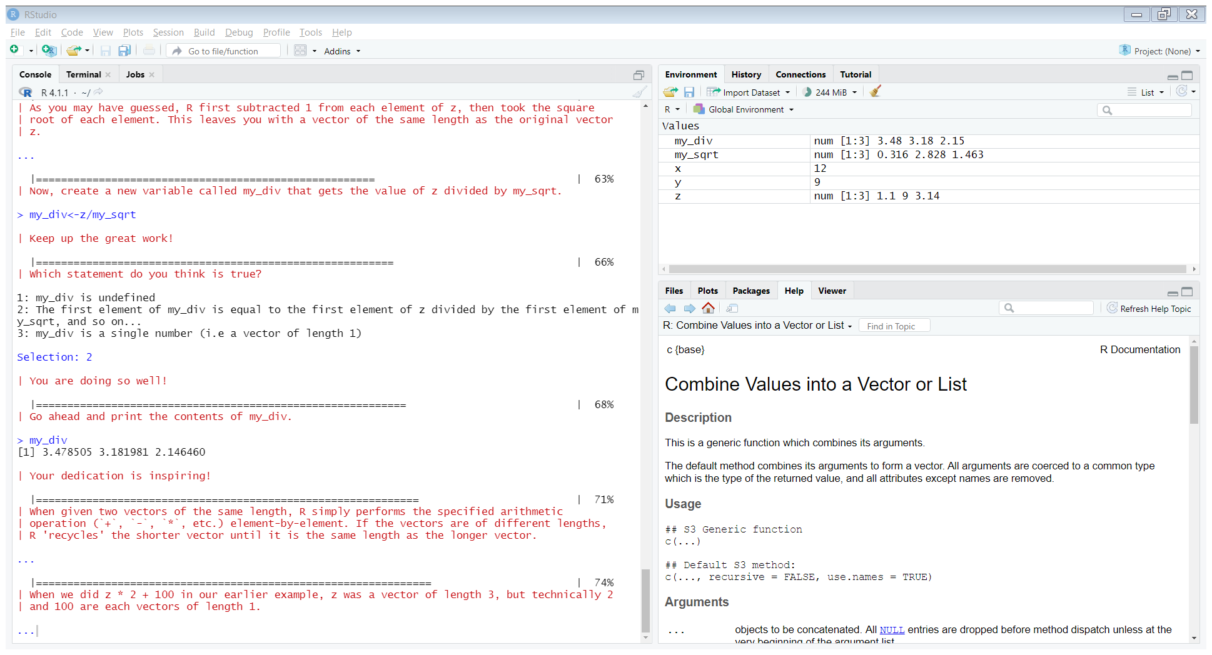

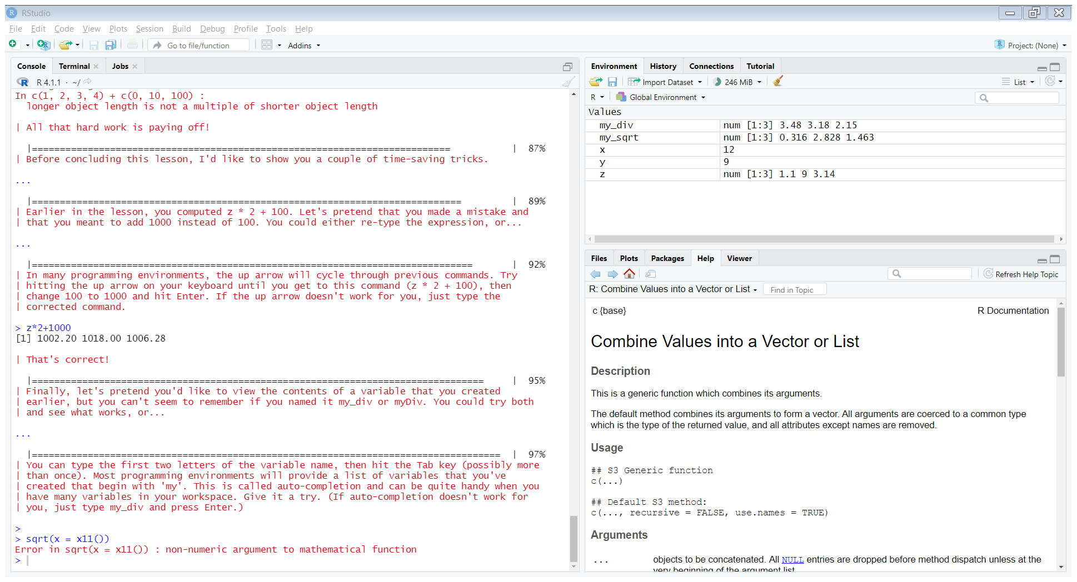

1. **Workspace and Files**

1. **Sequences of Numbers**

1. **Vectors**

1. **Missing Values**

1. **Subsetting Vectors**

1. **Matrices and Data Frames**

