**Name: Usama Mehmood**

**Roll No: i16-0190**

**CP Major Assignment Submission (hierarchy of Classes)**

Class **Flight**

{

**FlightSeats** obj;

//Data Members & Functions

}

Class **FlightDataBase :** public **Flight**

{

**Flight** obj;

//Data Members & Functions

}

Class **Passenger**

{

//Data Members & Functions

**Luggage** obj;

}

Class **Luggage**

{

//Data Members & Functions

}

Class **Booking** : public **FlightDataBase** , **Passenger**

{

//Data Members & Functions

}

Class **FlightSeats**

{

//Data Members & Functions

}

Class **Payment (Abstract Class)**

{

//Data Members & Functions

}

Class **Ticket**  : public **Payment**

{

//Data Members & Functions

}

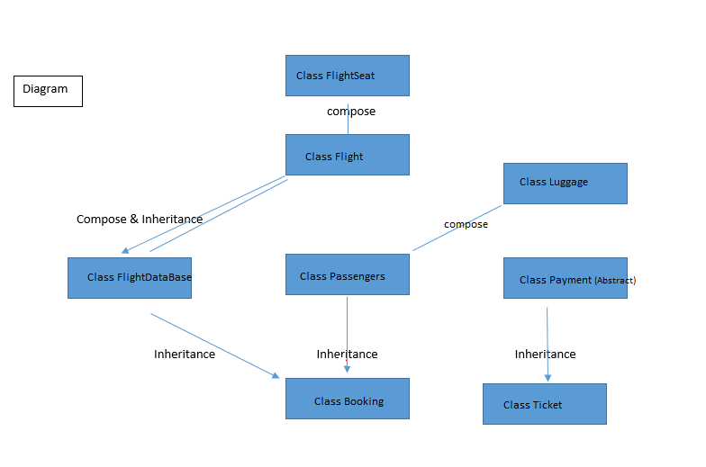

**Requirement meet:** Flight has a number of seats and according to seats, flight has corresponding available passengers. A booking system receives a flight details and book a given seat in that flight and issue a booking id to the passenger. A Ticket is generated according to booking ID and flight charges and payment is made(Imaginary). A payment is an abstract Class. A menu can add new flight, delete existing flight, make new booking, cancel new booking, calculate luggage charges, show sitting plan of a flight and the schedule of all flights and many more features.

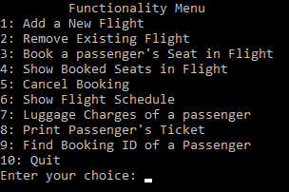

Diagram

compose

Compose & Inheritance

Inheritance Inheritance Inheritance