|  |
| --- |
| Department of Software Engineering  Mehran University of Engineering and Technology, Jamshoro |

|  |  |  |  |
| --- | --- | --- | --- |
| Course: SWE324 - Data Warehousing and Data Mining | | | |
| Instructor | Rabeea Jaffari | **Practical/Lab No.** | 10 |
| Date | 2nd Aug 2018 | **CLOs** | CLO-4: P3 & P4 |
| Signature |  | **Assessment Score** | 1 Marks |

|  |  |
| --- | --- |
| Topic | Data mining technique: association rule analysis |
| Objectives | * To learn Data mining using Microsoft Azure Machine Learning Studio. * To perform association rule analysis using Apriori algorithm in Microsoft Azure ML Studio. |

Class Task

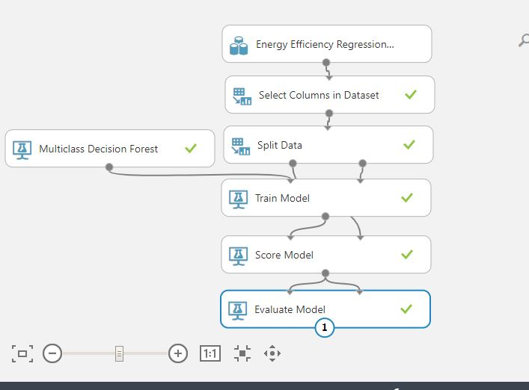

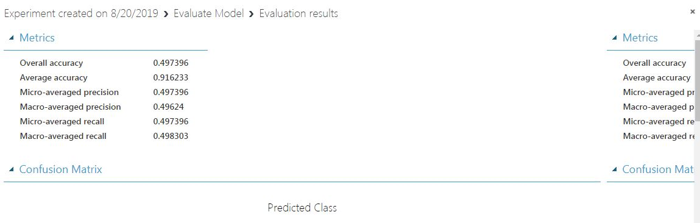

**Labtask:**

|  |
| --- |
| Lab Tasks |
|  |

Take any dataset in CSV format and derive association rules and frequent item sets from it using any one of the approaches described above.

